**EXERCISE 9B. PROTECTING NATURAL RESOURCES – TODAY AND FOR THE CENTURIES AHEAD**

|  |  |
| --- | --- |
| *OBJECTIVE*  *In this exercise, the group will review the importance of protecting natural resources, now and for future generations. They will also discuss some of the challenges and how to address them.*  **After this exercise the participants will be able to:**   * Identify the importance and benefits of protecting their natural resources. * Identify key constraints to sustainable natural resource management and actions to address them. | |
| *EQUIPMENT NEEDED*   * Flip chart, marker pens, printout of the figure *Two scenarios for the future*. | *EXPECTED OUTPUTS*   * Group members have discussed and reviewed their own rationale for protecting their local natural resources. * Group members have identified the key challenges they face in preserving their natural resources and some actions that can address these challenges. |
| *TIME*  45 minutes-1 hour | *PREPARATION*   * The facilitator should review the rationale for protecting local natural resources (livelihoods, ecosystem services, current trends with natural resources) and be prepared to lead the group in a discussion of this topic. |

*SUGGESTED PROCEDURE:*

1. Start the meeting with a discussion on the local natural resources that are essential for the livelihoods of community members. Make sure that you cover various resources (soil, air, water etc.) and multiple sources (for example, a stream, a lake and rain as sources of water).
2. Once the main natural resources are identified, continue by facilitating a short discussion on the most important ecosystem services for the community (please cover examples from all four: provisioning, regulating, supporting and cultural).
3. Bring the two together by engaging the participants to talk about the current trends with key local natural resources.
   * + Are most of the natural resources healthy and being managed well?
     + Are any particular resources under threat, and how serious is the situation?
4. Pass around the two pictures from *Two scenarios for the future* and ask which scenario is more likely to occur in their community. Recap the key local natural resources and trends. Lead the group in a discussion of what specific developments could lead to the outcome in each picture. Use the key trends identified during the previous discussion as starting points. For example, if there was a problem with erosion caused by gullies, lead a discussion into what would happen if the gullies expanded and the erosion got worse. Conversely, discuss what will happen if they are plugged/filled and contour lines are constructed on the slopes.
5. Continue by exploring the challenges to addressing these problems. Ask the group to identify some key constraints. Write down the key constraints on the flipchart, relating them to type of ecosystem service and type of problem (erosion etc.). Specify the problem and solutions:

* What actions could they take to address these constraints?
* Who could take these actions, and in which timeframe?

Write down all answers on the flip chart, to preserve a record for the community.

1. At the end of the discussion, thank the group for their inputs and encourage them to both implement what they have learned and to share their knowledge with others in their community and beyond.

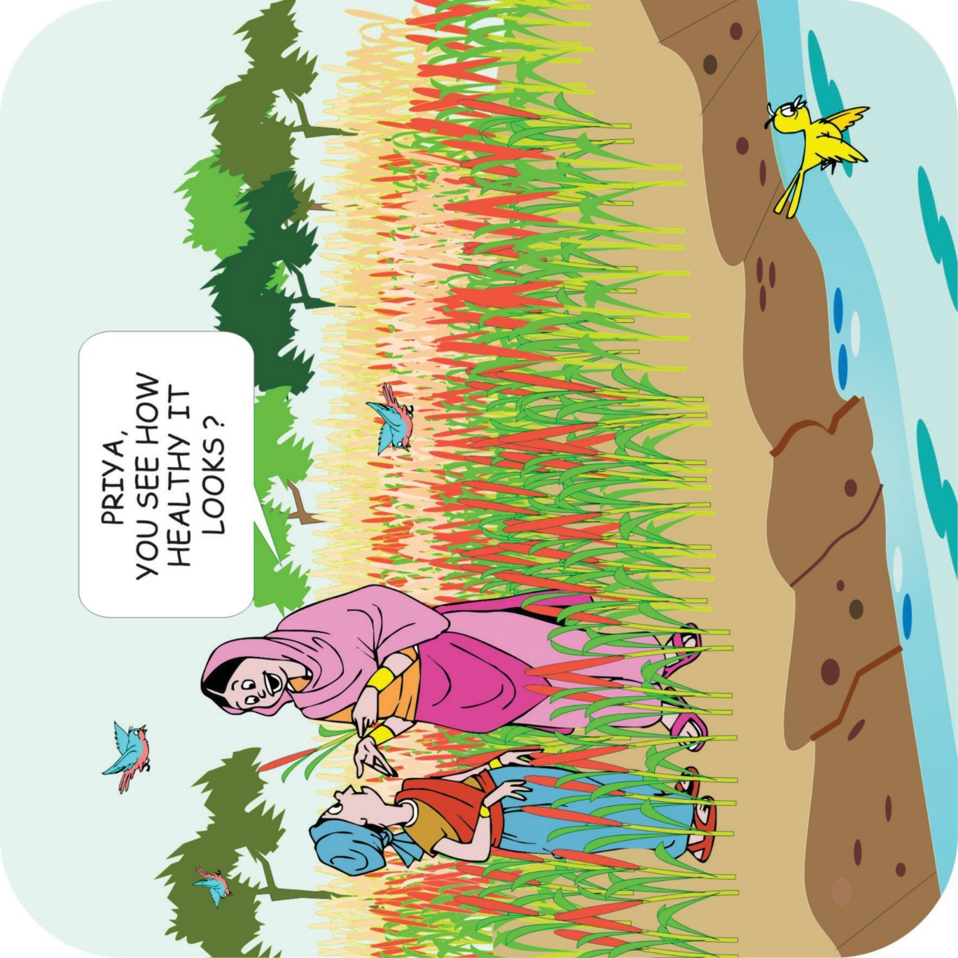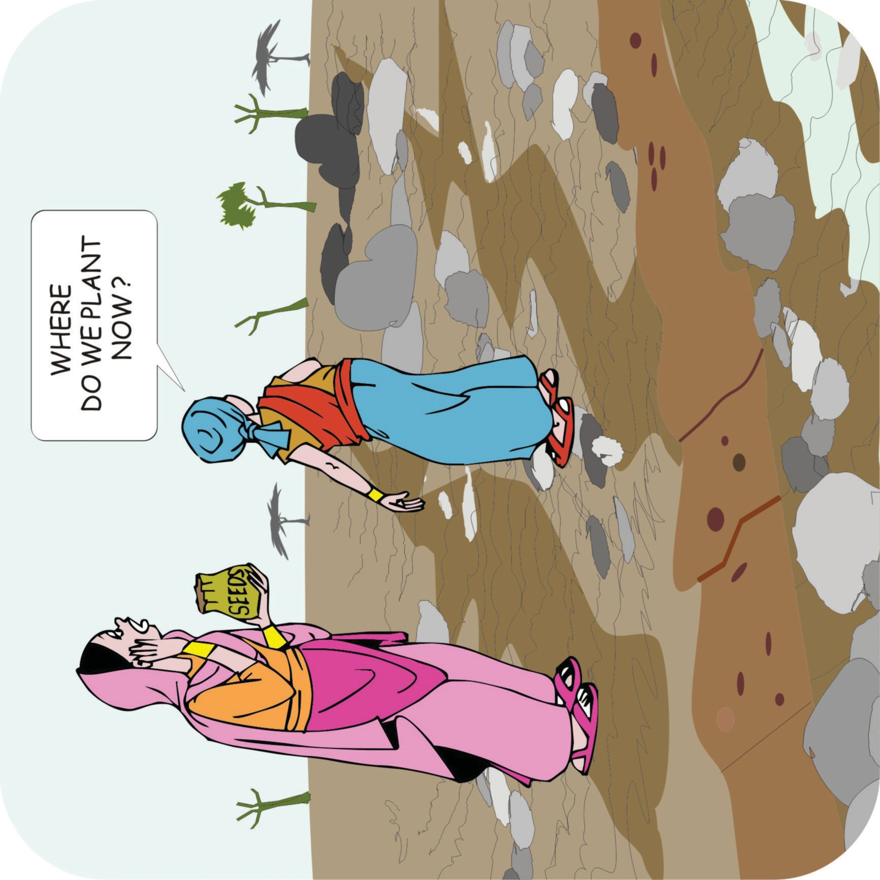

**Two scenarios for the future**

**Two scenarios for the future**