EXERCISE 9A. ECOSYSTEM SERVICES
OBJECTIVE
After this exercise the participants will be able to:
- Explain the concept of “ecosystem services” in their local context.
- Describe the concept of “payment for ecosystem services” in case it is offered by external agencies.
EQUIPMENT NEEDED  - Flip chart, marker pens | EXPECTED OUTPUTS  - Group members have identified the main ecosystem services that they enjoy in their local environment.  - Group members have discussed the payment for ecosystem services model and have identified such opportunities (if available).
TIME  45 minutes- 1 hour | PREPARATION  - Familiarize yourself with the concept of ecosystem services. Identify at least one locally specific ecosystem service in each category (provisioning, regulating, supporting and cultural). The facilitator should also review the concept of payment for ecosystem services and examine whether any organizations are supporting this scheme in the community or wider area. Consider inviting representatives of these organizations to this meeting.

SUGGESTED PROCEDURE:
- Present to the group the concepts of ecosystem services and payment for ecosystem services. Ask if there are any questions, and lead a short discussion to clarify these concepts.
- Guide the group in a discussion of local examples of ecosystem services. Cover each of the four categories (provisioning, regulating, supporting and cultural); list as many examples as possible on the flip chart.
- Ask the group who – outside of their community – also depends on these services that are generated in their community. For example, clean water and clean air might be used by people in nearby urban centers. Write down as many as the group can list. Discuss whether these external people should have some responsibility for maintaining the ecosystem services that they depend on.
- Ask the group how the negative environmental trends they identified earlier in their ecosystem assessment might impact local ecosystem services and the people identified in point 3 above. Discuss the concept of payment for ecosystem services. If there are examples of local initiatives in the area discuss these in great detail, covering the organizations, the types of services and implementation. If there are no suitable local examples use examples from the region or country.

- Continue with a discussion that will examine the benefits and weaknesses of the scheme. If there is a locally available initiative consider inviting a representative of the organization to the meeting. Ask multiple questions to better explain the scheme and its benefits as well as to assess local interest in participating.
- Which key resources are preserved by the initiative?
- How does the community benefit from safeguarding these resources?
- Would their community be interested to participate in such a scheme?
- Who might have an interest in making such payments?
- How would these payments be handled?
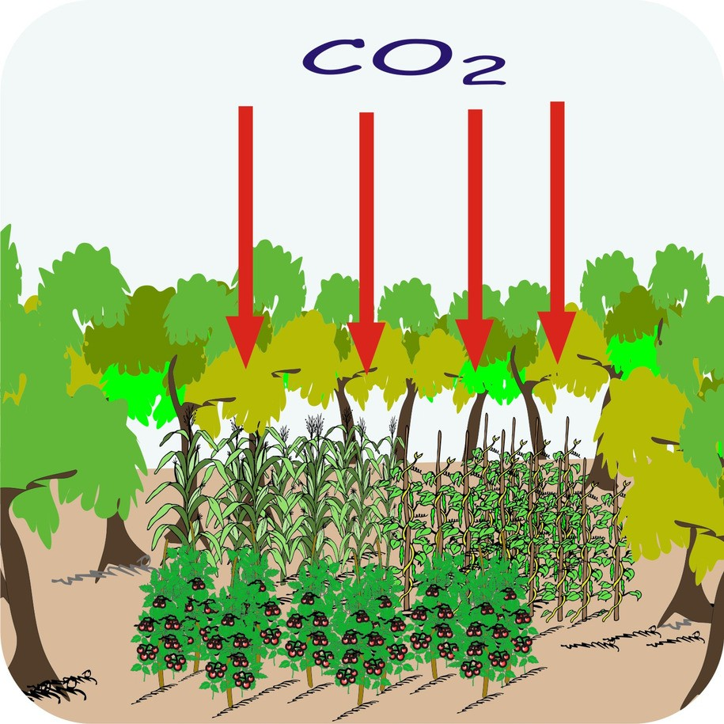
- Record the answers and make sure that the group retains a copy for future reference.

