**EXERCISE 8. INTRODUCTION TO FOOD WEBS**

|  |  |
| --- | --- |
| *OBJECTIVE*  **After this exercise the participants will be able to:**   * Describe how all living things are connected and the mechanism behind this connection. * Explain the importance of biological diversity and maintaining balance in our environment. | |
| *EQUIPMENT NEEDED*   * A large picture of a food web diagram. If there is none available then draw one using available tools (markers and paper, sticks and the ground, etc.). | *EXPECTED OUTPUTS*   * Group members understand the roles of “producer” and “consumer” organisms as well as how matter and energy are transferred from one species in the food chain/web to another. * Group members understand how the removal of one species affects the population(s) of other species and the need for balance in the ecosystem. |
| *TIME*  1 hour | *PREPARATION*   * Familiarize yourself with the concepts of food webs, producer, consumer and their connections. Select some good local examples of the negative effects when the local ecosystem has gotten out of balance. Talk to the participants and the local inhabitants to explore these stories. |

*SUGGESTED PROCEDURE:*

1. Show the diagram to the group and ask group members to name local examples of some of the key species within the diagram (e.g., types of trees or grasses, types of insects, birds and other animals that eat those insects, local predators like wild cats, etc.).
2. Explain how “producer” organisms use photosynthesis to convert nutrients and solar energy into organic matter and chemical energy. Also, explain how energy and matter are transferred from one organism to the next up the food chains.
3. Discuss with the group what happens when one organism (or animal) is removed from the web. What happens to the organisms to which it is connected?
4. Continue with a discussion on what is happening to the different groups or organisms in the local ecosystem. Use the following questions to simulate discussion. Please adapt the questions below and introduce other relevant questions if necessary:

* Are there still many apex predators around (wild cats, tigers)?
* Are the local producer organisms thriving (trees, grass)?
* How are the current conditions of local producer organism, and what is the effect on the other species in the system?
* Is there an increased number of insect pests in our crops? If so, why?
* Are there more mice and rats in the storage bins? If so, why?
* What are possible effects of cutting down trees to make charcoal?
* Where does the mountain lion get energy and nutrients, and what happens to the energy and nutrients in the mountain lion when it dies?

1. Summarize the main points from the food web diagram. Make sure that the following information is covered:

* All living things are connected to other living things (we are also part of this web).
* Chemical energy and organic matter are generated by producer organisms and move from one organism to another up the food chains.
* If one species of organism is removed from an ecosystem, it will have a serious impact on the other organisms.
* It is vital to protect the non-living resources that are necessary for producers to grow and prosper.
* They are the basis that supports all the other life forms in an ecosystem.
* Diversity and balance are important for the long-term productivity of the ecosystem.

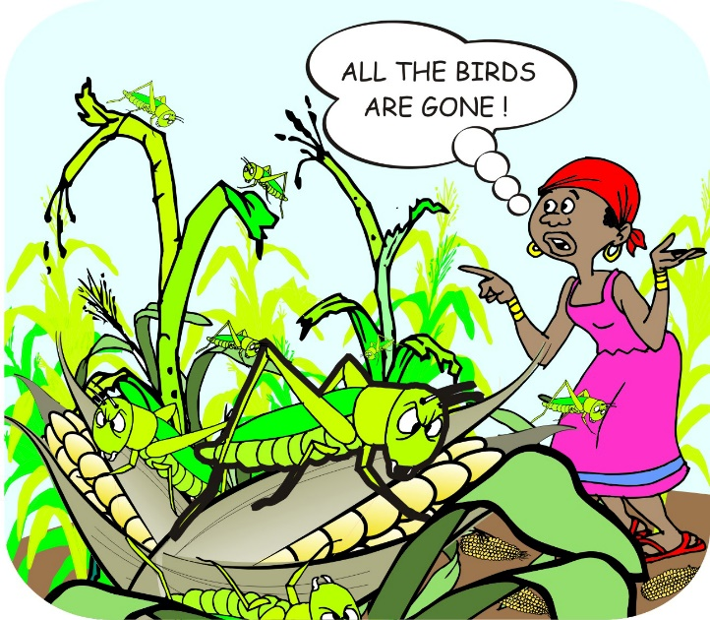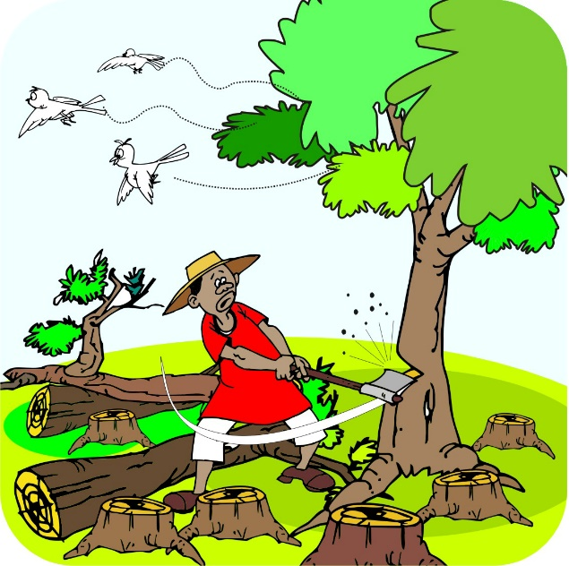

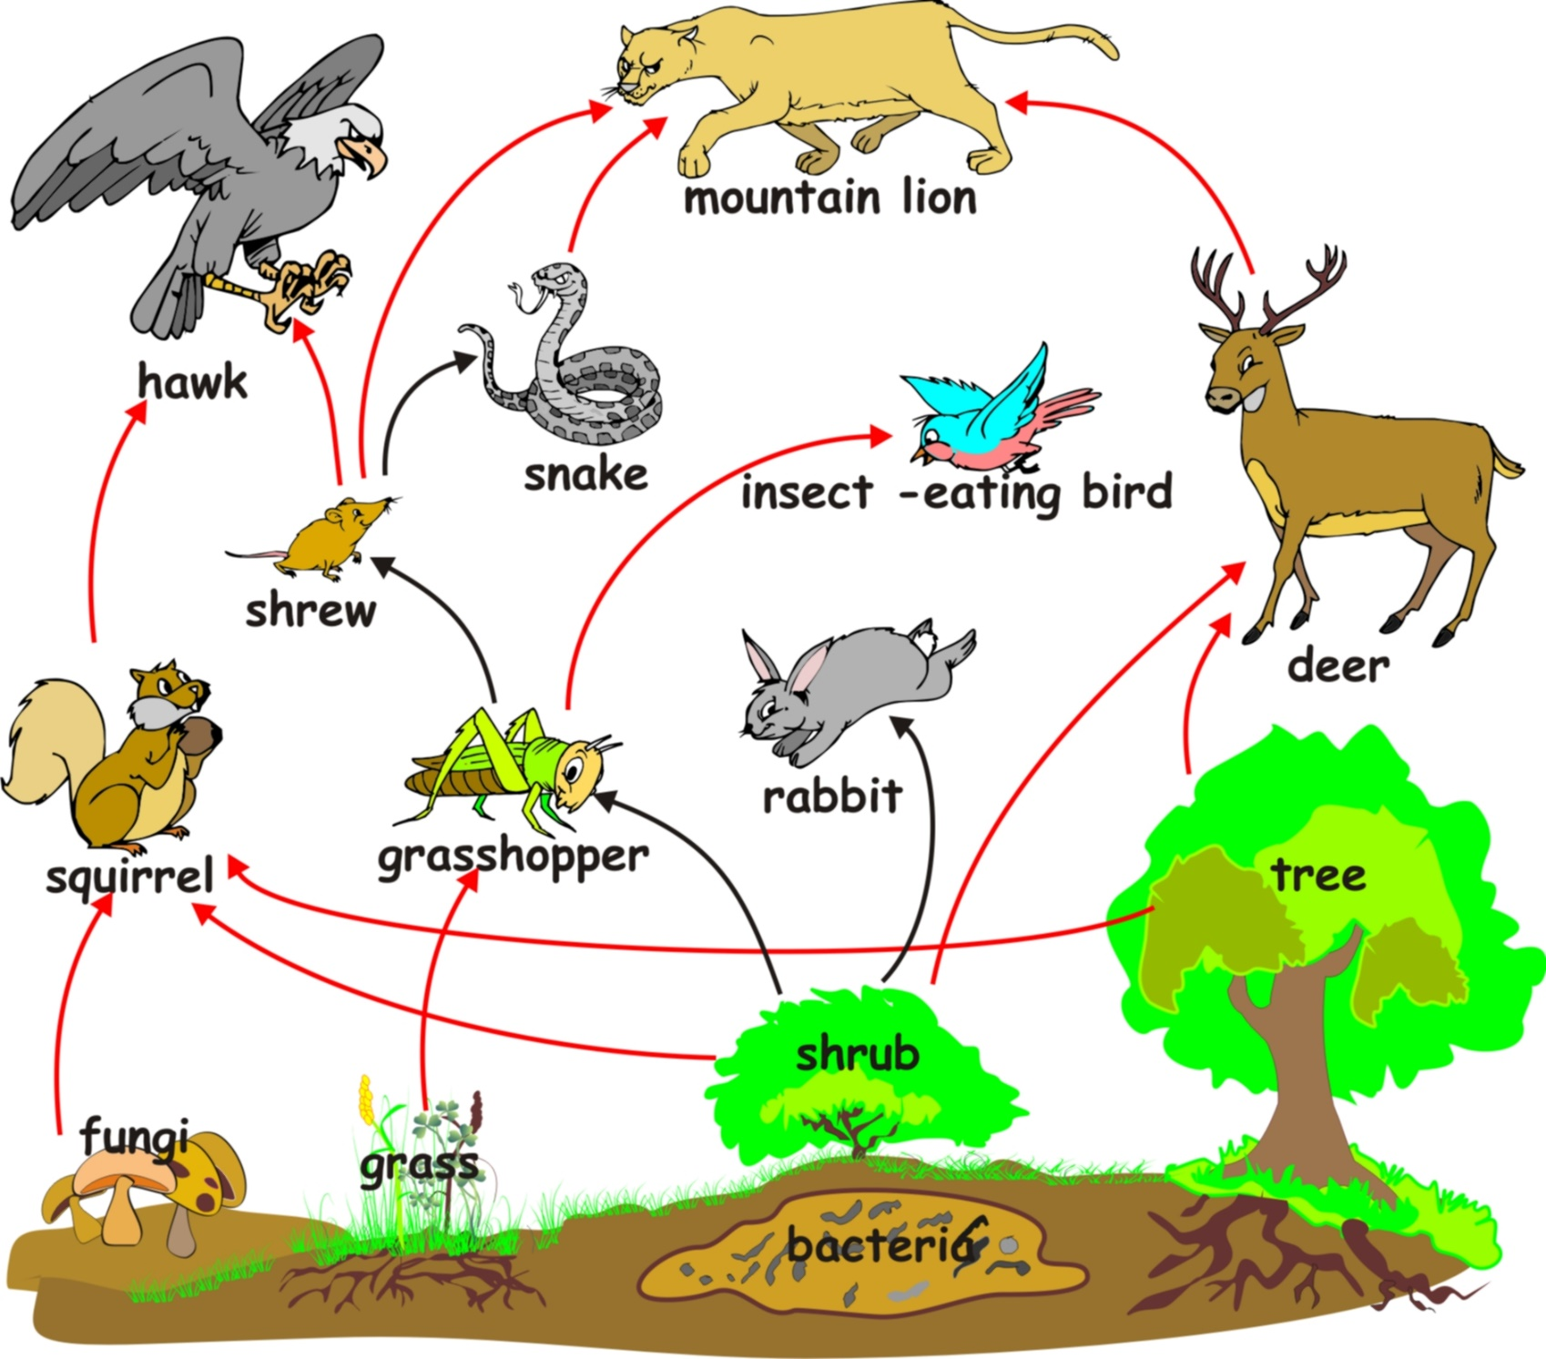

**A food web**

