**EXERCISE 5C. DETERMINING SOIL TEXTURE**

|  |  |
| --- | --- |
| *OBJECTIVE*  **After this exercise the participants will be able to:**   * Use a simple and practical system for determining soil texture. | |
| *EQUIPMENT NEEDED*   * Some water in a container and two or three soils of different textures (these might be found near to each other in a field, or collected and brought to the meeting) | *EXPECTED OUTPUT*   * Group members will learn a systematic way to compare the texture of different soils. |
| *TIME*  15-20 minutes | *PREPARATION*   * Identify where the group can access soils of different textures. Try the exercise in advance of doing it with the group. |

*SUGGESTED PROCEDURE:*

1. Explain to the group that they will do an exercise to determine the different types of soil. Briefly describe the main types of soil (sand, clay, silt and loam) and their properties.
2. Divide the group into smaller groups of 3 to 5 persons each. Each group should run the test on at least two different soils, following the procedure described on the next page.
3. Afterward, come together as a group and ask participants to describe what they learned. Ask which types of soil are found on their own farms, and what they have noticed for the effect of these soils on plant growth. Ask:

* Which soils are best for growing which crops?
* Which soils are best during rain/ drought?

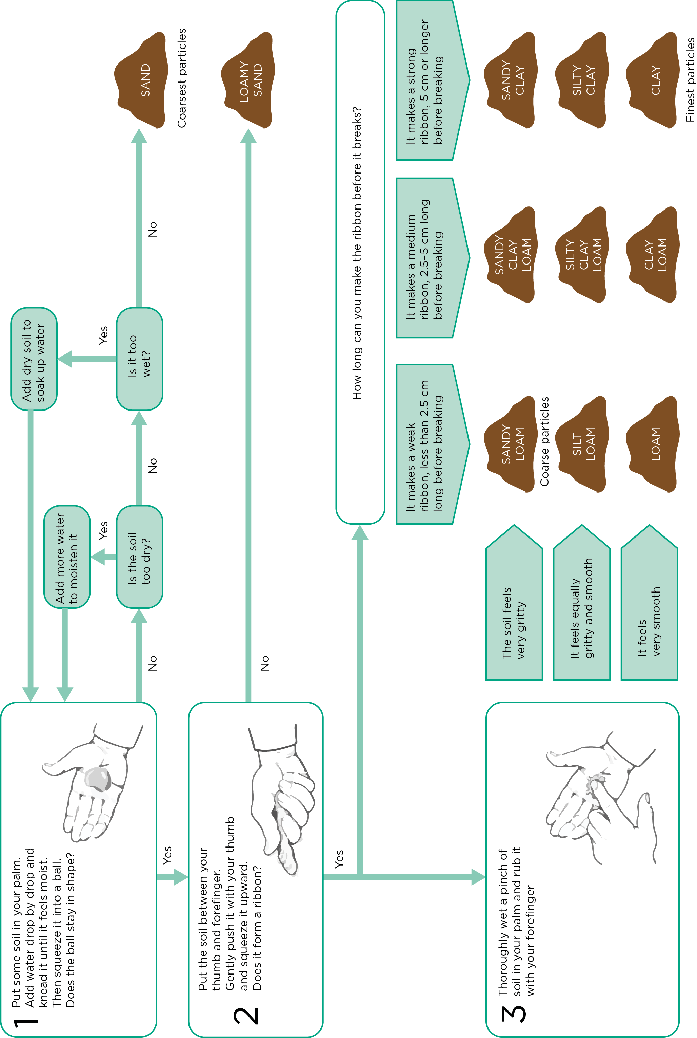

**Guide to soil texture by feel**