EXERCISE 5A. COUNTING SOIL ANIMALS
OBJECTIVE
After this exercise the participants will be able to:
- Measure the population of soil animals in the topsoil, a key indicator of soil health and its ability to produce crops.
EQUIPMENT NEEDED  - Aluminum can or homemade square metal frame.  - White or light colored cloth or sheet.  - Instruments for cutting and digging (machete, cutlass or shovel). | EXPECTED OUTPUTS  - Group members have learned how to measure the topsoil’s macrofauna (the soil animals that are visible to the eye).
TIME  15- 30 minutes per site measured | PREPARATION  - The facilitator should first make a sampling frame, using an aluminum can or a square made out of scrap metal. If using a can, you need to remove the top and bottom. The can should be big enough to hold 800 grams of soil (at least 15cm tall). If making a metal frame, you can solder 4 flat square pieces of metal (about 17cm by 17cm and 15cm tall) together to make a square frame, without a bottom or top part. The best time to carry out this exercise is after rain, when the soil is slightly damp but not very wet.

SUGGESTED PROCEDURE:
- Before starting the measuring exercise, spend a few moments describing how you constructed the metal square frame or the can. They may have to construct a frame on their own in order to measure topsoil quality on their own farms.
- Push the can or metal square frame into soil, until about 3 cm of the frame are sticking out of the ground.
- Use a machete or shovel to dig beneath and around the can of soil. Take out the can with the soil and place it on a white sheet or cloth. Separate the soil from the can.
- Count the number of soil animals that you can see and record this number. Facilitate a discussion with the group: ask what these soils animals signify for the health of the soil, and how their presence affects plant growth. If needed, explain that the more soil animals are present, the more fertile the land.
- Use the can to take samples at other locations on the plot and compare the differences in the presence of soil animals. Ask the group what are some of the reasons why there might be differences.
- Tell the participants:
  - As you add more organic matter to your soil, you can return to count soil macrofauna each year at the same time with the same size can or frame. You should see the number of soil animals increase.
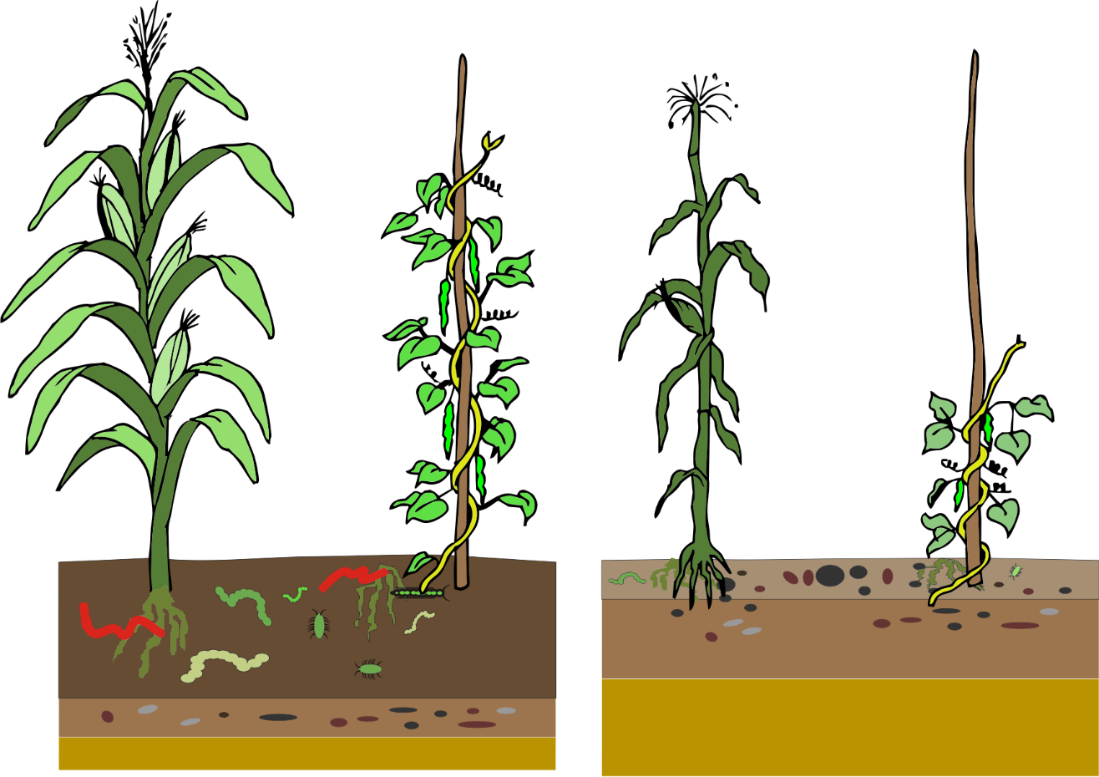
Note: If your soil has lots of stones or pebbles, do not use this method.

