**EXERCISE 2. VIEWING SOIL EROSION IN RUNOFF WATER**

|  |  |
| --- | --- |
| *OBJECTIVE*  **After this exercise the participants will be able to:**   * Explain the meaning of erosion by demonstrating that muddy rivers indicate water flowing out of farmers’ fields is carrying precious soil. * Assess the extent of this erosion. | |
| *EQUIPMENT NEEDED*   * A clear glass container (like a water glass) * 3 clear bottles and some dirt suitable to demonstrating river sediment | *EXPECTED OUTPUT*   * Group members understand the implications of dirty runoff water, and know how to obtain a relative measure of the soil loss (erosion). |
| *TIME*  30-45 minutes | *PREPARATION*   * This exercise is best conducted during the rainy season when a nearby water source is carrying dirty runoff water. Look for any potential streams ahead of the meeting. |

*SUGGESTED PROCEDURE:*

1. Collect a sample of water in the clear glass container from the stream or water body you identified in the preparation. Display this glass where the group can see it during your discussion.
2. Ask the group whether they have observed a difference in the color of the water of local streams/rivers before, during, and after the rains. Why is the color different? Lead the conversation to the point where group members recognize that the darker color usually means that the water is carrying more soil. Discuss where this soil comes from.
3. After about 30 minutes, look again at the sample of water that was collected at the beginning of the discussion. See if the water has cleared up at all, and if some of the soil has settled in the bottom as mud. Discuss what you see with the group members. Suggest that they do this simple test on their own close to their farm to see how much soil is being carried away by runoff water.

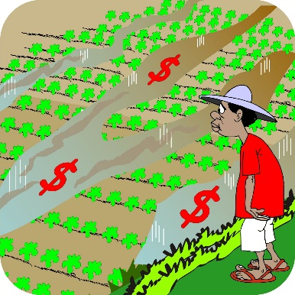

**Note:** if you cannot find a nearby source of muddy water, gather three clear bottles and fill them up with water. Then ask farmers to add varying quantities of soil, shake the bottles, and try to replicate the color of the rivers in the area. The bottles should have varying degrees of clarity to show the river sediment before (clearer), during (darker), and after (darkest). Use the different bottles with varying sediment densities to discuss the questions covered in this exercise.

*QUESTIONS TO STIMULATE DISCUSSION:*

1. How dark is the runoff water? Probe for different gradations or local terms.
2. What is the color of the runoff water (red, brown, grey)? What do the different colors mean?

