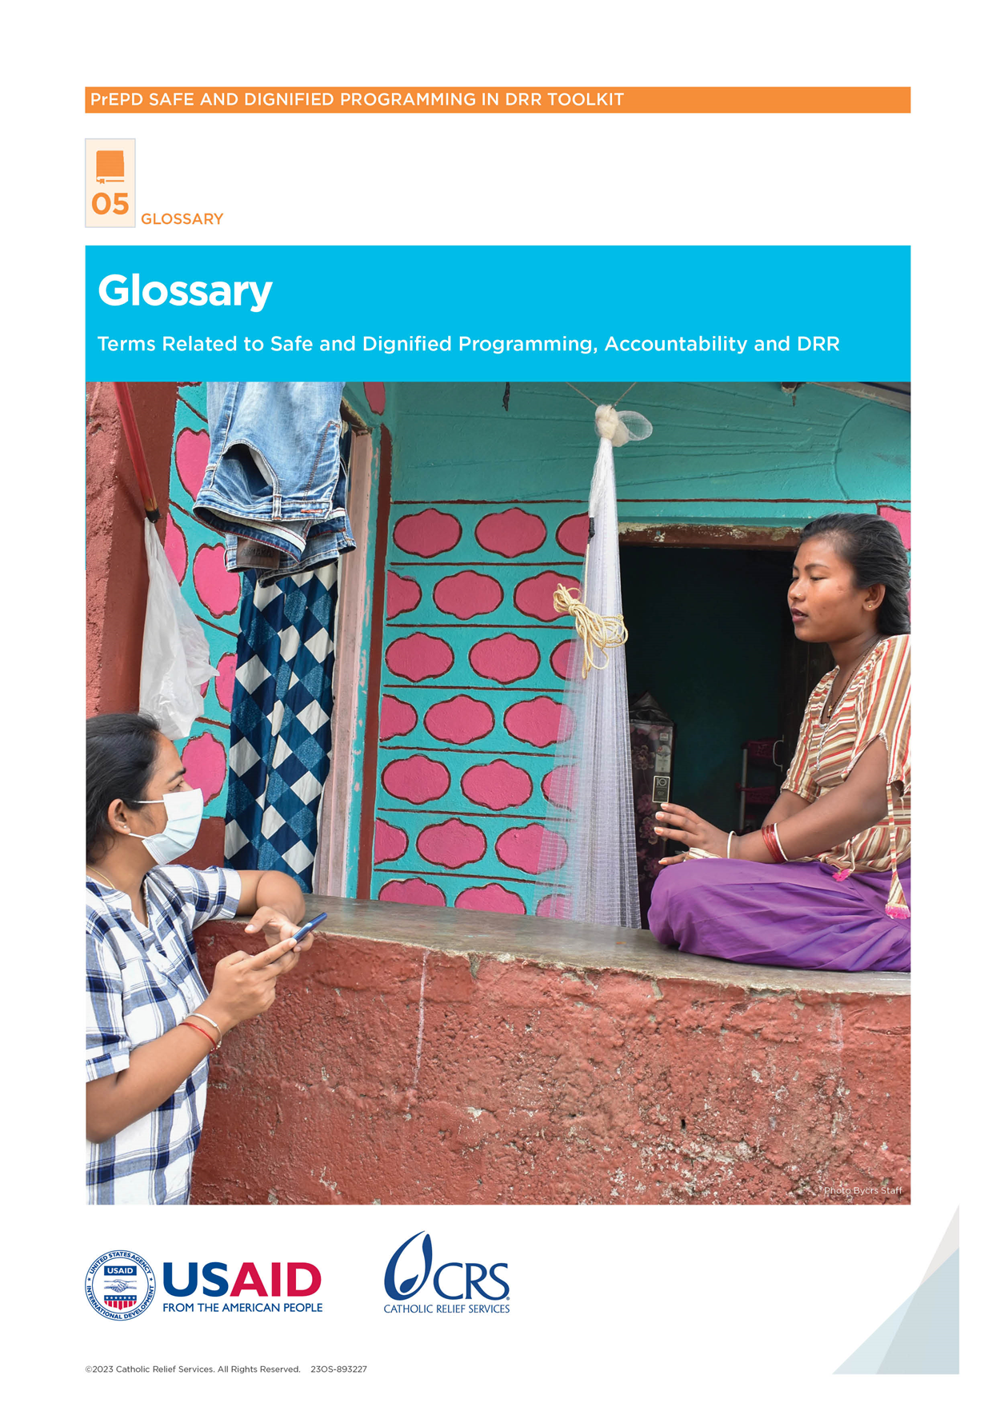

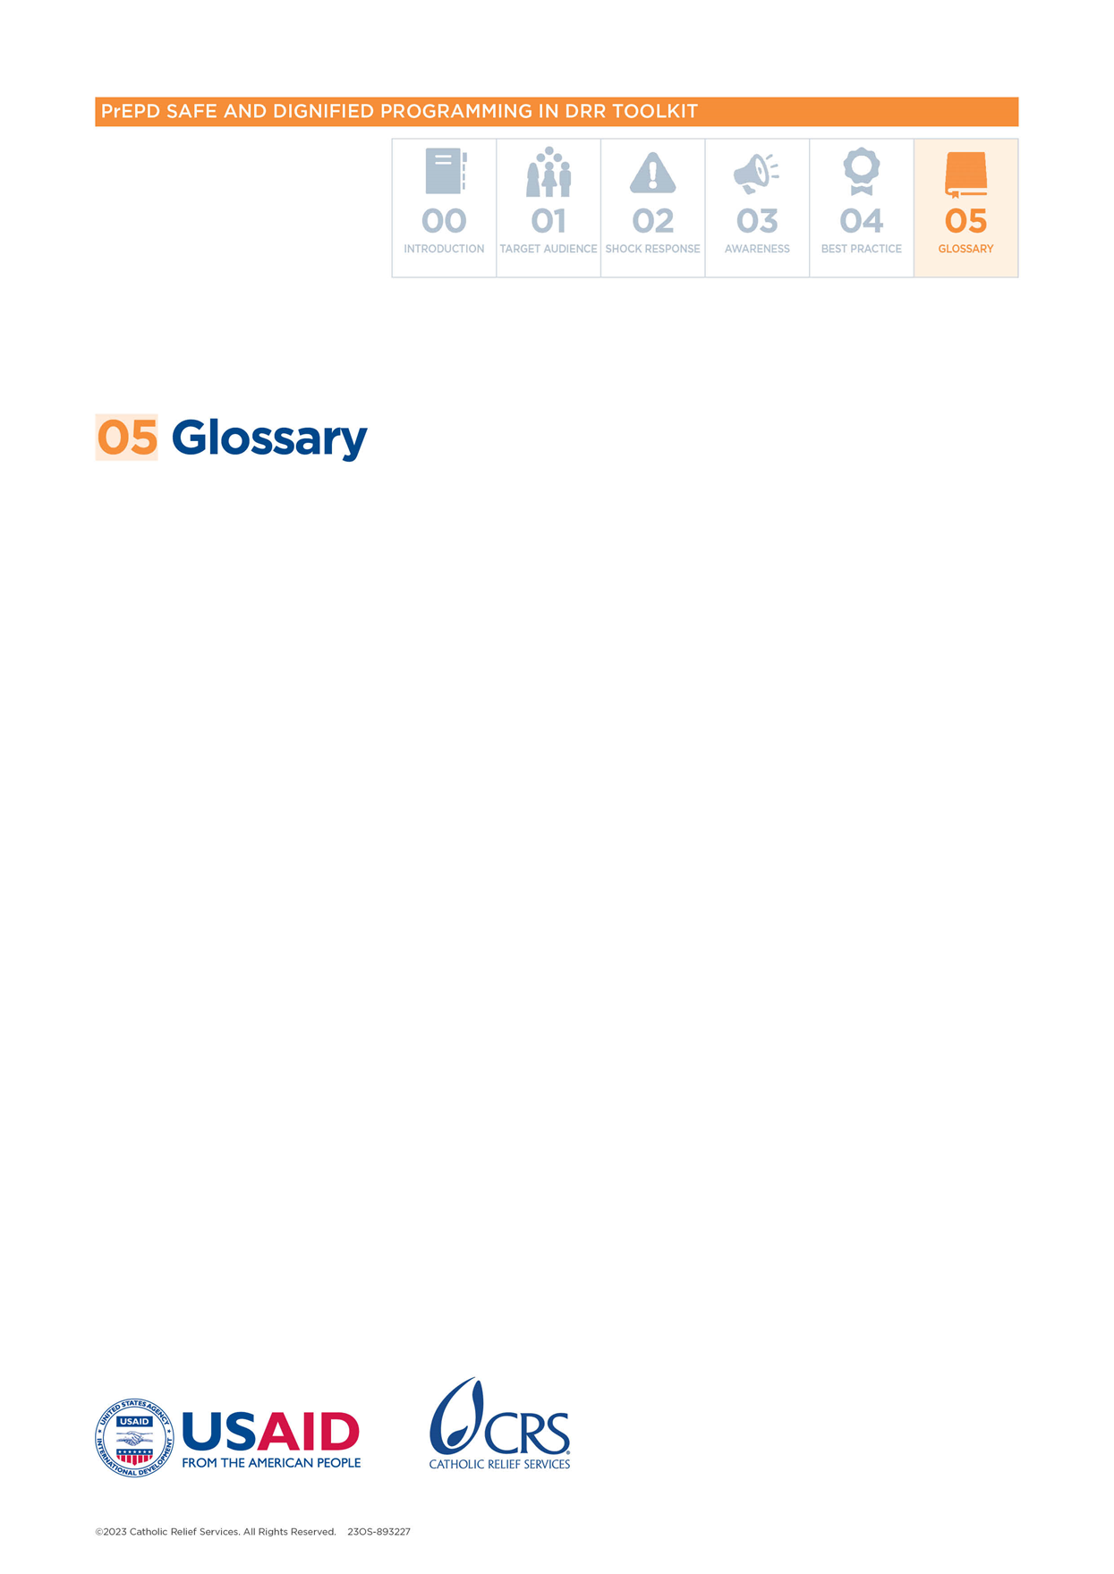

Glossary

## Abuse

**Definition:** When a person purposely hurts another person who they have power over. Abuse can be physical, emotional or sexual.

## Access

**Definition:** The right or ability to receive assistance or to use a particular good or service. Unrestricted access means there are no barriers to using that good or service.

## Accountability

**Definition:** Using power responsibly and in a way that is clear and open for everyone to see, especially for the people who are affected by how that power is used.

## Accountability to Affected People (AAP)

**Definition:** The process of using power responsibly by considering and being held accountable by an affected population, especially people who are affected by how that power is used.

## Action Plan

**Definition:** A plan that explains the steps you must take to reach a goal. Action plans give you important information about activities, deadlines, who is responsible for what and what resources you will need.

## Affected Population, People Affected by Crisis

**Definition:** People who are affected, either directly or indirectly, by a crisis.

**Explanation:** We say people are directly affected when they have an injury or illness, are evacuated, displaced or relocated, or if the crisis directly affects their livelihoods or economic, physical, social, cultural and environmental resources.

## Age

**Definition:** How long a person has been alive.

**Explanation:** Age is a key factor in doing analysis in programs on vulnerabilities, needs and capacities of different groups. People face different risks depending on their age/life-stage. Age can also overlap with other factors, such as sex/gender, and create higher risks. It is important to collect data that is disaggregated by age.

## Aid Worker

**Definition:** Someone who works or volunteers for an international or national non-governmental organization (NGO) or aid organization.

**Explanation:** This includes:

* All international and national staff
* All personnel or employees
* Anyone who has a formal work agreement with these organizations:
* Interns
* Volunteers
* International and local consultants
* Contractors (including day laborers)

## Bureau for Humanitarian Assistance (BHA)

**Definition:** An organization that is part of United States Agency for International Development (USAID) and coordinates international disaster assistance from the United States of America (USA). BHA helps before, during and after a crisis.

## Capacity

**Definition:** The ability (knowledge, expertise, resources) of organizations or communities to deliver aid, reduce disaster risks and strengthen resilience.

## Cash for Work (CfW)

**Definition:** When a person is paid in cash for doing a particular kind of work. This is normally paid according to time worked (number of days, daily rate) or according to the work done (number of items made, cubic meters dug, etc.).

## Child

**Definition:** Every human being below 18 years of age, irrespective of when the local law considers people as adults.

## Child in Conflict with the Law (CICL)

**Definition:** Anyone under 18 years of age who comes into contact with the police or courts because they are suspected or accused of a crime.

## Child Protection (CP)

**Definition:** Child protection means keeping children safe from harm. Harm includes violence, abuse, exploitation and neglect.

## Child With Disabilities (CWD)

**Definition:** A child whose body, mind or senses work differently from most other people in a way that makes it difficult to do certain things. Together with different kinds of barriers, this can prevent the child from participating in society equally.

## CHS Alliance

**Definition:** A group of humanitarian and development organizations that work together to improve aid work by following the Core Humanitarian Standard (CHS).

**Explanation:** CHS is a document that describes commitments that organizations can use so the work they do to help people is better and more effective.

## Civil Society Organization (CSO)

**Definition:** A non-profit, voluntary citizens’ group that is local, national or international and works on a particular humanitarian issue or area.

## Climate Change Adaptation (CCA)

**Definition:** Changes individuals, households or communities make to manage and prepare for how climate change affects us now and will affect us in the future.

## Climate Risk

**Definition:** Refers to when you analyze how climate change may affect us and how likely are those effects. It considers how we can respond and which responses are socially acceptable.

## Cluster

**Definition:** Groups of humanitarian organizations that work on particular issues—such as water, health, protection, logistics, etc.

## Code of Conduct (CoC)

**Definition:** A CoC tells you what behaviors are and are not acceptable in an organization. It protects the people the organization serves, and the reputation of the organization.

## Community

**Definition:** A group of people who share or are thought to share cultural, religious or other social characteristics, and have a collective identity and shared goals.

## Community Engagement

**Definition:** A two-way dialogue between crisis-affected communities and organizations to understand communities’ needs and to build trusting relationships with them.

## Community-Based Organization (CBO)

**Definition:** A local, regional or national organization that works to meet community needs, make initiatives possible and encourage development.

## Community-Led Disaster Risk Management+ (CLDRM+)

**Definition:** When diverse groups in communities are involved with and lead the disaster risk management planning process. This involves identifying key challenges related to natural and manmade hazards, along with associated protection risks. Outputs of the process include developing action plans to reduce risks that have been prioritized by vulnerable communities.

## Complaint

**Definition:** When you express that you are angry, dissatisfied or disappointed with an organization because of something it did, or something it failed to do.

## Confidentiality

**Definition:** The obligation to make sure that information about a person is not shared without permission.

## Core Humanitarian Standard (CHS)

**Definition:** A standard that describes commitments that organizations and individuals can use to improve the humanitarian assistance they offer communities.

## Cyclone

**Definition:** A storm that often brings very heavy rain.

## Defilement

**Definition:** Sexual activity with a child (any person under 18 years of age).

**Explanation:** This is a serious crime under law in numerous countries.

## Dignity

**Definition:** The importance and value of a person, which gives them self-respect and makes others respect them.

## Disaster

**Definition:** An event that creates damage, loss or destruction to people or communities.

**Explanation:** Disasters create human, material, economic and environmental losses.

## Disaster Management

**Definition:** Actions taken to prevent, prepare for, respond to or recover from a disaster, now and in the future.

## Disaster Preparedness

**Definition:** The information and skills that governments, response and recovery organizations, communities and individuals develop to predict, react to and recover from disasters.

## Disaster Prevention and Mitigation (P&M)

**Definition:** Efforts to reduce the damage and suffering that disasters can cause.

## Disaster Risk

**Definition:** The deaths, injuries or damage that a system, society or community may experience over a particular time.

**Explanation:** Riskis calculated by looking at hazards, exposure, vulnerability and capacity.

## Disaster Risk Management

**Definition:** Using disaster risk reduction policies and strategies to prevent, reduce and manage risk. This strengthens resilience and reduces losses in a disaster.

## Disaster Risk Reduction (DRR)

**Definition:** The policy goal of preparing for and lessening risk.

## Disaster-Vulnerable Communities

**Definition:** Communities that could or are likely to experience natural disasters.

## Diversity

**Definition:** The range of different values and characteristics—such as beliefs, backgrounds, abilities and other personal characteristics.

**Explanation:** To protect all affected people in a disaster, it is important to recognize, understand and value these differences during planning.

## Do No Harm

**Definition:** The idea of not accidentally hurting or harming people while doing humanitarian work.

## Drought

**Definition:** An unusually long period of dry weather that damages crops.

## Early Warning System (EWS)

**Definition:** A system for checking and predicting hazards, understanding disaster risks and doing communication and preparedness activities. Together, these make it possible to lessen the risks of disasters.

## Earthquake

**Definition:** A shaking or trembling of the earth because of volcanic activity or movements in the earth’s plates.

## Economic Loss

**Definition:** The monetary value of total or partial destruction of physical assets (like land, tools or machinery) in an area. Total economic loss also includes a decline in value because of this.

## Emergency Field Operations Manual (EFOM)

**Definition:** A manual that helps Emergency Responders set up operations at the beginning of an emergency.

## Environmental Stewardship

**Definition:** Using and managing natural resources in a sustainable way and actively restoring them.

## Evacuation

**Definition:** Moving people and assets to safer places before, during or after a dangerous event in order to protect them.

## Evacuation Center (EC)

**Definition:** A temporary safe space that provides people with basic shelter during an emergency.

## Exploitation

**Definition:** When someone trusted or with power over others takes advantage of their position to control others or achieve their consent.

**Explanation:** One example is when a group (an organization or government) has resources that meet the needs of a vulnerable group.

## Exposure

**Definition:** Temporarily moving people and assets to safer places before, during or after a dangerous event to protect them.

## Family Tracing and Reunification

**Definition:** When you find separated family members and reunite them after a natural disaster, armed conflict or other violent situation.

## Feedback

**Definition:** People’s opinions, complaints and suggestions about how organizations behave and what they do.

## Feedback Mechanism

**Definition:** A system that helps people who get assistance or are affected by a crisis to tell organizations if the assistance is helpful or if they have complaints.

**Explanation:** Organizations can use this information to improve their work. People can also give feedback informally outside of this system.

## Flooding, Flood

**Definition:** When large amounts of water cover an area that is usually dry.

## Focus Group Discussion (FGD)

**Definition:** A type of group interview to discuss people’s opinions or find out what issues are most important to a community or group.

## Gender

**Definition:** Refers to the social roles and behaviors that women, girls, men and boys adopt. Gender roles are learned, can change and are different from culture to culture.

## Gender Division of Labor

**Definition:** How a society divides work among men and women, boys and girls, according to gender roles established in society.

**Explanation:** What society considers suitable and valuable work for each sex.

## Gender Role

**Definition:** The role or behaviors that are associated with each sex, based on cultural attitudes in society.

## Gender-Based Violence

**Definition:** When a person is hurt because of their gender. This includes physical, sexual or mental harm and threats. It can happen in public or in private.

## Global Protection Cluster (GPC)

**Definition:** The Global Protection Cluster is a network of NGOs, international organizations and United Nations (UN) agencies that work together to protect populations during humanitarian crises, for example, armed conflict and natural disasters.

## Harassment

**Definition:** Harassment is behavior in the workplace that is unwanted and uninvited, threatening or offensive, and creates a hostile environment.

## Hazard

**Definition:** Any event, situation or activity that can cause death, injury, property damage, disruption or environmental problems.

## Hazard Map

**Definition:** A map showing areas that are exposed to natural or manmade hazards.

## Hotline

**Definition:** A telephone number you can call to report problems.

## Human Rights

**Definition:** The basic rights and freedoms that we believe belong to every human being, regardless of their characteristics or status, from birth until death.

## Humanitarian Actor

**Definition:** An organization that supports humanitarian causes and brings international humanitarian assistance to the places and people who need it.

## Humanitarian Assistance

**Definition:** Help from organizations that try to save lives and ease suffering during a crisis.

## Impairment

**Definition:** An injury, illness or condition that means that parts of a person’s body, brain or senses do not work the way they normally would or the way they do in most people.

## Impartiality

**Definition:** For humanitarian actors, impartiality means helping every person in need and treating every person equally in a humanitarian crisis.

## Inclusion

**Definition:** When all people and groups can participate fully in economic, social, political and cultural life *(see next column for explanation).*

**Explanation:** This principle protects vulnerable groups—such as women, children, youth, the elderly and people with disabilities—and are included during DRR exercises (e.g., vulnerability/capacity mapping and action planning) to mitigate the impact of specific hazards.

## Information, Education and Communication (IEC)

**Definition:** Using posters, flyers, brochures or radio/TV advertisements to try to change how people approach a particular problem.

## Inter-Agency Standing Committee (IASC)

**Definition:** A high-level forum that organizes humanitarian preparedness and response efforts, forms policy and agrees on how to strengthen humanitarian action.

## Internally Displaced Persons (IDPs)

**Definition:** People who are forced to leave their own home due to war, violence, human rights violations or environmental disasters—but do not cross a border.

## International Non-Governmental Organization (INGO)

**Definition:** An organization that is independent of government and extends the idea of a NGO to an international level.

## Intersectionality

**Definition:** A way of thinking about how different kinds of discrimination (for example racism and sexism) combine and overlap. This is especially important for marginalized people and groups.

## Key Informant Interview (KII)

**Definition:** Personal, detailed interviews with people who have experience of something of which/whom the interviewer is interested.

## Landslide

**Definition:** When a mass of rock or earth moves downward on a slope, usually very quickly.

## Livelihood

**Definition:** A livelihood is a means of making a living. It encompasses people’s capabilities, assets, income and activities required to secure the necessities of life.

## Local Government Units (LGUs)

**Definition:** A unit that has authority over the smallest geographical area that is recognized as an administrative and political unit.

## Marginalized

**Definition:** When people or groups are treated as less important than others.

## Marginalized Group

**Definition:** A group of people who do not enjoy the same rights and freedoms as the rest of society because they are considered less important.

## Meaningful Access

**Definition:** Giving people access to help and services based on their needs and without barriers (that is, without discrimination).

**Explanation:** This requires paying special attention to individuals and groups that may be particularly vulnerable or have difficulty accessing help and services.

## Misconduct

**Definition:** When a person behaves in ways that are not acceptable, especially at work.

## Mitigation

**Definition:** Actions that can lessen the harmful effects of a disaster.

## Monitoring, Evaluation, Accountability and Learning (MEAL)

**Definition:** Tracking the progress of a program, changing it based on feedback and data, and assessing results to improve the quality of the program and be more accountable to people who participate in it.

## Natural Hazard

**Definition:** A natural process or event that may kill or injure, damage property, destroy livelihoods, interrupt services and cause disruption or environmental damage.

## Needs Assessment

**Definition:** When you collect information about what a person or group’s basic humanitarian needs are for food, hygiene, shelter, education, etc.).

## Non-Governmental Organization (NGO)

**Definition:** An organization that is independent from government and usually non-profit.

## Persons with Disabilities, People with Disabilities

**Definition:** A person whose body, mind or senses work differently from most other people’s, in a way that makes it difficult to do certain things; it may also be due to various barriers.

**Explanation:** This can stop the person from participating fully and equally in society.

## Post-Disaster Needs Assessment (PDNA)

**Definition:** An objective, comprehensive and government-led assessment of damages, losses and recovery needs after a disaster.

## Power

**Definition:** Thisis a measurement of how much different people or parts of society can control resources or each other.

## Preparedness

**Definition:** The knowledge and capacities that governments, organizations, communities and individuals develop to prepare for, respond to and recover from disasters.

## Preparing for Enhanced Protection in Disasters (PrEPD)

**Definition:** CRS’s 18-month global project to help communities add protection to their work on disaster risk reduction, preparedness and response.

## Prevention

**Definition:** Activities to reduce existing and new risks and protect people from risks.

## Program Cycle

**Definition:** The entire course of a project.

## Program Participant

**Definition:** Any person who participates in a program carried out by an organization.

**Explanation:** This term is preferred to “beneficiary.”

## Protection

**Definition:** Everything you do to make sure people’s fundamental rights are respected and people are free from violence, coercion, discrimination and deliberate deprivation.

## Protection Against Sexual Exploitation and Abuse (PSEA)

**Definition:** Actions to protect vulnerable people against sexual exploitation and abuse by humanitarian workers.

## Safe and Dignified Programming, Protection Mainstreaming

**Definition:** This helps make sure programs respect the safety, meaningful access and dignity of people and communities.

## Protection Risk

**Definition:** The defines the possibility of someone experiencing danger or harm—including through violence, coercion, discrimination or deliberate deprivation.

## Protection Risk Analysis

**Definition:** Protection risk analysis helps you to understand the risks that threats and vulnerabilities can create.

**Explanation:** It is important to look at how these risks can affect people’s access to their rights, safety and dignity.

## Protection Threat, Threat

**Definition:** A threat created by other people (such as violence, coercion, discrimination, etc.) that affects a person’s ability to access their rights and get help.

## Protection from Sexual Exploitation, Sexual Abuse and Sexual Harassment (PSEAH)

**Definition:** The term the UN and NGOs use to describe what they do to protect people against sexual exploitation and abuse from their own staff.

## Psychological First Aid (PFA)

**Definition:** Offering compassion and support to a person who is suffering, focused on listening and linking them to available services and support.

## Rape

**Definition:** When a person penetrates any part of another person’s body without their consent.

**Explanation:** Consent means that you freely agree to something.

## Referral

**Definition:** Directing a victim/survivor somewhere else because they need help that their current service provider cannot give them.

## Referral Pathway

**Definition:** A safe way for people to find different kinds of help, like medical care or help from the police.

## Resilience

**Definition:** The ability to deal with and recover well from a difficult experience or situation in a reasonable amount of time.

**Explanation:** Resilience can include preserving and restoring essential structures and functions.

## Response

**Definition:** Offering help and goods during or right after an emergency to save lives, reduce health problems, protect the public, maintain human dignity and meet basic needs.

## Rights and Entitlements

**Definition:** Individuals and communities receiving assistance have various rights—including the right to access basic services on the basis of need, to live in safety and dignity, not to be hurt, to get information about services/assistance provided and to be able to give feedback and make complaints.

## Safeguarding

**Definition:** The responsibility that organizations have to make sure their staff members and work do not harm children and adults who are at risk, and do not expose them to abuse or exploitation.

## Safeguarding Agent

**Definition:** A member of the community who is trained to help people with safeguarding issues during an emergency response and support them if they choose to report a problem.

## Safeguarding Policy

**Definition:** An organization’s guidelines that explain its duty to treat all people with respect.

## Safety

**Definition:** Being protected from danger, risk or injury—including physical, environmental, social, spiritual, political, emotional or psychological harm.

## Sendai Framework for Disaster Risk Reduction (SFDRR)

**Definition:** The Sendai Framework for Disaster Risk Reduction 2015–2030 focuses on how to prevent risks, reduce existing risk and increase resilience.

## Sensitization

**Definition:** A way of making people more aware of an issue by repeatedly giving them information about it.

## Sex

**Definition:** This refers to the biological characteristics of women and men. It is natural, determined by birth and therefore generally unchanging and universal.

**Explanation:** The different biological and physiological characteristics of males and females.

## Sexual Abuse

**Definition:** When someone forces or threatens someone with sexual contact because they are stronger or have more power.

## Sexual Assault

**Definition:** Any form of sexual contact that one person forces on another person against their will.

## Sexual Exploitation

**Definition:** Abusing a person’s vulnerability, unequal power or trust for sexual purposes. This can include profiting in any way from another person being sexually exploited.

## Sexual Exploitation and Abuse (SEA)

**Definition:** When a person uses a position of power for sexual purposes against a program participant or vulnerable member of the community.

## Sexual Harassment

**Definition:**  Any unwelcome words, actions, or any other behavior that is sexual between people in a workplace is sexual harassment. The behavior is generally considered offensive in the local context and interferes with work.

## Sexual Violence

**Definition:** When a person forces another person or people to do anything sexual that they do not freely agree to, by force or through threats.

## Shelter

**Definition:** A place for people to live when it is not safe to stay in their homes.

## SPHERE Handbook

**Definition:** The SPHERE handbook explains minimum humanitarian standards to promote quality and accountability in humanitarian programs.

## Staff

**Definition:** People who work for an organization—including volunteers, visitors and consultants.

## Standard Operating Procedures (SOPs)

**Definition:** Step-by-step instructions for how staff members in an organization should do different jobs or tasks.

## Storm Surge

**Definition:** An unusual rise in the level of seawater during a storm, compared to the normal tide.

## Suggestion Box

**Definition:** A box where people can leave comments anonymously about how a program can be improved.

## Survivor, Victim

**Definition:** A person who has been harmed, sexually exploited or abused.

**Explanation:** The term “survivor” emphasizes strength, resilience and survival. The term “victim” emphasizes that the person must be protected and needs justice.

## Survivor-Centered Approach, Victim-Centered Approach

**Definition:** An approach that puts survivors’ wishes, safety, and well-being at the center of the process, at all times and in all situations.

## Suspicion

**Definition:** A concern that a fellow worker is abusing or exploiting someone. You must report suspicions using the official agency reporting mechanisms.

## Tsunami

**Definition:** A great wave or several very large waves, caused by movements in or under the water.

## Typhoon

**Definition:** An extremely large, powerful and destructive storm that often starts in the northwestern Pacific Ocean.

**Explanation:** Typhoon, hurricane, cyclone and tropical cyclone are different words for the same thing in different regions.

## Unaccompanied Child

**Definition:** A child outside of its home country that has been separated from all adults in its family (and any other adults who care for the child).

## United Nations (UN)

**Definition:** The UN was set up to help governments work together to maintain peace and security, develop friendly relations and encourage cooperation.

## United Nations Office of Disaster Risk Reduction (UNDRR)

**Definition:** A UN office that aims to put the International Strategy for Disaster Reduction and the Sendai Framework into effect.

## Vulnerability

**Definition:** A characteristic or circumstance that puts a person at higher risk of being harmed or hurt. Vulnerability is different for each person and situation.

## Vulnerability Assessment

**Definition:** A vulnerability assessment iswhen information is collected about how people, communities, assets or systems are vulnerable to hazards with an attempt to understand what causes these vulnerabilities.

## Vulnerable People

**Definition:** People who have more difficulty taking care of themselves and protecting themselves against harm or exploitation.

**Explanation:** This can be for any reason, including age, illness, trauma or disability.

## Water, Sanitation and Hygiene (WASH)

**Definition:** WASH programs aim to make sure people have safe drinking water, hygiene and sanitation services.

## Zero Tolerance

**Definition:** No tolerance for inaction when allegations of sexual exploitation, abuse and harassment are received.

### Glossary Process

CLEAR Global worked through a number of steps to create a glossary that would be useful to Catholic Relief Services (CRS)’ partners in talking about protection and accountability with community members and between each other. The process focused on creating a glossary of challenging concepts which can be hard to convey across languages.

The glossary process began with a discussion to fully understand the needs of CRS and its in-country partners and what were the main terminology challenges. CRS provided large volumes of existing materials to CLEAR Global, from which CLEAR Global extracted terms for consideration and discussion, resulting in a selected term list. For each selected term, a clearly written definition was created by CLEAR Global. These were discussed with CRS teams until there was an agreement that the definition appropriately captured the full meaning of the term. The final step in the definition process was a review of each definition to ensure that they were written using plain language principles.

The terms were translated into four selected languages and reviewed by a second translator and CRS teams. This process was followed by a field-test process whereby the most complex terms per language were selected. CLEAR Global supported CRS country teams to test the terms with people from within their communities from different demographic groups through a series of focus groups. This process ensured that the terms were well understood by all sections of the community, non-stigmatizing and conveyed the full meaning intended. Feedback from the community testing phase was incorporated into a further revision of the glossary for review and finalization.