**EXERCISE 9. KEEPING RECORDS**

|  |  |
| --- | --- |
| *OBJECTIVE*  **After this exercise the participants will be able to:**   * Efficiently keep records | |
| *EQUIPMENT NEEDED*   * Notebooks (if available) for records * Flip chart or large pieces of paper, marker pens, cards | *EXPECTED OUTPUTS*   * Agreements on the type of records to keep, who is responsible, and where to store them |
| *TIME*  60 minutes | *PREPARATION*  If possible, have the committee buy the notebooks the group will need for record keeping beforehand. You can use them to explain how to keep each type of record. |

This exercise helps the group decide what types of records to keep, and learn how to keep them.

*SUGGESTED PROCEDURE*

1. Ask the group **whether it is important** to keep records of their group. Ask them why. If necessary, suggest some reasons (*Examples:* *they help members remember what has happened, help them make better decisions, document money received and paid out and who owes what, enable the group to monitor progress, help avoid misunderstandings, may be required by the government and other organizations*).
2. Ask the participants to name the **types of documents** and other records that they should keep. Make a list of these on the cards (one type of record on each card).
3. Ask them to say **what each type of record is for**. How is it used? Why is it useful?
4. Ask them **whose job** it is to maintain each type of record (the secretary, treasurer, marketing coordinator, production coordinator, etc.). As the group agrees on each person responsible, give that card to the person responsible.
5. Ask the group **how** the records should be made. Memorized, handwritten in a notebook, on loose sheets, with a typewriter, a computer, a mobile phone…? Ask them to think through the benefits and disadvantages of each method, and to decide which method (or methods) to use.
6. Using the notebooks and flipchart, explain how to keep each type of record.
7. Ask **where** the records should be kept. How best to keep them safe? Should copies be made for safety? How should this work?
8. Remind the group that in addition to written records, they should also memorize the most important details – such as the provisions of the constitution and how much each person owes or is owed. That way they can check on the records if they are lost or tampered with.

**Records**

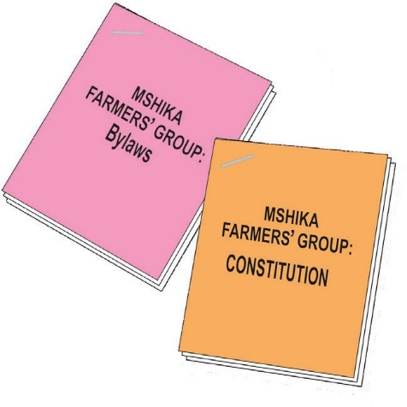

**Basic documents**

* Constitution
* Bylaws
* Registration documents

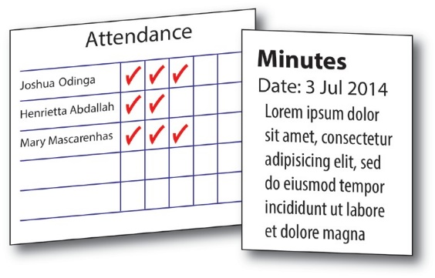

**Meetings**

* Attendance at meetings and training courses
* Minutes of meetings

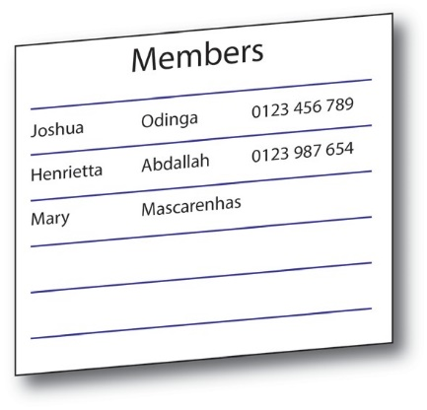

**Membership**

* List of members

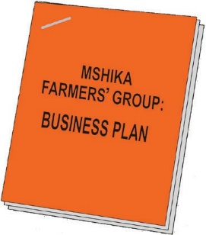

**Plans and activities**

* Reports to donors and other supporters
* Business plans
* Annual activity plans
* Quantities of produce produced and sold
* Progress monitoring
* Evaluation reports

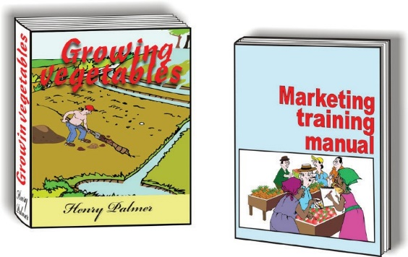

**Technical documents**

* Training materials
* Reference materials

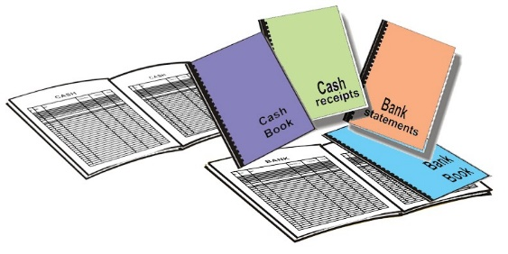

**Financial records**

* Membership fees paid
* Loans made and interest received
* Savings deposited by members
* Bank account details
* Bank statements
* Cash book
* Invoices and receipts
* Financial reports

ORGANIZING AND MANAGING FARMERS’ GROUPS 111