**EXERCISE 8. HOLDING A MEETING**

|  |  |
| --- | --- |
| *OBJECTIVE*  **After this exercise the participants will be able to:**   * Hold efficient group meetings | |
| *EQUIPMENT NEEDED*   * Flipchart paper or large pieces of paper, marker pens * Roles for each member to play | *EXPECTED OUTPUTS*   * A sample agenda for a meeting * Agreement on how to make decisions |
| *TIME*  2 hours | *PREPARATION*  None |

This exercise guides the group through the process of planning and holding a meeting and making decisions.

*SUGGESTED PROCEDURE*

1. Ask the participants to think of good and bad meetings that they have attended. What makes a good meeting? What makes a bad one? Why do people stop attending meetings? Note their ideas on the flip chart.
2. Ask participants if there is value in drawing up an agenda beforehand. If needed, explain why this is helpful.
3. Ask what the key items in a meeting should be. List these on the flip chart, then ask the participants to put them in the right order.
4. Once the participants have agreed on the agenda, ask selected members to perform a role-play of a meeting for 5–10 minutes. Give each person a brief guide on the role they should play. Ask the person who has been elected chair to coordinate the meeting, just as he or she would do in real life. Ask the secretary to take notes, etc. Guide the group to make sure they follow the agenda and resolve any problems.
5. After the end of the role-play, ask the rest of the participants to comment on how the simulated meeting went. What went right, and what went wrong? What could be done differently next time?

*NOTE*

The items and order will depend on the type of meeting (regular meeting, committee meeting or general meeting) and the type of group.

* A savings and lending community should have a fixed order for handling its business.
* A marketing or production group can be more flexible.

See the separate course on savings and lending communities for how to run meetings for this type of group.

**Role play of a meeting**

# Possible meeting agenda

1. Attendance
2. Welcome and opening
3. Agree on agenda
4. Report by production coordinator
5. Report by marketing coordinator

# Roles

1. Report by treasurer
2. Discussion of loans from the group’s loan fund
3. Any other business
4. Close

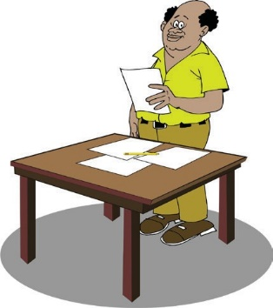

**Chairperson**

Your job is to:

* **Lead the meeting** and facilitate discussion, ensure the agenda is kept to and

that decisions are made

* Ensure everyone (especially women and the poorest people) are **heard**
* Ensure the group’s **con- stitution** is followed
* Keep the meeting short and **enjoyable**



**Secretary**

Your job is to:

* Take the **attendance** register
* Note the **decisions** made
* Remind the chairperson about the **constitution** (it allows loans for investment in busi- nesses)

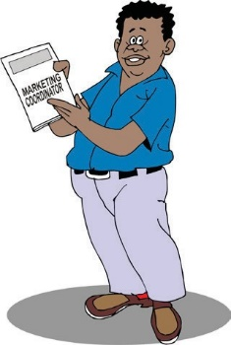

**Marketing coordinator**

Your job is to inform the group that trader who normally buys the group’s produce wants to buy **5 tonnes** next year (twice as much as last year)



**Production coordinator**

Your job is to inform the group that it plans to produce **3 tonnes** of onions next year

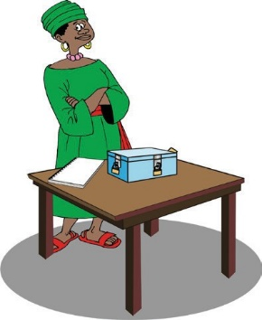

**Treasurer**

Your job is to inform the group that it has **10,000 shillings** that it can loan out to members



**Member 1**

You want the group to approve a loan of **8,000 shillings** to invest in a poultry business



**Member 2**

You want the group to approve a loan of **7,000 shillings** to pay for a wedding



**Member 3**

You want the group to approve a loan of **3,000 shillings** to invest in your melon-marketing business

ORGANIZING AND MANAGING FARMERS’ GROUPS 103