**EXERCISE 6A. LEADERSHIP STYLES AND QUALITIES**

|  |  |
| --- | --- |
| *OBJECTIVE*  **After this exercise the participants will be able to:**   * Explain why leadership is important by using their own experience of observing and interacting with leaders in their everyday life. | |
| *EQUIPMENT NEEDED*   * Flipchart paper, marker pens | *EXPECTED OUTPUTS*   * Participants can identify different leadership styles and the characteristics that a good leader should have |
| *TIME*  40 minutes | *PREPARATION*  None |

*SUGGESTED PROCEDURE*

1. Ask the participants to think of a leader they admire who is not a member of the group. This could be a national, regional or local leader. They should not give the leader’s name.
2. Ask them about the qualities that make this leader effective, or the reasons they admire this person. Summarize the responses on a large sheet of paper. Ask what happens if these “good” qualities are absent in a group of people. Note the responses on the paper.
3. Ask which is more usual: one person who has all the necessary qualities, or two or three people who each have some of the qualities and who lead together. Discuss the advantages and disadvantages of such an arrangement.
4. Introduce the three different styles of leadership: commanding, consulting, and enabling. Invite individual participants to role play each style. Emphasize that there is no best style: each style might be appropriate for a particular situation. Leaders may switch between styles depending on the needs.
5. Ask the group to name the advantages and disadvantages of each style. Note the responses on the paper. Which style would work best for them?

**Leadership styles**

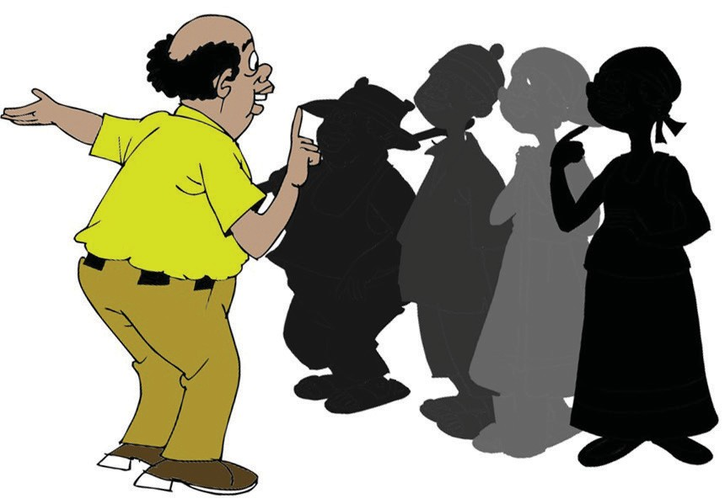

**Commanding**

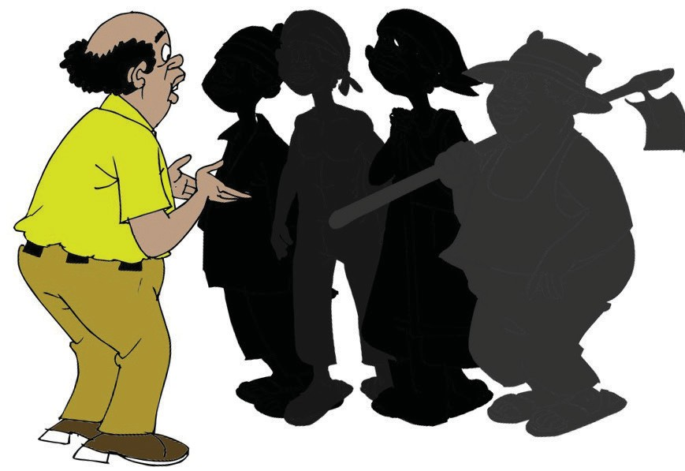

**Consulting**

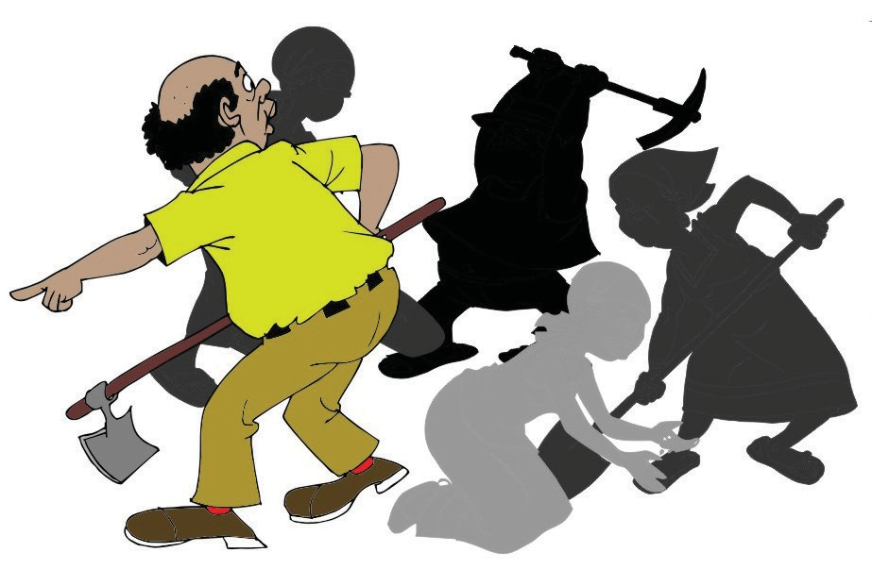

**Enabling**

ORGANIZING AND MANAGING FARMERS’ GROUPS 83