**EXERCISE 5. PARTICIPATION**

|  |  |
| --- | --- |
| *OBJECTIVE*  **After this exercise the participants will be able to:**   * Understand their role as a group member | |
| *EQUIPMENT NEEDED*   * Flipchart paper, marker pens | *EXPECTED OUTPUTS*   * An agreed list of roles, rights and responsibilities for members |
| *TIME*  2 hours | *PREPARATION*  None |

This exercise helps group members understand how to work together in a group. What are each person’s roles, rights and responsibilities?

*SUGGESTED PROCEDURE*

1. Ask the participants to think of an **ideal group member**. What are his or her characteristics? List these on a large sheet of paper. Discuss the key characteristics, and any controversial items. (Some ideas: express opinions, listen, be honest, treat others with respect…)
2. Next, ask them what **rights** the group members should have. List them on a second sheet. (Some ideas: have opinions listened to, elect leaders, be informed about activities, be treated equally…)
3. Now ask them what they think a group member’s **duties and obligations** should be. List their ideas on another sheet of paper. (Some ideas: abide by rules and decisions, attend meetings, elect leaders, contribute to decisions…)
4. Finally ask them how they can **contribute** to the group and its goals. List these on a fourth sheet. (Some ideas: pay membership fee, contribute labor and skills, prepare refreshments…)
5. Explain that the group will work in a **participatory, egalitarian manner**: everyone should be treated equally and have an equal say. Members will elect their own leaders, set the group’s rules and decide on activities. But along with rights come responsibilities: to take part, contribute and work for the common goals. The stronger the participation, the stronger the group.

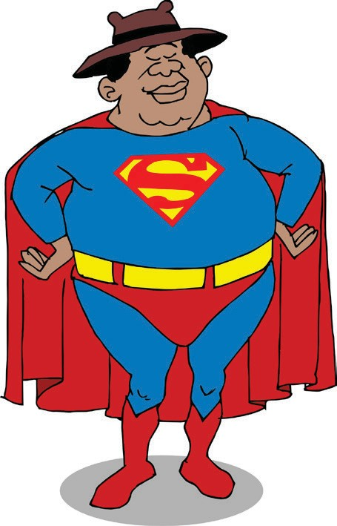**Participation**

# An ideal group member

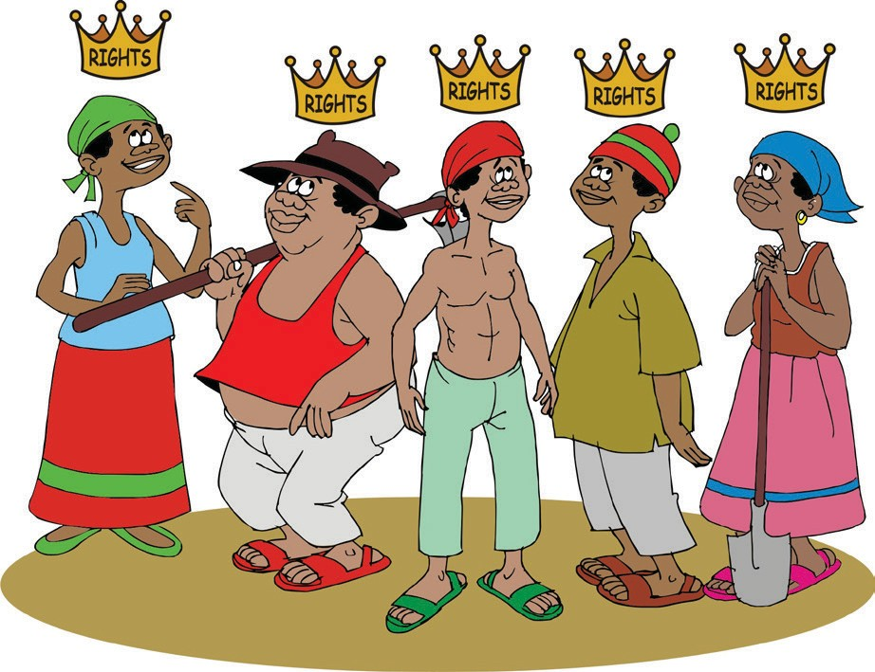

**Members’ rights and benefits**

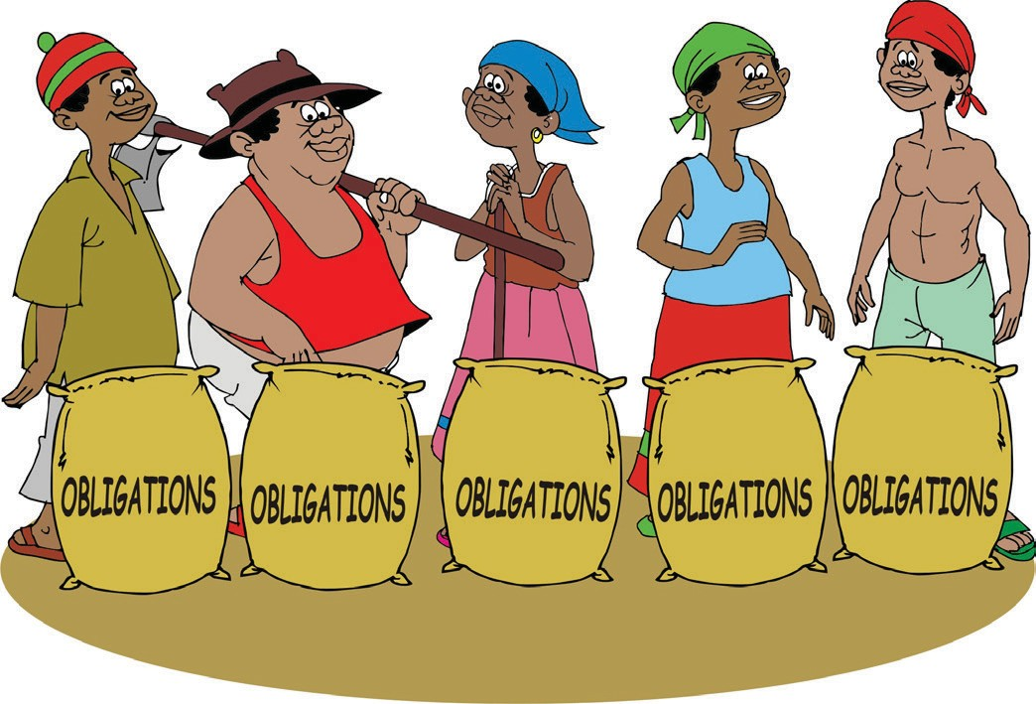

**Members’ duties and obligations**

**Types of contributions**

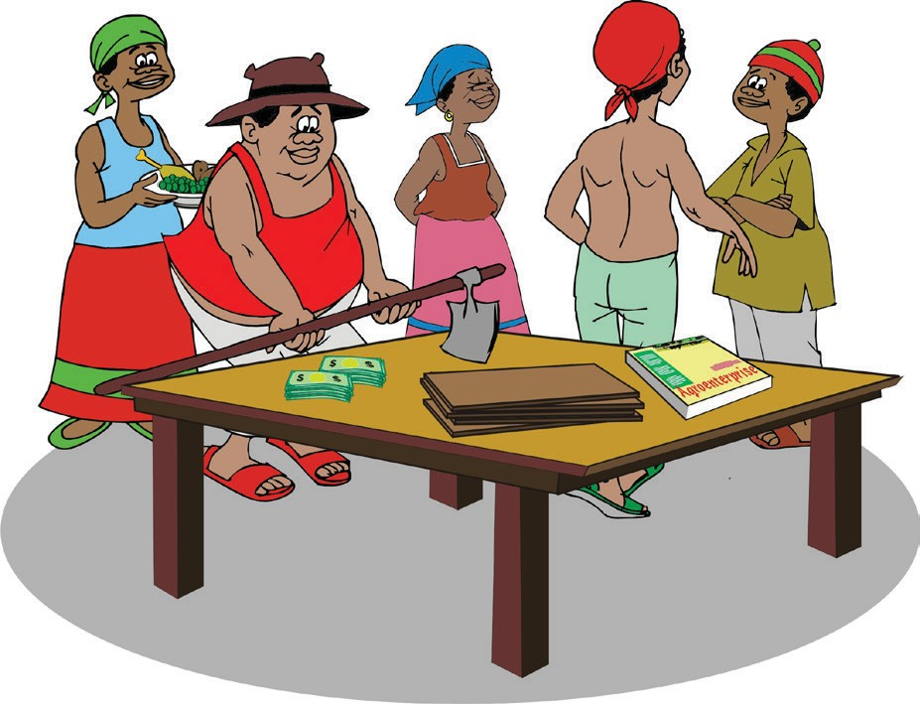

ORGANIZING AND MANAGING FARMERS’ GROUPS 71

**Types of contributions**