**Possible entry points**

# 1 Agricultural production

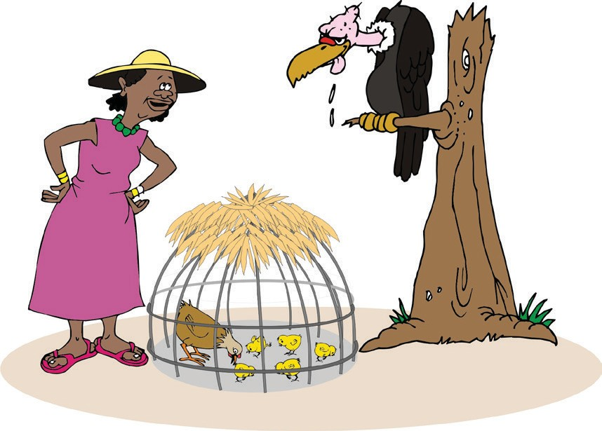**3 Savings and loans**

**5 Innovation**

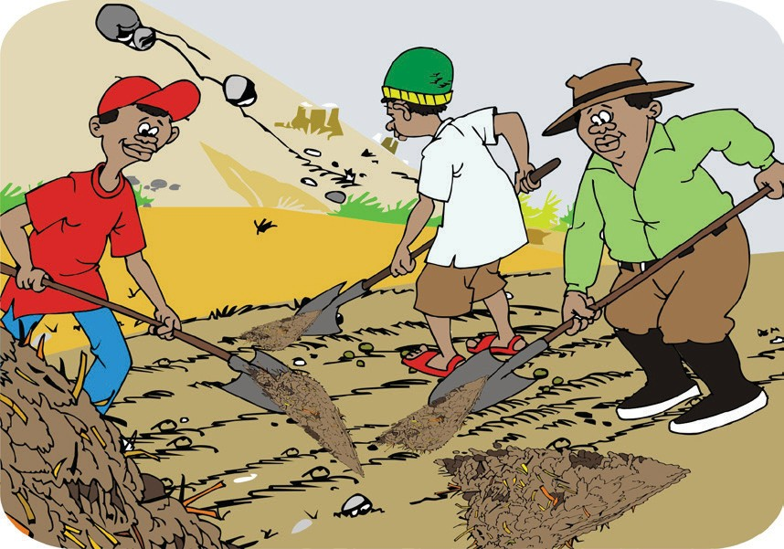

**2 Natural resource management**

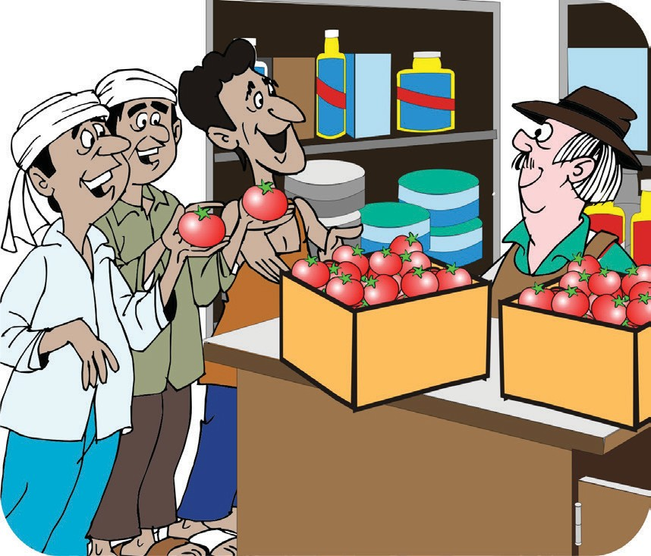

**4 Agro-enterprise**



**6 Other entry points?**

ORGANIZING AND MANAGING FARMERS’ GROUPS 59