**EXERCISE 4A. CHOOSING POSSIBLE ENTRY POINTS AND GROUP TYPES**

|  |  |
| --- | --- |
| *OBJECTIVE*  **After this exercise the participants will be able to:**   * Identify suitable entry points to help the community to develop its development goals and to decide on what types of groups to form. | |
| *EQUIPMENT NEEDED*   * Large sheets of paper, marker pens | *EXPECTED OUTPUTS*   * Decisions on the types of groups to develop, and the target members * A list of initial steps to undertake for each of the possible entry points |
| *TIME*   * 2–3 hours in one or more sessions | *PREPARATION*  •Gather information about the community (see previous lesson) |

This exercise helps you and other members of the project team work with the community and its leaders to choose an entry point for your work. This exercise may be run in stages:

* A discussion with the project team, partners and possibly the donor.
* Focus groups with the target community or communities to collect relevant information.
* Review of existing community organizations, with additional information from the community.

*SUGGESTED PROCEDURE*

1. Ask the group to suggest possible starting points. Write them on a large sheet of paper.
2. Discuss each of the suggestions and eliminate those that are not relevant.
3. For each of the other suggestions, discuss the current situation in detail and the preliminary steps that would be needed to use that entry point. Note your conclusions in Table 9.
4. Discuss which entry point (or points) is/are likely to be the most promising for the community members.
5. If you need additional information, hold a focus group for community members to discuss this.
6. Select the specific types of groups that the project will begin with, and the criteria for selecting the target group members.

*QUESTIONS TO STIMULATE DISCUSSION*

* What decisions have already been made (e.g. in terms of focus on a particular entry point or type of group)? What constraints are there (budget, time, staff skills, etc.)?
* Are the farmers organized? Might existing groups be adapted to take on the activities?
* What major problems do the farmers face? What opportunities might they have for improving their situation?
* What disadvantaged groups are there in the community (such as women or the landless)? Should they be the focus of the project? How might they be involved?
* What types of assistance would the community need? What kinds of investment are required?
* Will the project need to make investments before starting a particular set of activities? (For example, will it have to invest in infrastructure before trying to promote improved production techniques?)

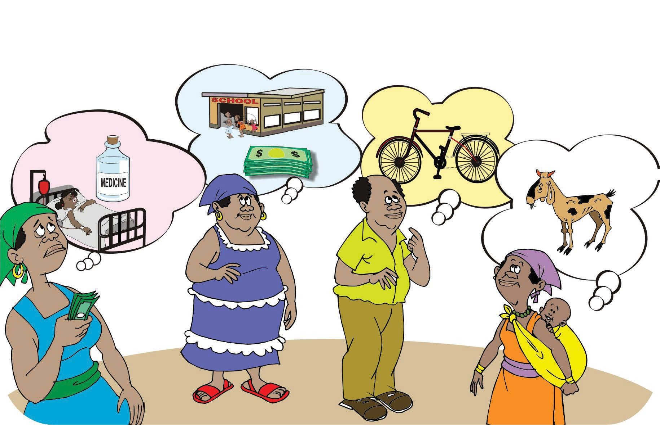

ORGANIZING AND MANAGING FARMERS’ GROUPS 57

|  |  |  |  |
| --- | --- | --- | --- |
| **ENTRY POINT CURRENT SITUATION PRELIMINARY STEPS REQUIRED** | | | |
|  | 1 Agricultural production |  |  |
|  | 2 Natural resource management |  |  |
|  | 3 Savings and loans |  |  |
|  | 4 Agro-enterprise |  |  |
|  | 5 Innovation |  |  |
|  | 6 Other entry points? |  |  |

58 ORGANIZING AND MANAGING FARMERS’ GROUPS