TABLE 6 IDENTIFYING YOUR TARGET GROUP

|  |  |  |  |  |  |
| --- | --- | --- | --- | --- | --- |
| **NAME OF HOUSEHOLD OR INDIVIDUAL** | **WEALTH CATEGORY** | **COMMERCIAL ORIENTATION** | **…** | **…** | **SELECTED** |
| **1.** |  |  |  |  |  |
| **2.** |  |  |  |  |  |
| **3.** |  |  |  |  |  |
| **4.** |  |  |  |  |  |
| **5.** |  |  |  |  |  |
| **6.** |  |  |  |  |  |
| **7.** |  |  |  |  |  |
| **8.** |  |  |  |  |  |
| **9.** |  |  |  |  |  |
| **10.** |  |  |  |  |  |
| **11.** |  |  |  |  |  |
| **12.** |  |  |  |  |  |
| **13.** |  |  |  |  |  |
| **14.** |  |  |  |  |  |
| **15.** |  |  |  |  |  |
| **16.** |  |  |  |  |  |
| **17.** |  |  |  |  |  |
| **18.** |  |  |  |  |  |
| **19.** |  |  |  |  |  |
| **20.** |  |  |  |  |  |
| **21.** |  |  |  |  |  |
| **22.** |  |  |  |  |  |
| **23.** |  |  |  |  |  |
| **24.** |  |  |  |  |  |
| **25.** |  |  |  |  |  |
| **26.** |  |  |  |  |  |
| **27.** |  |  |  |  |  |
| **28.** |  |  |  |  |  |
| **29.** |  |  |  |  |  |
| **30.** |  |  |  |  |  |

46 ORGANIZING AND MANAGING FARMERS’ GROUPS

**Whom do you want to reach?**

# Vulnerable but viable

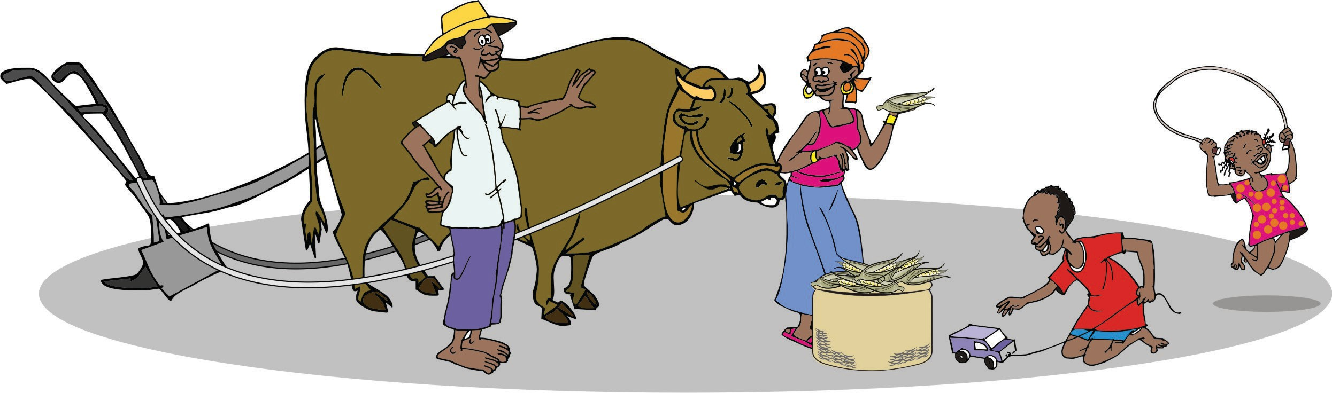

**Market-ready smallholders**

**Commercial smallholders**

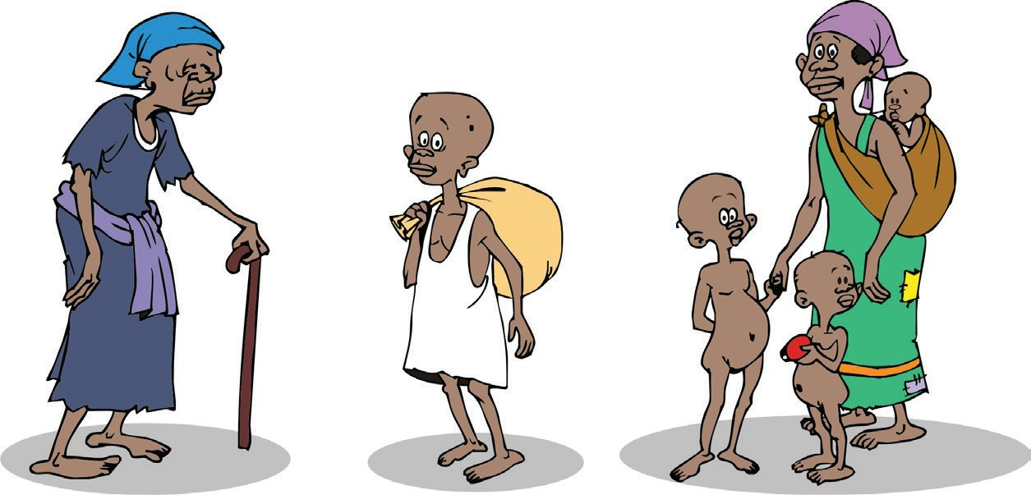**Highly vulnerable**

ORGANIZING AND MANAGING FARMERS’ GROUPS 47