**EXERCISE 3A. GATHERING INFORMATION ABOUT THE COMMUNITY**

|  |  |
| --- | --- |
| *OBJECTIVE*  **After this exercise the participants will be able to:**   * To gather and analyze information about the community. | |
| *EQUIPMENT NEEDED*   * Large pieces of paper and marker pens; notepads and pens; sticks, stones, leaves, chalk | *EXPECTED OUTPUTS*   * Information about specific aspects of the community. |
| *TIME*  Varies depending on type and number of techniques used | *PREPARATION*  • Invite members of the community to participate in the exercise. You will need one team member for each type of exercise |

Participatory rural appraisal is a basket of techniques for working with local people to gather and analyze information about the community. Many techniques exist; choose those that will generate the information you need. You can adapt the techniques to suit the requirements, or come up with your own. Before choosing a technique, think carefully about what you want to find out and how you will use the information.

*SUGGESTED PROCEDURE*

1. Divide the community members into groups according to the type of technique they want to use. For the historical timeline, for example, you need older people; for the transect walk it is a good idea to have the farmers whose land you will cross. Assign at least one team member to coordinate and make notes for each group.
2. Ask the groups to undertake the exercise. Make sure the results are recorded on large sheets of paper.
3. Bring the groups back together in plenary, and ask each group to present their findings. Lead a discussion to probe deeper into the information gathered.
4. Transfer all the notes, maps, etc. to notebooks. Leave the large sheets and a copy of the notes with the community as their permanent record.

The following pages give examples of the results each exercise generates.

**Community map**

**What for:** Identifies physical features, infrastructure, resources and boundaries of community.

**How:** Local people to draw a map of their community, showing key features and problems.

**How long:** 2–4 hours.

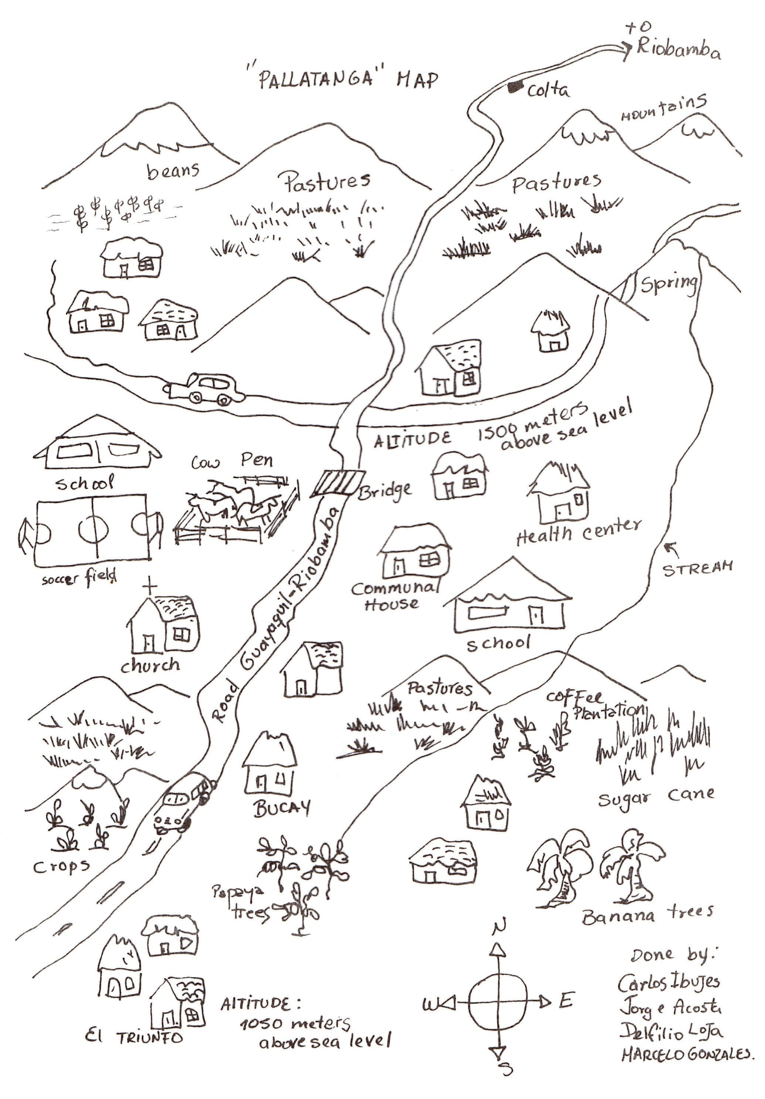

Source: Selener et al. (1999) p. 27.

# Transect walk

**What for:** Shows natural resources and relationships in a community or on a farm. **How:** People walk across the community or farm, noting key features in each location. **How long:** 1–4 hours, depending on length of walk.

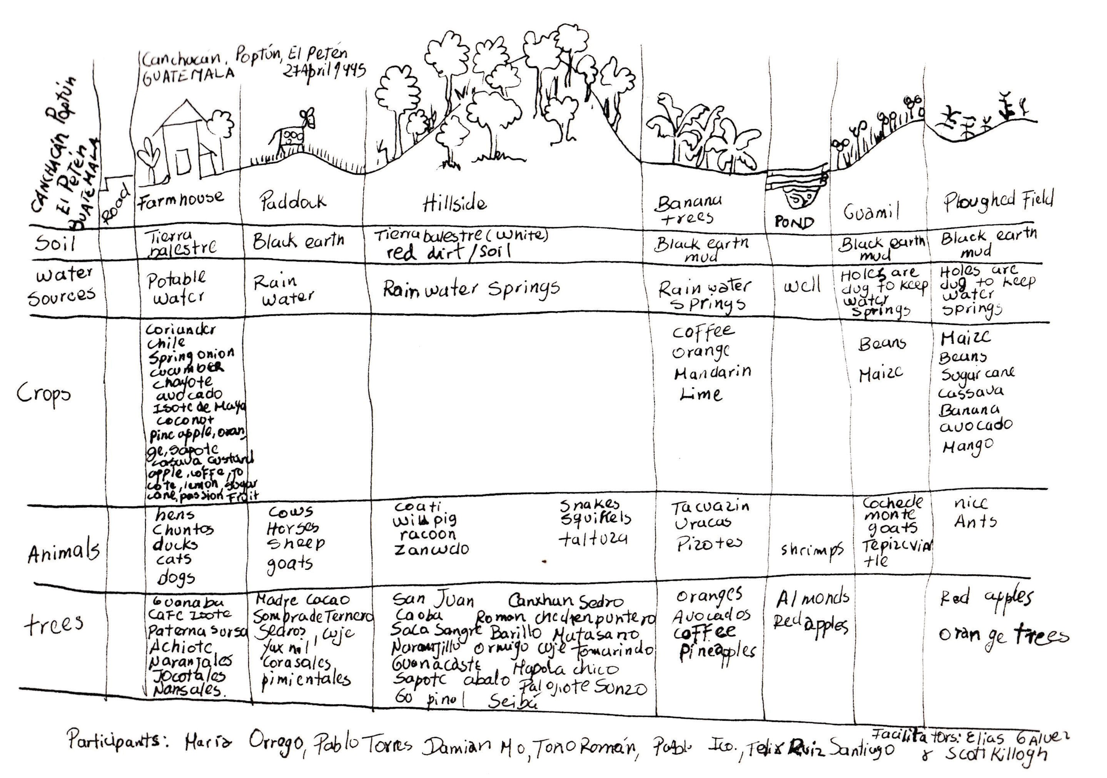

Source: Selener et al. (1999) p. 65.

38 ORGANIZING AND MANAGING FARMERS’ GROUPS

# Seasonal calendar

**What for:** Shows seasons, crops and livestock, activities and labor requirements in a year.

**How:** People draw calendar to show key activities and events during the year.

**How long:** 1–2 hours.

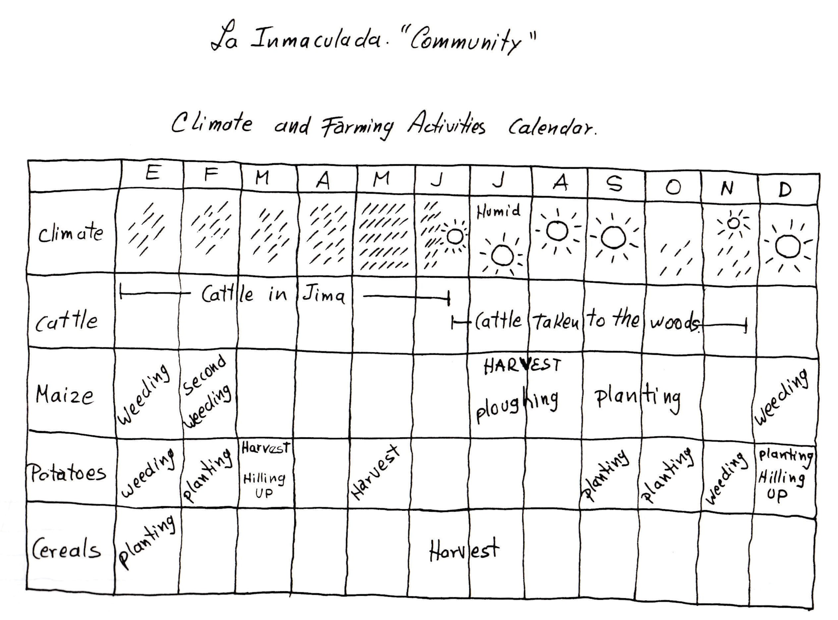

Source: Selener et al. (1999) p. 74.

# Historical timeline

**What for:** Shows the community history, key past events and trends.

**How:** Older people describe current situation in the community and recall events 10, 20 and more years ago.

**How long:** 1–2 hours.

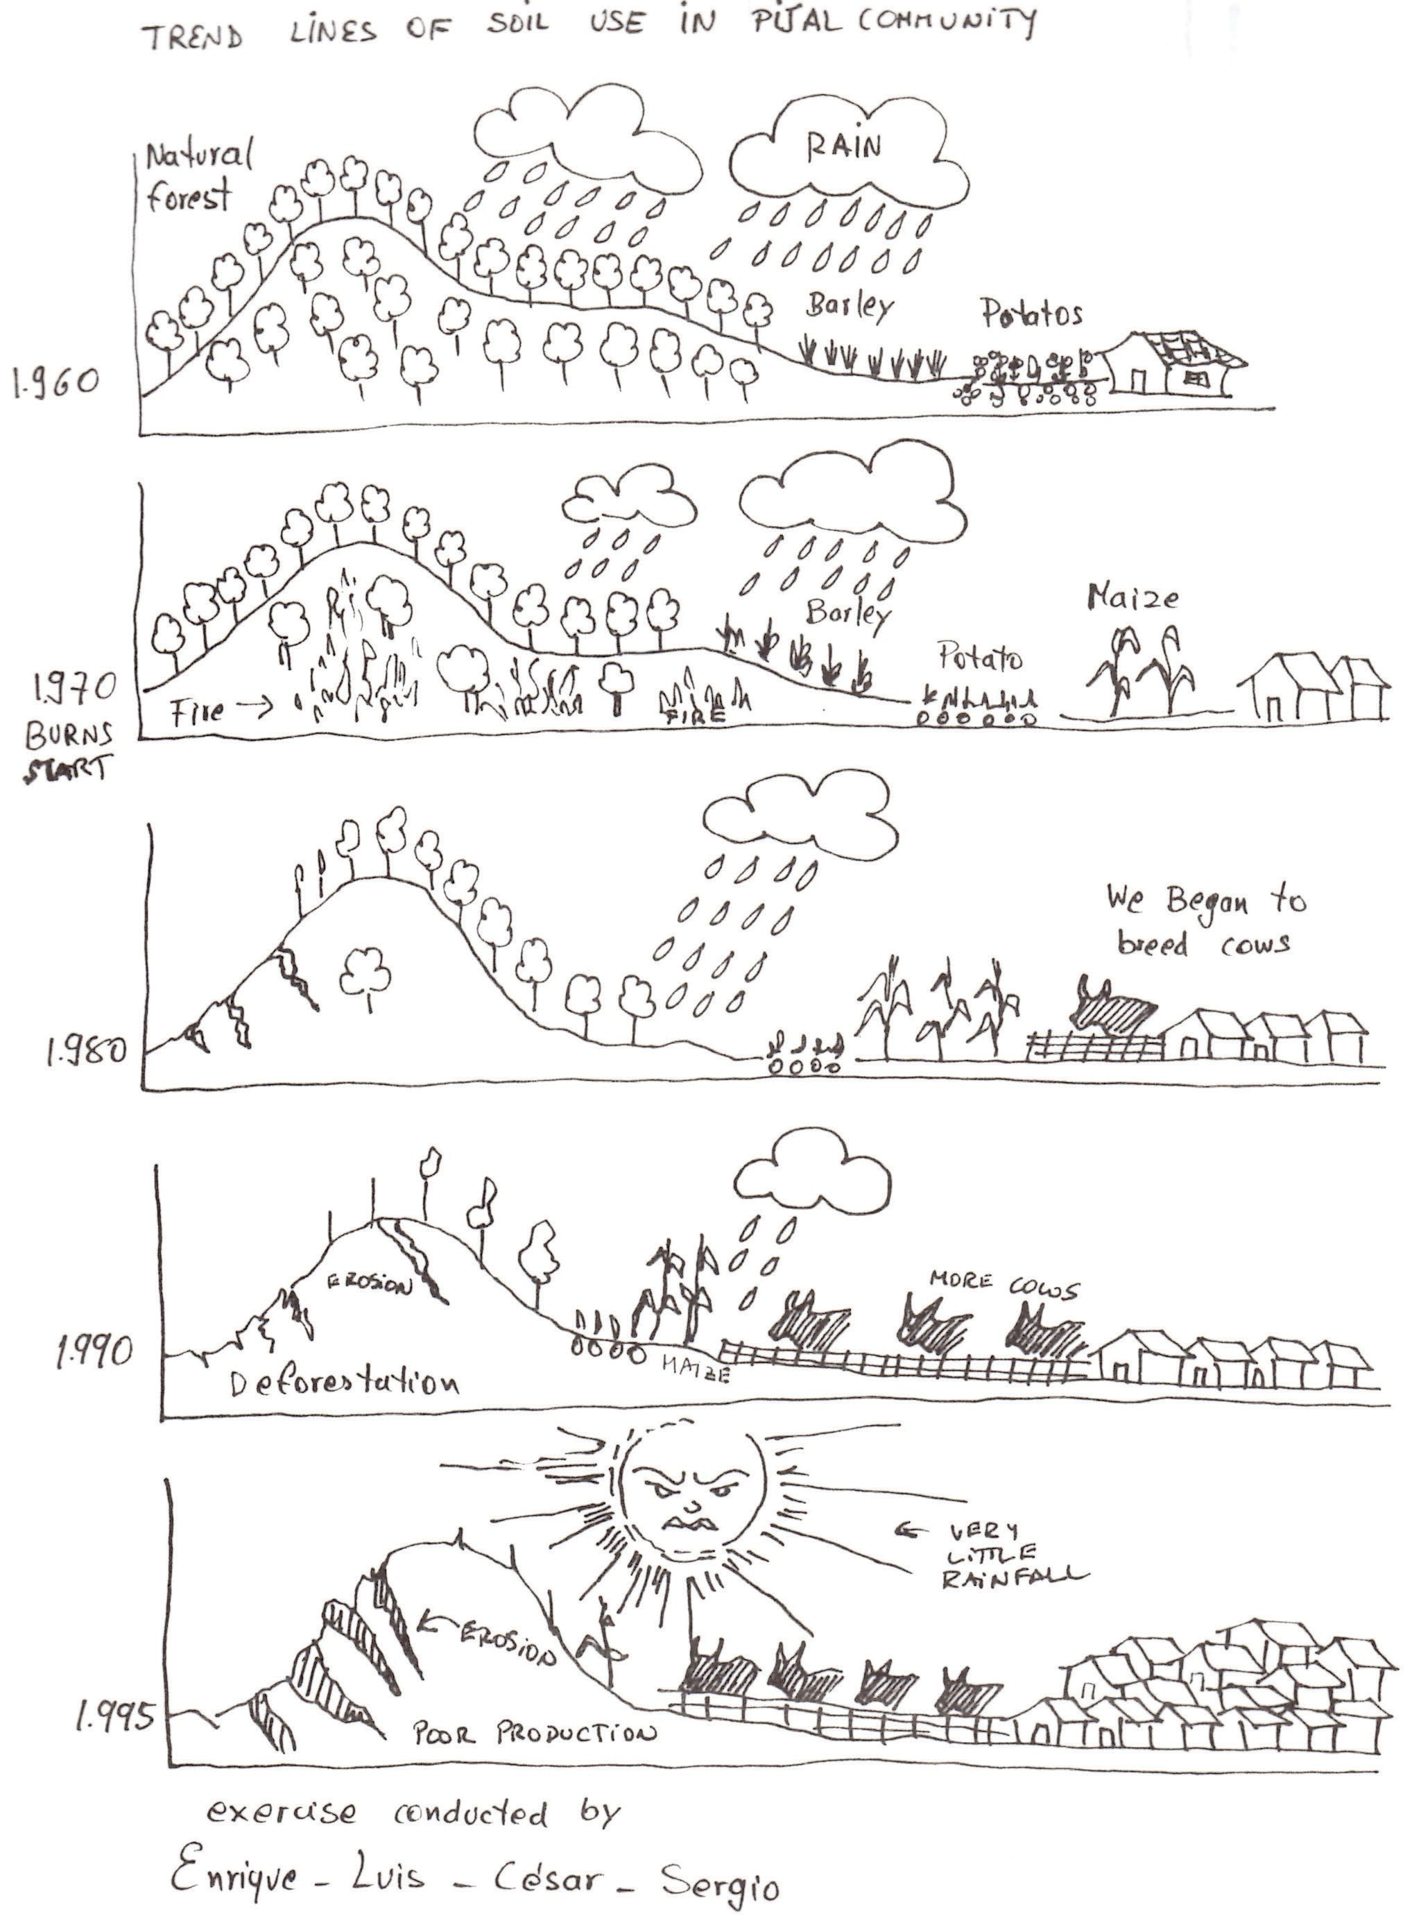

Source: Selener et al. (1999) p. 35.

40 ORGANIZING AND MANAGING FARMERS’ GROUPS

# Daily timetable

**What for:** Shows daily activities of men and women in the community.

**How:** Men and women separately draw 24-hour clocks showing what they do each day.

**How long:** 1 hour.

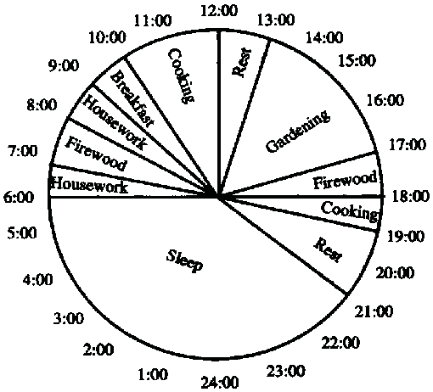

Source: FAO no date.

ORGANIZING AND MANAGING FARMERS’ GROUPS 41

# Venn diagram

**What for:** Shows organizations that affect the community and the relationships among them.

**How:** People draw circles representing organizations. Overlaps or lines between them show their relationships.

**How long:** 1–2 hours.

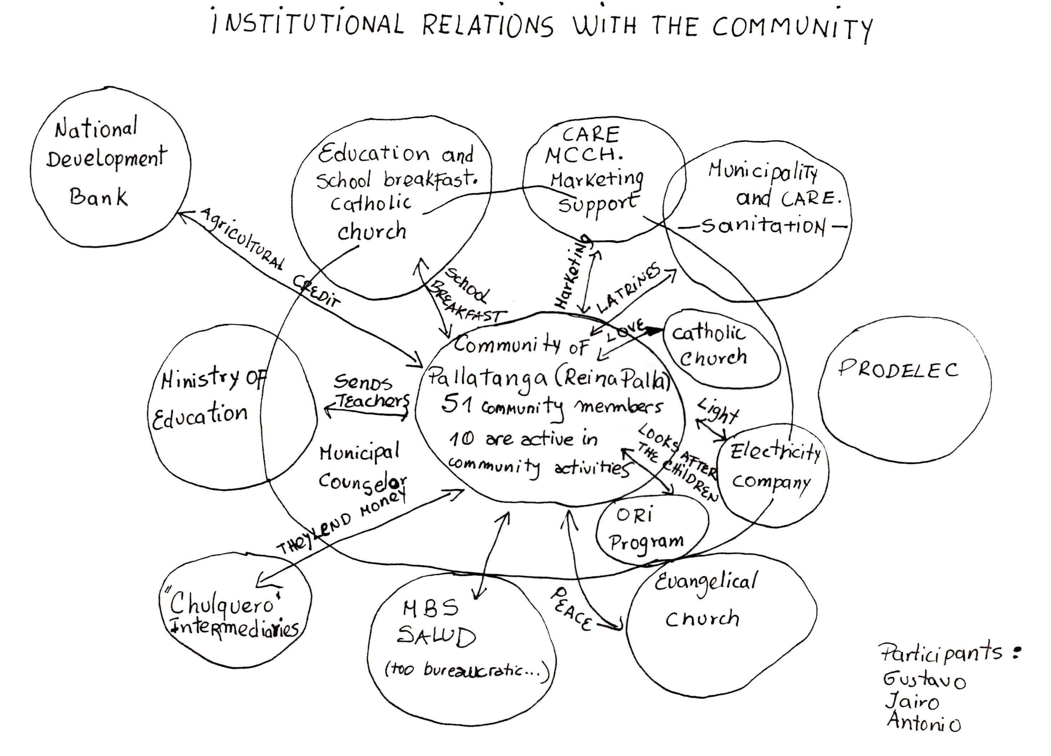

Source: Selener et al. (1999) p. 23.

42 ORGANIZING AND MANAGING FARMERS’ GROUPS

# Matrix

**What for:** Compares alternative crops, livestock, trees, enterprises or intervention options.

**How:** People list items then score them according to criteria they choose.

**How long:** 1 hour.

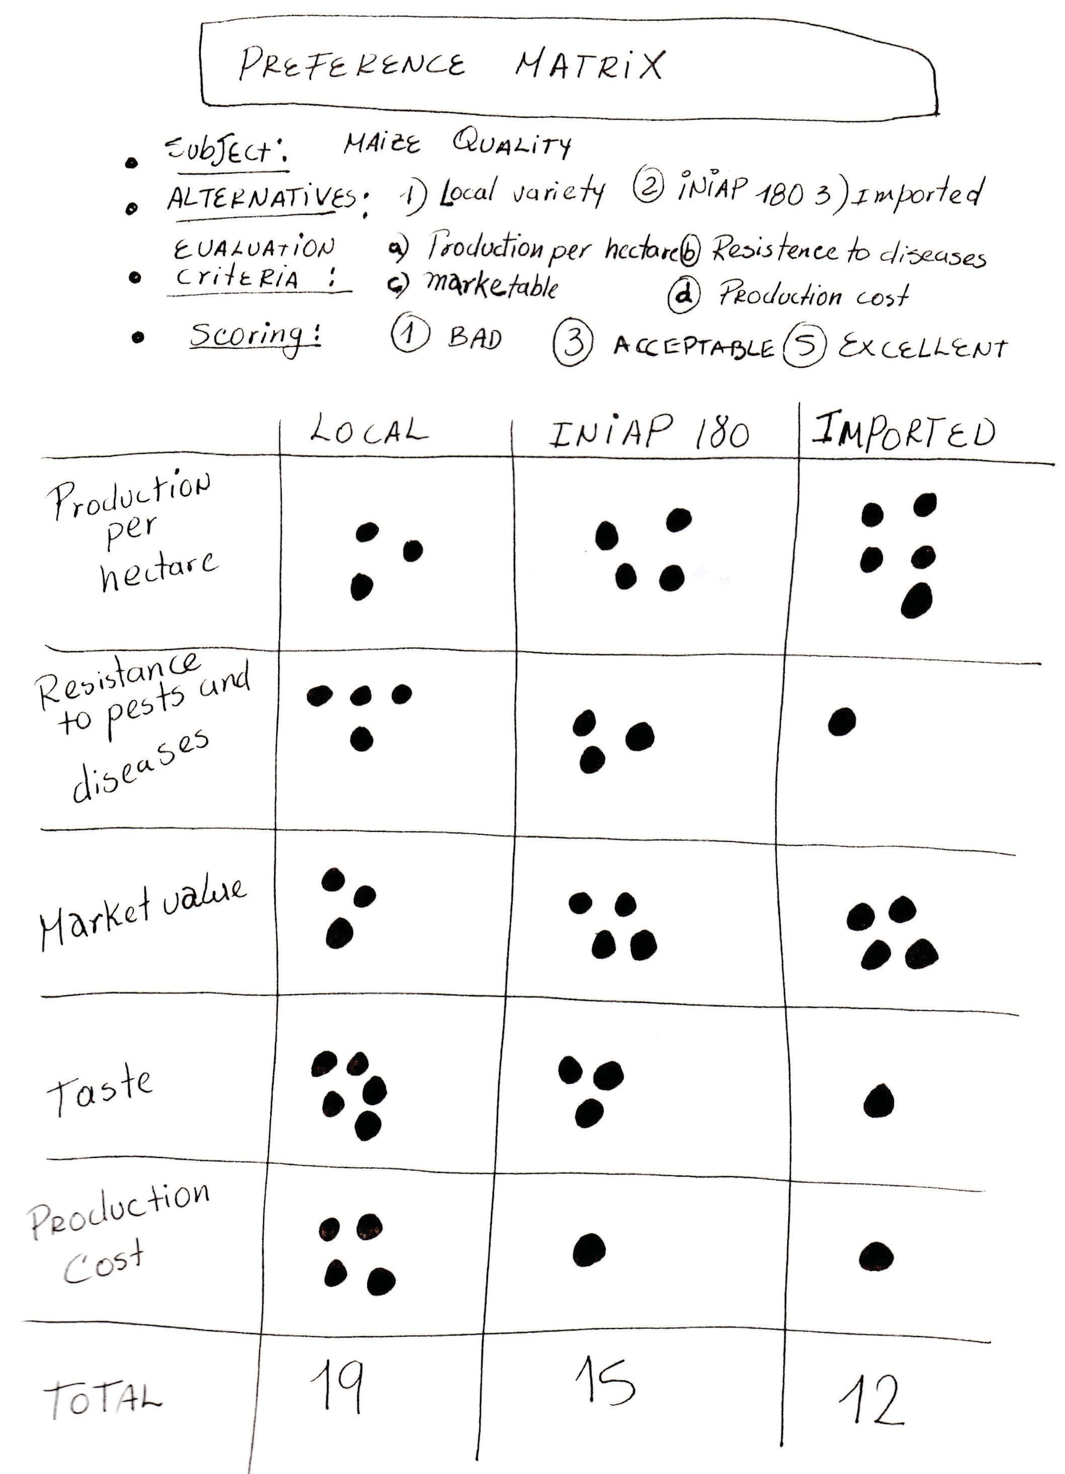

Source: Selener et al. (1999) p. 77.

ORGANIZING AND MANAGING FARMERS’ GROUPS 43

# Ranking

**What for**: Prioritizes and selects among a set of alternatives.

**How**: People give scores to a set of alternatives, then put the alternatives in order of preference.

**How long**: 1 hour.

