EXERCISE 2. THE ROLE OF THE GROUP PROMOTER
OBJECTIVE
After this exercise the participants will be able to:
- Describe problems that group promoters face and potential solutions to them.
- Suggest ways to solve problems that other group facilitators face.
EQUIPMENT NEEDED  - Pairs of chairs arranged in two concentric circles. The outer chair in each pair faces towards the center of the circle; the inner chair faces outwards | EXPECTED OUTPUTS  - Understanding of problems faced by facilitators and ideas on how to overcome them
TIME  60 minutes | PREPARATION  None
In this exercise, you and your colleagues will share and analyze your experience as group promoters or facilitators. This exercise is based on Pretty et al. 1995: pp 201–2: The Margolis wheel.

SUGGESTED PROCEDURE
- Ask the participants to reflect on particular problems or constraints they have faced (or expect to face) when facilitating groups. These problems may be general (about the program or approach as a whole) or specific (relating to a particular group or individual). Give the participants 5 minutes to think about and note down some issues.

- Ask the participants to sit in any of the chairs. Explain that those sitting on the inside circle are the consultants. It is their job to suggest solutions. Those sitting on the outside are the clients or problem-presenters. They will briefly present a particular problem they have faced. Each pair will have 3 minutes to discuss a problem and how to overcome it.

- After 3 minutes, the outside circle rotates one chair, bringing a new client to each consultant. The clients may present the same problem as before or choose another one.

- Give another 3 minutes for discussion, then invite the outer circle to rotate again.

- After 3 or 4 rounds, give 2 minutes for the clients and consultants to write down a summary of problems and solutions.

- Ask the clients and the consultants to change places with each other, and repeat the exercise.

Discussing the group promoter’s role

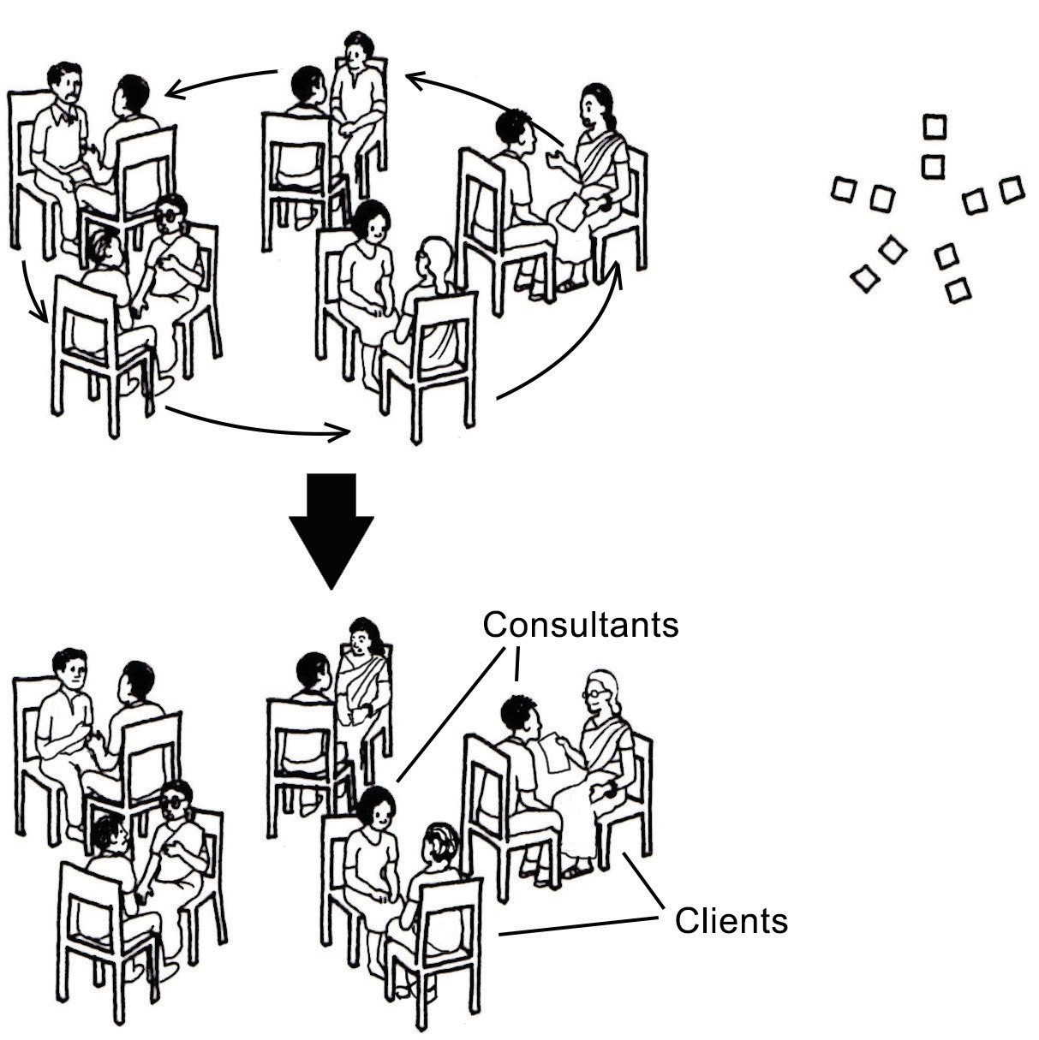

22 ORGANIZING AND MANAGING FARMERS’ GROUPS

