**EXERCISE 17. SECOND-ORDER ASSOCIATIONS**

|  |  |
| --- | --- |
| *OBJECTIVE*  **After this exercise the participants will be able to:**   * Anticipate how to ally with other groups. | |
| *EQUIPMENT NEEDED*   * Flipchart paper, marker pens | *EXPECTED OUTPUTS*   * Understanding of the issues the group may encounter if they form/join a second-order association |
| *TIME*  60 minutes | *PREPARATION*  None |

This exercise has participants think about how to cooperate with other groups in the area.

*SUGGESTED PROCEDURE*

1. Explain what a second-order association is and how it can benefit the group.
2. Write the group’s name and the names of several other (imaginary) local organizations on a flipchart so all can see (see next page for some ideas; make up your own groups to suit the local situation).
3. Divide the participants into several small groups. Tell them that each small group represents one of the organizations on the flipchart.
4. Ask each small group to identify the areas of common concern that “their” organization has with each of the others. (*Examples: production of same crop, concern over natural resources, interest in marketing*). With which of the other organizations would they consider forming a second-order association? What functions should it have? What would they see as the benefits of such an association? What would be the drawbacks?
5. After the small groups have finished discussing these issues, invite them to report back to the plenary. Which groups were included in the association, and which were not included? Why? What functions might the association take on?
6. Ask the small groups to consider how a second-order association should be organized. How should it be governed? What committees and officers should it have? How should they be chosen? Should the member groups pay fees?
7. Again, invite the small groups to report back to the plenary. Facilitate a discussion of the methods and potential pitfalls of forming a second-order association.

**Which group should we partner with?**

# 

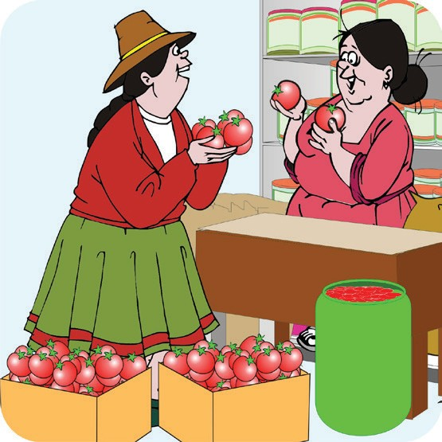Chicken producers’ group

Tomato processing group

Dairy producers’ group

Input suppliers’ association

Vegetable producers’ group

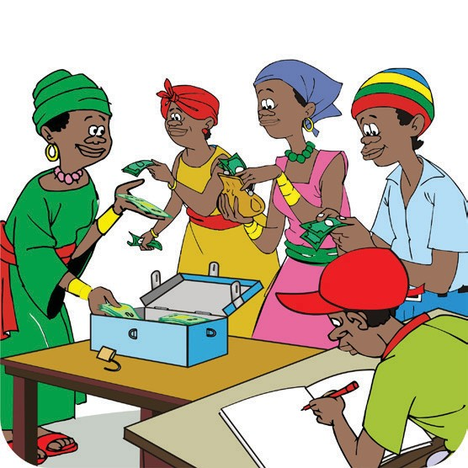

Savings and internal lending community association

# 

Irrigation association

Cassava producers’ association

Milling group

# 

Maize marketing association

Cultivation mutual-help group

Health self-help group

Livestock producers’ group

192 ORGANIZING AND MANAGING FARMERS’ GROUPS