**EXERCISE 16. HELPING GROUPS TO GROW**

|  |  |
| --- | --- |
| *OBJECTIVE*  **After this exercise the participants will be able to:**   * Identify future possibilities for group growth. | |
| *EQUIPMENT NEEDED*   * Flipchart paper, marker pens | *EXPECTED OUTPUTS*   * A set of options for the group to consider if it is successful |
| *TIME*  60 minutes | *PREPARATION*  None |

This exercise enables participants to look to the future and think about what they might do if they are successful.

*SUGGESTED PROCEDURE*

1. Ask the participants to imagine their situation a year or two from now. How they will know if the group has been successful? What will the group have achieved? What will it be doing? (*Examples: it will have sold x tonnes of produce; it will have installed an irrigation system; it will have stopped erosion on the village’s fields.*)
2. Ask participants to imagine new challenges that the group may face because of its success. What might those challenges be? (*Examples: More people want to join the group; the group may produce more than the local market can absorb; the members may want to expand into growing new crops.*)
3. Select three or four of the challenges they have named. Divide the participants into smaller groups to discuss each of these challenges (one challenge per group). Ask them to discuss the nature of the challenge and how they will deal with it.
4. Ask each small group to report back to the plenary. Facilitate a discussion of their ideas.

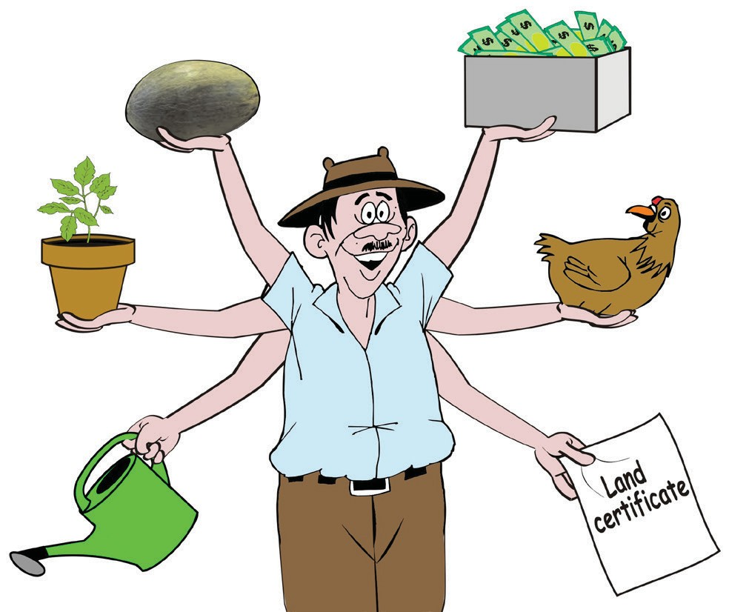**What might we do in the future?**

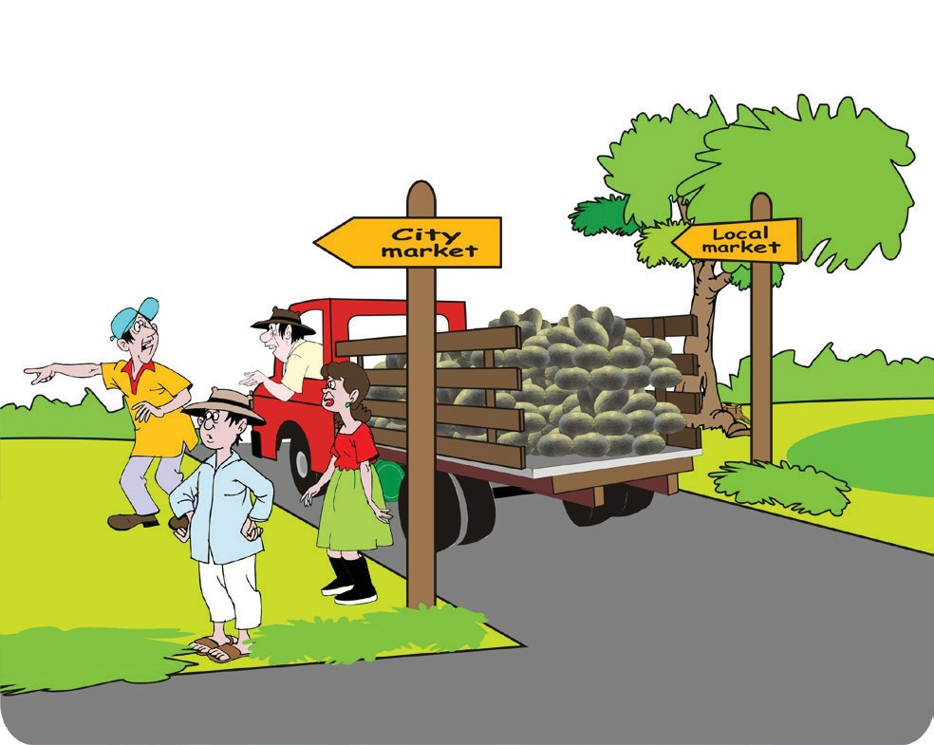

Sell to a new market

Add new activities

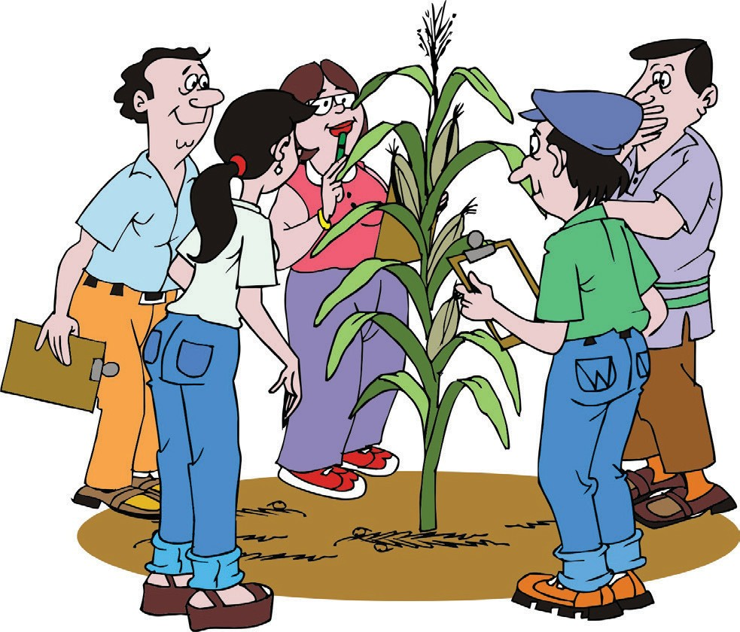Consider permitting more people to join the group

Expand production

Learn new skills

ORGANIZING AND MANAGING FARMERS’ GROUPS 183