**EXERCISE 15. COMMUNICATION**

|  |  |
| --- | --- |
| *OBJECTIVE*  **After this exercise the participants will be able to:**   * Identify with whom the group needs to communicate, and how to effectively communicate with them. | |
| *EQUIPMENT NEEDED*   * Colored cards, marker pens | *EXPECTED OUTPUTS*   * A list of audiences matched with the channels used to communicate with them |
| *TIME*  60 minutes | *PREPARATION*  None |

This exercise helps participants determine who the group’s audiences are, and how best to communicate with them.

*SUGGESTED PROCEDURE*

1. Ask the participants to think of the different types of people or organizations that the group will need to communicate with. (*Examples: the local government, other farmers’ groups, potential members, microfinance organizations, traders, input suppliers.)* Ask them to write each type on a separate card. Make sure they include “current group members” as one of the categories.
2. On a table or the floor/ground, group the cards into categories of similar types of people. For example, “microfinance organization” and “bank” could go into the same category: “financial institutions.”
3. Ask small groups of participants to each discuss one of the categories. Ask each group to identify the characteristics of their particular audience: how old are they? How many of them are there? What is their educational level? What do they know about the topics the group is interested in? How do they normally get information?
4. Ask the small groups to identify the types of information the group wishes to either get from their particular audience, or to provide to that audience. For example, traders may be interested in the types, quality and amount of produce the group produces; the group may want to tell them about the price they expect and the amount they have produced.
5. Ask the groups to think of how best to communicate with each audience. Meetings? Mobile phone? Written information? Formal presentations?
6. Ask the groups whose responsibility it is to communicate with each group. The marketing coordinator? The production coordinator? The chairperson?
7. Ask the groups to report back to the plenary on their discussions. Summarize their reports in a table on a flipchart. (*See the following page for an example. Note that the actual categories may be different from the ones shown here*.)

**With whom do you need to communicate?**

# Influential persons

* + Government
  + Donors
  + Supporters

**FARMERS’ GROUP**

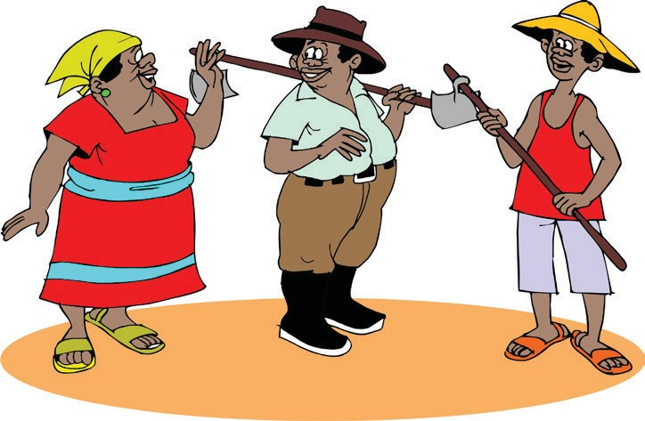 

# Peers

ORGANIZING AND MANAGING FARMERS’ GROUPS

* Other farmers and com- munity members
* Potential members
* Other groups

# Internal

* Officers

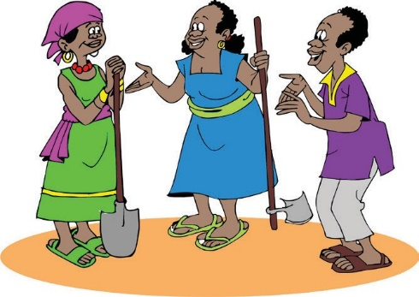

* Current members

# Financial services

* Banks
* Microfinance institutions

# Business partners

* + Potential and actual customers
  + Traders
  + Input suppliers

175