**EXERCISE 14. RESOLVING CONFLICTS**

|  |  |
| --- | --- |
| *OBJECTIVE*  **After this exercise the participants will be able to:**   * Reach win/win solutions to conflicts. | |
| *EQUIPMENT NEEDED*   * A bowl of dried beans or stones * Flipchart and marker pens | *EXPECTED OUTPUTS*   * Understanding of the different outcomes of facilitating a conflict |
| *TIME*  60 minutes | *PREPARATION*  None |

This exercise helps participants seek a win–win consensus solution to conflicts. It uses a scoring system to show consensus (win–win), compromise (win–draw or draw–draw), win–lose and lose–lose situations.

*SUGGESTED PROCEDURE*

1. Ask the participants to think of conflicts or disputes they have come across or heard about related to agriculture (or whatever your field of intervention is). Ask them to describe two sides of the argument as objectively as possible. Note the topic and the positions of each side on a flip chart.
2. Divide the participants into small groups of three people each. Explain that in each trio, two people (A and B) will be arguing on opposite sides. The third person (C) must facilitate an agreement between them. The facilitator must try to help the opposing sides reach an agreement that is to the advantage of both.
3. Allocate roles to the persons A and B in each trio (see next page).
4. Allow the trios 15 minutes to try to reach an agreement.
5. Ask members A and B in each trio to take a few beans from the bowl. They should keep the number of beans secret for the time being. Each person should take 3, 2 or zero beans, depending on whether they felt they had won, drawn or lost the negotiation (see next page).
6. Ask member C in each trio to briefly describe the conflict to the plenary and the agreement reached. Members A and B in that trio then reveal how many beans they have. Note these numbers on the flipchart.
7. Facilitate a discussion of the various outcomes. Which one is best? (*6 beans, or consensus*). Which is next best? (*5 or 4 beans, or compromise*). Which is the least desirable? How did the trios reach the agreement? What did the facilitator do to help? What prevented them from reaching agreement?

**Resolving conflicts**

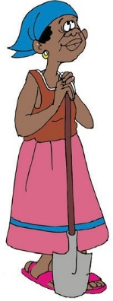

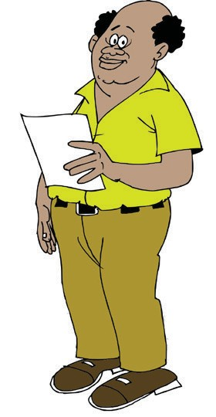

**A: Farmer:** Does not want canal to cross her land

**B: Community leader:** Wants to build canal to irrigate land in the village

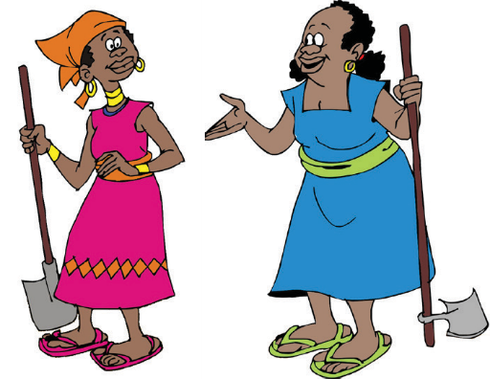

**A: Farmer 1:** Wants to burn stubble on her fields

**B: Farmer 2:** Wants to avoid his fields being burned by fire from neighboring field

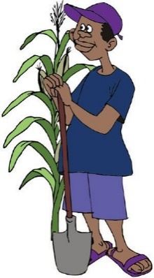

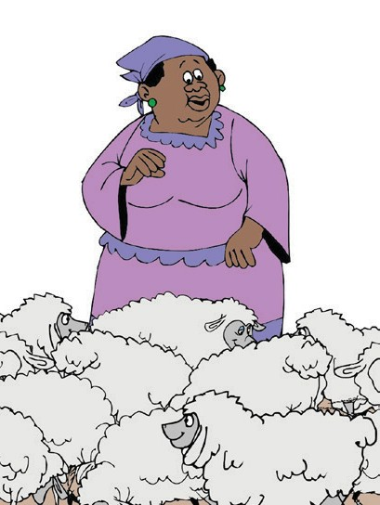

**A: Livestock keeper:** Wants to graze animals on land

**B: Farmer:** Wants to use land to grow crops



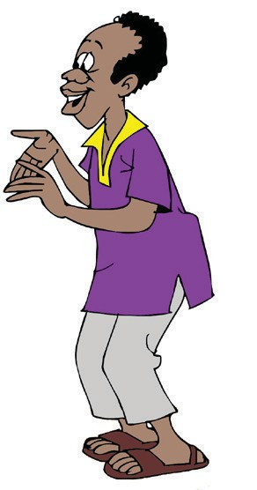

**A: Farmer:** Wants to sell melons at ¢20 each

**B: Trader:** Wants to buy melons at ¢15 each

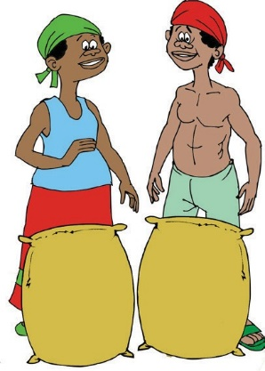

**A: Maize grower 1**: Wants the group to sell grain today to pay for an emergency

**B: Maize grower 2**: Wants the group to keep grain in the hope the price will rise



**Scoring**

**3 beans** if he/she felt they won (the agreement benefited them).

**2 beans** if they felt it was a draw.

**0 beans** if they felt they had lost (or if no agreement was reached).

**Totals**

**6 beans in all:** both felt they won (this is the consensus solution).

**5 beans in all:** one felt he/she won, one felt it was a draw (compromise).

**4 beans in all:** both felt it was a draw (also compromise).

**3 beans in all:** one felt he/she won; the other person lost (win–lose).

**2 beans in all:** one felt it was a draw, one felt he/she lost (lose–lose).

**0 beans:** no-one felt they won, or an agreement was not reached (lose–lose).

ORGANIZING AND MANAGING FARMERS’ GROUPS 165