EXERCISE 7A. DEVELOPING A MONITORING PLAN
OBJECTIVE
After this exercise the participants will be able to:
- List questions for monitoring the farmer group’s activities.
- Describe indicators to measure these questions.
- Explain how the indicators should be monitored, who should do it, how, where, and when.
EQUIPMENT NEEDED  - Large sheets of paper, cards, marker pens | EXPECTED OUTPUT  - A list of questions that can be used to select indicators.  - List of indicators and detailed instructions how to gather and evaluate information.
TIME  20-30 minutes | PREPARATION  - Obtain the Water pitcher and water glass before the group meets  - Review the scenario that will be presented to the group and prepare some questions to guide the discussion
A monitoring plan is important because it will allow you to make sure that your project stays on track and is successful. It also focuses your efforts on asking and answering the right questions, and thus helps you avoid wasting time and resources collecting information you will not use.
SUGGESTED PROCEDURE
- Divide the participants into groups of about 5 to 6 persons. Ask them to think of questions that can provide information on the progress towards achieving the goals and activity plans that they developed earlier. Ask the groups to write the questions on cards (one on each card) and to hand them to you. Note that you can ask each group to consider the same issues at one time, or divide up the goals and related action plans among the different groups. If you decide to have all of the small groups consider the same goals/action plans at the same time you can follow steps 2–6 below. If you decide to let each of the small groups work on different goals/action plans at the same time, then you will need to modify steps 2–6 accordingly.
- In the plenary discussion, compile the questions from each of the small groups into similar topics. Rewrite them if necessary to make them clearer. Make sure the group as a whole agrees on the questions.
- Break the participants into new groups of about 5 to 6 persons. Ask the groups to identify indicators to measure the answer to each question. (Keep the small groups the same if they are working on different topics.)
- Ask a representative from each group to present the results of their work. Put the list of questions and indicators somewhere so all can see.
- Look at the indicators and identify the ones that are most suitable and easiest to measure. Re- member they must be SMART: Specific, Measurable, Attainable, Relevant and Time-bound.
- Divide the questions and their corresponding indicators among the subgroups. Ask each group to discuss the following questions for each indicator.
- Which tools can be used to measure this indicator (how?)
- Who should be responsible?
- Where do you need to take measurements?
- What do you need to take the measurement (with what?)
- When do you need to take the measurement?
- Instruct the participants to write down their decisions in a table (Table 12).
- When the groups have filled in their monitoring plan, rotate the groups so that each group gets the plan of another group in front of them. Let the new group discuss, review and if needed revise the plan.
- In a plenary discussion, review the results of the groups and initiate a discussion about the monitoring plan.
- Finalize and agree on the monitoring plan with all involved. Get firm agreements from the individuals responsible for different activities that they are willing and able to fulfill those responsibilities and that they are committed to doing so.
QUESTIONS TO STIMULATE DISCUSSION
- Is the monitoring plan realistic? Can it be achieved by the farmer group, without overloading them with monitoring and evaluation tasks?
- Does the monitoring plan have cost implications? If so, where will the necessary funds come from?
- Does the group have enough knowledge to carry out the monitoring, or is it necessary to involve other people? If so, who?
- Does the group need training on any of the tools and methods
Example of planning indicators
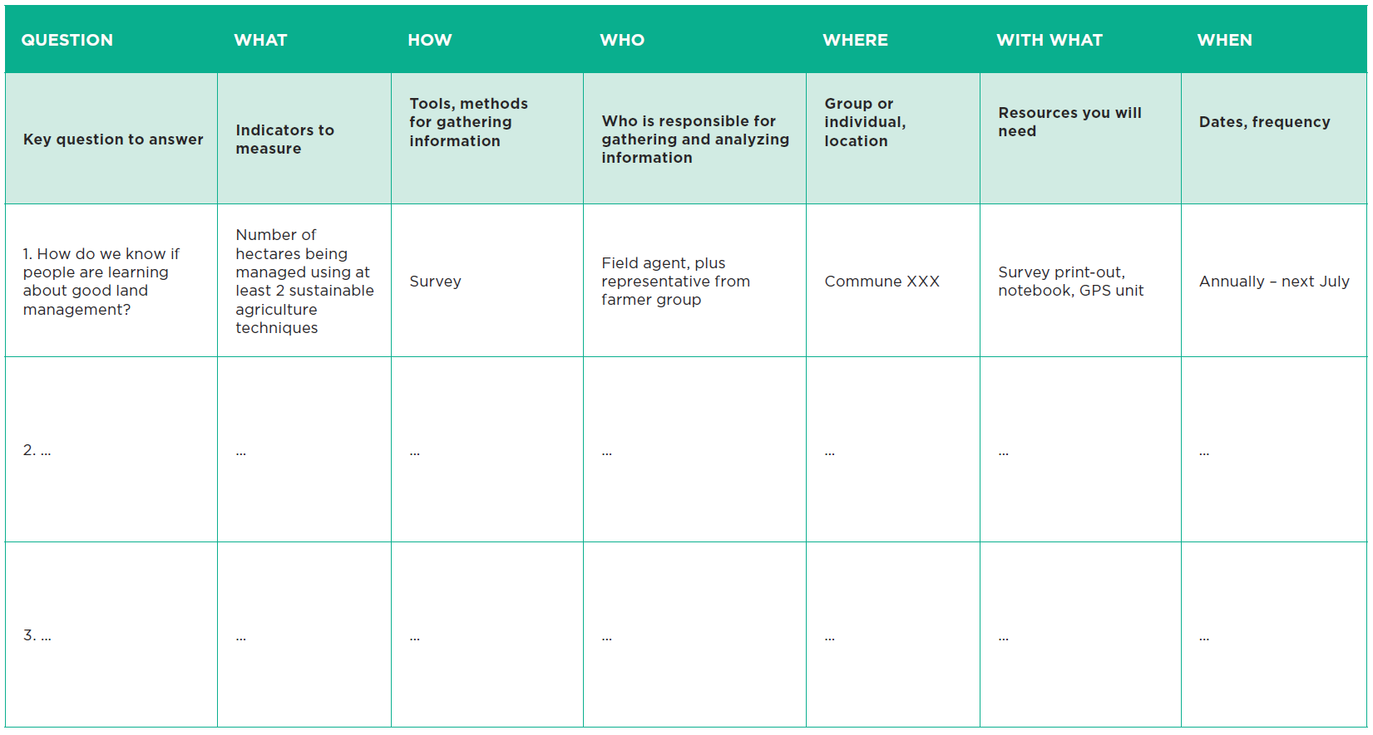
PLANNING INDICATORS

