**EXERCISE 5B. DEVELOPING A NATURAL RESOURCES MANAGEMENT PLAN**

|  |  |
| --- | --- |
| *OBJECTIVE*  **After this exercise the participants will be able to:**   * Develop and agree on a plan to manage the natural resources in a particular area. | |
| *EQUIPMENT NEEDED*   * Large pieces of paper, markers | *EXPECTED OUTPUT*   * An agreed plan (or plans) on natural resource management. |
| *TIME*  3 hours | *PREPARATION*  It’s a good idea to have already completed at least the following:   * Exercise 1b. Setting goals * Exercise 4a. Drawing a social-resource map * Exercise 4b. Gender roles and responsibilities in natural resources management * Exercise 4c. Identifying hotspots or problem areas * Exercise 4d. Problem tree * Exercise 5a. Choosing solutions. |

*This exercise leads the participants through the process of developing a plan to manage their natural resources. This plan may be for one year or for several years. It may cover a single farm, a group of farms, a particular area (such as an area being threatened by a quickly-growing gully), or the whole community or watershed. It may be best to start off with a large, general plan for the whole community or watershed, and then in another session to help individual farmers plan how to implement the activities on their own farms.*

*SUGGESTED PROCEDURE:*

1. Draw Table 10 on a flip chart. List in the first four columns the problems, solutions, activities and inputs that the farmer group identified in Exercise 5a.
2. In the **Activity** column, ask the group to be as specific as possible in terms of numbers and amounts. How many checkdams do they want to build? How large an area needs to be sown with grass?
3. In the **Inputs** column, refine the lists from Exercise 5a following the more detailed list of activities.
4. In the **Location** column, ask the group to specify exactly where the activity will take place. If it is helpful, get them to mark the locations on a map. You can use or copy the resource map they drew in Exercise 4a, or they can draw a new map.

*(Note that the problems and the interventions may be located in different places. For example, if a dried-up well is a problem, the intervention may be a tree-planting campaign to protect the area upslope from the well.)*

1. In the **Person(s) responsible** column, invite them to say who will lead the activity and make sure things get done, and who will do the work. Make sure that the leaders are responsible and committed, and that you get firm commitments from everyone! It may be advisable for the group to design a system of sanctions if, for example, someone does not turn up to work as agreed.
2. In the **Timing** column, put down the dates when the activities will take place. Again, make sure you get commitments from all concerned. If there are many activities, it may be useful to draw up a separate calendar showing what is going to happen when.
3. Ask the participants to look at the **Activities**. Mark in one color those activities that will have a short-term benefit. Mark in another color those activities that will have a long-term benefit. Is there a good balance? Do you need to add, re- move, or change any activities?

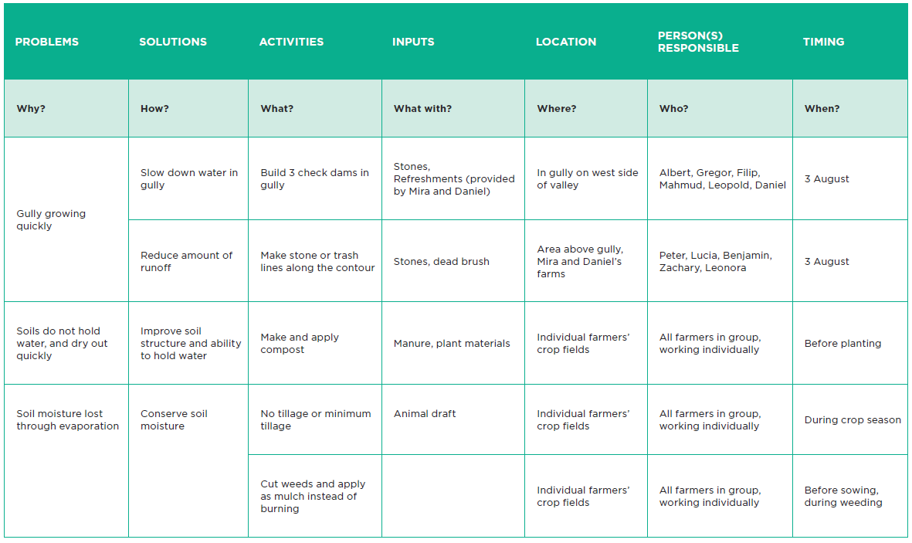**Natural resource management plan**