**EXERCISE 5A. CHOOSING SOLUTIONS**

|  |  |
| --- | --- |
| *OBJECTIVE*  **After this exercise the participants will be able to:**   * Choose solutions that address their priority problems. | |
| *EQUIPMENT NEEDED*   * Flip chart and markers | *EXPECTED OUTPUTS*   * A list of solutions to address the group’s priority natural resource management problems. |
| *TIME*  2-3 hours | *PREPARATION*   * Review the list of priority hotspots or issues (Exercise 4c), and their causes and effects (Exercise 4d). |

*Solutions are determined based on the problems, opportunities and the biophysical conditions of the area that you’ve just analyzed during your ecosystem assessment.*

*Having a comprehensive list of inputs, materials, people, funds, and other resources that are available for farmer groups to use in designing solutions is critical for selecting realistic solutions. Farmer groups should brainstorm techniques they’re familiar with that have proven to be successful. You can use your inventory of local practices as a reference.*

*You should also reflect on the principles and technical options that you have just learned about, and try to connect them with the identified priorities. As a facilitator, you should have a good understanding of the possible technical solutions from the theory module and the annexes in this document to help your group find solutions.*

*SUGGESTED PROCEDURE:*

For each of the top four or five priority issues the group identified earlier:

1. Develop a list of possible interventions based on the problems that you and the group member have uncovered and the solutions that you feel would work well locally.
2. Review this list and decide which interventions are most important for your group.
3. Review the initial list and decide which interventions can be addressed by the group members themselves, and which will require interaction with external stakeholders. Also discuss the types of resources that may be required to implement each of the interventions. If group members do not have the resources themselves, where could they obtain the resources?
4. Organize the results of the discussion in a table like Table 8.
5. Facilitate a follow-up discussion around these questions (you may add other ones as appropriate for your local context):
   * What are the most practical solutions given the resources that the group has access to?
   * What information might you still need before you finalize your strategy?
   * Do some of the interventions require consultation, input or action from external stakeholders? If yes – which ones and how could they be engaged?
   * Do you need more information on any of the solutions? If yes, where will you get it?
   * Do some of the solutions require more money or resources than the group has? If yes, what are other possible sources for the necessary resources?
   * Are there government or NGO programs within your area that could help with what you want to do? If yes, how do you get in touch with them and seek their assistance?

**Remember:** Natural resource management problems are often a result of an inappropriate technology (e.g., overgrazing on slopes) and a social or economic problem (e.g., lack of access to adequate fodder). Solving the problem probably involves both a technological fix (fencing off the overgrazed area, planting fodder grasses) as well as a social initiative (getting people to agree to rules about grazing animals).

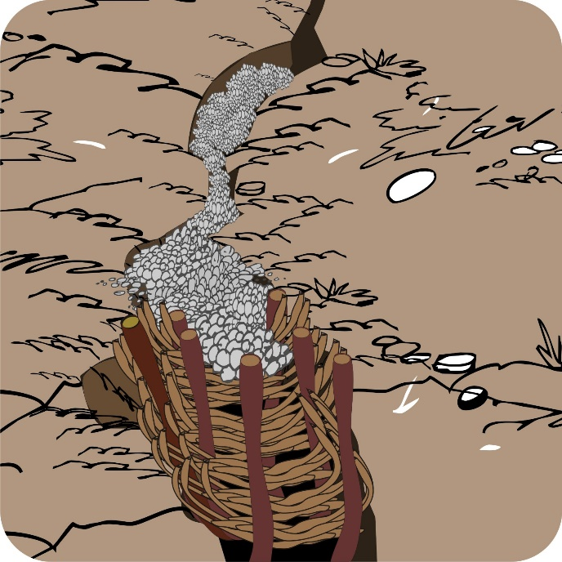

1. Discuss what additional activities you may need to add to ensure that the social aspects are addressed.
   * Are there land tenure issues you need to consider?
   * Are there any potential conflicts that could arise from these activities?
   * Is the local government or other community group ready and able to support these activities?
2. Agree on the main solutions and activities the group members would like to do.