**EXERCISE 4C. IDENTIFYING HOTSPOTS OR PROBLEM AREAS**

|  |  |
| --- | --- |
| *OBJECTIVE*  **After this exercise the participants will be able to:**   * + - * Identify natural resource related problems in a watershed or community. | |
| *EQUIPMENT NEEDED*   * A map of the area * The social-resource map completed together with the community during Exercise 4a. * The transect diagram completed during Exercise 2D. | *EXPECTED OUTPUTS*   * Participants understand how to identify environ-mental hotspots and have identified key problems in their own area. |
| *TIME*  45 minutes- 1 hour | *PREPARATION*   * Take a walk around the area again, looking for as many different kinds of evidence of soil erosion and other natural resource problems as possible. Choose several of these hotspots that are close together and easy to visit. Plan a walking route for the group to visit these areas. |

*(This exercise can also be done as part of the mapping or transect walk*.)

*SUGGESTED PROCEDURE:*

1. Together with the participants walk to the first hotspot.
2. Talk about the key signs of hotspots. Ask the group if they can see any of those signs nearby. After they have identified some, ask them what they think causes the problem, and what might happen if the problem continues.
3. Take the group to another hotspot nearby and repeat the discussion. Identify any additional problem areas that the group did not mention. Explain what is happening in these areas.
4. Ask the participants to look for additional hotspots as they are going home, and to remember how many, their location and type.
5. At the next meeting, ask people to share their observations and discuss briefly the extent of the erosion and other natural resource problems in this watershed or area.

*THINGS YOU’LL NEED:*

**A MAP OF THE AREA**

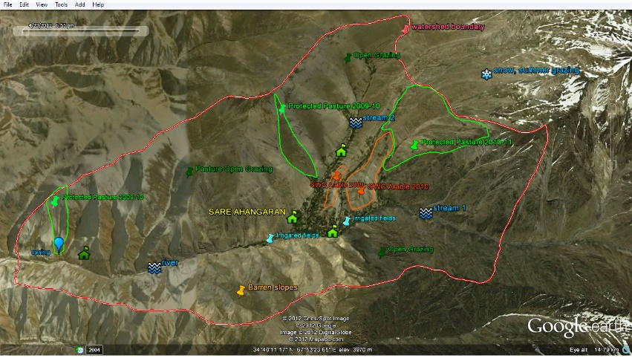

**SOCIAL RESOURCE MAP (FROM EXERCISE 4A)**

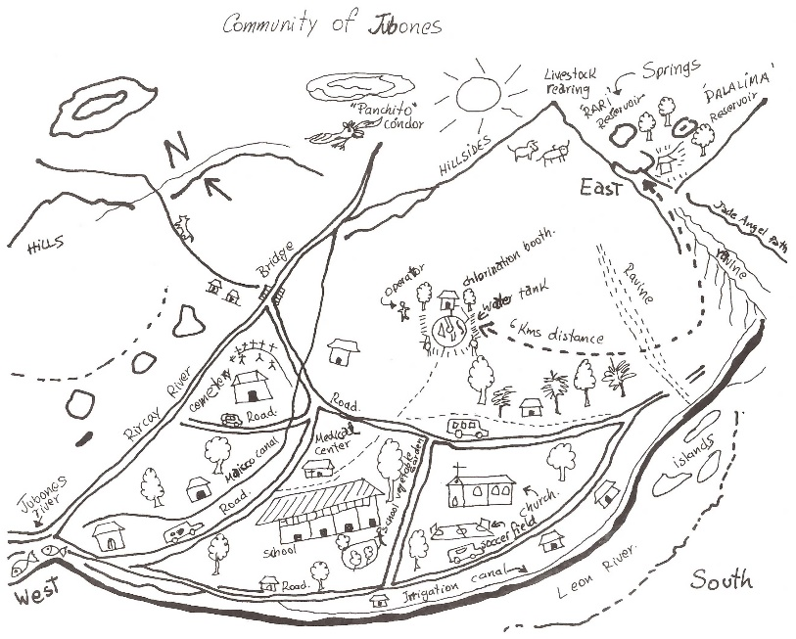

**TRANSECT DIAGRAM (FROM EXERCISE 2D)**

