**EXERCISE 4B. GENDER ROLES AND RESPONSIBILITIES IN NATURAL RESOURCES MANAGEMENT**

|  |  |
| --- | --- |
| *OBJECTIVE*  **After this exercise the participants will be able to:**   * + - * After completing this exercise the participants will be able to:       * Collect information and explain the differences and similarities between the way that man and women interact with the natural resources in their community (perceptions, knowledge, and activities). | |
| *EQUIPMENT NEEDED*   * + - * Large sheets of paper, cards or small pieces of paper, marker pens | *EXPECTED OUTPUTS*   * A list of roles and responsibilities for men and women as well as shared ones. |
| *TIME*  1 hour | *PREPARATION*   * Make three large drawings of a man, a woman and a couple. * Prepare cards or small pieces of paper, each showing a different type of farm work (plowing, sowing, fertilization, weeding, harvesting, caring for livestock, etc.), daily household tasks, and community work. |

*Adapted from FAO and IIRR (2012).*

*This exercise explores the difference between the perceptions, knowledge, and activities of men and women in relation to natural resources.*

*SUGGESTED PROCEDURE:*

1. Put the drawings of a man, a woman and a couple in a row on the ground.
2. Ask the participants to put each of the cards showing agricultural activities and other tasks under one of the drawings. Instruct them to put a card under the drawing of the man if he normally does that task, under the woman if she does it, or under the couple if both do it. Start off with tasks that are easy to categorize, and then go on to more difficult ones. Let the participants take over the exercise and conduct the discussion.
3. Ask the group to analyze the workloads: how much work does each task take, and who does it? Link the tasks and workloads to land and water management activities. Explore the knowledge and perceptions of these resources and activities. Focus the discussion on how women might contribute and what problems they face in doing so.

*QUESTIONS TO STIMULATE DISCUSSION*

* How are women and men involved in managing land and water for different purposes: rain-fed crops, irrigated crops, livestock production and so on?
* Compare what women and men do now to what their mothers and fathers used to do. How have the tasks changed? Why?
* Who (men, women, or together) should be involved in planning land and water management activities?
* Who does what, in families headed by women? In families affected by HIV/AIDS? How are these families different from other families?
* How are older people different in their handling of natural resources? How about people from different ethnic groups? Owners of big farms? Landless people? Richer and poorer people?

*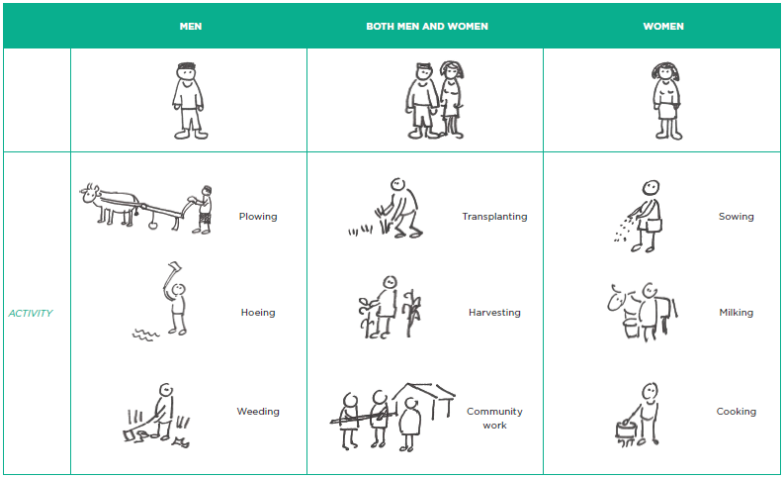EXAMPLE OF A GENDER ACTIVITY MATRIX*