EXERCISE 4A. DRAWING A SOCIAL-RESOURCE MAP
OBJECTIVES
After this exercise the participants will be able to:
- Produce a map showing key features of the area (watershed, community or village). It will indicate the land uses, soils, water features and vegetation – highlighting hotspots and opportunities.
- Identify problems in natural resource management and locate possible solutions.
EQUIPMENT NEEDED  - Large, flat area to draw a map on the ground.  - Sticks, stones, and leaves to represent buildings, fields and forests.  - Large sheets of paper and markers.  - Camera (to take pictures of the finished map).  - A topographic map, aerial or satellite photo (such as a printout from Google Earth -not essential but will aid the exercise, esp. in larger catchment areas). | EXPECTED OUTPUT  - A completed map of the watershed or community, showing features such as hills and valleys, rivers and streams, roads, buildings and fields, along with land use and areas with natural resource problems.
TIME  2 hours | PREPARATION  - Prepare a checklist with questions relevant to the natural resource issues in your area.  - Select a suitable location to draw the map:  - A large, clear, sandy piece of ground (draw in the sand with a stick, and use stones and leaves to show the locations of buildings, fields, forests, etc.).  - A smooth concrete floor (like the floor of a school classroom). Use colored chalk.  - A large sheet of paper (use colored marker pens).
A map is a basic tool for identifying natural resource problems and opportunities and for planning interventions. Drawing a map together with the local participants enables them to become fully involved in the analysis and planning process right from the beginning. A social-resource map is different from other resource maps because it includes information about the community and how they are connected to the natural resources.
Mapping should not be looked at as a one-off exercise. A map can be the first step to identify priority areas, and more detailed maps of particular areas can be produced afterwards. Also, a map should be continually updated as changes and additions are made. You may also use this map to demarcate treated areas. You can get the participants to draw a map from scratch, or you can base it on an existing map or aerial/satellite photo.
This exercise is best done with a small group of people – no more than 15.
SUGGESTED PROCEDURE:
- Determine the limits of the mapping area. Describe to the participants the area the map should cover – a watershed, a community, a village and surrounding gardens, a single farm, etc. Make sure the participants know the boundaries of this area: the administrative borders of the community, the ridges separating one water- shed from another, the boundaries of the farm. If necessary, take people outside to point out the boundaries.
- Chose a starting point.
  - If you’re mapping a watershed or sub-watershed, ask a participant to start by identifying the main river in the area. Add tributaries and springs. From there, identify the ridges, and the points from which all water drains to the same point. (This might be the river’s source, or the point where the river enters a larger river. Refer to the module Understanding natural resources, Lesson 4 for a reminder of what a watershed is.) Help the community to delineate the water- shed.
  - If you’re mapping a community area not limited by a watershed boundary, ask a participant to begin by choosing an important landmark in the community (the village hall, the church, the main road) and marking this on the map.
- Ask the other participants to mark other important resources on the map. Do not interrupt unless they stop. If they do, prompt them for other things they could add: boundaries, villages and settlements, landscape and soils, water re- sources, infrastructure, land use, problem areas, or planned interventions. Ask them also to mark their own farms on the map. Refer to Box 9 for ideas on what to include.
- Ask the participants a series of questions about the way they use and interact with their resources. Prepare a checklist beforehand with questions that are relevant to the issues in your area. You can refer to the “Social and economic issues” section in Lesson 2, and to Exercise 2a for questions to ask. If you’ve already done those analyses, you probably don’t need to do them again. Mark important responses on the map. Questions might include the following:
- Demographics and vulnerability. How many families live in the area? Where do the most vulnerable live?
- Important resources. Identify the main resources. How much of each resource is available? How many people use it? Which are the main problems or hotspots?
- Areas of under-utilized potential. Which areas have the most potential?
- Areas of social concern or potential conflict. Which areas are riskiest? Who owns the important resources? Are there any ongoing conflicts around these resources? If so, how intensive and who is involved?
- Leadership. Who has access or control over the resources? What community groups work already in the area?
- When the map is finished, ask the participants to describe it and to discuss what it shows. Ask if there is anything that is unclear. Make sure they have marked things like the north point, directions and distances to nearby places, and so on.
- Finally, you might want to ask them to draw another map of how they would like their com- munity to look in the future. This allows for some preliminary planning, and encourages people to contribute their ideas.
- Copy a map drawn on the ground onto paper, and post it on the wall in the community building as a permanent record. Take a photograph or copy the map to keep for reference. You’ll use information from this map to make your Google Earth map. During subsequent transect walks, you’ll take GPS coordinates and transfer them to Google Earth in order to prepare a composite map.
QUESTIONS TO STIMULATE DISCUSSION
- What resources does the community share? What do community members think about sharing common resources, such as forests and rivers? If there is disagreement about the planned use of a particular resource, how is this addressed?
- Can outsiders use the resources? What are the terms and conditions of such use? Who benefits?
- Do men and women have different rights to use land and water? How about people from different ethnic groups? Rich and poor?
NOTES
For most purposes, accuracy and scale are not important; it is more important to visualize the relative locations of different features.
Sometimes women are reluctant to contribute to the map. If so, ask them to draw a separate map. It will often show different things from the men’s map– things that women see as important.
You can ask participants to draw maps showing specific resources, activities, use details: crop types and yields, disease problems, who in the family does what, soil types, and so on. You can then use this map as a starting point for discussing these issues.
Participants can also draw maps of their own farms and use these for describing their farming systems and analyzing problems and planning improvements.
You can use a map of a watershed as the basis of discussions on erosion, water conservation, upstream and downstream issues, policies, or land ownership.
Maps are very useful for monitoring and evaluation as they can show changes over time. If participants draw a map at the end of the project cycle, they can compare it with the map at the start of your project to see what changes have taken place.
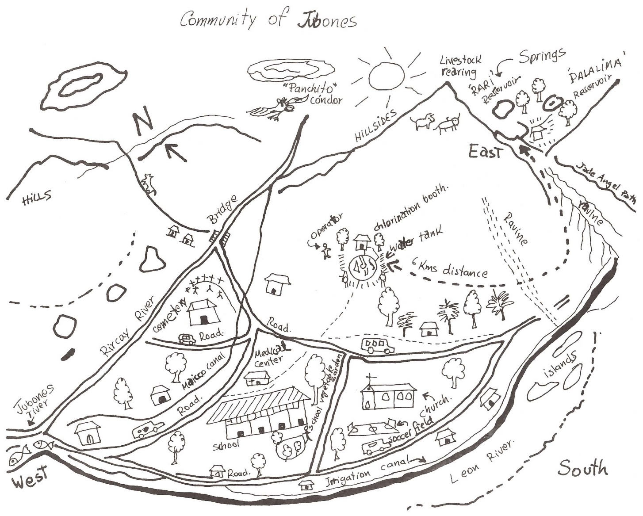
EXAMPLE OF A RESOURCE MAP

