**EXERCISE 2D. TRANSECT WALK**

|  |  |
| --- | --- |
| *OBJECTIVE*  **After this exercise the participants will be able to:**   * + - * Identify and discuss key natural resources.       * Determine which issues are relevant for individual farms and which are at the watershed level.       * Determine which natural resources are not being used or managed to their full potential.       * Understand the relationships between the land- scape, land use, farming systems, and problems with soil, water and crops.       * Record GPS coordinates of key resources or land- marks. You’ll use these later to prepare a Google Earth map of the area (see Staff Exercise B). | |
| *EQUIPMENT NEEDED*   * GPS, flip chart, markers, notebooks and pens | *EXPECTED OUTPUTS*   * One or more transect diagrams of the areas of interest to the farmer group as well as an under- standing of the landscape, land use, land tenure, farming systems, and problems with soil, water, crops, and natural vegetation. * A Google Earth composite map. |
| *TIME*  20 minutes for instruction; 2 hours for the transect walk; 1 – 3 hours for data organization, mapping and discussion. | *PREPARATION*   * Prepare a checklist of the information the participants will be looking for, or a template for a transect diagram. * Choose a route that will cut across a large variety of landforms and land use types (e.g., from a hill across to a valley), and that is likely to cover the expressed/anticipated hotspots or opportunities in the area. |

*You can use this exercise to gather information on the relationships between the landscape, land use, farming systems, soils, water use, and crops. It identifies opportunities and hotspots as well as stimulates discussion of local problems and possible solutions.*

*Once you have determined your priority areas from the mapping exercises, your transect walk should be conducted in those areas. A transect walk uses the information from the mapping exercise to get more detailed information about the area. Transect walks are also useful in your regular monitoring.*

*SUGGESTED PROCEDURE:*

1. Outline the goals of the transect walk. Decide the scope: Will it focus on a single “average” farm, or a larger area of the community or watershed? Use your resource map to decide where more detailed information might be useful and important.
2. Provide participants with materials and instructions on the planned walking route and the duration. Give them a checklist of information they should be looking for or a template for a transect diagram. If possible, show them a sample completed transect diagram.
3. Turn on your GPS and set it on “track”. If you are not able to track, take waypoints along the way, including your start point, end point, and key resources along the way. Note in your notebook what each point represents.
4. During the walk, stop frequently at interesting places, and make sure you capture the differences in land use and soil type. Encourage participants to observe the main features, discuss the differences and record what they see at each place.
5. Use this opportunity to discuss with farmers the key identified resources, priorities, and trends. Highlight several of the key topics associated with resource management and make sure the participants note down or memorize the information at each location.
6. At the end of the walk, ask one of the participants to draw a profile (cross-section) of the route on the big sheet of paper (or on a blackboard). Mark the most important land types and features (hilltops, river, village, forest, crops etc.) on this profile. Use little drawings to show trees, houses, crops etc.
7. Engage the participants in a general discussion about the information on the diagram. What were the key resources? How do they relate to each other? What are the key problem areas? What opportunities were identified?

*QUESTIONS TO STIMULATE DISCUSSION*

Some additional areas to discuss:

* **Healthy resources.** What resources are healthy or seeing positive trends? Why? What are the implications for the area?
* **Areas not reaching their potential.** Which areas are not reaching their potential and why? Which ones are the most important? Why? What are the effects or implications of these trends? How can these negative trends be reversed?

*NOTES*It may be useful to have two or more groups, each led by a different type of guide (e.g. a man and a woman, or people from two different ethnic groups or primary livelihood sources). By walking in different directions, you can cover more area and make sure the findings are more representatives of the whole area.

*TYPES OF INFORMATION TO NOTE IN A TRANSECT WALK*

* **Soil type.** Use local names for the soils. If too simple (e.g., the word used is just a name of a color, like “brown”) ask about other details, such as stoniness, depth and fertility.
* **Crops and vegetation.** Use local terms and criteria to describe the cropping systems, pasture types, trees and other vegetation.
* **Animals.** Record the type and approximate numbers of livestock. Are they stall-fed, ranched or free grazing?
* **Water.** Note where the transect crosses or is near to any water sources, such as rivers, streams, springs and reservoirs. Ask how much water they normally hold and in which periods. Is there ever flooding? If yes, when, where and how frequently?
* **Ownership.** Is land in the area privately owned or communally owned? Do the farmers own the parcels of land on which they work? If they rent or sharecrop, are they able to make decisions about soil and water conservation, such as tree planting or
* other technologies? Note that if problematic issues are identified, they may have to be addressed in the course of your later work.
* **Problems.** Ask about any problems related to soils, plant nutrients, crops, water, forests, livestock, pests and diseases. Any recent changes in erosion, burning, fertilizer needs, crops, yields or pollution? Ask them to point out which signs indicate changes (e.g., certain types of plants flourishing or wilting).
* **Current management practices.** For pasture and forest land, describe management practices such as fencing, controlled burning, seeding, selective felling and coppicing. For cropland, describe the soil management practices (tillage, soil conservation measures, fallows), cropping practices (rotations, intercropping, burning, weeding), nutrient practices (manuring, compost, fertilization, grazing of residues), water management (mulching, water harvesting, irrigation, drainage). Note what can be seen during the walk, but also ask what happens at other times of year.
* **Opportunities.** Note what people say about ways to improve the management of resources, increase productivity and reduce land degradation. Which crops have they been considering as future livelihood options? What kinds of farming and animal products have been in high demand on the local markets? Which resources seem to be plentiful in the area?
* 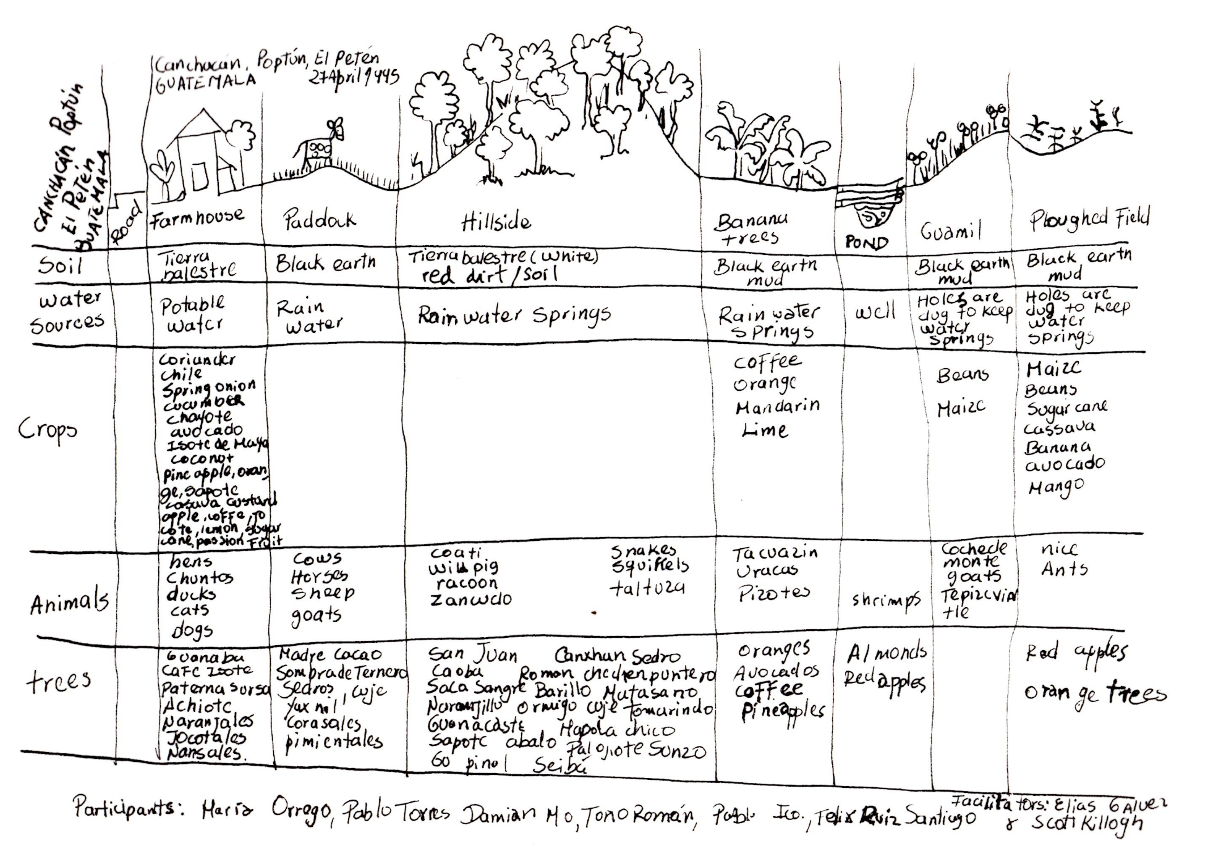

**Example of a transect diagram**