**EXERCISE 2C. SEASONAL CALENDAR**

|  |  |
| --- | --- |
| *OBJECTIVE*  **After this exercise the participants will be able to:**   * Visualize farming activities throughout the year, and understand the changes in farming and in the environment that occur during the year. * Define when interventions in natural resources management may be needed. | |
| *EQUIPMENT NEEDED*   * Sticks, pebbles, leaves or other local materials; area of flat bare ground or large sheet of paper, marker pens. | *EXPECTED OUTPUTS*   * A calendar showing farming activities and other features that vary from one month to another. |
| *TIME*  1.5 hours | *PREPARATION*   * None |

Adapted from FAO and IIRR (2012)

*This exercise enables participants to describe and analyze their farming and other activities throughout the year. It builds an understanding of the farming system, and shows when it may be possible to make improvements in natural resource management.*

*The participants can draw the calendar using several different tools: on the ground using sticks, on a smooth concrete floor using colored chalk, or with marker pens on a big sheet of paper.*

*SUGGESTED PROCEDURE:*

1. Draw a line across the top of the piece of ground (or the paper) and divide it into 12 equal sections – one for each month. Draw several additional horizontal lines across the paper below the first one. These will become the rows in which the information on different activities will be entered.
2. It is usually easiest to start by asking about rainfall. Ask which month the rainy season begins (e.g., April), and write the name of this month at the start of the line. Write the names of the other months in order after it.
3. Ask the participants to indicate the relative amount of rainfall expected in each month. They can draw a line or use pebbles to show how much rain falls in each month (more pebbles mean more rain).
4. Ask the participants to show when they do major tasks, such as plowing, irrigation, weeding, and repairing dams.
5. Ask them to show how much work the men put into farming (or other key livelihoods), and how much work the women do in each month. Use different rows and different types of stones or leaves for men and women (more stones mean more work is done in that month).
6. Repeat this process, one subject after another, for other topics: flooding, food availability, water availability, income sources, prices, and so on, until all the seasonal issues are covered. For each row, draw a symbol or letter next to it to show what it represents. Ask the participants to explain how they manage in times of food or water shortage, and to say at what time of year they have major expenses, where they obtain the income, and so on.
7. If possible, make a record of the finished calendar (taking a picture or drawing it out on paper). It is useful to post it on the wall as a permanent record and reference for further discussions.
8. Have each group present their calendars to the other groups and facilitate a discussion.

*QUESTIONS TO STIMULATE DISCUSSION*

* What are the main sources of income in the community? How does this change over the seasons? How does income vary over the year? Are there periods of no income?
* How do women’s calendars compare with men’s? What are the busiest periods for women and for men? Are there daily, seasonal or yearly labor peaks and shortages?
* When are people likely to have spare time for major building work (such as building structures to control erosion)?
* How does food availability vary throughout the year? Are there periods of hunger?
* How does water availability vary throughout the year for various uses (household, small and large livestock, irrigation)?
* During what seasons do people have the hardest times to make ends meet? Which resources are used most during these seasons?
* What are the key natural resources used at different times of year? Are there periods of critical stress for these resources?

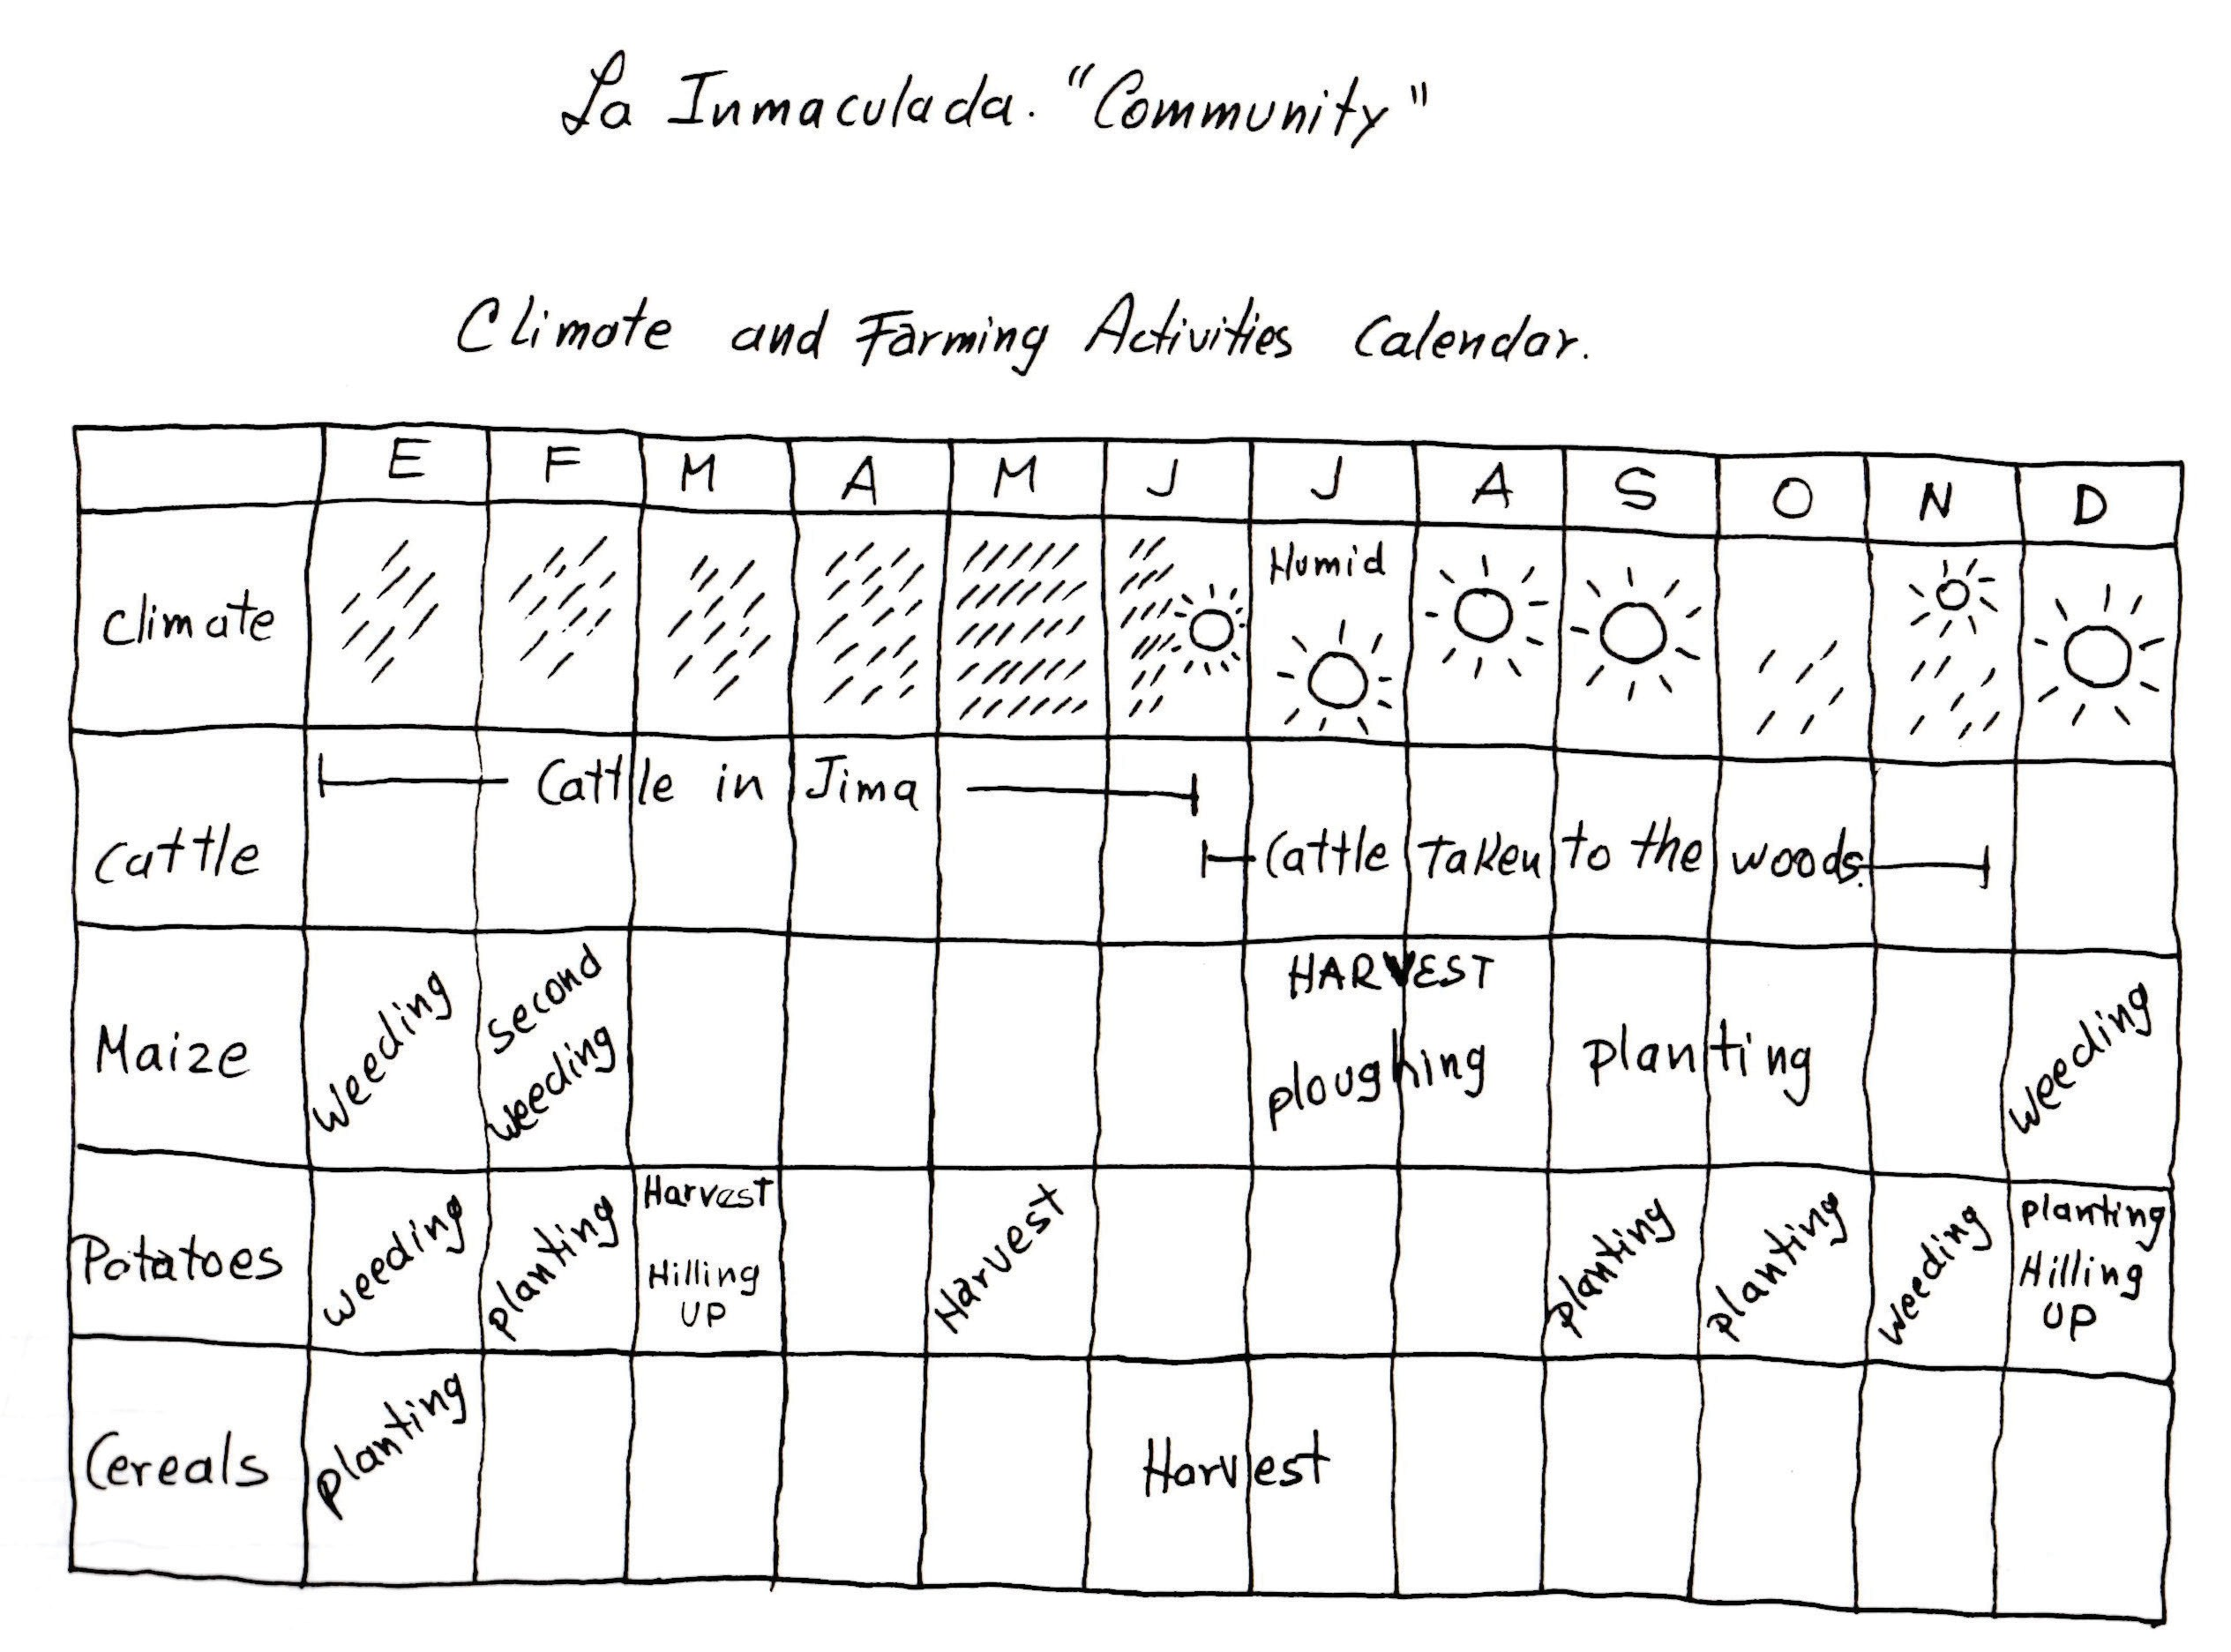

Source: Selener et al. 1999

**Example of a seasonal calendar**

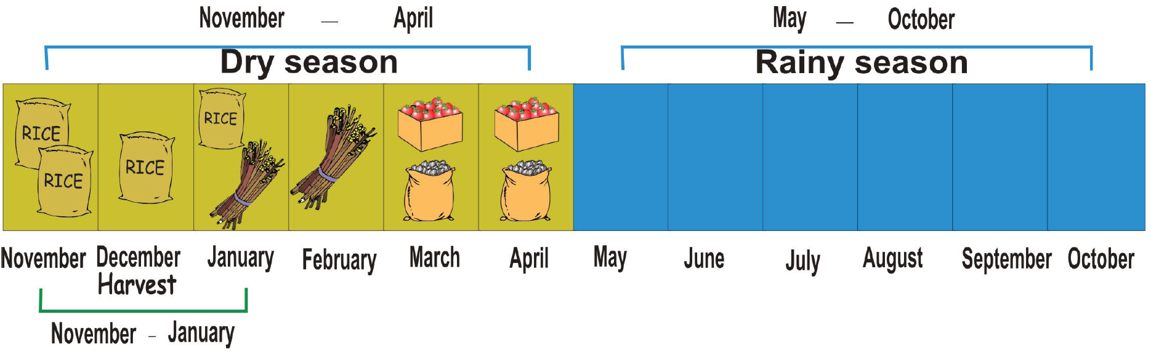

**Example of a seasonal calendar**