**EXERCISE 2A. VULNERABILITY ANALYSIS**

|  |  |
| --- | --- |
| *OBJECTIVE*  **After this exercise the participants will be able to:**   * + - * Determine who are the most vulnerable members of the community, and who are the least vulnerable. * Describe how people of different levels of vulnerability use natural resources. | |
| *EQUIPMENT NEEDED*   * Flipchart and markers | *EXPECTED OUTPUTS*   * List of different groups in the community and their interests in natural resources. |
| *TIME*  1-2 hours | *PREPARATION*   * Arrange meetings with your groups. |

*SUGGESTED PROCEDURE:*

1. Make a list of the different groups in the community – some that you think are vulnerable, some that are not.
2. Ask the community to brainstorm other groups or categories of people in the community. What else makes some people vulnerable and some not? Be sensitive to the local culture as you write these groups.
3. Facilitate a brief discussion about these different groups of people. Which are the most vulnerable? Which are the least vulnerable? Write down some words that people use when they answer. What does “vulnerable” mean in this community?
4. Next, make a list of the main natural resources in the community that people value. You can use images if some people are not literate.
5. For each resource, discuss each of the groups you wrote down. Ask the following questions:

* Who has **access** to each of these resources? Who does not?
* Who has **control** over each of these resources? Who does not?
* Who has a say in how resources are **managed**? Who does not?
* Do some groups cause more **damage** to resources than others? What would motivate them to change their behaviors?
* Do some groups have **opportunities** to benefit from – or to help others benefit from – improved natural resources management?

1. Note these characteristics in a table like Table 2.

*QUESTIONS FOR DISCUSSION:*You may find, for example, that many of the richer farmers have irrigated land in the valley, while the poorer farmers have small plots on steep slopes. Maybe landless people or children from poor families work on their neighbors’ land or herd their animals. Explore who owns or controls what land; who has rights to resources such as trees or grazing areas; and who has an interest (or no interest) in improving how resources are managed.

* Who are the most vulnerable people in the community? Who are the least?
* How do these vulnerabilities affect natural resources? How does good or bad management of natural resources affect vulnerable people?
* What do the differences in access and control of resources mean for your project?
* How can you ensure that even vulnerable people can benefit from managing their natural resources better?

*NOTES:*

It is easy to overlook entire groups of vulnerable or important members of a community during implementation. The more vulnerable groups (e.g., the destitute) may not be able to attend meetings, or may not feel they have the right to express their views. Similarly, larger landowners may not be interested in the activities although their involvement is vital to success.

During implementation, make sure that all people from all categories are somehow involved in decision-making and in implementing activities. Design the monitoring and evaluation system to take these categories into account.

*EXAMPLES OF CATEGORIES OF PEOPLE IN A COMMUNITY*

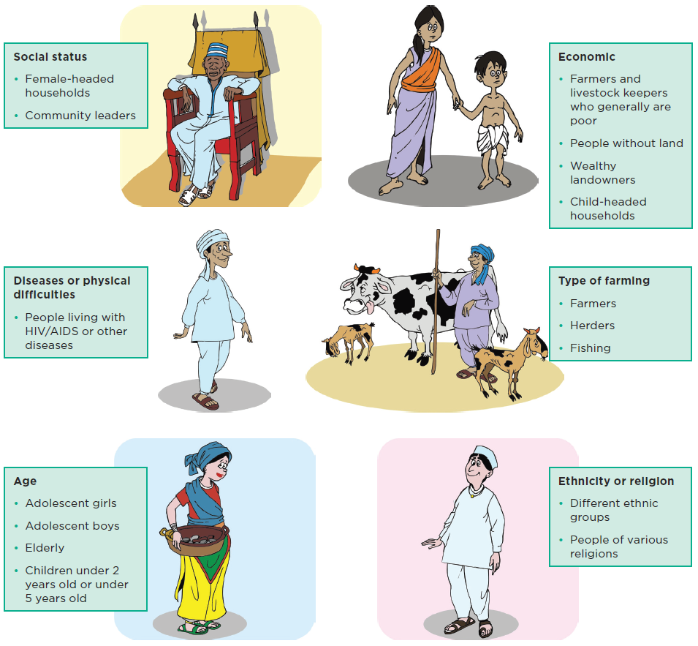

*MAKE SURE YOU HAVE A MAP*

Google Earth is an easy way to see overall land cover if you have a computer and an Internet connection. The information is not usually up-to-date, but it still provides a useful overview of the area where you work.

<https://www.google.com/earth/>

*EXAMPLE OF VULNERABILITY ANALYSIS*

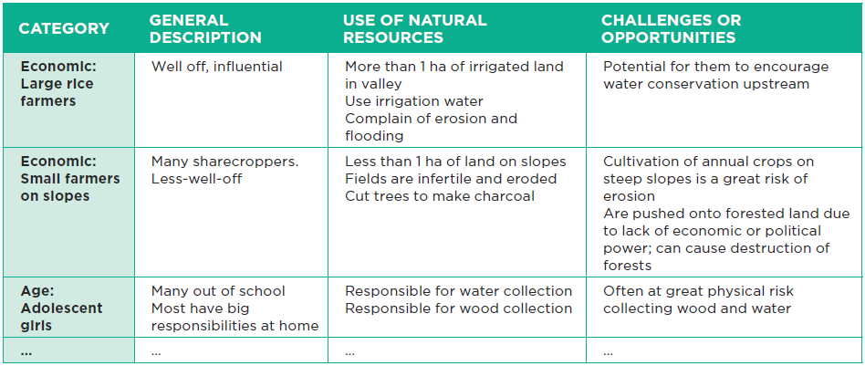

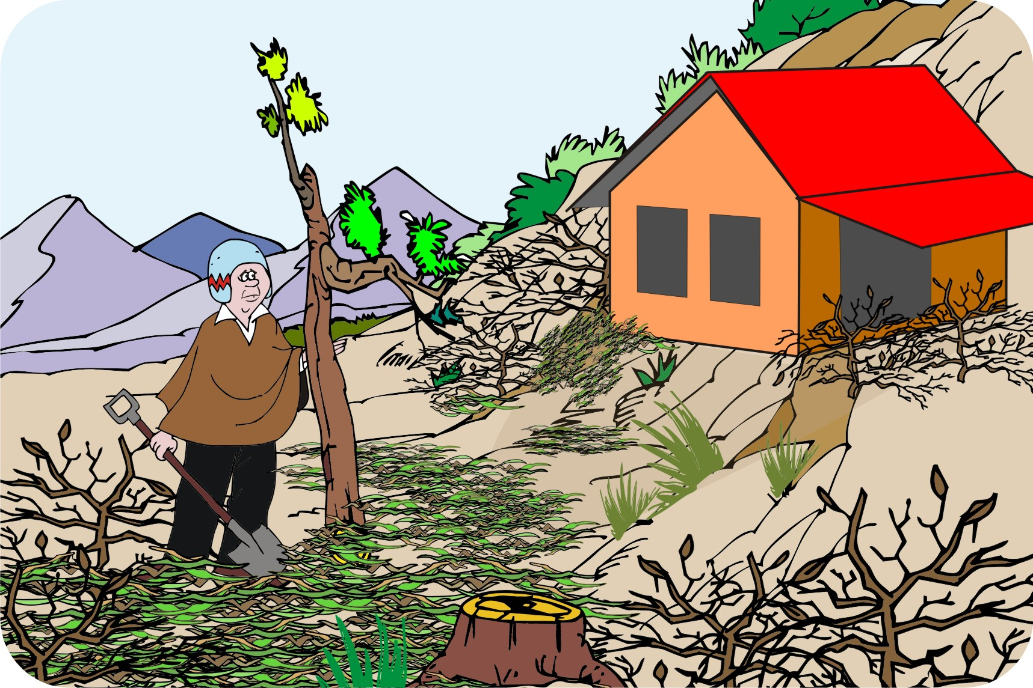

*Name at least three things you observe in this picture that make this person vulnerable.*