**EXERCISE 1B. SETTING GOALS**

|  |  |
| --- | --- |
| *OBJECTIVE*  **After this exercise the participants will be able to:**   * Determine the goals that farmer groups have for their livelihoods * Prioritize goals that farmer groups care about the most. | |
| *EQUIPMENT NEEDED*   * Resource list from Exercise 1A, flip chart, and markers | *EXPECTED OUTPUTS*   * Present and future lists |
| *TIME*  45 minutes | *PREPARATION*   * Exercise 1A * Prepare a list of questions beforehand |

*SUGGESTED PROCEDURE:*

1. Refer the participants to the lists they made in Exercise 1A. You may refer them to the discussion you had during previous meetings as well.
2. Divide the participants into groups of men and women. If the groups are all male or all female, still divide them in different groups as valuable insights may emerge. The size of the groups will depend on the situation; it may be appropriate to have more than two groups.
3. Ask groups to look at their current list of existing resources. The three main questions are:

* What are your main goals for your farms or community resources for your livelihoods?
* What would you like your farms or community to look like in the future?
* What are the key changes that would need to take place in order to achieve your goals and have the farms and community you want in the future?

1. Ask each group to draw the farm or community they would like to see in the future. Make sure that they include as much visual detail as possible, and that they describe the details if needed. For example, if there is a section of land covered by forest, ask them to specify what type of trees and vegetation are there. How do they see themselves using these trees? What else is there in the forest? Ask them to share in plenary.
2. Once the groups have identified the resource-related goals, ask them to prioritize them based on production, income, health and livelihoods. Highlight the top two or three goals on this list and compare them with the other groups. What important similarities are there between the different lists? What are the differences?

*QUESTIONS FOR DISCUSSION:*

What are the most important goals for men and women? If they are different, what are the two or three main goals the group would like to prioritize? Consider selecting at least one each from the men’s list and the women’s list.

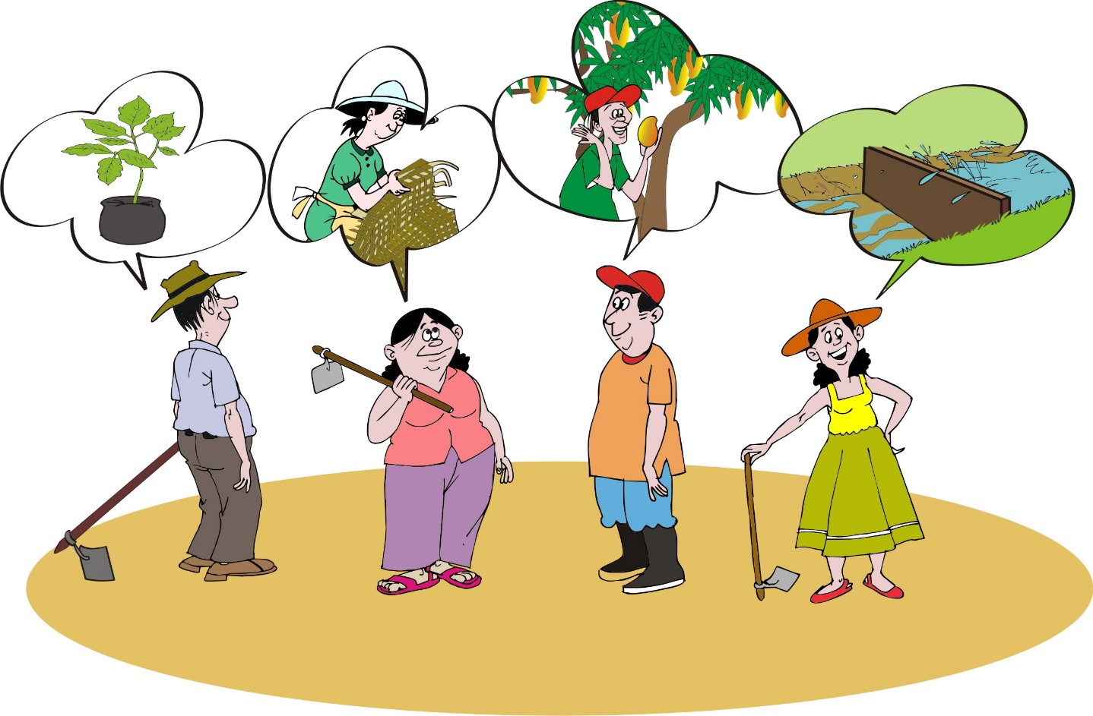

*NOTES:*

You may get many varied answers when you ask about goals, but continue to probe. Narrow the goals that are explicitly related to soil, water, and vegetation for all members of the group. For example, ask farmers to look at the goals they have listed. Which of these are related to your soil, water, and vegetative resources? Probe with further questions related to these resources. For example, if the response is “we want higher incomes,” probe to find out more. What on your farm, or from your community, currently provides you with income? If farmers say it’s their maize crop, there are several management practices they can use to increase the productivity of their maize. If farmers say it’s their petty trading, note this down, but continue to probe to find other priority goals related to natural resource management. Organize identified goals by whether or not they are primarily related to local natural resources.



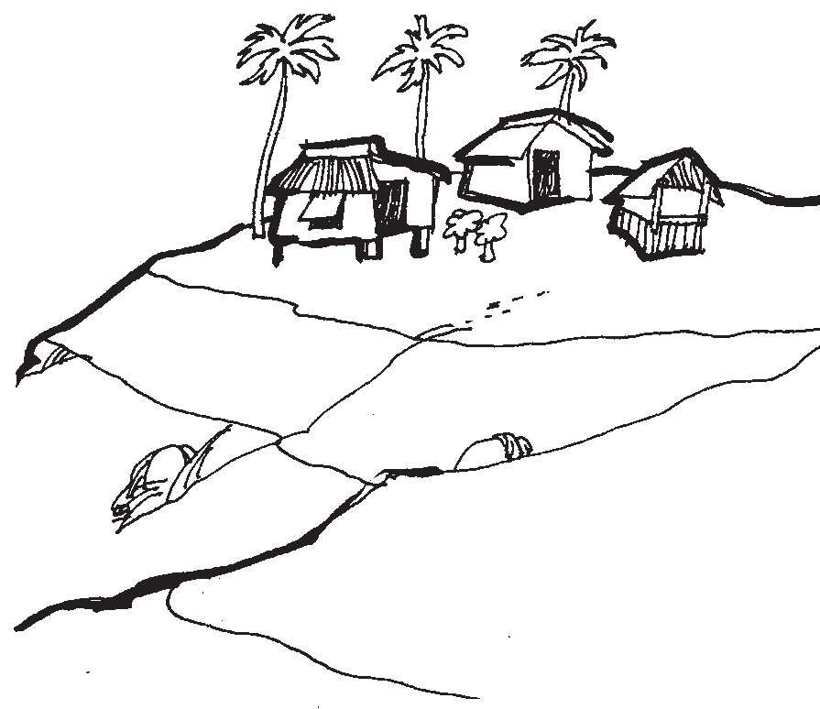

**Dry well**

**Erosion**

**Bare rock**

**Low yields**

**Gully**

**Setting goals**

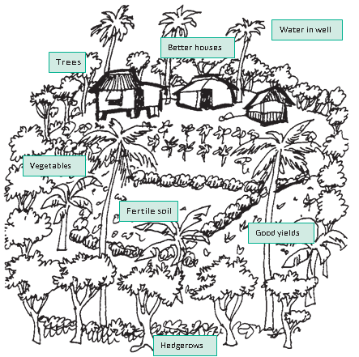

**Setting goals**