**FIELD EXERCISE 2. UNDERSTANDING PROFIT AND CROP SEASONAL CALENDARS**

|  |  |
| --- | --- |
| *OBJECTIVE*  **After this exercise the participants will be able to:**   * Describe what is a profit or a loss * List costs to producing a crop * Describe income * Understand sales units * Complete a crop seasonal calendar | |
| *EQUIPMENT NEEDED*   * Flip chart and marker * Calculator * Pencil * Images | *EXPECTED OUTPUT*   * Producers understand profitability calculations and how to include income and costs information in a crop seasonal calendar. |
| *TIME*  60 minutes | *PREPARATION*   * Practice the field exercise before going to the session. Make sure that you have drawn the activity tables on the flipchart paper prior to the session. Have the images ready to show to illustrate the topics that are discussed. * For the profit calculation activity please consider the values (costs and incomes) given. These can be adjusted to better match the local currency; the currency has intentionally been left out of this activity. If you do, please be sure to select whole number values to ensure easier understanding by the participants. |

***SUGGESTED PROCEDURE:***

**Ask**: Please describe what “Profit” means.

Once you have answers from 2-3 participants, clarify by giving the answer below.

**Say***:* Profit is the amount earned from the sale of the crop minus the money that was necessary to produce and bring the crop to market.

If the amount of money necessary to produce and bring the crop to market is more than the amount you earned from the sale then we do not call it a profit, but a “loss.”

**Say**: Now we’re going to discuss income.

A farmer’s income from a crop or product depends on two things:

* The sales price per unit (for example: kilogram, bag, crate, or other) of the crop.
* The quantity of crop (in units) sold

Before we discuss more about income let’s discuss what sales units are.

Sales units are the amount of a crop sold for a certain price.

**Ask**: What are some sales units used for your crops or produce?

Have several participants respond with their answer and clarify the answers if necessary.

*Demonstrate: Have props to demonstrate your examples. Have a bag for maize or other crop used to describe sales units. Or bring a bag of produce and write the weight (in kilograms) on it so you remember. It is best to bring two different examples of sales units. The importance is to demonstrate examples of sales units.*

***Say***: Here are some examples:

When a trader is buying a crop from a producer the trader will tell the price for a certain amount of a crop. For example, a farmer works with a trader to sell his maize. The trader says that he will pay 2000 per bag, so in this case the sales unit is a bag.

Another example: tomatoes may be sold by the kilogram. So, when someone buys tomatoes he/she may purchase 5 tomatoes; the tomatoes will be weighed to determine the amount in kilograms. In this case, the sales unit is a kilogram (which is the same as a kilo).

One more example is with rice. Rice is sold by the cup. The price is set by the cup (quantity). So, the sales unit is a cup.

**Say*:*** Now let’s discuss income further.

Income= Sales price per unit x Number of units sold

And, remember, income is not the same as profit. Income is the amount gained from selling a crop. To calculate profit one must also subtract the costs of production and bringing the crop to market.

To work out how much money he/she will make from the sale of a crop (the profit), farmers need to calculate their costs and their income with the following formula: Net income= Income - Costs.

**Say**: Now, let’s discuss costs.

Farmers have two main kinds of costs for production:

* Material Costs
* Labor Costs

We will go through each and discuss.

Material Costs

**Say:** Material costs include all the costs for the materials that are required to grow, harvest, and process your crop.

**Ask**: What are some examples of material costs?

After the farmers have listed their costs, turn the flip chart to reveal the costs that you have written down before the session.

*Here are examples of material costs for crops:*

* Seed
* Fertilizer
* Pesticides (includes herbicides, insecticides, fungicides)
* Bags and harvest containers
* Market fees and taxes
* Transport to market costs

*Material costs for livestock:*

* Land rent
* Animal feed
* Pens and holding equipment
* Medicines and veterinary materials
* Transport to market

Labor Costs

**Say**: Now, let’s talk about the other main type of costs: labor costs.

These include all the paid labor costs required to grow, harvest, process, and market a crop. It includes workers contracted on a daily or hourly basis, or labor hired for production tasks, as well as barter labor.

**Ask**: What are some types of activities that may be done by hired labor?

*Examples of labor costs include:*

* Hired labor for production
* Land preparation/cultivation
* Sowing seeds
* Fertilizer application
* Weeding
* Pesticide application
* Harvest
* Post-harvest: threshing, drying, cleaning, sorting, grading, bagging, and storage.
* Market transport: driving, loading/unloading.

Family/Unpaid labor

**Say**: It is important for producers to consider the costs that they would have if they were to pay those family members who are unpaid.

**Ask***:* Which farmers have family members help with farm activities? Are they paid?

**Say**: Let us talk a bit more about unpaid labor.

Often farmers do not take into account the cost associated with using family labor as they do not have to pay out cash to cover it. Quantifying the use of family labor and putting a monetary value to it is important. This helps farmers understand the full cost of their enterprise. It will also help them decide between different production options. Some crop or livestock keeping activities may require more family labor than others.

If you have not thought or figured in family labor cost, you should consider doing this. It is important to know how much the cost would be if you had to pay for this labor. Any of the above listed activities should be accounted.

Indirect costs

**Say***:* It is also important to think about indirect costs. Indirect costs may or may not have a cash value.

Examples of indirect costs are:

* The use of family labor that prevents a family member doing something of value; for example, when children that tend livestock or help in production activities are not able to attend school.
* The need to hire help or pay in-kind compensation for undertaking household responsibilities or child care because involvement in a productive activity does not leave time to attend to these tasks.

**Ask**: Have you all thought about these types of indirect costs before? What do you think about these costs?

*ACTIVITY:*

***Say***: Now we’re going to do an activity in which we will calculate profit or loss of a selected crop as a group.

The first activity that we will do is to go through an example of how to calculate profit/loss for a selected crop. We will act out a conversation between a field agent and a farmer and discuss a crop.

**Preparation instructions for activity:**

*Ask a participant to play the role of Ishmail. The participant should be able to read the information. If it is not possible to have someone who can read the information the facilitator will need to cover both roles. Take some time to explain to the participant who is playing Ishmail what he/she needs to do. Give the participant the role play table and ask him/her to look at the information on the sheet and to answer the questions asked. The facilitator will write the answers on a flipchart. See the preparations at the beginning of the exercise, as the table should be prepared ahead of time on the flip chart.*

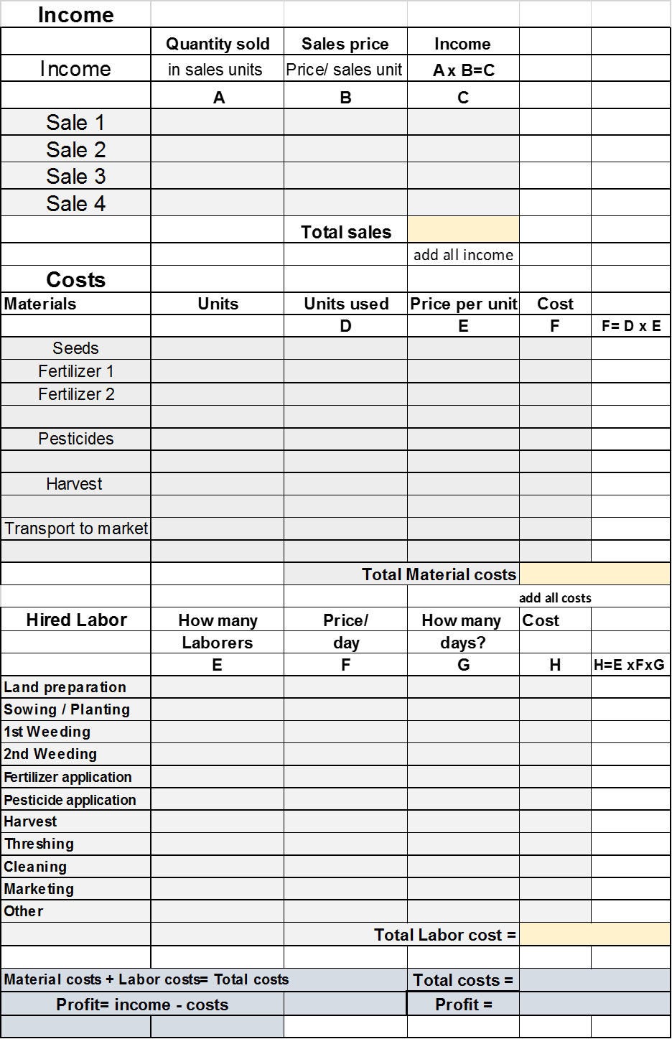

*SUGGESTED PROCEDURE:*

**1)** Introduce the role play.

**Say**: Isaac is a field agent in a village called Mbale where maize is grown. Isaac has the task of assisting farmers in the village who grow maize. He is to help the farmers calculate the profit of growing maize. The facilitator will play the role of Isaac the Field Agent.

**2)** The table should be drawn on the flip chart so that all participants can see as the information is filled in**. Draw the table before the session and fill it in during the activity.**

**3)** The facilitator who is playing the role of Isaac will now ask Ishmail the questions about his maize production. Start reading the discussion on the **role play exercise** page (below).

**4**) Once the profit has been calculated ask the participants if they have questions and then discuss.

**5**) Next, after the activity has finished,

**Ask**: How will you all benefit from knowing the profit or loss from a crop?

Let 3-4 participants answer.

**Say**: If you all would like to have assistance with this on an individual basis please let me (or Field Agent) know.

**Take away message:**

**Say*:*** As producers, you need to think about your profitability, not just the income that you have earned. Work with me or another support person to help you calculate your profit if necessary. Once you know the profit of a crop this can help you in planning out your finances better and to start thinking about how to compare different crops and their profitability. Overall, being able to know your profit allows you to make better decisions.

***ROLE PLAY ACTIVITY:***

**Profit assessment of a crop**

The dialogue is between Isaac (facilitator) and Ishmail (farmer). Ishmail has a short table below of answers to give. It is intentional that Ishmail’s answers are brief so that the participant does not need to read much text.

**Isaac (or Facilitator) says**: Good morning, Ishmael! How is your family? I am here to talk with you about the maize you produced this past season. Did you produce a good amount?

**Ishmail answers**

**Isaac**: How much did you produce?

**Ishmail answers**

**Isaac**: How much did you sell?

**Ishmail answers**

**Isaac**: What price did you get?

**Ishmail answers**

**Isaac**: Ok. Thanks for that information. Can we talk about your production costs?

**Ishmail answers**

**Isaac**: Let’s start with your materials. How much did your seeds cost? How much did you use?

**Ishmail answers:** 100/bag, used 4 bags

**Isaac**: For fertilizers, did you apply them?

**Ishmail answers**

**Isaac**: What did you use and how many bags?

**Ishmail answers:** Urea, 1 bag

**Isaac**: How much did each bag of fertilizer cost?

**Ishmail answers:** 4000

Did you buy any items for harvest? Like bags or storage materials?

**Ishmail answers:** bags

**Isaac**: How many did you buy?

**Ishmail answers:** 30

**Isaac**: How much did the bags cost?

**Ishmail answers:** 100 each

**Isaac**: Did you hire labor?

**Ishmail answers**

**Isaac**: Let me ask you, did you use your family to help with any activities?

**Ishmail answers**

**Isaac**: For planting, how many people did you hire?

**Ishmail answers:** 1 person

**Isaac** : How many days did the laborers work?

**Ishmail answers:** 2 days

**Isaac**: How much did you pay them?

**Ishmail answers:** 300/day

**Isaac**: Any other hired labor?

**Ishmail answers**

**Isaac**: How many people did you hire to help with harvest?

**Ishmail answers:** 1

**Isaac**: How many days did the laborer help with harvest?

**Ishmail answers:** 3

**Isaac** :How much did you pay him?

**Ishmail answers:** 300/day

**Isaac**: Ok. Thanks so much, Ishmael. Now let’s calculate your profit.

**Say**: First I will add the income to get total sales.

*Enter the number into the box*

**Say***:* Next let’s add the material costs.

*Add the numbers and enter into the total material costs.*

**Say***:* Now let’s add the labor costs.

*Add the numbers and enter into the total labor costs*

**Say***:* Now we have what we need to calculate the total costs.

Go through each of the costs as below.

**Say**: Materials = 7,500

Hired labor= 1,500

Total labor = 9,000

**Say**: Finally, let us calculate the profit

Go through each as follows:

The income = 15,000

The costs = 9,000

The profit = 6,000

The following are the answers to be given by Ishmail during the exercise.

**Ishmail’s maize production**

|  |
| --- |
| **Income** |
| Produced: 50 bags of maize |
| Sold 30 bags |
| Sale price: 500/bag |

|  |
| --- |
| **Costs** |
| *Seed cost*: 100/bag |
| Used 4 bags |
|  |
| *Fertilizer:* |
| Urea was used |
| 1 bag was used |
| It cost 4000 |
|  |
| *Bags for harvest* |
| Bought 30 bags |
| Each bag cost 100 |
| **Hired Labor** |
| *For sowing* hired 1 person |
| Paid by the day at rate of 300 |
| 2 days of work for sowing |
|  |
| *Harvest time hired labor* |
| 1 person was hired |
| Paid by the day at rate of 300 |
| 3 days of work |

Below is the answer key for profit calculation.



*ACTIVITY 2:*

**Crop seasonal calendar**

*It will be necessary to use to flip chart pages for the calendar below. Use the first sheet for the production information and the second sheet for the remaining information. Prepare this before the session.*

**Facilitator leads this exercise:**

**1)Say:** Next, we will add a crop production cycle into a seasonal calendar. This is of value because it allows you all to see how the costs and income for a crop occur during the year. This is similar to the seasonal calendar that was learned in Financial Education**.** Do you all remember completing a seasonal calendar in the past? The purpose of the activity is for you all to think more about when you need to have cash for crop production and how this may affect other costs. Also, this can help you see when you need to save most and to think about when you may be able to spend. The next step after this is to put in the actual costs of different items over the year and calculate a budget. Your Field Agent or SILC PSP should be able to assist you with this if necessary.

Describe how the seasonal calendar works. Show that each month of the year is displayed. The participants are to answer the questions on the left side according to which month or months fits their situation.

The facilitator will be putting an “X” into the months that apply. Note that multiple “X”’s can be placed in a box to make it clear that it is the most common month for a particular question.

**2)** Go through each question or statement and have the group answer as best as possible. It is fine to have several months checked for a particular answer but limit the months if possible.

**3)** Once the questions have been answered, ask the group to review the overall calendar**.**

**Ask:** based on what you have answered, are there ways that you could improve those times when you have cash? Do you all see how over the year your cash levels vary?

**Ask**: How can you manage to sell the crop when the prices are highest?

Once the discussion has finished,

**Say*:*** The purpose of these activities was to show you all how crop production costs and household expenses happen over the year. It may be possible for you to help your household have more cash by understanding crop profitability and understanding the times when cash is least and most. Over the year you may be able to better manage these times. When you leave here think about this and how you may be able to work with your household to save more or to better plan for those months when costs are highest. Work with your SILC PSP or Field Agents to help plan for saving and budgeting.

