**EXERCISE 7A. MARKET MAPPING**

|  |  |
| --- | --- |
| *OBJECTIVE*  **After this exercise the participants will be able to:**   * Identify their current and potential marketing channels * Describe potential new ways of marketing their products. | |
| *EQUIPMENT NEEDED*   * Large sheets of paper, marker pens | *EXPECTED OUTPUTS*   * Diagrams of existing value chains and potential markets for the priority products |
| *TIME*  1 hour | *PREPARATION*   * If the group has already drawn a map of its resources, bring it with you. You can refer to this when drawing the new diagram to avoid having to repeat information. |

*This exercise enables the farmers to describe how they market their products, and encourages them to think about ways to improve their marketing.*

*SUGGESTED PROCEDURE:*

1. Ask the farmers to draw a diagram showing where they grow their crops, raise their livestock, and store and sell their produce. The diagram does not have to be a map.
2. Select one of the priority products and ask the farmers to show where it goes after it leaves the farm, and who is involved in marketing. They should draw the sellers, buyers, services (such as drying, milling, storage, transport and credit), and destinations.
3. If the product is sold in different places, ask the farmers to show these on the diagram. They should draw as much of the value chain as they can, if possible all the way to the consumer.
4. If they are considering more than one product for their enterprise, ask them to draw separate diagrams for the other products.
5. Ask them where the problems in marketing are, and how they might be overcome. Ask where they might find alternative buyers for each product. Mark these buyers on the diagram.

*QUESTIONS TO STIMULATE DISCUSSION:*

* Do you process the product in some way before selling it – such as drying, husking or milling?
* Do you sort or grade the product? How you package it – in sacks, boxes or crates?
* How much of the product do you sell? How many kilograms or sacks?
* Who buys this product? Do you sell to several different buyers? Do you know the buyers? Do they buy regularly from you? Do you sell at the same time as your neighbors?
* Where do you sell the product – at your farm, in the village, or in the market? Does the buyer pick the product up? Who arranges transport? How do you transport the product?
* What happens to the product after you sell it? Does someone else buy it? In what form do people consume it?
* What problems do you face in selling the product? Is it easy to find buyers? Does the price vary much? Can you get a good price?

*NOTES*

The value chains for some products are short and simple. For example, farmers may sell some types of produce (such as vegetables) directly to the consumers. Other value chains are long and complicated – think of cotton, which is ginned, spun, dyed, and woven before being made into clothes that consumers buy.

Farmers may be able to draw short value chains quite easily. But they may find it difficult to describe longer or more complicated chains.

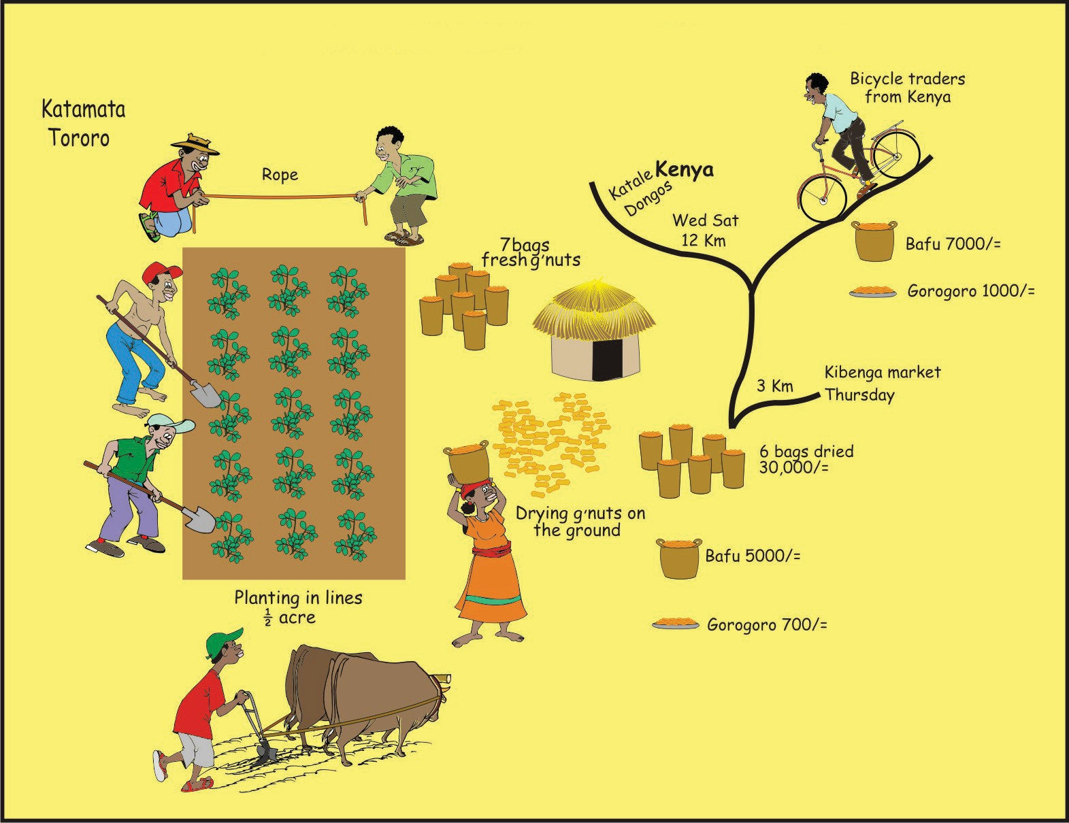**EXAMPLE OF A MARKET MAP DRAWN BY FARMERS FOR GROUNDNUT IN EMBU DISTRICT, KENYA**