EXERCISE 2A. CHOOSING WHICH PROBLEM TO ADDRESS
This exercise enables the group to determine the most important problem to address. It gives

the large sheet of paper, one above the other. Draw horizontal lines between the problems to

each person the same voice as everyone else. This is important to ensure that the richer or more powerful farmers do not dominate the decision making.
Source: FAO. Piloting farmer field schools

OBJECTIVE
After this exercise the participants will be able to:
- List and prioritize problems and choose which one to address.

EQUIPMENT NEEDED
- Large sheet of paper, marker pens (or blackboard and chalk).

EXPECTED OUTPUTS
- A prioritized list of problems, and agreement on which the farmers wish to address.

TIME REQUIRED
- 1 hour

PREPARATION
- None

SUGGESTED PROCEDURE
- Divide the participants into small groups of 3–4 people.
- Ask each group to identify two or three major problems they face in crop or livestock produc- tion, processing or marketing.
- In plenary, ask the groups to report the problems they have identified. Write all the problems on
separate them.
- Explain to the participants that they each have three votes. They should vote for the three problems that they think are the most important. They vote by drawing a vertical stroke ( | ) next to each of these three problems.
- Each of the participants goes individually to the chart to put three strokes next to their priority problems.
- When everyone has finished, add up all the strokes next to each problem. The problem with the highest score is the one the participants as a whole think is the most important.
- Review the results to ensure that there is a con- sensus. Then discuss whether the problems rep- resent the topics they would like to study further and learn about during the farmer field school.

NOTES
Men and women often have very different ideas on what the most important problems are. Consider dividing the group into men and women to do this exercise.
Similarly, cattle owners and crop growers are also likely to think that different problems are important. They may decide to form separate groups to find solutions to their own problems.
You can also do this exercise with illiterate farmers using symbols or drawings to represent the problems. Give each person 3 (or 10) stones or dried beans. Each person votes by putting a certain number of stones or beans against each problem: more for serious problems, less (or none) against less important problems. When everyone has voted, count up the number of stones or beans against each problem to find out which people think is the most important.

PROMOTING INNOVATION 15

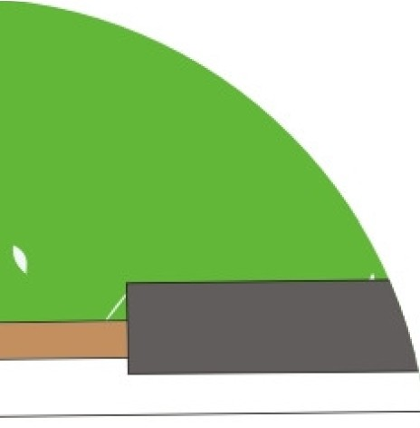

VOTES
11111
1111
111111111

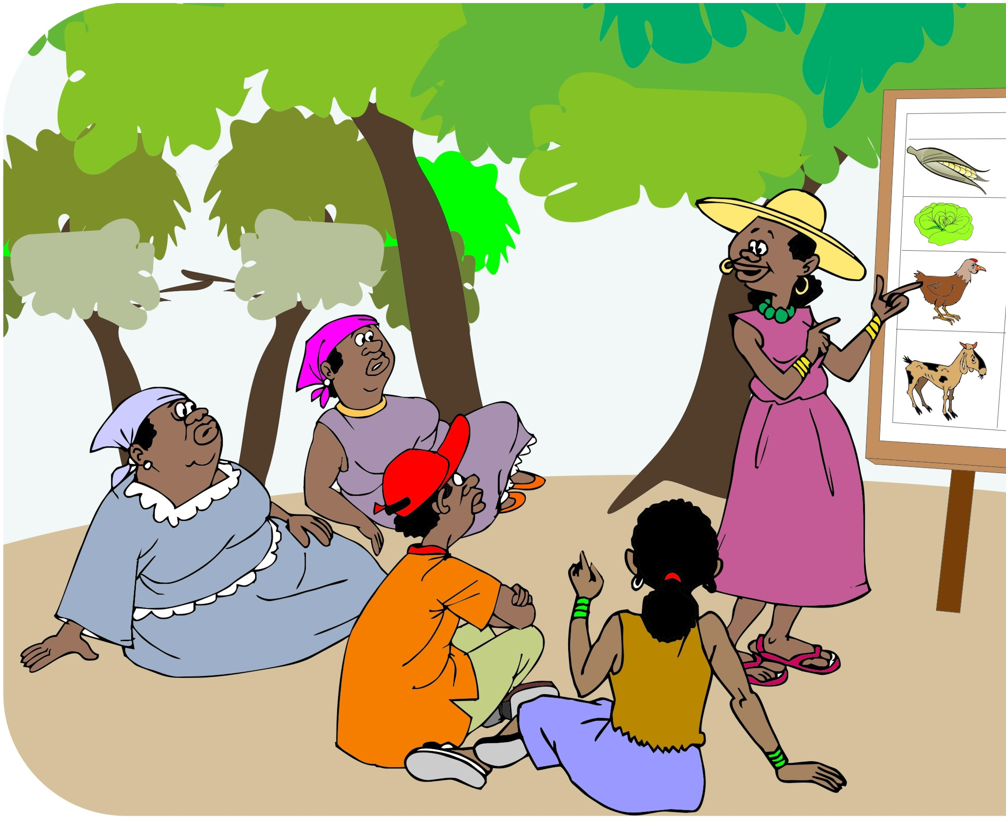111

