**EXERCISE 2. VISIONING “BASIC SESSIONS”**

|  |  |
| --- | --- |
| *OBJECTIVE*  **After this exercise the participants will be able to:**   * Describe the desired future for their community or farmers’ group. * Identify the steps they will need to take to reach this desired situation. | |
| *EQUIPMENT NEEDED*   * Large sheets of paper, marker pens | *EXPECTED OUTPUTS*   * A long-term goal and a series of concrete steps to achieve this goal. |
| *TIME*  1 hour | *PREPARATION*   * None |

*Teaching Tip: Visioning is a method that can be used at various levels in a project to help people imagine what their situation could be like in the future and the steps they need to take to achieve that future goal.*

*SUGGESTED PROCEDURE:*

1. Ask the community group to think about their current food security and income situation. Get them to draw a picture of their existing situation.
2. Ask the community members to imagine what they would like to change in their farm or village in the long term, in 10 years’ time. List these goals on a second sheet of paper under the same headings.
3. Ask the group members to think of the **long- term activities** they will need to do in order to reach this goal. For example, if they want to build a school, bring more land into cultivation? install irrigation? Get a loan from the bank? List these activities on another sheet of paper.
4. Ask the group members to repeat this exercise, but this time to think of activities in the medium term – say, three of five years from now. Get them to be more specific and realistic about their suggestions. Their suggestions should lead them towards the long-term goals they have just set out. Record their answers on another sheet of paper.
5. Now get them to repeat the exercise for short- term activities, to do in the next year or production cycle. This time they should be very specific and realistic about what activities they will undertake, who will do what and when, and what types of support they will need. Record their ideas on another sheet of paper.
6. Mark which activities they can do themselves with their existing resources, and which will require external support.
7. Summarize the results of the discussions and notes.

**Visioning**

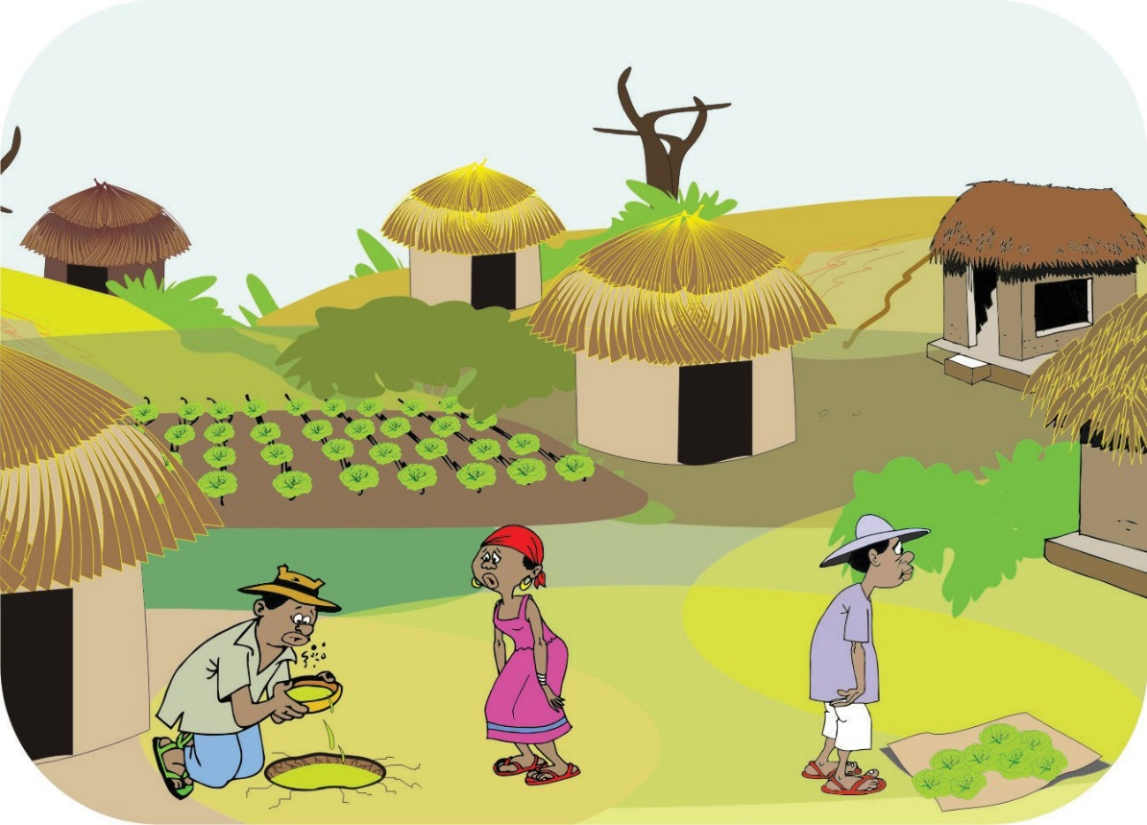**WHERE WE ARE NOW**

**WHERE WE WANT TO B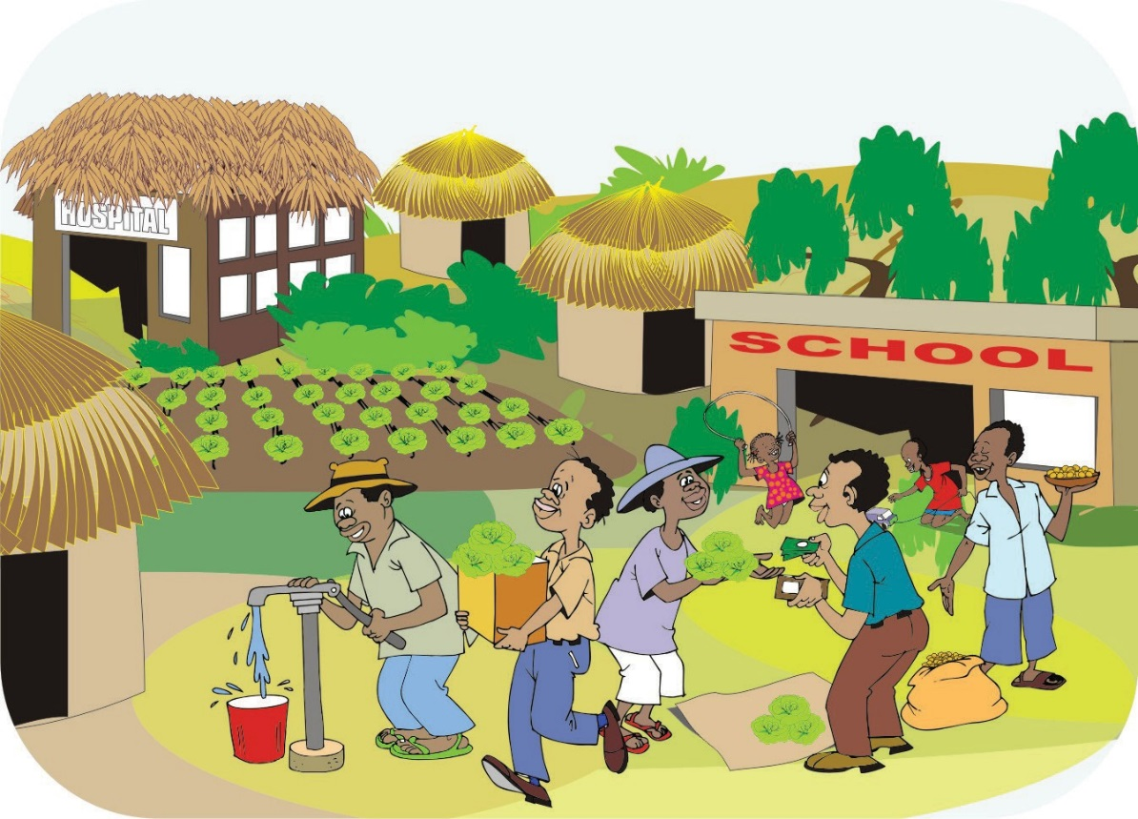E**