**EXERCISE 14. USING THE CANVAS TO BUILD A BUSINESS PLAN**

|  |  |
| --- | --- |
| *OBJECTIVE*  **After this exercise the participants will be able to:**   * Build a business plan using the business model canvas | |
| *EQUIPMENT NEEDED*   * Large sheets of paper, marker pens, sticky notes, scissors * Information on the value proposition (product), market, business services, costs, expected income, etc. If you have a computer and printer, bring a printout of this information if possible. | *EXPECTED OUTPUTS*   * Large parts of a business plan. |
| *TIME*   * 3 hours | *PREPARATION*   * Draw an empty canvas grid on a large sheet of paper, and label the nine areas. |

*The canvas is a helpful way to visualize and order information to help farmers build a business plan.*

*SUGGESTED PROCEDURE:*

1. **Explain the purpose** of the exercise – to build a business plan based on the information the farmers have already collected and the decisions they have made. Now work with the farmers to fill in sticky notes for each of the boxes.
2. **Value Proposition (Product)**: Ask the farmers to describe the product: the type, volume, quality and so on. Ask them to write these ideas on sticky notes. Put them in the Product area of the canvas (1).
3. **Customers**: Now ask them to describe the Customers: who are they, how many are there, etc.? Put this information on sticky notes in the Customers area (2).
4. **Channels**: Move to the Channels (3): make sticky notes on how the farmers deliver the product to the buyers.
5. **Customer** **relations**: Discuss how the farmers identify potential buyers and how they maintain contacts with them. Put this in the Customer relationships areas (4).
6. **Income**: Ask the farmers about the revenue they earn from sales. Get specific figures if possible on prices and volumes. Put this information in the income area (5).
7. **Key Resources**: Moving over to the left side of the canvas, ask the farmers to describe the Key resources (6) they use and the main activities (7). Put these sticky notes in the relevant areas of the canvas.
8. **Key Partners**: On the far left of the canvas, get them to list the main Business services and partners (8).
9. **Costs**: in the Costs area (9), ask them to list the various costs they incur in producing and marketing their product.
10. By the end of this process, you should have a canvas with many sticky notes.
11. Sort the information the farmers have gathered into the nine categories represented in the canvas. There are different ways to do this:
12. Check what additional information you need, and ask the farmers to generate it.
13. Write the body of the business plan based on the information you have ordered.

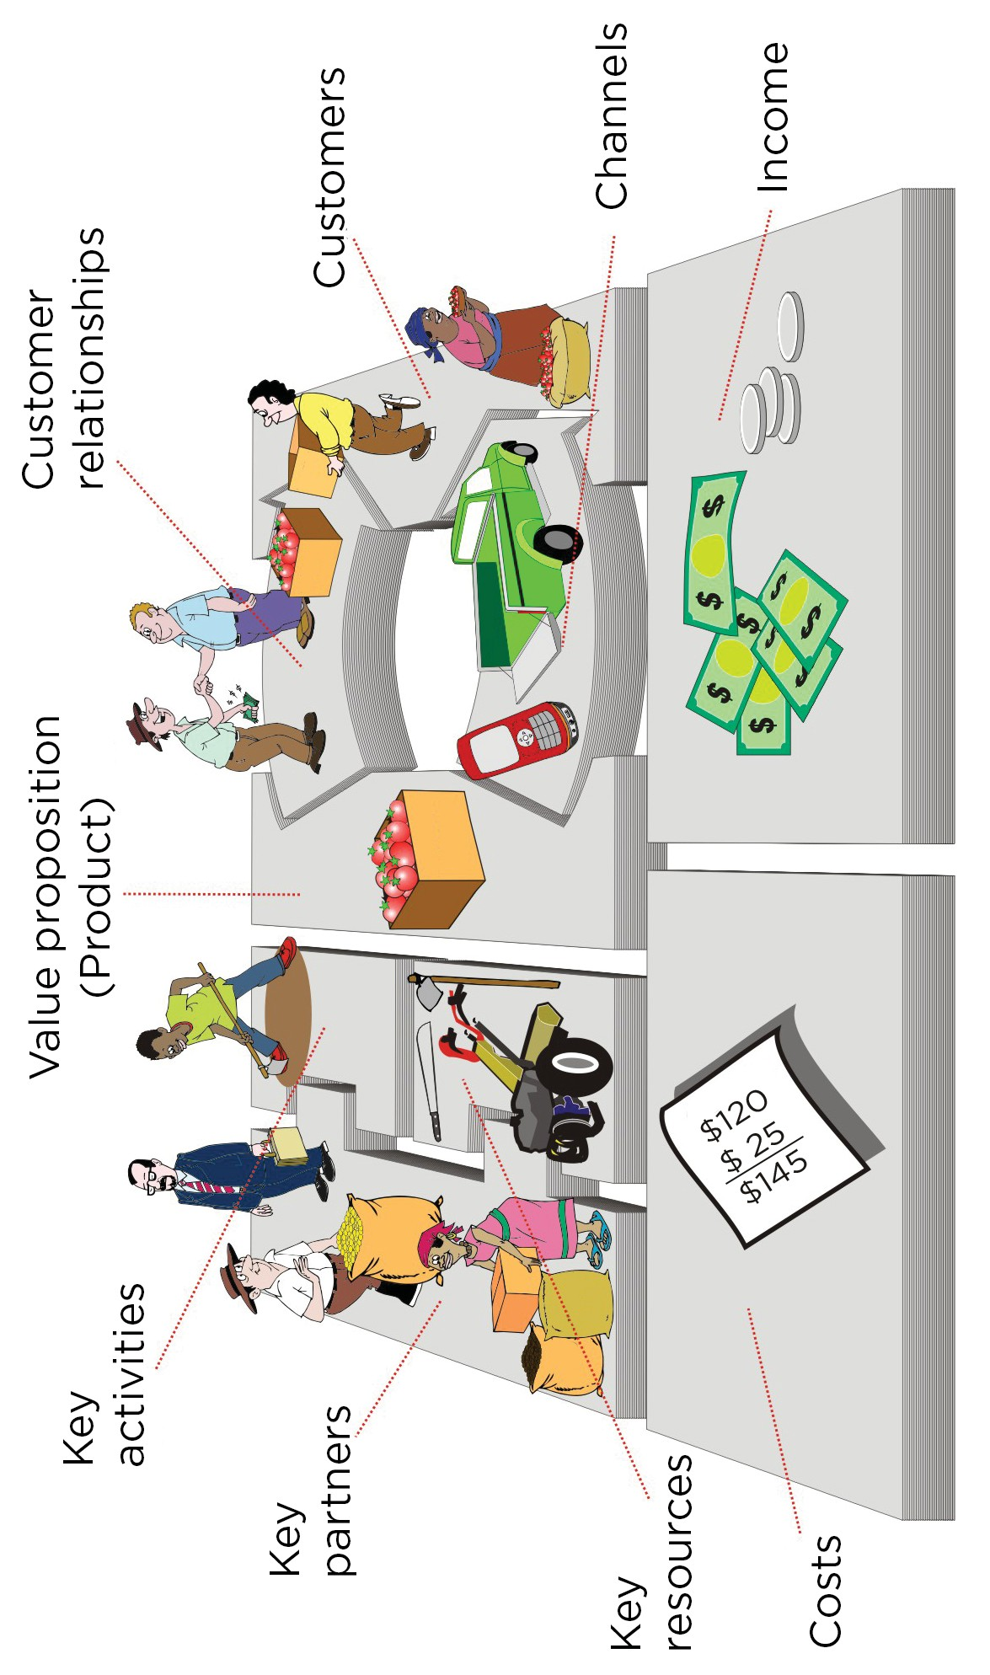

# Business model canvas template

# 

**Example of completed business model canvas for current situation**

