**EXERCISE 13B. MARKET MAPPING**

|  |  |
| --- | --- |
| *OBJECTIVE*  **After this exercise the participants will be able to:**   * Identify future market opportunities and marketing channels for their product(s) * List the changes needed in production and marketing for them to sell their product(s) to this market. | |
| *EQUIPMENT NEEDED*   * Large sheets of paper, colored marker pens * Information from previous exercises (see Preparation) | *EXPECTED OUTPUTS*   * Diagrams of actual and planned value chains and markets for the selected product |
| *TIME*   * 2 hours | *PREPARATION*   * Market map prepared in Exercise 7A * Information on product prices and markets from the market survey and analysis (Exercise 7B and Exercise 7C) * Production information (Exercise 8) * Cost information (Exercise 10) * Information for selection of agroenterprise (Exercise 12) |

*This exercise helps the farmers to visualize and map the future market for their product, and the changes in production and marketing they need to make in order to achieve this. The map on the desired future is a vision of what farmers would like to achieve. it becomes the basis for building a common plan on how to improve marketing opportunities.*

*SUGGESTED PROCEDURE:*

1. Ask the farmers to redraw the market map diagram (showing where they produce the product, store and sell it) considering their current knowledge.
2. Ask the farmers to add information on costs, volumes, and prices to the diagram.
3. Now ask the farmers to draw a new diagram showing what they want their production and marketing to look like in around 5 years’ time, after they have implemented all the changes they planned.
4. Ask them to start with the product volume, quality, and timing. Ask them to write the details on the diagram.
5. Then ask them to consider the production steps and inputs they need to supply this amount of product at the right times. Get them to systematically consider each step in production and harvesting, paying attention to detail. They should include decisions made so far, but also consider things they have not yet thought of or discussed. Make sure they write the costs and amounts of inputs on the diagram.
6. Then switch to the marketing side of the diagram. Get them to think of what they need to do after harvest and before sale, and how to find a buyer and manage the sale.

*QUESTIONS TO STIMULATE DISCUSSION*

**The product**. How much do the farmers need to produce to serve their chosen market? What quality must the product meet? When should the product be ready for sale – all at one time, or at regular intervals throughout the season? Where should it be collected or delivered?

**Production activities**. What does the group need to do to produce this amount and quality of the product, at these times? How much product can each farmer produce? What inputs (seed, feed, fertilizer, agrochemicals, labor) are needed? What activities does each farmer (and the group) need to undertake? How are they different from what the farmers do now?

**After harvest**. What do they need to do after the harvest and before sale? What types of processing and storage are needed? Do they have to grade, sort and package the product? What about transport and communications? Think about the market: only grade if the market pays a premium for the graded produce!

**Marketing**. What arrangements and agreements need to be made for marketing? Is a buyer already identified, or how will they find a buyer? Does the group need a fixed agreement or contract, and what should the prices and terms be?

**Costs and revenues**. How much do the inputs cost? How much do production activities such as plowing, weeding and harvesting cost? What is the expected price?

*NOTES*

The figure shows the initial marketing map drawn by farmers in Embu district, Kenya, for groundnut. They produced a limited amount of groundnuts, mainly for subsistence, using hand hoes as their main tools. They lacked appropriate drying or storage facilities, and linked with intermediaries from outside the village to sell their produce.

The second figure shows the map they drew to show the changes in the production and marketing they will make to increase their production. This diagram shows the farmers working together, with access to tractors to plow the land. Crops are planted in rows and sprayed to control pests and diseases. The houses have tin roofs, so are therefore more suitable for storage. The farmers produce a lot of groundnuts, and sell them in bags in large consignments. They hire a pickup truck to take their groundnuts to more distant markets and to add value to the crop.

**Market maps**

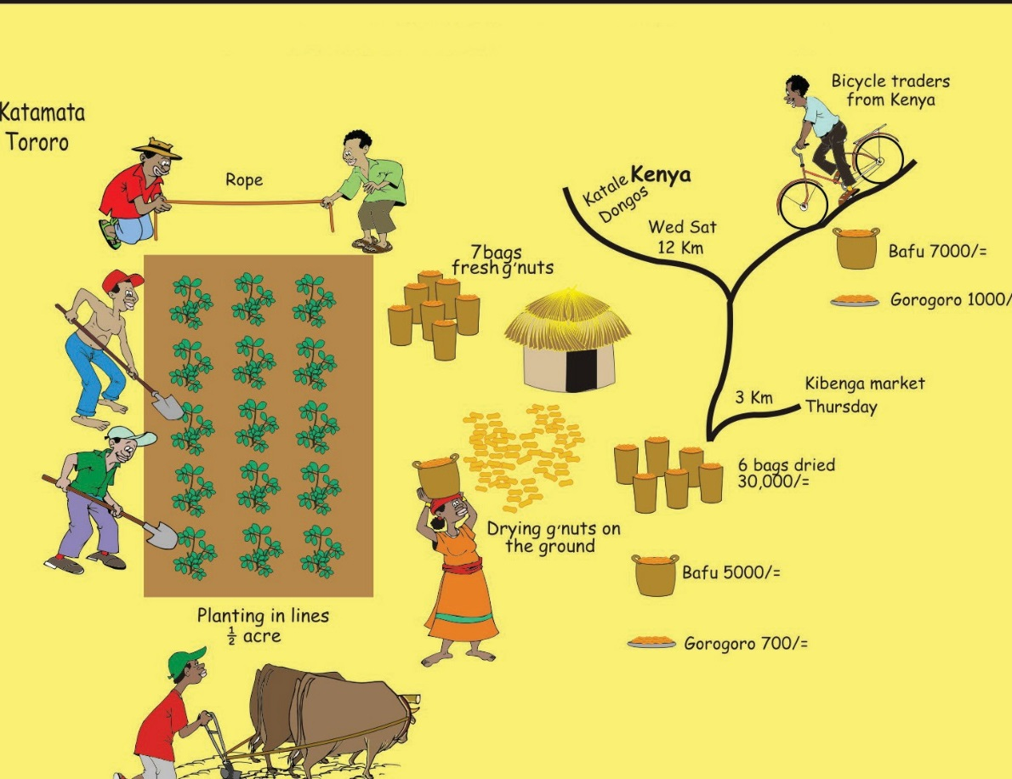**MARKET MAP FOR DESIRED MARKETING OF GROUNDNUT IN EMBU DISTRICT, KENYA**

**MARKET MAP DRAWN BY FARMERS FOR GROUNDNUT IN EMBU DISTRICT, KENYA**

