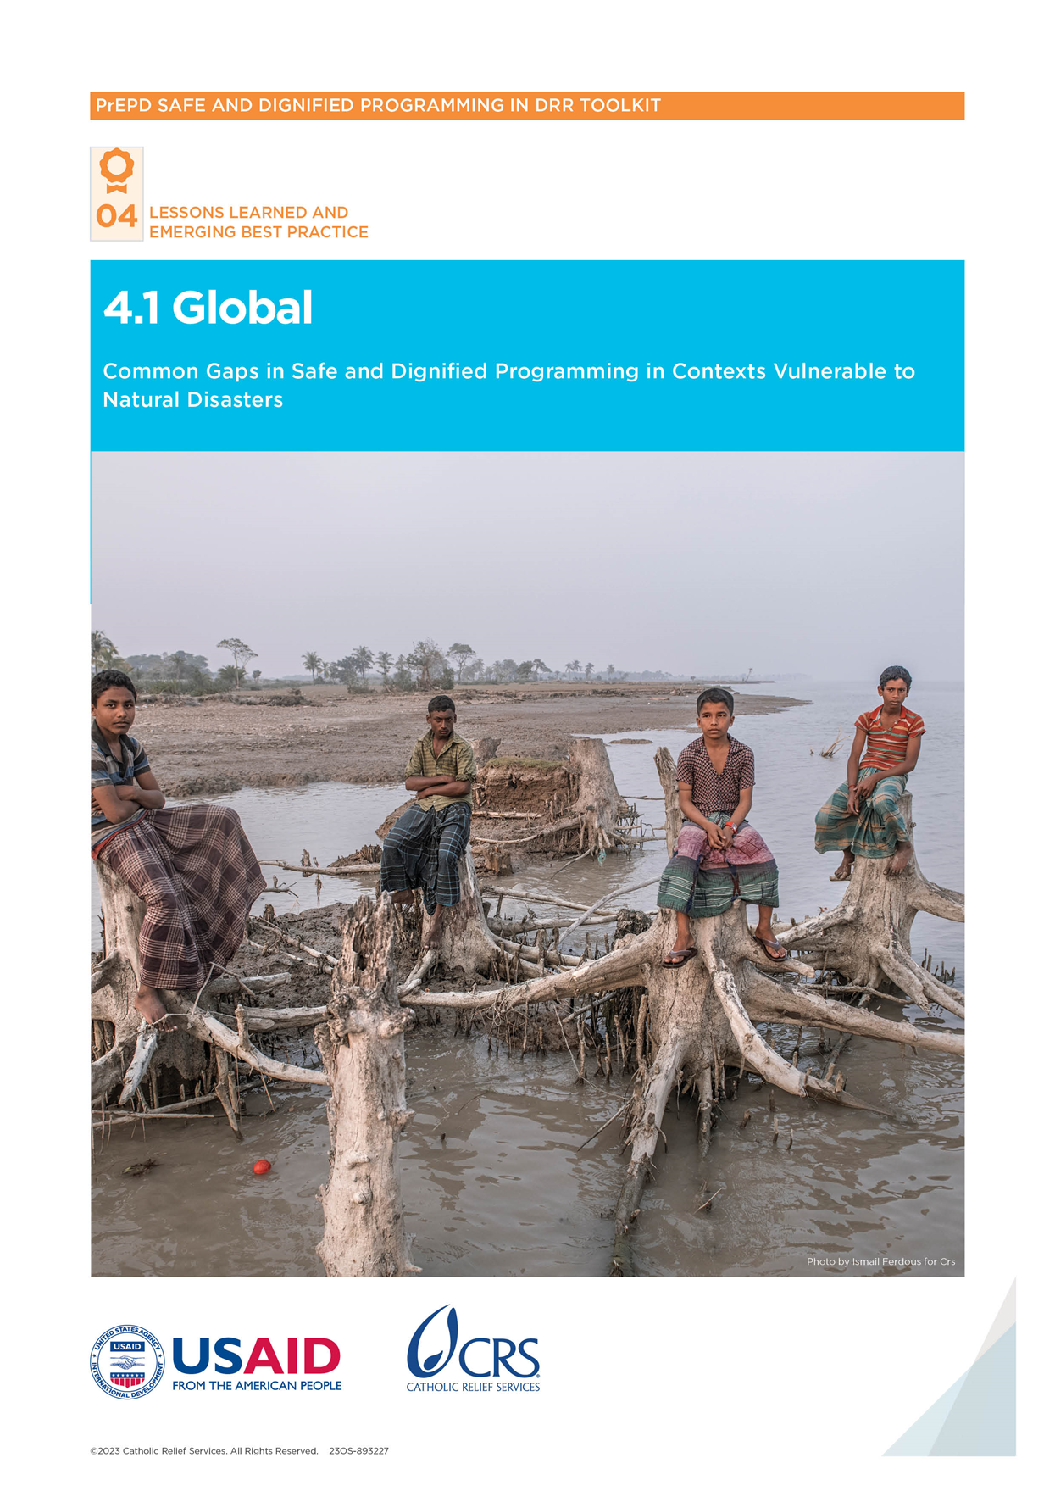

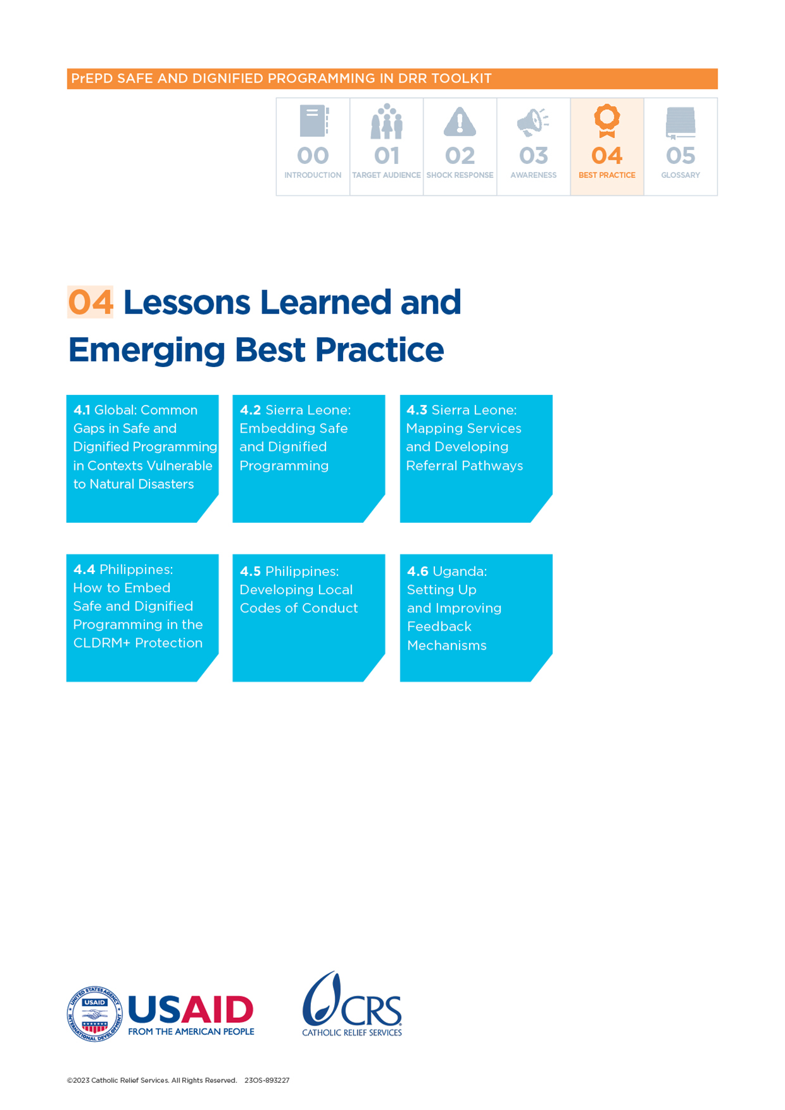

Global: Common Gaps and Needs for Safe and Dignified Programming in Contexts Vulnerable to Natural Disasters

Catholic Relief Services (CRS) conducted a detailed needs assessment before the United States Agency for International Development (USAID)/Bureau for Humanitarian Assistance (BHA)-funded *Preparing to Enhance Protection in Disasters (PrEPD)* project started. The assessment looked at safe and dignified programming in disaster preparedness and response activities in the pilot countries (the Philippines, Sierra Leone and Uganda) and at the global level. It highlighted common priorities, perspectives, needs and capacities that may be relevant in other contexts.

CRS conducted key informant interviews (KIIs). At the global level, respondents included representatives of the United Nations High Commissions for Refugees (UNHCR), Caritas Internationalis, the Core Humanitarian Standard (CHS) Alliance and United Nations Office for Disaster Risk Reduction (UNDRR). At the country level, there were KIIs with eight organizations in the Philippines, seven in Sierra Leone and four in Uganda. A secondary data review examined the gap in safe and dignified programming in disaster preparedness and response work at the global and national levels.

# What were the needs?

The assessment found that in the urban areas targeted in the **Philippines**, informal settlements with diverse religious and ethnic makeups were particularly vulnerable to disasters. Data after Typhoon Pablo in 2012 and Typhoon Yolanda in 2013 showed an increase in sexual and gender-based violence (SGBV). Older people and people with disabilities were also identified as particularly at-risk because of their limited mobility. In Manila, the needs assessment found that the urban poor face eviction and relocation issues. Women, children and youth faced sexual violence, harassment and abuse (including online sexual exploitation), while informal workers navigated unfair labor practices.

In **Sierra Leone**, the assessment found that rapid population growth in Freetown had forced vulnerable and low-income communities to settle in high-risk areas—such as low-lying coastal locations, river channels and deforested upper catchment areas.Flooding, fires and other disasters frequently displaced people and communities. This was disrupting already precarious livelihoods and decimating assets and resources.

In **Uganda**, the findings highlighted that vulnerable groups—including young children and older people—were particularly affected by floods and landslides due to their limited mobility during evacuation. This led to high psychological trauma.Multiple sources highlighted the increased risk of SGBV as communities and family structures were disrupted or displaced by disasters.

# Unaddressed safe and dignified programming needs during disasters

According to respondents in Sierra Leone and Uganda, **community engagement** was not meaningful or inclusive. Consultations with communities can be rushed, with insufficient attention to the needs of children, women, youth, older people, people with disabilities and people with chronic diseases. Communities do not know what they can expect from humanitarian actors and the lack of engagement and information does not create trust between humanitarian responders and affected communities.

**Mapping of protection services** and information on referrals were raised as gaps in all the countries involved in the project, and at the global level. The capacity of Disaster Risk Reduction (DRR) and humanitarian actors to safely orient people to specialized services was raised. A lack of service providers for key protection needs was also seen as a gap. Some global respondents noted that mapping exercises often happen at the national level and overlook community-based protection mechanisms that may meet some needs. This highlighted a barrier linked to the lack of coordination between DRR and protection actors at all levels.

**Feedback mechanisms** were also deemed unsatisfactory by respondents. Where mechanisms existed, they were often inadequate; it was felt that diverse community members were not consulted on their preferred ways to give feedback and make complaints. The mechanisms were not always designed to accept sensitive issues, particularly those related to abuse and exploitation, or to accommodate speakers of marginalized languages and non-literate informants. Managing and responding to feedback and complaints was not systematic and there was a lack of coordination between actors to refer feedback and share trends. Affected communities did not know if any action was taken because of their feedback, which contributed to a lack of trust between communities and humanitarian responders.

# Community knowledge of rights and entitlements

Community knowledge of rights and entitlements in humanitarian response varied across the pilot countries. In the **Philippines**, communities frequently exposed to humanitarian activities were more aware than those who were not. In **Uganda**, communities generally lacked information on rights and entitlements, resulting in the underutilization of services and discouraging participation. Global respondents emphasized the need for better information-sharing and community engagement. They felt humanitarian organizations make too many assumptions about what people know and do not share messages in accessible languages and formats.

The assessment found that affected communities did not know the most basic information or where to access trusted, accurate information. This issue was worse for marginalized and excluded groups, who in some contexts may be perceived as not having any rights. Communities’ understanding of rights and entitlements was seen by global respondents as essential to improving accountability of humanitarian actors and reducing safeguarding issues.

# Coordination gaps

Coordination across key stakeholders was a challenge in all target locations and at the global level. In the **Philippines**, local partners noted that networking was weak. In **Sierra Leone**, respondents said that coordination between the national and local levels was fragmented. There were no systematic coordination fora in **Uganda**, and gaps between national and subnational levels were highlighted as a feature of the context. This was understood to contribute to a top-down planning model with communities placed only on the receiving end, rather than participating in a meaningful way.

Global respondents painted a similar picture, noting that DRR, protection and humanitarian stakeholders work separately and do not share information or plan and prioritize as a collective. Competition between actors was also felt to prevent effective coordination, as organizations vie for funding. The UN system is difficult for local actors to navigate because of language issues, geographic proximity and power dynamics between international and local organizations. A lack of effective coordination skills was also an issue, as softer skills that build consensus and foster participation are not prioritized.

# Recommendations to support safe and dignified programming

Different stakeholders in the PrEPD project identified various ways of ensuring DRR actors embed safe and dignified programming across their policies, strategies and practice. These included:

|  | Observations | Recommendations to enable safe and dignified approaches |
| --- | --- | --- |
| **Lack of capacity** | Lack of capacity of local disaster management structures (including district and village level committees) on safe and dignified programming | * Capitalize on high levels of interest in learning. * Provide more opportunities for training and support on safe and dignified programming to a range of actors—including local disaster management committees. |
| **Protection risk analysis** | A lack of understanding of protection risks by local DRR actors—including misconceptions on what constitutes harm, abuse or exploitation | * Build capacity and provide tools for protection risk analysis. * Ensure focal points at the local/district level integrate protection analysis processes into the Disaster Risk Reduction and Management (DRRM) processes. * Share key findings of protection analysis with focal points throughout project implementation. |
| **Excluded groups** | The exclusion of vulnerable groups from emergency preparedness and response planning—including women, children, people with disabilities, etc. | * Provide safe and dignified programming training to local DRR actors. * Combine the use of specific tools—such as the Community-Led Disaster Risk Management (CLDRM+)—with activities to raise awareness on rights and entitlements in communities. * Include diverse groups in the community consultation activities and throughout the implementation of the preparedness and response plans—including through support for participation in local languages. |
| **Referral pathways** | Unwritten, incomplete or unknown referral pathways resulting in few people being referred for support | Support local authorities to consolidate the different pathways to services (where these exist) into a single one-stop-shop document.  Identify ways to continue capacity building activities, even after an emergency.  Map and contact protection actors at the community levels to understand what, if any, referral pathways exist. Ensure those leading the disaster risk reduction and management processes have information about these referral pathways. |
| **Design of feedback mechanisms** | Lack of community consultation when designing feedback mechanisms | Consider whether existing feedback mechanisms/channels are safe and inclusive.  Build the capacity of staff/actors to create community awareness of rights and entitlements.  Consult different groups on their preferences and ability to access different feedback channels. (consider literacy, language, access to the internet, phones and/or phone credit, etc.). |
| **Use of feedback mechanisms** | Lack of awareness of feedback mechanisms and referral pathways in the community meaning many cases of abuse are not being reported | Support local DRR actors to set up multiple feedback channels by giving financial and technical support, as well as ongoing training and accompaniment. Please refer to PART 2, Tool 2.1.  Include diverse groups in the community in the choice, design and update of feedback mechanisms. Please refer to PART 2, Tool 2.1.  Promote the best practice of setting up multiple channels and supporting feedback in local languages.  Where appropriate, consider how to promote inter-agency feedback mechanisms.  Develop and use communication materials on feedback channels with the community.  Develop simple referral pathways that staff can use to orient survivors to appropriate services. Please refer to PART 2, Tool 2.2. |
| **Security** | Lack of security and general rise in criminality—including thefts, fights and increased drug and alcohol abuse | Consult communities on protection gaps and accountability needs.  Consider including and prioritizing Psychological First Aid training for all responders—including those working on feedback mechanisms (such as help desks and hotlines). |
| **Coordination** | Lack of awareness of protection coordination mechanisms, and/or poor mobilization and coordination by DRR actors, leading to safe and dignified programming approaches being overlooked and the marginalization of community disaster committees from responses | Support local DRR actors to coordinate with local protection actors—including through the protection cluster where relevant—on services and best practices.  Support local authorities to address coordination gaps and make meetings efficient and productive.  Consider DRR coordination meetings at the community level.  Use the tools—such as the referral pathway—to explore and develop links with protection actors at multiple levels. Please refer to PART 2, Tool 2.3. |