TT 1.2: Protection Triangle

Adapted from: Caritas Australia, CRS, Trócaire, CAFOD. [*Protection Mainstreaming Training*](https://cafod.azurewebsites.net/ProtectionMainstreamingFramework.pdf). (2018: 15).

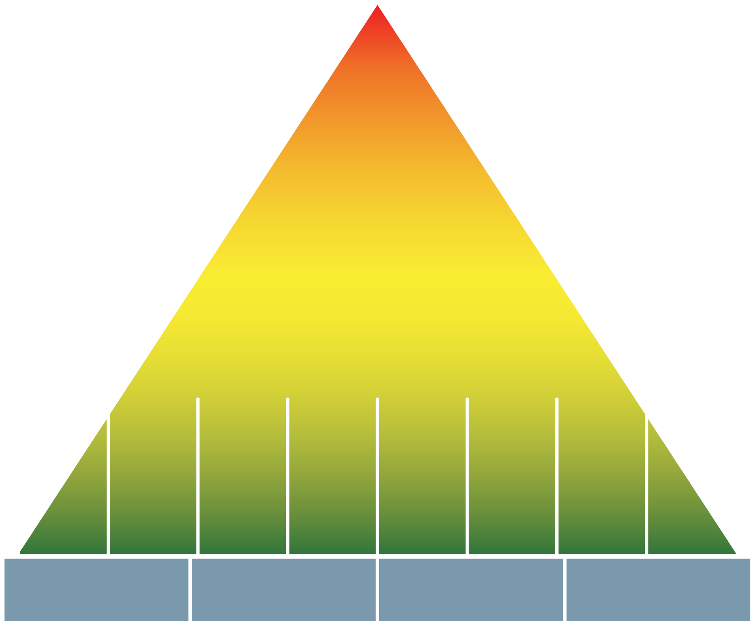

Core components of **Protection Mainstreaming**

Guiding   
Principles

**Targeting Priority Groups**

**Analysis**

**Mapping/   
Referral**

**Information  
Sharing**

**Community  
Engagement**

**Feedback  
Mechanisms**

**Staff   
Conduct**

**Coordination/  
Advocacy**

**Meaningful   
Access**

**Accountability to Beneficiaries**

**Participation and Empowerment**

**Do No Harm**(Safety and Dignity)

**Protection   
Integration**

**Stand**

**Alone**

# Cut out these slips

|  |
| --- |
| Latrines built with a ramp for wheelchairs |
| Education project with a feedback and complaints box |
| Distribution of food in 5kg bags so older people can carry them |
| Earlywarning systems that include different ways of sharing information |
| Counseling services for survivors of gender-based violence |
| Cash transfers for female heads of households to reduce their vulnerability to sexual exploitation |
| Advocacy with government authorities on forced evictions of displaced people |