Grain vendor
Rapid Seed System Security Assessment
Foreward
- A mix of smaller retail grain traders and larger grain wholesalers who serve the area should be selected to interview.
- If the survey is administered by phone, remember, respondent’s attention is shorter in phone surveys versus face-to-face interviews; therefore, a phone survey should last around 20 minutes, and no more than 30 minutes.
- If the survey takes place in the market, remember the vendor’s first priority is to sell seed, so be respectful of that and allow him/her to conduct their business.
- Questionnaires should be administered by enumerators fluent in the local language.
- Initially introduce oneself as an employee of _______ undertaking a survey to understand the seed and input supply situation in the zone. Tell the individual that the survey will last around 30 minutes. Ask if they would be willing to cooperate. Tell them that all responses are confidential and have no bearing on who may or may not receive project benefits in the future. Thank them for their participation.
- The survey is intended to be administered prior to planting for the upcoming season.

Basic Information
Date of interview: ____________________________________________________________________
Enumerator Information
Name: ________________________________________________________________________________
Gender (select one): □ Male □ Female
Organization: ________________________________________________________________________
Respondent Information
Name: _______________________________________________________________________________
Gender (select one): □ Male □ Female Age: □ Age < 29 □ >29
Name of Enterprise: ________________________________________________________________
Female-owned or Female-led Enterprise: □ Yes □ No
Position in Enterprise: □ Owner □ Manager □ Employee
□ Other (specify)_____________________
Period of upcoming season: From ____/____ To ____/_____
Location
Admin 1: _____________________________ Admin 2: ___________________________________
Name of village: _____________________________________________________________________

Questions

- Trader characteristics [wholesaler/ retailer]
□ Trader □ Wholesaler
a. To whom do you sell?
    - Farmers
    - Local traders
    - Regional traders
    - Collectors
    - Other [specify]

b. What is the percentage of your product that you sell to each group?

- Trader assets
a. Vehicle type
□ Truck □ Motorcycle □ Bicycle □ Cart □ Other (Specify)_______________
b. Warehouse [None/ room in house or shop/ larger warehouse]
□ None □ Room in house □ Larger Warehouse

Note: For questions 3-7 (except the why’s) please complete the below table

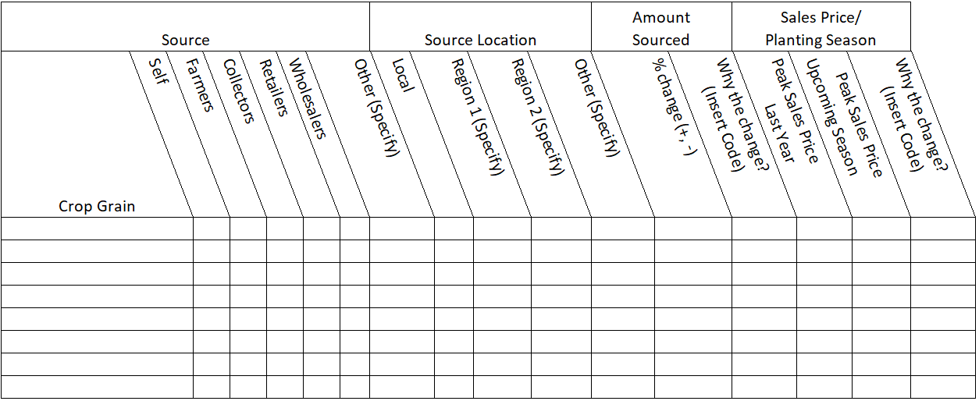

- What types of grain do you trade?

- Where do you source each type of grain?

a. From whom?
    - self-production,
    - directly from farmers, collectors,
    - other traders,
    - wholesalers,
    - other
b. From what geographic region (s) [by crop]?

- Will you be sourcing more/less/the same from these sources this upcoming planting season (use local name or period)?
□ More □ Less □ The same
a. If more or less, estimate the % change

b. Why the change (insert the number in the chart)?
          - Higher purchase price
          - Lower purchase price
          - Greater accessibility
          - Less accessibility
          - Other (Specify)

          - Greater production
          - Lower production
          - Higher demand
          - Lower demand
          - Higher sales price
          - Lower sales price

- What were your peak sales prices for grain last year during the planting season? [Put options in increments of 10%]

- What do you anticipate will be peak sales prices for grain this upcoming planting season?

a. If there is a change in price, why the change (insert the number in the chart)?
          - Greater production
          - Lower production
          - Higher demand
          - Lower demand
          - Higher sales price
          - Lower sales price

          - Higher purchase price
          - Lower purchase price
          - Greater accessibility
          - Less accessibility
          - Other (Specify)

- Do you distinguish between grain for use as seed and other grain? (if No, go directly to question 10)
□ Yes □ No
a. How [multiple options]?
          - Clean grain
          - Keep varieties pure
          - Select grain
          - Store separately
          - Different sources
          - Do germination tests
          - Other
b. Do you sell grain for use as seed at a higher price?
□ Yes □ No
i. If so, what is the premium (%)

Note: For question 9 (except the why) please complete the below table

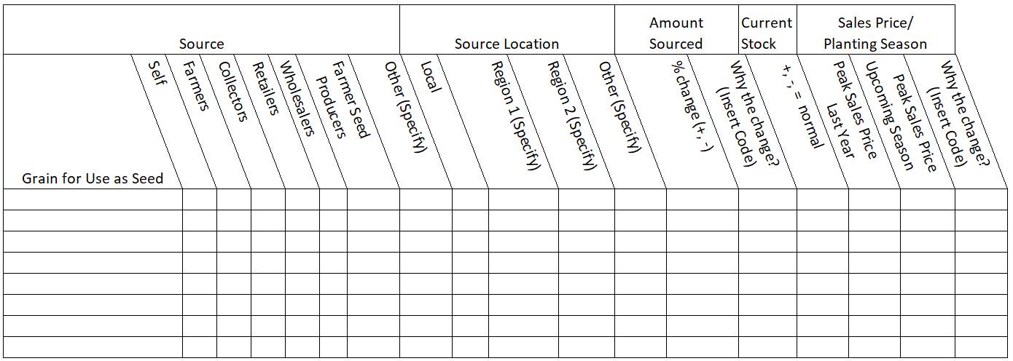

- Is grain moving freely to markets?
□ Yes □ No
a. If not, why?
    - Government movement restrictions
    - Fuel shortages, damaged transportation infrastructure
    - Other

- What are the major constraints to obtaining grain? Please explain.

- What grain used for seed do you sell?

a. What is your source of seed quality grain?
    - Self-production
    - Directly from farmers,
    - Collectors, other traders,
    - Wholesalers,
    - Other (Specify)_________________
b. Do you currently have grain used for seed in stock (by crop, as applicable)?

c. Is the quantity above or below ‘normal’ stock levels? Why or why not?

- Do you normally use credit?
□ Yes □ No
a. What is your normal source?

b. Has that been affected by recent events? If so, how?
□ Yes □ No

- Do you normally offer credit to your customers?
□ Yes □ No
a. If so, are you continuing to supply credit and to whom?
□ Yes □ No

b. If you are not supplying credit to those you normally do, why are you not supplying them credit?

