Agrodealer/Seed Supplier interview
Rapid Seed System Security Assessment
Foreward
- Sample agrodealers or input suppliers (e.g., cooperatives) who supply seed to farmers in the area.
- In situations where in-person contact is not advisable, surveys should be administered by phone. Respondent’s attention is shorter in phone surveys versus face-to-face interviews; therefore, a phone survey should last around 20 minutes, and no more than 30 minutes.
- Questionnaires should be administered by enumerators fluent in the local language.
- Agrodealers are often very occupied during business hours. Check to make sure what time would be most appropriate for the interview.
- Initially introduce oneself as an employee of _______ undertaking a survey to understand the seed and input supply situation in the zone. Tell the respondent that the survey will last around 30 minutes. Ask if they would be willing to cooperate. Tell them that all responses are confidential and have no bearing on who may or may not receive project benefits in the future. Thank them for their participation.
- The survey is intended to be administered prior to planting for the upcoming season.
Basic Information
Date of interview: ________________________________________________________________________
Survey number code: _____________________________________________________________________
Period of upcoming season: From ____/_____ To ____/____
Enumerator Information
Name: ____________________________________________________________________________________
Gender (select one): □ Male □ Female
Organization: _____________________________________________________________________________
Respondent Information
Name: ____________________________________________________________________________________
Name of enterprise: ______________________________________________________________________
Position in enterprise: □ Owner □ Manager □ Employee □ Other (Specify) ______________
Gender (select one): □ Male □ Female Age: □ Age < 29 □ >29
Person with disabilities: □ Yes □ No
Location
Admin 1: ________________________________ Admin 2: ______________________________________
Name of village: ___________________________________________________________________________

Questions

- Characteristics of agrodealer:
  - To whom do you sell?
    - Local Farmers
    - Regional Farmers
    - Other agrodealers
    - Other [specify]
  - Independent operator or part of a larger business?

Note: For questions 2-8 (except the “why’ follow up questions) please use the below table to document responses.

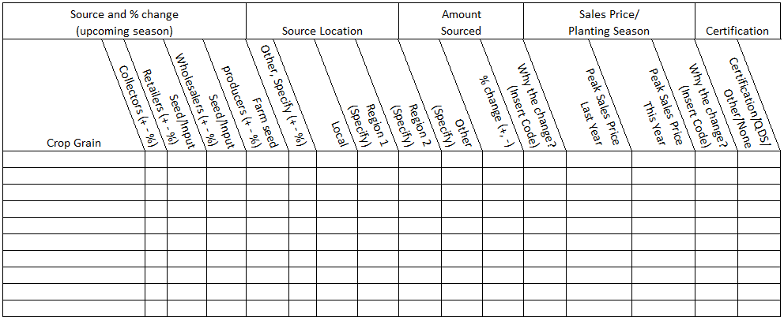

- What crop seed/varieties do you carry? [For major crops, including vegetables and tubers already identified by the survey team or alternatively ask for the top 5 staple crops and top 5 cash crops for example]

- Where do you source your crop seed? Please specify type of vendor and region

- Will you be sourcing more/less/the same from these sources this season?
□ More □ Less □ The same
  - If more or less, estimate the % change.

  - Why the change?
          - Change in supply
          - Change in demand
          - Change in purchase price
          - Change in my purchasing power
          - Change in accessibility
          - Other (specify)

- What were your peak sales prices last year and what are they this year?

  - Why the change (if any)?
          - Change in supply
          - Change in demand
          - Change in transportation costs
          - Change in storage cost
          - Change in labor costs
          - Other (specify)

- What kind of certification do the seeds carry?
□ Standard certified □ QDS □ Other □ None

- What seed varieties do farmers prefer? Are there any differences in preferences of men, women, male youth, female youth, PWD? If yes, please specify.
□ Yes □No
men’s preferences:
women’s preferences:
male youth’s preferences:
female youth’s preferences:
PWD’s preferences:

- What percentage of your clients are:
% male clients:
% female clients:
% male youth:
% female youth
% PWD:

  - Have your clients changed since the crisis began?
□ Yes □No
  - If yes, why?

Other inputs

- Do you sell fertilizer? If yes, please fill in the table below.
10. Type of fertilizer sold | 11. Where do you source the fertilizer (by type)? | 12. Will you be sourcing more/less/the same from these sources this season? | 13. if more or less estimate the % | 13a. Why the change?  - Change in supply  - Change in demand  - Change in purchase price  - Change in my purchasing power  - Change in accessibility | 14. What were fertilizer prices at the same time last year? | 14a. What are current fertilizer prices | 14b. Why have prices changed?

- Do you sell pesticides (including insecticides and herbicides)? If yes please fill in the table below.
- Where do you source the pesticides? | - Will you be sourcing more/less/the same from these sources this season? | 18a. If more or less estimate the % | 18b. Why the change?  - Change in supply  - Change in demand  - Change in purchase price  - Change in purchasing power  - Change in accessibility | - Have prices of pesticides increased, decreased or remained unchanged since the same time last year? | 20a. If prices have changed, estimate the % change. | 20b. Why have prices changed?

- What are the major constraints to the input supply chains for seed, fertilizer, and pesticides?
    - Government movement restrictions
    - Fuel shortages
    - Damaged transportation infrastructure
    - Risk to travel
    - Supply shortages at regional or national level
    - Other
  - What can be done to address those constraints?

- Are there any current challenges around stocking inputs (e.g., storage, offloading, maintaining inventory, etc.)? If so, please specify.
□ Yes □No

- Do you normally receive credit from your suppliers or banks? If so, please specify.
□ Yes □No

  - What is your normal source of credit?
    - Bank
    - Supplier
    - Individual
    - Trade association
    - Government
    - NGO
    - Other
  - Has that been affected by the crisis? If so, how?
□ Yes □No

- Do you normally allow customers to purchase on credit?
□ Yes □No

[If there is a crisis currently (Covid, conflict, drought, flooding, etc.) ask the following questions]:

- Specify the crisis.

- Has your offering credit to customers (lf #17 above is yes) been affected by the crisis? If so, how? Probe for any differences in providing credit to men, women, male youth, female youth, PWD.
□ Yes □No

- In light of the crisis, how has your business changed and how have you managed to adapt to these changes?

- In light of the crisis, have you received any support/advice from your suppliers and/or credit sources, from agro-dealer or seed trade association, from local authorities or govt projects or NGOs?
□ Yes □No
  - If so, what kind of support?
    - Grants
    - Line of credit
    - In kind support
    - Transportation
    - Other

Thanks for your time.

