**EXERCISE 3. STAKEHOLDER ANALYSIS**

|  |  |
| --- | --- |
| *OBJECTIVE*  **After this exercise the participants will be able to:**   * + - * Identify the different stakeholders who need to be involved in planning and managing the natural resources.       * Identify potential conflicts or problems early on. | |
| *EQUIPMENT NEEDED*   * Flip chart, marker pens | *EXPECTED OUTPUTS*   * A list of stakeholders who need to be involved in managing the natural resources, along with their interests and the type of involvement needed. |
| *TIME*  1 hour | *PREPARATION*   * Find out about national and local regulations on water and watershed management in the area. * Prepare a draft list of stakeholders to stimulate the discussion if necessary. |

*A stakeholder analysis identifies who has* ***interest*** *in natural resources in the area, who has* ***influence*** *over the resources zone, and when and how each stakeholder should be involved in the work. This helps ensure that the right people are consulted and take part in decision-making and implementation of the project.*

*If you have already done Exercise 2a, you can use this exercise to focus on stakeholders outside the community.*

*SUGGESTED PROCEDURE:*

1. Ask the participants to identify the stakeholders in the community who **manage** or **use** key natural resources. Encourage them to think of different groups: small and large farmers, livestock owners, landless people, the very poor and so on. Ask the participants to list the key characteristics of each group, and how they use land and other resources, such as wood and water. On a flip chart, make a table like Table 6 and list this information in the first three columns.
2. Invite the participants to think of people or organizations that **influence** the resources in some other way, for example, absentee landowners, farmers upstream whose land-use practices result in erosion, and government organizations that must give approval for major changes. Add rows to the table for this information.
3. Ask the participants to think of other people who are **affected** by these key natural resources. Examples include people downslope who rely on water from wells fed by rain falling in the area, and villagers downstream whose land may be flooded after heavy rain. Ask the participants to think of their characteristics and how they inter- act, use, depend and influence the resources in question. List these groups in the table.
4. In the fourth column, list how each stakeholder may **influence** the resources and management improvements. For example, a local authority has influence because it can determine how the natural resources may be used. A large landowner may have influence because a planned irrigation canal has to cross her land. Influence can be both positive and negative.
5. In the fifth column, note how they may be **affected** by how the resource is used.
6. In the last column, note when and how each stakeholder should be **involved**. Immediately, in regular meetings with farmer groups? During budgeting? Implementation? Monitoring? The type of involvement may be one of the following:

* **Informed.** The stakeholder is kept abreast of activities through occasional visits, phone calls, copies of reports etc.
* **Consulted.** The stakeholder is more actively solicited for input (e.g., information, knowledge and decisions) but is not directly involved.
* **Actively involved.** The stakeholder has a strong voice in decision-making and works in partner- ship with the farmer groups.
* **In charge.** The stakeholder is responsible for managing part of the process and/or performance of the farmer groups.

*QUESTIONS TO STIMULATE DISCUSSION*

* Who owns the land? Who manages it? Who grows crops on the land? Who grazes their livestock or collects wood there?
* Where does the water come from? Where does it go once it leaves the land?
* What is the land tenure system in this area? How does land change hands? Where do the landowners or caretakers live? Do men and women man- age different areas of land?
* Is the land and water shared by more than one village? Is there any conflict over ownership or sharing? Do the affected households have access to alternate lands for agriculture, or for grazing?
* 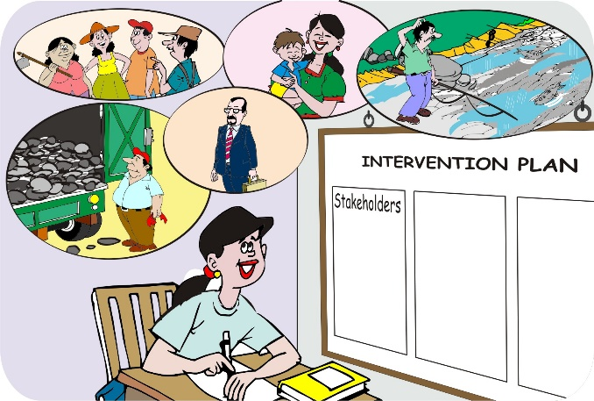What local or national regulations affect the use of the land, water and trees in this area? Which organizations are involved? What are relevant laws and by-laws, or policies? (For example, are there bylaws against cutting trees? Does the government provide subsidies?) Are the local regulations being enforced or ignored? How, and by whom?
* What other organizations or projects are active in the area?
* Are farmers organized in any type of local group? What types of groups (watershed committee, savings and internal lending group, farmers’ cooperatives etc.)? What are their main strengths and weaknesses?

**Analyzing stakeholders**

TABLE 6 EXAMPLE OF ANALYZING STAKEHOLDERS

|  |  |  |  |  |  |
| --- | --- | --- | --- | --- | --- |
| **STAKEHOLDERS** | **CHARACTERISTICS** | **HOW THEY USE THE RESOURCES** | **INFLUENCE OVER THE RESOURCES** | **HOW THEY ARE AFFECTED** | **WHEN AND HOW TO INVOLVE STAKEHOLDERS** |
| **Smallholder farmers** | Farm 1–2 ha each Organized in production groups | Grow crops Collect firewood  Use irrigation water | Control erosion on own land | Erosion, flooding, lower soil fertility | Actively involve throughout the year |
| **Herders** | Keep 5 cattle and 10 goats From outside village | Herd animals on open land  Use water for animals | Agree to restrict grazing | Lack of grazing | Actively involve in dry season |
| **Ministry of Water** | Office in town | Water for downstream users | Approve plans to protect springs |  | Consult periodically, obtain approval as required |
| **…** | … | … | … | … | … |

