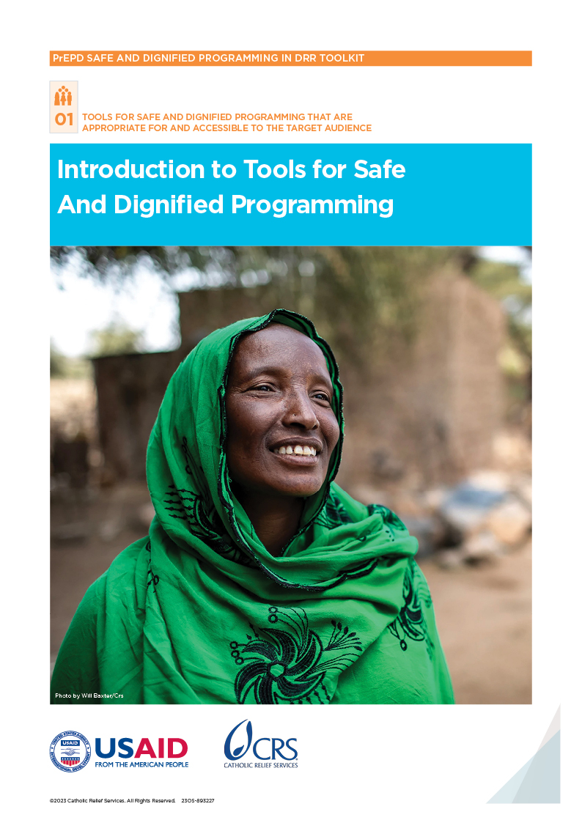

Introduction

Acknowledgments
The Preparing to Enhance Protection in Disasters a (PrEPD) Toolkit was collaboratively developed by Rebecca Hiemstra, Aude Archambault, and Alberta Santini. This document has undergone multiple rounds of reviews and has benefitted from the invaluable input of CRS staff across various technical departments. The tools were extensively field-tested by PrEDP country teams in Uganda, the Philippines and Sierra Leone.
Special appreciation is extended to Katy Cantrell and all Catholic Relief Services (CRS) staff who actively contributed their insights during the review and testing phases. Additional gratitude goes to Matthew Sarsycki and Gitonga Karimi for incorporating their specialized disaster risk reduction (DRR) technical revisions, which significantly enhanced the Toolkit’s relevance for protection and DRR first responders, as well as government actors. Their contributions have elevated the overall quality of the Toolkit. Catherine Cowley played an indispensable role in editing and supporting the design of this Toolkit, ensuring clarity and coherence in its content.
The Peer Reference Group (PRG) deserves commendation for their collaborative efforts during the initial phase of the Toolkit’s development, ensuring rigorous quality control throughout the entire process. Every member organization and network actively participated in the revision process, underscoring their unwavering commitment to enhancing protective and accountable responses for the most vulnerable in natural hazard contexts. The PRG comprises distinguished protection and humanitarian organizations, including the United Nations High Commissioner for Refugees (UNHCR), Trocaire, Caritas Internationalis/Protection Mainstreaming Working Group (PMWG), Asian Disaster Preparedness Center (ADPC), Communicating with Disaster-Affected Communities Network (CDAC), the European Commission Humanitarian Aid (ECHO) and CLEAR Global. Their collective endeavors have played a pivotal role in shaping and refining the PrEPD Toolkit.
We express our sincere gratitude to every contributor and collaborator involved in the design phase for their dedication, expertise and unwavering commitment to enhancing the tools and resources available to those engaged in protection and disaster response. These collective efforts have played a pivotal role not only in shaping this Toolkit, but also in making substantial contributions to the advancement of CRS’s shared mission. This mission revolves around ensuring dignified and safe DRR responses in natural hazard settings for the most vulnerable individuals in need. These invaluable contributions have made a lasting impact, reinforcing our commitment to safeguarding the well-being of communities in times of crisis.

Acronyms
ADPC | Asian Disaster Preparedness Center
BHA | Bureau for Humanitarian Assistance
CDAC | Communicating with Disaster-Affected Communities
CBO | Community-Based Organization
CLDRM+ | Community-Led Disaster Risk Management + Protection
CDMC | Community Disaster Management Committee
CoC | Code of Conduct
CRS | Catholic Relief Services
DRR | Disaster Risk Reduction
DRRM | Disaster Risk Reduction and Management
FGD | Focus Group Discussion
GAM | Gender-Age Marker
GBV | Gender-Based Violence
GPC | Global Protection Cluster
HR | Human Resources
IASC | Inter-Agency Standard Committee
ICT | Information and Communication Technology
IEC | Information, Education and Communication
INGO | International Non-Governmental Organization
IT | Information Technology
IVR | Interactive Voice Response
KII | Key Informant Interview
LGU | Local Government Unit
NDRRM | National Disaster Risk Reduction and Management
NGO | Non-Governmental Organization
OCD | Office of Civil Defense
OSM | Open Street Map
PFA | Psychological First Aid
PrEPD | Preparing to Enhance Protection in Disasters
PRG | Peer Reference Group
PSEA | Protection Against Sexual Exploitation and Abuse
PWD | People with Disabilities
SEA | Sexual Exploitation and Abuse
SGBV | Sexual and Gender-Based Violence
SHAKE | Supporting Households and LGUs Awareness and Knowledge for Earthquake Preparedness
SIMEX | Simulation Exercise
SMS | Short Message Service
SOP | Standard Operating Procedures
STD | Sexually Transmitted Disease
ToR | Terms of Reference
UN | United Nations
UNDRR | United Nations Office for Disaster Risk Reduction
UNHCR | United Nations High Commissioner for Refugees
UDHR | Universal Declaration of Human Rights
USA | United States of America
USAID | United States Agency for International Development

Roadmap
This toolkit includes the following sections:
Introduction: An overview of the toolkit including how to use it, the guiding principles underpinning the work and a list of the available tools.
Part 1: Tools to support Safe and Dignified Programming in disaster risk reduction and management (DRRM). The tools are designed for DRR and humanitarian actors. They include training materials to increase knowledge and understanding of Safe and Dignified Programming as well as tools to guide DRRM plans at the community level.
Part 2: Tools designed for local DRR and humanitarian actors to support shock-responsive local systems. They include guidance on how to set up or adapt feedback mechanisms, referral pathways and Codes of Conduct (CoCs). Part 2 also includes a simulation exercise to test feedback mechanisms.
Part 3: Tools and training materials to raise awareness on rights and entitlements with diverse community members—including materials to support community Safeguarding Agents. The tools are designed for use in communities by local DRR and humanitarian actors.
Part 4: Case studies from the project—including lessons learned on embedding Safe and Dignified Programming approaches in preparedness and response work.
Part 5: Glossary of key terms used in the toolkit.

Introduction to the toolkit
The most recent Annual Report by the Global Protection Cluster (GPC) reported that more than 150 million people were in need of protection assistance due to conflict, violence, epidemics and climate-related disasters. This is 40 million more vulnerable people than were recorded in 2021 and represents, to date, the highest increase in one year.
In November 2019, recognizing that protection concerns were not sufficiently included in preparedness work, DRR actors called upon the GPC to ensure that protection be considered in disaster preparedness and risk reduction. As protection needs continue to increase, many communities across the world remain unprepared to manage the specific protection risks and impacts associated with natural disasters.
Community-based DRR initiatives often include the core principles of participation, inclusion, accountability and leadership. However, the needs and priorities of vulnerable groups are often misunderstood and poorly addressed, which means that DRR and humanitarian organizations do not always design and implement responses that ensure access, dignity and safety for the most marginalized people. Because of this, vulnerable people may be disproportionately affected by disaster and by the resulting response.³ Protection risks present in their communities may threaten their safety or they may face barriers to accessing assistance. Further, they may be unable to safely provide feedback or register complaints when the response is ineffective or inappropriate.
Embedding Safe and Dignified Programming into disaster preparedness and response is key to ensuring that DRR and humanitarian actors can provide appropriate, accessible, safe and sustainable support to people and communities. Also key is linking this work with the localization agenda and focusing on building and supporting national and local capacities whenever possible.

What is Safe and Dignified Programming?
Safe and Dignified Programming ensures that programs respect the safety, meaningful access and dignity of people and communities.
Within this project, the team adapted CRS’ Safe and Dignified Programming Framework and focused on six areas: analysis, community engagement and participation, feedback and complaint mechanisms, information sharing, mapping/referral and staff conduct.

Background to the project
To address these needs, CRS launched its USAID/BHA-funded PrEPD project in 2021. The 18-month project aimed to deliver a comprehensive toolkit to support local DRR and humanitarian actors to embed Safe and Dignified Programming into their work. To ensure the guidance was grounded in the needs and priorities of local stakeholders, the toolkit was developed and tested in three countries: the Philippines, Sierra Leone and Uganda.
These countries were selected based on their high risk of frequent, rapid-onset disasters—including storms, floods, earthquakes and landslides. All have existing DRR systems and actors but needed to build capacities to fully embed Safe and Dignified Programming.
An in-depth needs assessment was carried out before the project began in order to identify gaps in Safe and Dignified Programming. The assessment found that in all three countries, Safe and Dignified Programming approaches were not consistently used ahead of or during disasters and were often missing from national and local DRR contingency plans. There were also gaps in the knowledge of local humanitarian and DRR actors about Safe and Dignified Programming. Consequently, the needs and priorities of vulnerable groups were often misunderstood and poorly addressed. Community awareness about rights and entitlements was also low. Community-level shock responsive mechanisms—including feedback mechanisms and referral pathways—existed in the countries but were not widely used. The detailed findings of the needs assessment can be found in the case studies section of this toolkit (PART 4).
The results of the detailed assessment helped to frame the project around a few core areas, which evolved over the course of the project to encompass:
- Development of tools for Safe and Dignified Programming with local DRR actors that are appropriate for and accessible to the target audience
- Development of tools to support shock-responsive local systems—including feedback mechanisms and referral pathways
- Development of tools to raise awareness on rights and entitlements with diverse community members
- Case studies to capture learning around successful Safe and Dignified Programming approaches

Who is this toolkit for?
This toolkit is for local DRR and humanitarian actors to help them embed Safe and Dignified Programming approaches into their work.

How to use the toolkit
The toolkit is designed to be flexible. The tools do not have to be used in a particular order. The choice and use of tools will depend on the context, the type and length of the project and who is using the toolkit. It is important to choose the tools that are most relevant and useful in the context, and to further adapt them to include suitable examples for the specific context. They should also be translated into local language(s) wherever possible to maximize the engagement of marginalized groups.

Guiding principles
All the tools in the toolkit are based on three guiding principles:

Principle 1: Include diverse groups in the community
Diverse groups should be involved with and take the lead on any preparedness or response activities. This means involving different groups from the community who are more vulnerable and traditionally marginalized. This may include women, children, older people, people with disabilities, speakers of marginalized languages, particular ethnic groups, indigenous people, informal settlers or people who are displaced. These groups are often left out of disaster preparedness work, and their needs and preferences are often overlooked or ignored leaving them dangerously vulnerable in a disaster. It is important to include them to make sure everyone in a community is fully prepared for a disaster.

Principle 2: Leadership by the community
Local communities should be at the forefront of planning for and managing responses. They know their context best, and they know what hazards and protection risks they face. Building on this in-depth knowledge is critical to ensure that DRR work is appropriate, relevant and sustainable.

Principle 3: Accountability by all involved
Accountability means using power responsibly and in a way that is transparent to everyone, especially those who are affected by how that power is wielded. Effective DRR approaches should always be based on mutual accountability.

Developing the tools in a participatory and inclusive way
The tools in this toolkit were developed in a participatory way. They were adapted and refined in response to feedback from country teams, partner organizations and community groups. An example is the Community-Led Disaster Risk Management + Protection (CLDRM+) tool, which went through the following steps:
- As part of the global PrEPD project, CRS forged a working group of project leads from the three implementing countries and three global Technical Advisors. The group met online regularly throughout 2022 to review the different tools—including the CLDRM+ Facilitation Guide.
- Because the project in the Philippines was implemented in coordination with another DRR-focused project—Supporting Households and LGUs Awareness and Knowledge for Earthquake Preparedness (SHAKE)—the project team decided to test the tool during activities that were already planned, which included community-based DRRM planning sessions in ten targeted barangays (districts).
- CRS introduced staff from partners, including Caritas Pasig Inc. (CPI) and the Diocese of Malolos Commission on Social Action (MDSAC), to the CLDRM+ Facilitation Guide in a weeklong face-to-face workshop. The training included presentations on DRR and Safe and Dignified Programming as well as simulation exercises. The aim was to give partner staff the knowledge and confidence to co-facilitate the sessions.
- CRS and partners tested the adapted CLDRM+ Facilitation Guide with 360 participants (including 247 women) over a 2-month period. Participants included barangay and city DRRM committee members, community Safeguarding Agents (selected as part of the project) and DRRM Ambassadors. Representatives of diverse groups from the community were also invited—including older people, people with disabilities and single heads of households.
- Project staff documented learning from the sessions in each of the ten barangays—including direct feedback from participants.
- The CLDRM+ Facilitation Guide was updated based on the observations and feedback from the local partners organizations and community representatives.

List of tools
NUMBER OF TOOL | NAME OF TOOL | PURPOSE | COMPRISES
PART 1: Tools for Safe and Dignified Programming that are appropriate for and accessible to the target audience
 | Introduction to the tools for Safe and Dignified Programming |  | Overview,  Lessons Learned
1.1 | Safe and Dignified Program Foundations Training | To build foundational knowledge of local DRR and humanitarian actors on Safe and Dignified Programming | Training Facilitation Guide, PowerPoint, Handouts
1.2 | Safe and Dignified Programming Training Package | To increase the knowledge and capacity of local DRR and humanitarian actors on Safe and Dignified Programming | Training Facilitation Guide, PowerPoint, Handouts
1.3 | Community-Led Disaster Risk Management + Protection Facilitation Guide (CLDRM+) | To ensure diverse groups from communities are involved with and lead the DRR planning process | Facilitation Guide
PART 2: Tools for shock responsive systems
 | Introduction to tools to support shock-responsive protection and accountability systems |  | Overview,  Lessons Learned
2.1 | Context Analysis and Consultation Tool for Feedback Mechanisms | To help local DRR and humanitarian actors choose the best shock-resistant feedback mechanisms | Three-Step Tool
2.2 | Feedback Mechanisms Standard Operating Procedures (SOPs) | To help local DRR and humanitarian actors set up shock-responsive feedback mechanisms | Adaptable Tool
2.3 | Developing a Referral Pathway for Essential Protection Services | To help local DRR and humanitarian actors map protection services and develop referral pathways | Six-Step Tool
2.4 | Code of Conduct Tools | To help local DRR and humanitarian actors develop or adapt a Code of Conduct | Set of Four Tools
2.5 | Simulation Exercise Facilitation Pack | To test current feedback mechanisms and develop an improvement plan | Simulation Exercise Facilitation Guide, Handouts, Score Card
PART 3: Tools to raise awareness on rights and entitlements of diverse community members
 | Introduction to tools to raise awareness on rights and entitlements within communities |  | Overview,  Lessons Learned
3.1 | Awareness Session on Rights and Entitlements Facilitation Pack | To increase the knowledge and capacity of local communities on their rights and entitlements | Training Facilitation Guide, PowerPoint, Handouts
3.2 | Safeguarding Agent Terms of Reference (ToR) | To help local DRR and humanitarian actors identify and select community Safeguarding Agents | Tool Outlining the Roles and Responsibilities of Community Safeguarding Agents
3.3 | Safeguarding Agent Facilitation Pack | To increase the knowledge and capacity of community Safeguarding Agents | Training Facilitation Guide, PowerPoint, Handouts
PART 4: Lessons learned and emerging best practices
4.1 | Needs Assessment | To share lessons learned about common gaps in Safe and Dignified Programming in contexts vulnerable to natural disasters
4.2 | Sierra Leone | To share lessons learned about embedding Safe and Dignified Programming
4.3 | Sierra Leone | To share lessons learned about mapping services and developing referral pathways
4.4 | Philippines | To share lessons learned about how to embed Safe and Dignified Programing in the CLDRM+ process
4.5 | Philippines | To share lessons learned about developing local codes of conduct
4.6 | Uganda | To share lessons learned about setting up and improving feedback mechanisms
Part 5: Glossary

global_protection_cluster_annual_report_2021.pdf (globalprotectioncluster.org).
global_protection_cluster_annual_report_2021.pdf (globalprotectioncluster.org).
3 https://emergency.unhcr.org/entry/42554/accountability-to-affected-populations-aap.

