Case Study: Enhancing Protection in Disaster Preparedness and Responses through the PrEPD Toolkit: Lessons Learned from CRS Uganda's Dissemination Process
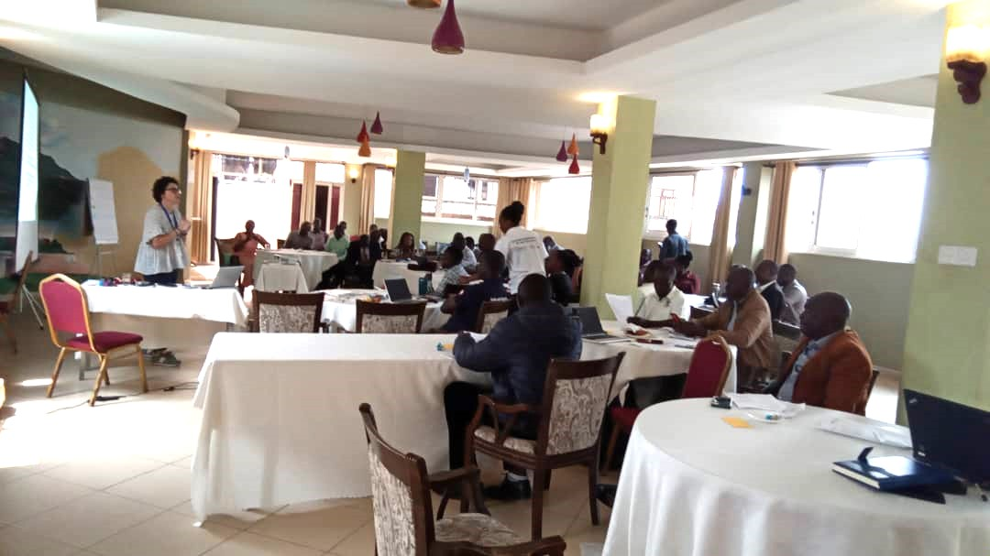
Sub-County Disaster Management Committees Mt. Elgon Region - Mbale – 18th January 2024. Photo by Irene Namanda for CRS.

I. Introduction: The PrEPD Project – A learning journey
In 2021, the Catholic Relief Services (CRS) Humanitarian Response Department embarked on a 24-month initiative known as the Preparing for Enhanced Protection in Disasters (PrEPD) project with funding from USAID's Bureau of Humanitarian Assistance (BHA). This initiative aimed to develop a comprehensive toolkit, the PrEDP Toolkit, designed to assist Disaster Risk Reduction (DRR) and humanitarian actors in strengthening protection mainstreaming and accountability in disaster-prone communities across three diverse countries – Sierra Leone, the Philippines, and Uganda.
Through a meticulous process of assessments at both global and national levelsand rounds of piloting and rolling out processes for the toolkit, by July 2023, the PrEDP teams reached a final comprehensive version that reflects the outcomes of collective experiences and learning across countries. The PrEDP toolkit is a compilation of various resources, encompassing tools, training materials, guidelines, templates, guides, examples, and best practices. Its aim is to guide actors in protection and accountability throughout the DRR project cycle.

II. PrEDP toolkit Dissemination Methodology
In Uganda, the CRS PrEPD team strategically chose the Disaster Risk Management Committee (DRM) as the primary conduit for disseminating the PrEDP toolkit, opting for a cascading approach that effectively reached the District, Sub-county and Village/community levels across six targeted districts in Uganda (Mbale, Bududa, Sironko, Bulambuli, Butaleja, and Namisindwa). This strategy allowed for a comprehensive reach throughout the administrative hierarchy, extending from the district level to the community level through DRM cells.
This PrEDP dissemination process saw significant strengthening through operational integration and knowledge exchange between the PrEDP project and the ECHO-funded Strengthening Community-led Actions on Disaster Preparedness and Response project, jointly implemented by Oxfam, CRS, Uganda Red Cross, and Caritas Tororo in the Mt Elgon Region. In particular, the Consortium ECHO-led project not only complemented the PrEDP DRM dissemination focus, but also opened up other strategic entry points for this process. It facilitated outreach to National Level DRR Policies and Frameworks, collaborated with District Officials to integrate a protection dimension into their contingency plans, emphasized vulnerability analysis and the identification of risky areas, and heightened the learning and sensitization of first responders through the dissemination of safe and dignified messages by Caritas Tororo.
Leveraging this opportunity, the dissemination process extended its advocacy and learning to the national level Disaster Risk Reduction (DRR) policy and frameworks, where the Office of the Prime Minister (OPM) plays a leadership role in Uganda's national disaster response. This influence was evident through the inclusion of a vulnerability lens and analysis in response design, and by drawing attention to the need for integrating a safeguarding stance among governmental officials in their interactions with communities. Furthermore, regular contacts, primarily facilitated by Caritas Tororo staff members, with program partners and community members at the field level within the PrEDP operational area, significantly supported the dissemination of PrEDP/Safe and Dignified-related messages. This effort also established a smooth communication channel open to possible adjustments in activities or setting prioritization scales.
Finally, this comprehensive review of the PrEDP dissemination process in Uganda sheds light on the successful distribution of the PrEPD toolkit, emphasizing the significance of diverse perspectives and experiences from actors involved in DRR responses at all levels. This case study aims to provide valuable insights for refining future dissemination strategies, ensuring the continued effectiveness, adaptation to the needs, and impact of such initiatives in disaster-prone communities.

III. PrEDP Dissemination Processes in Uganda
This case study delves into the experiences and outcomes of two successful dissemination events for the PrEPD toolkit, organized collaboratively by CRS and Caritas Tororo in Uganda.
The dissemination process started with a Training of Trainers (ToT) session in mid-November 2023, aimed to
equip DRR actors Oxfam, ACORD, Uganda Redcross Society, Caritas Tororo as well as key District disaster management committees representatives i.e. District Community Development officers, District National Resources officers, Senior Assistant Secretaries and Deputy Chief Administrative Officers with the necessary knowledge and skills to effectively transfer the learning embedded in the PrEPD toolkit to sub-county and village disaster management committees.
Following the ToT and up to the date of this case study, CRS and Caritas Tororo have conducted two overall successful dissemination events for the PrEPD Toolkit. The first event, held on November 22nd primarily targeted 35 high-level technical officials mainly at the district level. The second event, on January 18th, 2024, expanded its reach to include representatives from sub-counties from the PrEPD-targeted districts. The 18th of January 2024 event hosted a total of 41 participants, including five individuals recently trained as trainers in mid-November 2023. Both events were deemed successful, benefiting from the diverse experiences and concrete examples shared by facilitators and participants, crucial in consolidating the learning presented during the sessions. The experiences shared and lessons learned shared by participants contribute to the ongoing efforts to refine and optimize future dissemination strategies, ultimately enhancing the impact of disaster preparedness initiatives in vulnerable communities. The case study provides insights into the dynamics, achievements, and challenges encountered during the dissemination, offering valuable lessons for future initiatives.
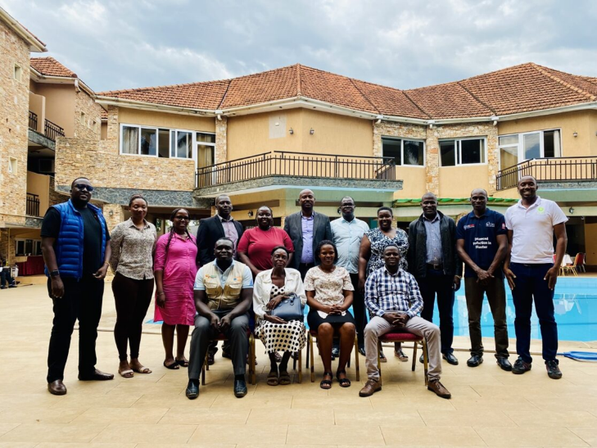
Methodology: Reflections and lessons learned about the PrEPD Toolkit dissemination process were gathered through targeted consultations with different audiences, as the Trainers of Trainers (ToTs) core team, from discussions with various government officials who participated in the January 18, 2024 dissemination event, key informant interviews (KII) with Caritas representatives in Tororo, focused consultations with ECHO’s consortium members, and active brainstorming with key CRS staff members . The inclusion of diverse perspectives provided a comprehensive understanding of the dissemination processes.
A field mission conducted by the PrEPD coordinator, Alberta Santini, from January 16th - January 22nd, 2024, in Mt. Elgon, played a crucial role in engaging key stakeholders actively participating in the dissemination process. This mission shed light on distinctive dissemination challenges and successes specifically encountered in the Mt. Elgon region, offering valuable insights that significantly contribute to ongoing efforts to enhance the impact of the PrEPD Toolkit dissemination processes as reflected below.
PrEDP ToT November 13 - 16, 2023, Wash and Wills Hotel in Mbale City, Mt. Elgon/ photo by Oswell Okello/CRS

IV. Observations and Lessons Learned:
To enhance the impact of the PrEDP toolkit dissemination, several recommendations have emerged from targeted consultations and lessons learned during the dissemination process. This section outlines key actions and suggestions aimed at refining future dissemination initiatives for disaster preparedness.
- Enhancing PrEDP toolkit dissemination: A Long-Term Journey, not a sprint: The recurring theme, emerging from the targeted consultations, emphasizes the critical need for an enhanced and sustainable PrEDP toolkit dissemination process to achieve lasting and transformative impact. The primary recommendation advocates a shift towards conducting more frequent sessions, each with a small number of participants, and extended durations. This strategic adjustment is intended to afford ample time for participants to share their experiences and actively engage in collaborative group work, fostering a richer and more impactful learning experience. Moreover, a distinct emphasis is placed on involving key political figures, surpassing the realm of technical actors, to optimize buy in and the efficiency of the dissemination process.
- Title: Enhancing Dissemination of the PrEDP Toolkit through Tailored Learning and Collaborative Engagement: Tailoring learning sessions to participant needs and cultivating collaborative learning are essential components for the effective dissemination of the PrEDP Toolkit. A comprehensive approach involves tailoring learning objectives and content to ensure alignment with the specific goals of each session and the diverse needs of participants. Additionally, follow-up learning opportunities, contingent upon budget availability, should be created to build on master and general dissemination events. Conducting comprehensive learning needs assessments at various levels facilitates effective customization of sessions to meet participants' unique requirements and better master the diverse PrEDP tools. Strategies for prolonged dissemination events, such as advocating for extended durations of two and a half days as recommended in consultations, are crucial for cultivating a deeper and more collaborative learning experience. This extension allows for dedicated focus on concrete planning exercises, facilitating active participant engagement and providing contributors with space and time to share experiences, reinforce understanding, and collaboratively plan for the practical implementation of safe and dignified principles. Support materials, particularly paper copies of the Toolkit, are imperative to facilitate revisions and ensure inclusivity during training sessions and continuous self-learning throughout the dissemination process.
- Enhancing effectiveness: Contextualize the PrEDP Toolkit to target audiences: The PrEDP Toolkit, crafted to empower first responders and Village-level DRM, harbors immense potential. However, to fully cater to the distinct main audience it targets, several actions are proposed to enhance its effectiveness. The primary focus centers on simplifying the content and incorporating, for instance, easy-to-remember checklists to augment usability. To achieve this, a comprehensive content review is still recommended, as the in-country learning is still unfolding. This process should emphasize creating concise one-pagers tailored to the unique contexts and needs of each context, in this case, Uganda. These one-pagers could be enriched with real case scenarios and references, providing practical insights and relevance. These reference materials should specifically cater to the essential actors involved in disaster response and management, delivering clear and accessible guidance. The adaptation to the national and local context of the tools included in the PrEDP toolkit, with local references, even including pictures of specific natural hazards, etc., and geographical areas, will best resonate with the targeted audience. This strategic approach not only simplifies the Toolkit's content but also transforms it into a practical and user-friendly tool for those actively engaged in disaster response efforts.

Safeguarding dimension in the PrEDP Toolkit: Unveiling its crucial role:
“If I have certification or an appointment letter, families, individual members, local government structure will feel confident to engage or seek information from us within the community,”
Safeguarding agent, Bukalasi sub-county, Bududa district

The PrEDP toolkit introduces a crucial dimension through safeguarding, prominently featured in its PART 3 with the suggestion to establish safeguarding agents. This aspect, notably evident in Uganda and the other two Country Programs (CPs) under PrEDP, has exceeded expectations and possibly even expanded beyond its initial scope. Particularly in areas lacking social services and organizational presence, the role of safeguarding has gained paramount significance, surpassing its initially envisioned impact at the local level. The existing safeguarding teams, as visited in Mazimasa and Bukalasi sub-counties, now serve as the sole entry points for government officials to receive and exchange information in these remote areas, and they have increasingly recognized the vital role of safeguarding—a realization facilitated by encounters and meetings facilitated by PrEDP. However, sustaining, clarifying, and formalizing this role is imperative for long-term positive impact. The formalization and certification through, for example, an Appointment Letter from the government, coupled with continued technical support from the district, CRS, and Caritas that aligns with an ongoing process to clarify their role and responsibilities by referring to a do-no-harm working framework, are crucial elements for continuity and would need to be considered as part of the ongoing unfolding process of the PrEPD learning. Providing material support and enhancing visibility are essential to empower safeguarding agents in effectively carrying out their responsibilities. These measures not only affirm the significance of safeguarding, but also contribute to the continued success of PrEDP's community-focused initiatives. The ongoing commitment to supporting safeguarding efforts ensures that safeguarding remains integral components of disaster response and community development.

V. Conclusion
The DRR landscape in Uganda has undergone significant changes in recent years, marked by a notable shift towards more community-led approaches. Traditionally, DRR efforts have often been spearheaded by the government or humanitarian organizations. However, this shift presents a great opportunity for INGOs and national or local civil society organizations to continue working within community-based approaches, embedding preparedness information to hazards, and building rights and entitlements to create safer communities. Despite this positive shift in focus, human and financial challenges persist. These challenges underscore the necessity for continued advocacy and integration of safe and dignified programming at the national policy level. This advocacy is essential to support sustainable changes towards safer and more dignified responses for all members of the community. As Uganda navigates these shifts and challenges, sustained PrEDP-generated learning, and adaptation to the specific context of its tools, and supported efforts towards community empowerment and policy integration, remain vital for the long-term resilience and well-being of its population.

The PrEDP Toolkit is available on CRS website.
Other examples of methodologies and stakeholders mapping for Toolkit Dissemination Exercises are provided in 1): Global Protection Cluster - Guidance for the Field Protection Clusters and AoRs on Preparedness for Protection in the Context of Climate Change and Disasters Accompanying Toolkit; and 2) Rural Health Information Hub – Rural Community Health Toolkit
Excluding Bukalasi, not included in the current ECHO project.
A final Evaluation is available at the CRS PrEDP Team.
Please see at Annex 2: Field Mission Report for more detailed information.

