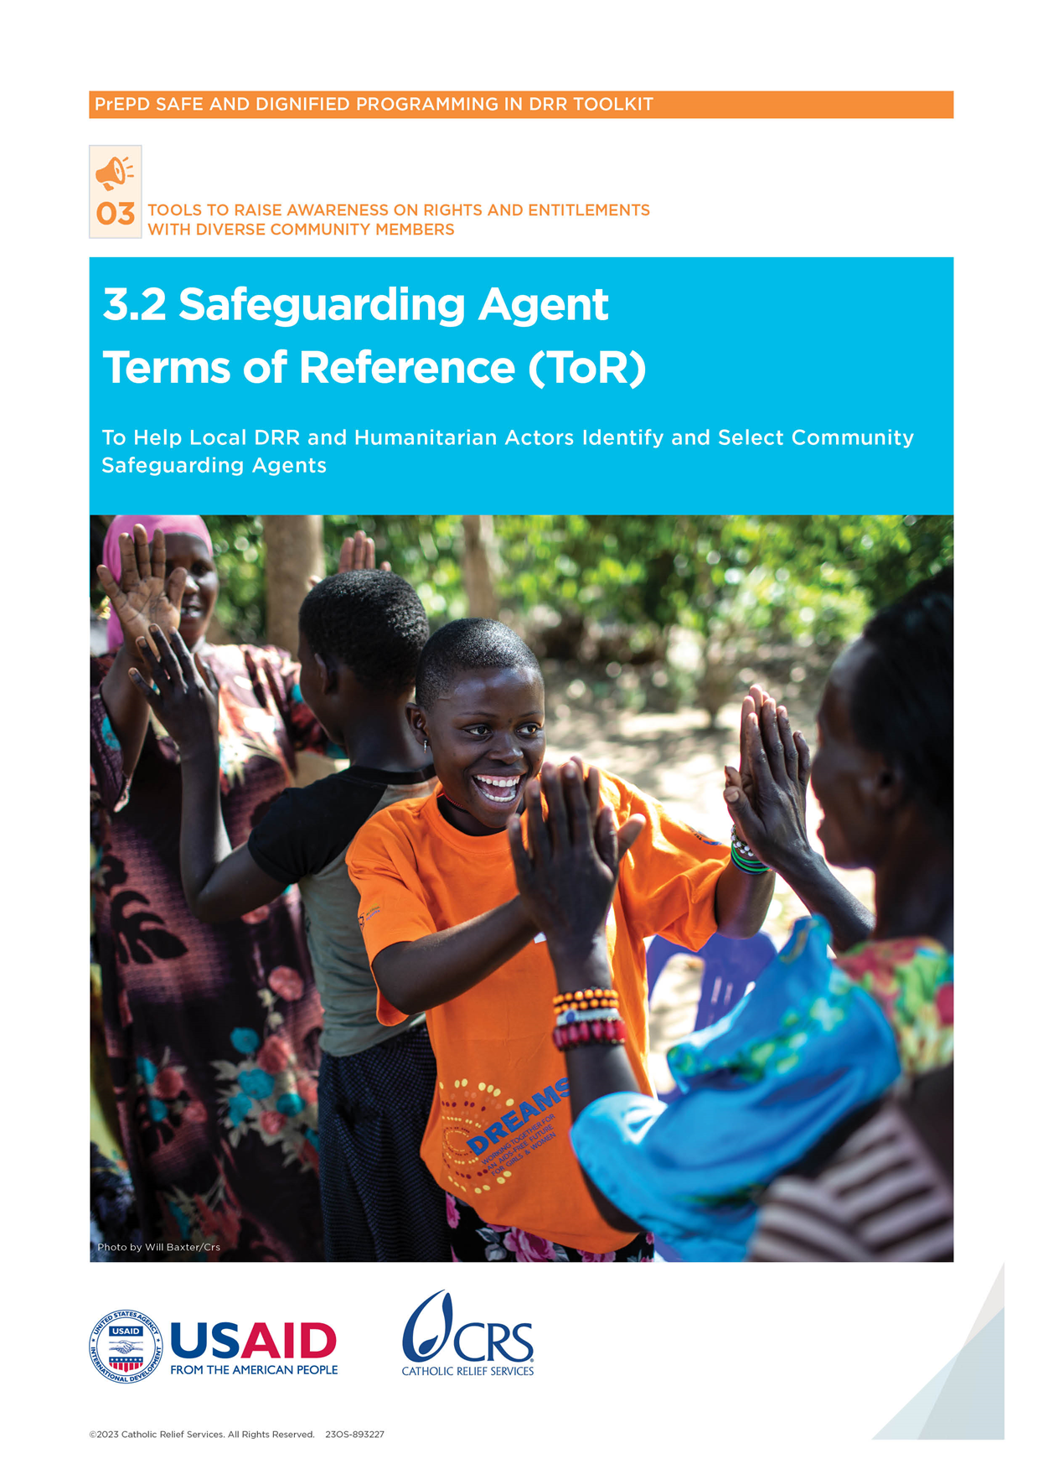

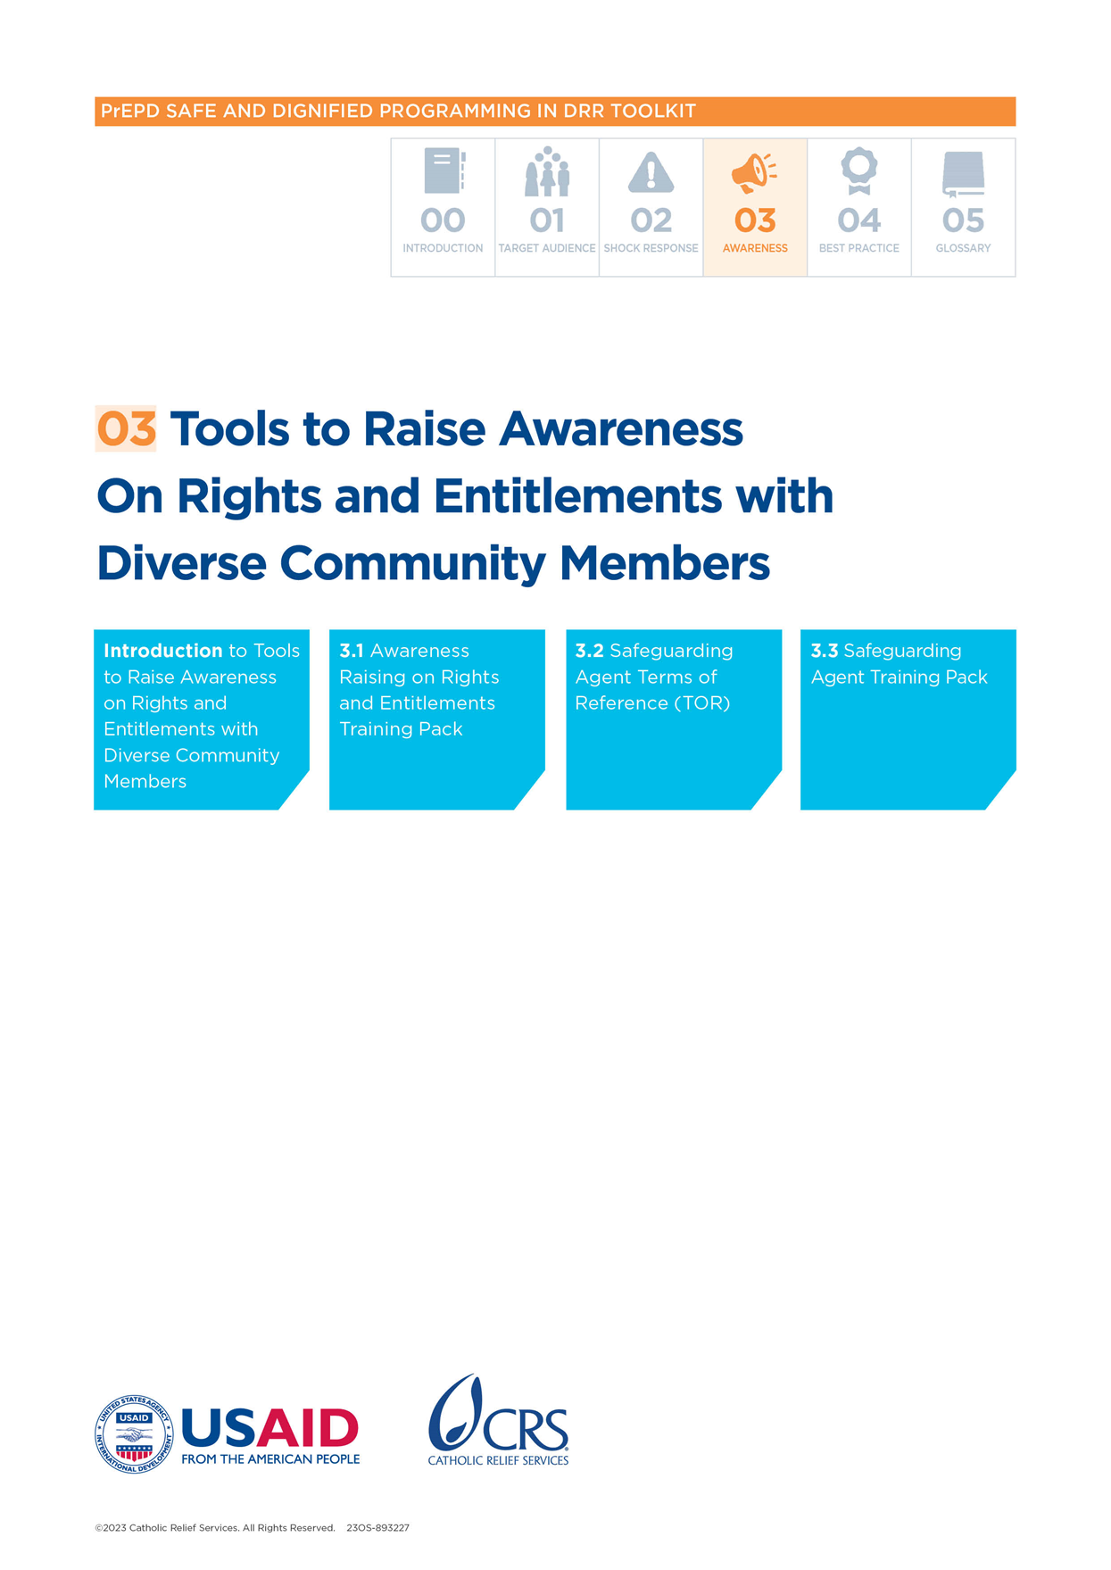

Safeguarding Agent Terms of Reference (ToR)

# Introduction

This tool aims to help local disaster risk reduction (DRR) and humanitarian actors identify and select community Safeguarding Agents. Community Safeguarding Agents are based in the community and are responsible for community safeguarding. These agents are the first point of contact for community members who report they have been harmed, abused or exploited by a staff member involved in an emergency response.

The community Safeguarding Agent will:

* Serve as a first point of contact for any community members who experience safeguarding issues during an emergency response
* Support the community member through the reporting process
* Contribute to raising awareness on safeguarding, particularly around rights and entitlements for community members, expected and prohibited conduct of staff members working for DRR and humanitarian organizations, and how and where to report complaints
* Gain sufficient awareness of existing referral pathways in the local area and share this information with communities to orient them toward essential services

# What is the purpose of this tool?

This tool is designed to support the identification and selection of community Safeguarding Agents. It includes selection criteria, roles and responsibilities and activities the agents should deliver.

# When to use this tool?

The tool can be used before a disaster to identify agents who can receive training and support before a crisis hits.

# How to use this tool?

The ToR can be adapted to the context; for example, if there is a local title for community/district disaster management committees.

# Who to involve?

The ToR if for those with the responsibility for identifying and selecting community Safeguarding Agents.

# Key definitions

**Psychological First Aid:** Offering compassion and support to a person who is suffering, focused on listening and linking them to available services and support.

**Referral Pathway:** A safe way for people to find different kinds of help, like medical care or help from the police.

**Safeguarding:** The responsibility that organizations have to make sure their staff and work do not harm children and adults who are at risk and do not expose them to abuse or exploitation.

**Safeguarding Agent:** A member of the community who is trained to help people with safeguarding issues during an emergency response and support them if they choose to report a problem.

**Sexual Abuse and Exploitation (SEA):** When a person uses a position of power for sexual purposes against a program participant or vulnerable member of the community.

# Selection criteria

To select people to become Safeguarding Agents, the following criteria should be followed.

The person has:

* Taken part in volunteer or advocacy activities in the community that focus on safeguarding and protection
* Been involved in disaster relief operations or activities in the community
* Had roles or positions working to promote human rights and protection against abuse or harassment, etc.
* Has the ability to communicate with and listen to a range of people
* Understands their sphere of influence in the community—including links with local networks and stakeholders
* Belongs to any marginalized or vulnerable sectors in the community
* Contributes to gender balance in the group of selected people
* Has one or more years of experience in the community mobilizing or leading capacity-building sessions (this is not needed but is a bonus)

# Roles and responsibilities

The community Safeguarding Agent is the focal point for safeguarding issues and concerns in the community, especially in times of crisis or disasters. It is a volunteer role and is based in the community.

The agent is responsible for observing and monitoring safeguarding issues and concerns, especially during emergency responses. Their role is also to assist disaster-vulnerable communities. They help these communities report or refer safeguarding and protection issues—including cases that involve sexual abuse and exploitation—to lead agencies or coordination bodies. Examples include the protection cluster, protection agencies, a government body and task teams for Protection against Sexual Exploitation and Abuse (PSEA).

Some specific duties of the community Safeguarding Agent are:

* Be the first point of contact for any community members who have experienced a safeguarding issue during an emergency response. The Safeguarding Agent also helps these community members report their experience if they ask for help to do that.
* Help raise awareness on safeguarding, especially on rights and entitlements for community members, and expected and prohibited behavior by DRR and humanitarian actors. They also raise awareness on how people can report complaints.
* Learn about referral pathways for different kinds of support and share this information with communities.
* Work with local organizations and local government to make sure community members can easily find and use information about how to make complaints and share concerns and ideas (known as Feedback Mechanisms).
* Help with psychological first aid during and outside emergency or crisis situations.

# Deliverables

Each community Safeguarding Agent will support and co-lead awareness sessions with the community. The sessions focus on:

* The definitions of SEA
* Expected and prohibited behaviors of DRR and humanitarian actors (these behaviors are often described in safeguarding policies and Codes of Conduct)
* How and where to report complaints—including any issues or concerns related to staff misconduct, such as sexual abuse and exploitation
* Where and how to refer people to services so they can get help to recover if they have been harmed

Signed by: Date:

____________________________________ _____________________________

# The role of a community Safeguarding Agent throughout a disaster timeline

|  |  |  |
| --- | --- | --- |
| **PRE-DISASTER  (24–48 HOURS BEFORE)** | **DURING DISASTER  (WITHIN 24 HOURS)** | **POST-DISASTER  (24–48 HOURS AFTER)** |
| Closely follow the national disaster management agencies’ advisory 48 hours before a natural hazard hits.  Coordinate with the local disaster management committee (or local equivalent) on the safeguarding support needed (in disaster preparedness initiatives).  Identify existing referral pathways and feedback mechanisms in the community. | Visit evacuation centers and record people’s safeguarding issues and concerns.  Help the local disaster management committee set up or adapt existing hotlines and help desks.  Tell people how to find help (orient them on referral pathways).  Tell people how to make complaints or give feedback. | Help with psychological first aid.  Share data trends/concerns related to safeguarding/SEA with the relevant local offices or agencies. |