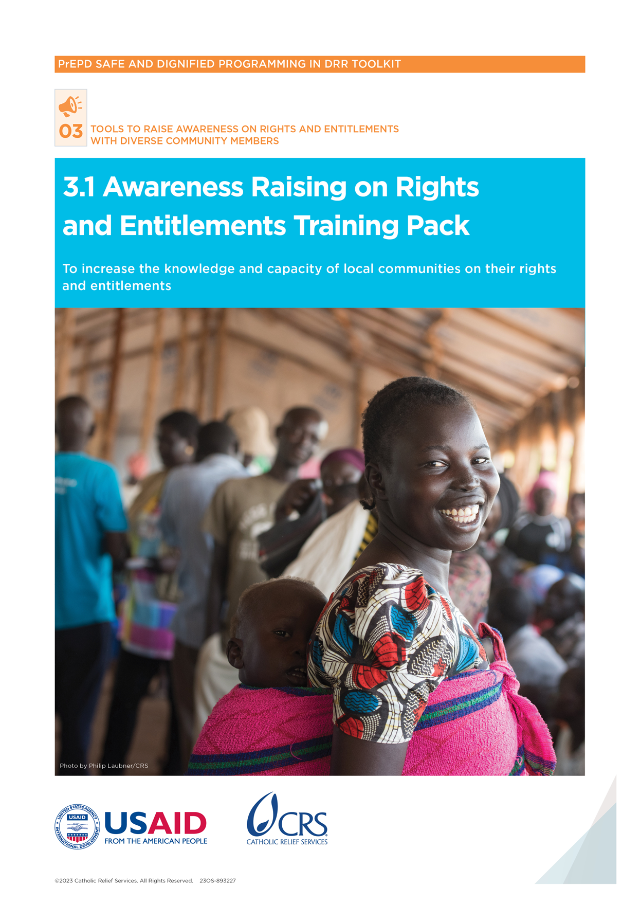

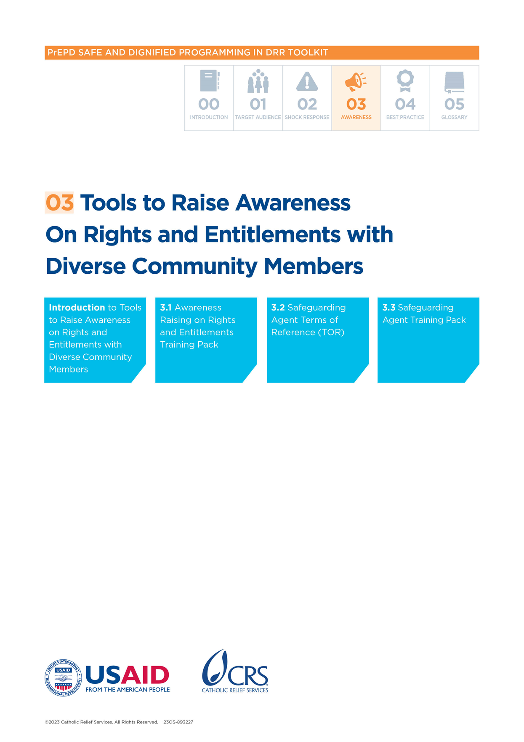

Awareness-Raising on Rights and Entitlements Training Pack

Purpose of tool

This training is designed to be an accessible, low-tech session for community members with the aim of increasing their knowledge and capacity on their rights and entitlements. It includes answering these questions:

* What rights do a person have to live with dignity and safety?
* What actions and behaviors are defined as sexual exploitation and abuse (SEA)?
* What actions and behaviors are expected and prohibited by disaster risk reduction (DRR) and humanitarian actors?
* How and where can a person report any issues or concerns related to staff misconduct—including sexual abuse and harassment?
* What services are available to support people who have experienced harm, and how can a person access these services (mapping and referral)?

Participants

* Community members

Time

* 150 minutes

Handouts

* HO 1: Key messages on rights and entitlements
* HO 2: IASC Six Rules

Training tools

* TT 1: True/False signs
* TT 2: SEA Scenarios
* TT 3: Reporting Scenarios

Materials

* 10 vouchers (pieces of paper)
* 8 chairs (or other items)

Training outline

* Welcome and introduction (10 minutes)
* Session 1: Overview of rights and entitlements (40 minutes)
* Session 2: Understanding safeguarding and sexual exploitation and abuse (60 minutes)
* Session 3: Reporting and referrals (30 minutes)
* Closing summary and recap (10 minutes)

|  |  |
| --- | --- |
| ****Methods**** | ****Contents**** |
| **Presentation** | **WELCOME** everyone to the session.  **INTRODUCE** yourself (name, organization, position, background, etc.) and the purpose of the session.  **EMPHASISE** that:   * This is a safe space for learning from the experience of others. * Everyone is free to share—there are no right or wrong answers.   **ENCOURAGE** everyone to participate and create a comfortable and informal atmosphere by using simple language and avoiding jargon. |
| **Icebreaker** | **ASK** participants to quickly form groups of 4–5 people. **ASK** participants to identify five things that all group members have in common (for example, number of siblings, type of job, favorite food, place of birth, etc.). **GIVE** participants 5 minutes to complete the activity. **EMPHASIZE** that we are all here to learn together and we all have more in common than we have differences—this is a safe space for everyone. |
| **Presentation** | **EXPLAIN** the objectives and agenda for the session.  **EXPLAIN** how the session will be conducted: exercises, role plays, discussions and work in groups. |

# Session 1: Overview of rights and entitlements

Time:

* 40 minutes

Objective:

* Participants understand basic information on their rights

Key messages:

* Assistance is free without anything given in exchange.
* Individuals and communities receiving assistance have various rights—including access to basic rights, not to be hurt, to be able to give feedback and complain, etc.

Materials:

* Flip chart and markers
* Sticky notes

Handout:

* HO 1: Key messages on rights and entitlements

Training tool:

* TT 1: True/False signs

Preparation:

* Set up True/False signs

| **METHODS** | **CONTENTS** |
| --- | --- |
| Discussion | Purpose  Participants understand the concepts of safety and dignity  Process  **ASK** participants what they think of when they hear the words “safety” and “dignity.” Use these questions to encourage people to share:  What do safety and dignity mean to you?  Can you share a time when you felt like you weren't safe? What made you feel that way?  Can you share about a time when you felt disrespected? What made you feel this way?  **EXPLAIN** that safety is about being protected from harm. Dignity is about being respected and valued. Every personhas certain rights and freedoms—including the right to live in safety and with dignity. Everyone has the right not to be hurt or mistreated. This is important to understand when receiving assistance and services from organizations and/or the government.  **EXPLAIN** that while everyone has the right to live with safety and dignity, not everyone experiences this, especially people who are considered to be vulnerable. It is important to recognize when people are being harmed. It is important to speak up and address the problem. All people from organizations and local governments who give assistance and services to people should respect their dignity and safety without causing them harm.  Debrief  All people have the right to live with dignity and safety.  All people from organizations and local governments giving assistance and services to people should respect their dignity and safety without causing them harm. |
| Exercise | Purpose  Learn about rights and entitlements in the context of service provision  Process  **PLACE** true and false signs **(****TT 1****)** in two locations. Ask participants to stand between them. **EXPLAIN** you will read statements about assistance from organizations and local governments. After each statement, if participants believe the statement is true, they should stand by the true sign. If they believe the statement is false, they should stand by the false sign.  After each statement, **ASK** a participant under each sign to explain why they chose that answer. After a discussion, **SHARE** the correct response.  Emergency assistance and services given by organizations are free.   * **Answer: TRUE.** Assistance and services are free, and no one should be asked for favors in exchange. A favor is something given to someone even though they do not owe it to them. For example, if someone asks for money or goods or sex for something that should be free, they are asking for a favor.   Information about assistance and services and how people are chosen to get them is private information (how people are chosen is called “selection criteria”).   * **Answer: FALSE.** People receiving assistance and support have the right to get information about services and assistance and to understand the selection criteria for them. This is not private information. Anyone can ask about it if the information is not shared.   Assistance and services should be based on need.   * **Answer: TRUE.** Assistance and services should be based on need.But people have the right to services and assistance based on their need without being denied help based on their sex, age, religion, etc.   Abuse of power of any kind over people and communities that causes harm is **never** OK.   * **Answer: TRUE.** People should always be treated with dignity. If anyone ever feels uncomfortable or that their dignity or safety are at risk, they have the right to say something and get help to solve the problem.   If someone working for an organization providing services has asked a person to do something inappropriate, it is best **not** to report it for safety and privacy reasons.   * **Answer**: **FALSE.** Inappropriate behavior should always be reported. The person complaining has the right to do this in a safe and confidential way. They also have the right to get a response regarding their complaint.   Organizations and local governments do **not** have to share information on how to report complaints. This is because the information is about their own internal procedures.   * **Answer: FALSE.** Everyone has the right to report any inappropriate behavior. Organizations and local governments should clearly explain how to report complaints. If this has not been explained clearly, the organization can be asked for this information.   **ASK** 2–3 participants to share something they learned from this session about their rights.  After discussion, **SUMMARIZE** key points that came up in the activity in plenary. **GIVE** participants the handout on Key Messages on Rights and Entitlements **(****HO 1****).**  Debrief  The types of assistance and services people get are based on their needs.  No one should use their power to control people or communities.  People have the right to be told about assistance and services available.  People have the right to know how people are chosen to get assistance or services (this is called “selection criteria”).  It is never okay if people working for organizations or local governments abuse their power, harm anyone in the community or treat them inappropriately. For example, no one should ever ask for favors in exchange for assistance or services.  People have the right to report any inappropriate behavior and harm. |

# Session 2: Understanding Sexual Exploitation and Abuse and Safeguarding

Time:

* 60 minutes

Objective:

* Participants learn what actions and behaviors constitute safeguarding violations SEA
* Participants learn what is expected and prohibited conduct of DRR and humanitarian actors

Key messages:

* Inappropriate behavior and abuse of power by staff providing services—including asking for favors in exchange for assistance—is never okay.
* Organizations and local governments must have no tolerance for sexual exploitation and abuse and abuse of power.
* If any of these rules are broken, they should be reported. This will help keep people safe.

Handout:

* HO 2: Inter-Agency Standing Committee (IASC) Six Rules

Training tool:

* TT 2: SEA Scenarios

Materials:

* Vouchers
* Chairs (or other items)
* Flipchart and markers

Preparation:

* Set up role-play

| Staff Conduct Role-Play, 30 minutes | |
| --- | --- |
| Exercise | Purpose  Participants understand and can identify safeguarding issues  Preparation  Before the training starts or during a break, choose another facilitator to play the second role in the role-play. Choose five volunteers who will participate in the role-play. Make sure they are clear on the purpose and messages of the scenario.  **PLACE** five chairs at the front of the room or gathering space. Note: if no chairs are available, use other items (for example, pens, fruit, notebooks, etc.). Prepare ten vouchers (pieces of paper) for the activity.  **ASSIGN** roles between the facilitators:  One facilitator oversees the vouchers.  The other facilitator oversees the chairs (or other items).  Process  **INVITE** the five volunteer participants to come to the front of the room or facilitation space. ASK the rest of the participants to watch the role-play and reflect on how it relates to the earlier discussion about safety and dignity.  **ASK** the participants to line up and face the audience. This way, the audience can see and hear what the facilitators and participants are saying. SPEAK clearly and loudly and **NARRATE** when needed to make sure that the audience hears and understands what is being said.  ROLE-PLAY as follows:  **Facilitator 1:**  **TELL** the group of five participantsthat you can see they have suffered a lot lately. Tell them you are there to help them. You have noticed they have no chairs, but you have vouchers they can use to get them. Tell them they are free to ask questions. Tell them they should come one at a time to get the vouchers. Then, they should trade in their vouchers for chairs.  **ASK** the five participants to come forward and line up. Explain that you have vouchers, which they can turn in to get chairs.  **DEMONSTRATE** inappropriate, disrespectful behavior to each of the five participants (**ENSURE** that the behavior and exchanges are clear for the audience watching and **NARRATE** when needed). Change which behaviors you use and in what order based on the context and participants. The below examples are only a guide and can be adapted. Facilitators do not need to follow the exact script or order.  **Participant 1**: Give the participant one voucher. Ask for money in exchange for a second voucher. If they agree, tell them you will give them an extra voucher. If they refuse, say that they will not receive another voucher. Tell them not to tell anyone else about the request for money, or you will make sure that they do not get a chair.  **Participant 2**: Wink at the participant or demonstrate favoritism (for example, complementing them). Give them two vouchers and ask them to provide their personal phone number, as you would like to call them later and visit them at home that evening.  **Participant 3:** Tell the participant that you know their uncle and that he is a good family friend. Give the participant three vouchers.  **Participant 4:** Give the participant one voucher. Tell them that they will get two vouchers if they go buy goods for you at the market (give an example of a good based on context). Tell them that this would be your secret and not to tell anyone.  **Participant 5:** Tell them that you don't think they should be in the program and that you are running low on vouchers. Refuse to give the participant a voucher, explaining that next time they can get one. |
| …continued | If any participants ask questions, **DEMONSTRATE** inappropriate behavior (ignore them, speak to them in a different language, turn your back on them, etc.)  Once participants have received vouchers, **EXPLAIN** that they should go to **Facilitator 2** to get their chairs.  **Facilitator 2:**  **ASK** participants to line up to get their chairs one by one.  **ASK** the participants to line up and face the audience. This way, the audience can see and hear what the facilitators and participants are saying. **SPEAK** clearly and loudly and **NARRATE** when needed to make sure that the audience hears and understands what is being said.  **DEMONSTRATE** inappropriate behavior. Change which behaviors you use and the order in which you use them based on the context and participants.   * **Participant 1:** Offer a chair to the participant in exchange for a date. If they refuse, tell them you will not give them a chair. If they agree, tell them you will give them two chairs. * **Participant 2:** Tell them that you will only give them the chairs at their home and you will visit them later at their house. Refuse to give them a chair and ask them to tell you where they live. * **Participant 3:** Give the participant one chair for the three vouchers and ask them to give you money with their next vouchers to get more chairs. Tell them that if they tell anyone about your request, you will take away their chair. * **Participant 4:** Tell the participant that their voucher is only valid if they buy you alcohol. Give them one chair and tell them to come back with the alcohol. Tell them they should not tell anyone about your request. * **Participant 5** (did not receive a voucher): Tell them to leave the distribution and that there are no more chairs left. Tell them you cannot help them. Ignore them if they ask questions.   **TELL** participants that if they are unhappy because some of them now have one chair, but others have none, they should work it out between themselves and exchange what they have.  After the role-play, ASK participants to return to their seats and DISCUSS in plenary. Use these questions to guide the discussion:   * *How did you feel about the behavior of the staff? Thinking about safety and dignity, what behavior was inappropriate? What behavior caused harm?* * *Did the staff provide you with free assistance?* * *Did the staff ask for anything in exchange?* * *Did the staff allow you to ask questions or complain?* * *Did the staff provide information about who got a chair and how many you should get?*   **EXPLAIN** that abuse of power by staff providing services is always unacceptable.  **EXPLAIN** that safeguarding means protecting community members from harm and the abuse of power by organizations and local governments. The role-play showed many problems with staff behavior and abuse of power (staff were asking for money in exchange for chairs and vouchers, staff asked for other favors, treated community members unfairly, etc.).  **Debrief**   * Inappropriate behavior and abuse of power by staff providing services—including asking for favors in exchange for assistance—is never okay.   Organizations and local governments must protect community members against the abuse of power and inappropriate behavior by staff. |

|  |  |
| --- | --- |
| **UNDERSTANDING SEXUAL EXPLOITATION AND ABUSE, 10 MINUTES** | |
| Discussion | **Purpose**  Participants understand the meaning of sexual exploitation and abuse  **Process**  **REMIND** participantsthat safeguarding means protecting community members from harm and the abuse of power by organizations and local governments. **REMIND** them that the role-play brought up many problems. **EXPLAIN** that one important part of protecting community members from harm is preventing sexual exploitation and abuse.  **ASK** participants what they think of when they hear the phrase “sexual exploitation and abuse.”  **EMPHASIZE** that it does not need to be a personal experience. They can share things they have heard.  **TELL** participants not to mention names or identify anyone. **TELL** them that if they are not comfortable, they do not need to share.  Use these questions for discussion:   * *What kind of sexual exploitation and abuse is there in your community?* * *What are some examples of sexual exploitation and abuse of which you are familiar (if participants don't share, bring up examples—such as organizations’ and local government staff asking for sex in exchange for assistance, making inappropriate sexual comments about community members, etc.)?*   **EXPLAIN** that sexual abuse refers to physical violation (or attempted violation) that is sexual, by force or in a situation where there is unequal power. Sexual exploitation refers to the abuse of power for sexual purposes (such as asking people to exchange sex in return for something).  **EXPLAIN** that sexual exploitation and abuse happens when organizations and local governments misuse their power and resources against community members.  **ASK** them to remember the role-play and share examples of sexual exploitation (for example, staff asking for favors—such as going on a date or giving personal contact information to visit participants at their homes late in the day, inappropriate behavior that made participants feel uncomfortable or unsafe, etc.).  **EXPLAIN** that sexual exploitation is never okay under any circumstances. **EXPLAIN** that it is the responsibility of organizations to prevent all forms of sexual exploitation and abuse. Sexual exploitation and abuse are never the fault of community members.  **Debrief**   * People have the right to always be treated with dignity and respect. * People have the right to always be free from abuse and harm. * Sexual exploitation and abuse are against the law and always unacceptable. * It is the responsibility of organizations and local governments to prevent sexual exploitation and abuse. |

|  |  |
| --- | --- |
| **SEXUAL EXPLOITATION AND ABUSE SCENARIO ACTIVITY, 20 MINUTES** | |
| Group  work | Purpose  Participants can identify examples of sexual exploitation and abuse  Process  **ASK** participants to think of someways that sexual exploitation and abuse could be prevented. Use these questions for discussion:   * *How can you protect yourself and others against sexual exploitation and abuse?* * *What rules should organizations and local governments follow to protect you and others?*   **EXPLAIN** that there are important rules that all organizations’ and local government workers must follow to protect the safety and dignity of people and communities and to not harm anyone.  **GIVE** participants copies of IASC Six Rules **(****HO 2****).** Note: depending on the literacy levels of the audience, it may not be appropriate to provide the copies. In this case, the facilitator verbally explains (see below).  **EXPLAIN** the following rules and **WRITE** the key parts on a flipchart. **EMPHASIZE** that any staff member who breaks one of these rules can be disciplined or even fired.  **SPLIT** the participants into two groups and **CHOOSE** two facilitators. The two facilitators will stand in a different corner of the room/facilitation space.  **GIVE** a copy of the SEA Scenarios **(****TT 2****)** to each facilitator.  **ASK** each group to move to one corner with a facilitator. The facilitator will explain the scenarios to the group. For each scenario, the group should decide if the behavior is acceptable or unacceptable (that is, was a rule broken).  Allow ten minutes for groups to discuss the scenarios.  **DISCUSS** the answers. Use the explanations below for each scenario to make things clearer:   * A male government worker comments on a “pretty girl” during a food distribution. * Unacceptable (rule broken): Not creating an environment that prevents sexual exploitation and abuse. * It could make the young girl feel uncomfortable because the government worker has more power than her, and she doesn't know if he will try to act on his statement. * This is degrading and humiliating behavior. * There are rumors of a staff member adding the name of his girlfriend to the list of people getting food aid. * Unacceptable (rule broken): Misusing power. * A community member in a shelter project is told she must have sex with a project volunteer to get her emergency shelter built. * Unacceptable (rule broken): Exchanging goods or services for sexual purposes. * Anyone supporting the project—including volunteers—must follow the same rules. * A male staff meets a 15-year-old female project participant in a bar for a drink and takes her to his house for sexual intercourse. * Unacceptable (rule broken): Performing sexual acts with children (anyone under the age of 18, regardless of the local age of consent). * A community member receiving assistance.   **DISCUSS** correct responses in plenary, highlighting the ways that the rules were broken.  Following discussion, **ASK** participants what they should do in all these cases as a next step. |

|  |  |
| --- | --- |
| **SEXUAL EXPLOITATION AND ABUSE SCENARIO ACTIVITY, 20 MINUTES** | |
| *…continued* | **HIGHLIGHT** the following:   * **Reporting is always the first step.** In every case, they should report the incident to the organization or local government that is providing assistance.   Debrief  The people who work for organizations and local governments giving assistance and services should:   * Always treat people with respect and dignity. * Always keep people safe from harm. * Never ask anyone for any kind of sexual favor in exchange for assistance or services. * Never harm, hurt or abuse people. * Never have any sexual contact or relationships with anyone getting assistance or services or with anyone under 18 years of age.   If any of these rules are broken, this should be reported to someone in authority. This will help keep people safe. |

# Session 3: Reporting and Referrals

Time:

* 30 minutes

Objectives:

* Participants understand how and where to report any issues or concerns related to staff misconduct—including sexual abuse
* Participants understand what services are available to support people who have experienced harm and how to access them (mapping and referral)

Key messages:

* People have the right to report any inappropriate behavior, exploitation or abuse.
* If people have any concern about the conduct of a staff member working for an organization and local government or have been harmed, this should be reported.

Training tool:

* TT 3: Reporting Scenario

Materials:

* Contact details of local referral pathways (if available)

|  |  |
| --- | --- |
| How to report and access services, 30 minutes | |
| **Discussion and group work** | Purpose  Participants understand how to report safeguarding incidents and how to access services  [*Note:* this session needs to be adapted based on three factors: 1) the local context, 2) which organizations and local governments are working in the area, and 3) which organizations and local governments are running the session]  Process  **EXPLAIN** that you will look at two scenarios of abuse by organizations and local governments, and they need to decide what to do next.  **GIVE** the reporting scenarios (**TT 3**) to participants. **READ** it together.  **ASK** participants to split into their groups and discuss the following for three minutes:   * *What would you do next?*   **DISCUSS** in plenary, highlighting:   * Reporting is always the first step. Mr. Abel abused his power and asked for money in exchange for assistance, which is always unacceptable. * People have the right to report. * Organizations and local governments providing services must give clear information on how to report. * If an organization or local government does not provide information on how to report, they should be asked for this information. * Anyone who complains has the right to receive a response from the organization or local government.   **ASK** participants if they know how to report to the specific organization(s) and local government(s) or the organization(s) and local government(s) working in their area.  **EXPLAIN** how to report:   * A complaints system has been set up at [name of organization/location*].* They can be contacted by [contact details] for further information. All complaints are kept confidential. * If someone feels that they have been harmed or discriminated against or someone working for a organization(s) and local government(s) has asked them to do something that was inappropriate, please report this using *[insert reporting mechanisms].*   **ASK** participants to read the second scenario (sexual exploitation and abuse). **READ** it together.  **ASK** participants to split into their two groups and discuss the following for three minutes:   * What would you do next? * How could you support the female community member?   **DISCUSS** in plenary, highlighting:   * Reporting is always the first step. Remind participants of their right to report and receive information on reporting and that they have the right to get a response to their complaint. * The person complaining may be the only person speaking out and the only person who can help the survivor and prevent this from happening again. * In this case, the community member needs to know: * **What services are available** to support people who have experienced harm (for example, a health clinic, an organization to help people who have experienced gender-based violence, etc.). * **How she can contact** these services to get help (for example, a phone number, a point of contact, etc.). |

|  |  |
| --- | --- |
| How to report and access services, 30 minutes | |
| …continued | **ASK** participants if they are aware of any local services and organizations that support people who have experienced harm so that they can get the support that they need. **DRAW** images of common organizations and local services (hospitals/clinics, police, etc.) on the flipchart as people discuss.  **EXPLAIN** how to access services:  If available, GIVE participants a referral card with available organizations and local government.  EXPLAIN how community members can contact and access these organizations and local government.  Debrief  People have the right to report any inappropriate behavior, exploitation or abuse.  It is important to report because the person complaining may be the only person speaking out and the only person who can help the victim.  If anyone has a concern about the conduct of a staff member working for an organization or local government or has been harmed, they should report it using [reporting mechanisms].  It is important to get support. Help and information is available from [insert name of organization or local government]. |

|  |  |
| --- | --- |
| Closing summary and recap, 10 minutes | |
| **Discussion** | **Recap key messages**  **ASK** participants to turn to the person next to them and share one key message they learned during this training. **ASK** several participants to share in plenary.  **RECAP** the following points:  **Emergency assistance and services are always free**   * If any services are not free, the government or organization should clearly say the reason why and the amount of the fees. * It is never okay if people working for organizations or local governments abuse their power, harm or treat people inappropriately. For example, no one should ever ask a person for favors in exchange for assistance or services.   **Information-sharing**   * People have the right to be told about available assistance and services. * People have the right to know how people are chosen to get assistance or services (this is called “selection criteria”). * People have the right to ask questions and raise concerns about the assistance or services available. Raising any concerns will not take away their right to assistance and services.   **Safeguarding and sexual exploitation and abuse**  The people giving assistance and services who work for organizations and local governments should:   * Always treat people with respect and dignity. * Aways keep people safe from harm. * Never ask people for any kind of sexual favor in exchange for assistance or services. * Never harm, hurt or abuse people. * Never have any sexual contact or relationships with people getting assistance or services or with anyone under 18 years of age.   **Reporting and referrals**   * If anyone is hurt or harmed, **it is never their fault**. It is the responsibility of organizations and local governments to keep people and communities safe and treat them with respect and dignity. * People have the right to make a complaint and do this in a safe and private way. All complaints are kept confidential and private. * It is important to get support. Help and information is available from *[insert name of organization or local government].*   **THANK** the participants for their active engagement. |

# HO 1: Key messages on rights and entitlements

## Your rights

Do you get assistance or other services from organizations and local governments? If so, you should know:

### Emergency assistance and services are always free

* The types of assistance and services you get are based on your needs.
* No one should use their power to control you or your community.
* If any services are not free, the government or organization should clearly say the reason why and the amount of the fees.
* It is never okay if people working for organizations or local governments abuse their power, harm you or treat you inappropriately. For example, no one should ever ask you for favors in exchange for assistance or services.

### Your right to information

* You have the right to be told about the assistance and services available to you.
* You have the right to know how people are chosen to get assistance or services (this is called “selection criteria”).
* You have the right to ask questions and raise concerns about the assistance or services you get. Raising any concerns will not affect your right to assistance and services.

### You have the right to be safe and to be respected

The people giving assistance and services who work for organizations and local governments:

* **Should always** treat you with respect and dignity.
* **Should always** keep you safe from harm.
* **Should never** ask you for any kind of sexual favor in exchange for assistance or services.
* **Should never** harm, hurt or abuse you.
* **Should never** have any sexual contact or relationships with you, other people getting assistance or services, or with anyone under 18 years of age.

 If any of these rules are broken, **please** report this to someone. This will help keep you and other people safe.

### Has a person who gave assistance harmed, hurt or abused you or someone else?

If anyone hurts or harms you, **it is never your fault**. It is the responsibility of organizations and local governments to keep you safe and treat you with respect and dignity.

* You have the right to make a complaint and report this person in a safe and private way. Your safety is the priority! All complaints are kept confidential and private.
* You have the right to get a response to your complaint or concern.

Do you want to make a complaint about a person who gave you assistance/services and who works for an organization or local government? Report it to *[insert reporting mechanisms].*

It is important to make a complaint. You may be the only person to speak up. You may be the only person to help yourself or others.

### Do you need support after being harmed, hurt or abused?

* It is important to get support. You can contact *[insert name of organization or local government].* There you can get more information about people who can support you.
* Seek medical attention immediately if you experience sexual abuse. You deserve care and support.

# HO 2: IASC Six Rules

Adapted from IASC Six Core Principles Plain English Version (2019)

[*IASC Six Core Principles/IASC/PSEA(interagencystandingcommittee.org*](https://psea.interagencystandingcommittee.org/update/iasc-six-core-principles)

## Rules on sexual conduct for humanitarian workers:

* Humanitarian workers can be disciplined—even fired—for unacceptable behavior in relation to sex.
* Humanitarian workers are not allowed to have sexual relationships with anyone under the age of 18, even if it is legal in their country. Saying they did not know the person's true age is not a valid excuse.
* Humanitarian workers are not allowed to pay for sex with money, employment, goods or services—including goods and services intended as aid to people in need. They must not use promises of these things to make other people accept any kind of behavior that humiliates or exploits them. This includes paying or offering money for sex with a prostitute.
* Humanitarian workers who might affect who gets goods and services must not have sex with anyone who may get that help. If they do, it destroys trust in the work.
* If a humanitarian worker is worried or suspects that anyone in their organization or another aid organization may be breaking humanitarian rules on sexual conduct, they must report it, following procedures set up by their agency.
* Humanitarian workers must create and maintain a work environment which prevents unacceptable sexual behavior and encourages staff to behave as set out in their codes of conduct. All managers are responsible for supporting and developing systems which maintain this environment.

# TT 1: True or False signs

**False**

**True**

# TT 2: SEA Scenarios

page49image310550016

|  |
| --- |
| A male team member comments on a “pretty girl” during an earthquake drill. |
| There are rumors a project staff member added the name of his girlfriend to the list of program participants. |
| A program participant in your DRR preparedness project is told she must have sexual intercourse with a contracted vender to get her home repaired. |
| A male volunteer meets a 16-year-old female program participant in a bar for a drink and takes her to his house for sexual intercourse. |

# TT 3: Reporting Scenarios

**Scenario 1:** Mr. Abel works for a local NGO and is planning a distribution of items to people affected by flooding. You are a community leader. You are not on the list because you did not lose anything in the flood. Mr. Abel tells you that if you pay him some money *[insert local amount]*, he will add you to the list, and you can also receive a kit. He asks you not to tell anyone about this.

**Scenario 2:** You are the community focal point for women’s affairs, and a female community member approaches you. She tells you that a local government officer named Mr. Hasan made her have sexual intercourse with him in exchange for food aid being distributed. The female community member is very upset.