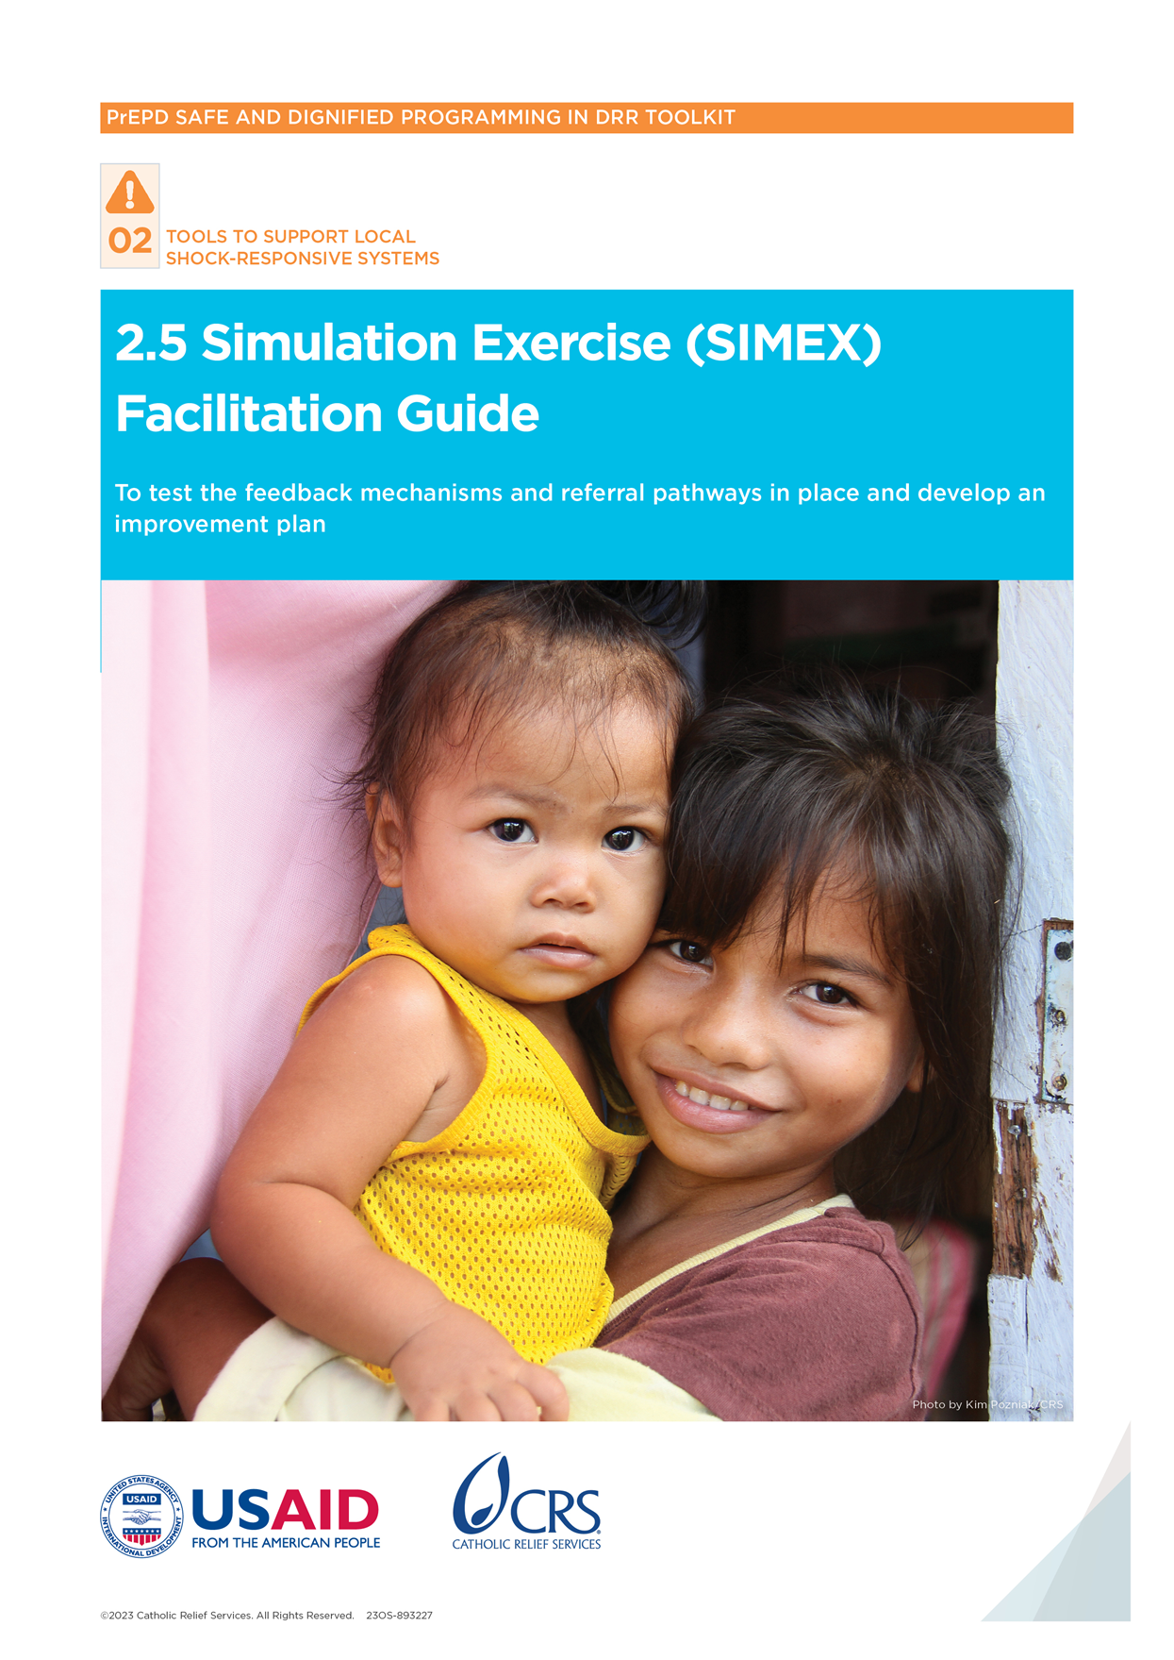

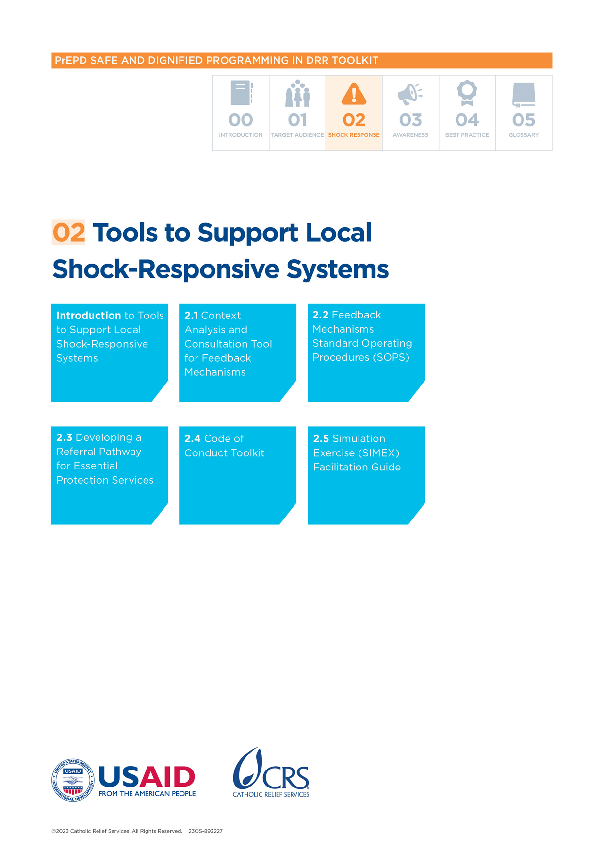

Simulation Exercise (SIMEX) Facilitation Guide

## Purpose of tool

This simulation exercise is designed for local disaster risk reduction (DRR) and humanitarian actors to test the feedback mechanisms and referral pathways in place as part of a safe and dignified programming approach. The exercise gives participants a space to:

* Practice handling sensitive feedback received through community-based feedback mechanisms.
* Use the referral pathway to orient survivors to available local services.
* Identify challenges and gaps in handling sensitive feedback within their organizations.
* Create action plans for improvement.

The following policies and procedures are needed for effective participation in the exercise:

* Feedback mechanism Standard Operating Procedures (SOPs)
* Referral pathway documents

## Participants

### Simulation exercise management team (SIMEX team)

This should have three or more people, including:

* **Simulation team leader (SIMEX leader)** responsible for the overall planning, implementation and evaluation of the exercise.
* **Observers** (one observer for each participating organization) will observe a group and give feedback at the end of the simulation. During the simulation exercise (Session 3), observers can clarify instructions, but they should not help the organizations develop their responses*.* The observers should be familiar with the feedback mechanism SOPs and referral pathways of the participating organizations.

### **Staff from participating organizations (participants/organizations)**

Each participating DRR or humanitarian organization should have at least three people represented in the simulation, including:

* Director or senior leadership
* Program director or senior-level program staff
* Safeguarding focal point or equivalent (if applicable)
* Monitoring and evaluation staff member (if applicable)
* Field-level staff member

Time

* 3.5 hours. The session can be shortened depending on how much time the participants have.

Handouts

* HO 1: Sample of General Emergency Scenario
* HO 2: Sample of Specific Project Scenario
* HO 3: Sample of Feedback Mechanism for Sensitive Feedback
* HO 4: SIMEX Form

Materials

* Pens
* Flipchart (optional)

Preparation

* Read through the Feedback Mechanism SOPs and referral pathways of the participating organizations.
* Adapt the general emergency scenario **(HO 1)** and specific project scenario **(HO 2)** using appropriate examples from the local context.

Outline and methodology

* **Session 1: Introduction** (30 minutes)

SIMEX team leader introduces the session and explains the process to participants.

Participants from the same participating organizations are grouped together.

Facilitator shares the general scenario **(**HO 1**)**, project scenario **(**HO 2**)** and explains the activity for Session 2.

* **Session 2: Simulation exercise (60 minutes)**

Facilitator shares the sensitive complaint scenario **(**HO 3**)** with a member from each participating organization.

Each organization works together in a team to document the process they would use to respond to the scenario.

The groups complete the SIMEX Form **(**HO 4**)** with their responses.

One observer sits in each group and takes notes of what is happening.

* **Session 3: Group meetings with SIMEX team** (30 minutes)

The SIMEX team holds meetings with each organization.

The organizations provide a brief presentation on their process for responding to the complaint.

Each organization hands in their SIMEX Form (HO 4**).**

* **Session 4: SIMEX team discussion/break** (30 minutes)

Organizations take a break while the SIMEX team goes through the feedback.

Final scores for each organization are discussed and completed on a single scorecard to share with the organization.

* **Session 5: Debriefing and action planning** (60 minutes)

Participants reflect on successes and challenges that emerged in the exercise.

SIMEX team shares back their reflections and observations.

Organizations create action plans for improvement and present them in plenary.

# **Scoring and** action planning

The SIMEX team will evaluate the exercise by giving scores against a set of seven expected outputs and by providing overall feedback and recommendations.

## Scoring

* The scorecard for the simulation covers seven required outputs (see below).
* Up to three points may be awarded per output depending on how they are rated:

3 = Yes/completely. This means the participants did all the expected action(s) or delivered the expected output(s).

2 = Partially. This means the participants only did some of the expected action(s) or only delivered some of the expected output(s).

1 = No/not at all. This means the participants did not do the expected actions or deliver the expected outputs.

* The highest possible score per organization is 21 points. The lowest is 7 points.
* One scorecard with comments and feedback should be completed for each organization by the SIMEX team.

## Action planning and reflection

After the exercise session, participants have a debriefing session to reflect on successes and challenges. The SIMEX team leader will then share overall feedback on what the teams did well and what could be improved. Organizations will then create simple action plans for improvement.

## **Expected outputs**

|  |  |
| --- | --- |
| **ASPECT TESTED** | **EXPECTED OUTPUTS** |
| Handling of sensitive feedback  Orienting survivor to further support | * The designated staff member receives and acknowledges the feedback provided by the complainant within 24 hours. * The receiver tells the complainant their identity will be protected and that appropriate actions will be taken by the organization. * The designated staff reports/forwards the feedback to the director or person of authority within 24 hours. * The staff who recorded the feedback keeps the information confidential and reports it only to senior leadership and designated staff. * The staff/safeguarding focal person gives an update to the complainant within 3 working days or sooner, depending on the seriousness of the situation. * Clear and accurate information is used from the referral pathway to orient the survivor to available local services (such as health, psychosocial support, legal services). * The wishes, needs and confidentiality of the survivor are respected. |

## Facilitation notes

| Methods | Contents |
| --- | --- |
| Session 1: Introduction, 30 minutes | |
| Presentation | Process   * Welcome the participants and share the simulation objectives. * Make sure all participating organizations have copies of their feedback mechanism SOP and referral pathway document with them. * Review the tools and processes that will be tested (the feedback mechanism SOPs, referral pathway). * Introduce the SIMEX management team (SIMEX team leader and observers). * Share the background on the simulation scenarios. * Share the sample general emergency scenario (HO 1)and give participants time to read through it. * Share the sample specific project scenario (HO 2)and give participants time to read through it. * Share the instructions for Session 2 (simulation exercise): * Each organization will work as a team, using their feedback mechanism SOP and referral pathway card. * A sample sensitive complaint (HO 3) will be given to one member of each team, received through their feedback mechanism. * Each organization uses the SIMEX form (HO 4) to explain their process for managing the complaint, including the: * Roles and responsibilities for each person involved in managing the complaint * Timeline for responding to the complaint * Process for managing the complaint and ensuring survivor/victim support * One observer should sit with each team and note feedback on their process. * They should treat the exercise like a real situation. * Allow time for questions. |
| Session 2: Simulation exercise, 60 minutes | |
| **Group exercise** | Process   * Tell the participants they have 1 hour to do the exercise and any technical aspects of the session. * Give the sample sensitive complaint to one member of each organization (HO 3). * Give the organizations 1 hour to work in groups and document the process. * One observer per organization sits with the group and writes any observations on the scorecard. They should focus on any strengths and areas for improvement. * Observers can clarify instructions but **should not help** the organizations document their process for managing the complaint. |
| Session 3: Group meetings, 30 minutes | |
| **Individual group meetings with SIMEX team** | Process   * The SIMEX team (observers and team leader) hold separate meetings with each organization. Each organization briefly presents their process for responding to the complaint. *Note:* these presentations should not take place in plenary but in individual meetings with the SIMEX team. * After presenting to the SIMEX team, each organization hands in their SIMEX Form (HO 4). * The SIMEX team ask questions and note down any comments and suggestions. |
| Session 4: SIMEX team discussion/break, 30 minutes | |
| **SIMEX team discussion** | Process   * Participants take a break while the SIMEX team meet to discuss the outputs. * The scores for each participating organization are discussed and completed on a single scorecard to share with the organization. * The SIMEX team notes down any overall feedback and trends to share in the plenary discussion, focusing on: * What organizations did well * What organizations could improve |
| Session 5: Debriefing and action planning, 60 minutes | |
| **Discussion and group work** | Process   * In plenary, invite the participants to say how they felt about what happened during the exercise. Allow time for discussion (10 minutes). Brainstorm on the following: * What worked well? * What were the key challenges? * What did they feel most confident about? * What did they feel least confident about? * Share overall feedback from the SIMEX team, noting: * What organizations did well * What organization could improve * Ask the organization to gather back into their groups with their observer. They should brainstorm some action points for their identified gaps/challenges (20 minutes). Observers should help the organizations clarify and agree the action points. * Ask each group to present their key action points in plenary.   Key messages   * It is important to have safe and confidential processes when handling sensitive reports. * The immediate escalation of sensitive feedback to the director/senior leadership is critical. * Senior leadership has a particular role and responsibility in making sure these processes are in place and known to all staff. * Survivors need to understand/be aware of the local support available through referral pathways. |

# HO 1: Sample of General Emergency Scenario

## Flooding in *[insert location]* causes massive loss of lives, properties and livelihoods.

Following 3 days of torrential rainfall, *[insert location]* experienced severe flooding along river banks on July 15. This led to widespread damage and loss in the *[insert district names]* districts. According to the local Red Cross and Ugandan Ministry of Health, there have been 98 deaths, 230 injuries and the destruction of 1,943 homes. Continued rainfall has led to increasing river levels and additional damage as three landslides occurred in the neighboringdistrict.

The flooding caused damage to homes, roadways, bridges and fields, destroying household and livelihood assets as heavy water washed them away and crops were destroyed by flood waters. Many homes collapsed under the pressure of the high water-levels, leaving people homeless. Waters continue to rise, posing an increased risk of landslides.

An estimated 2,250 persons have relocated to three evacuation centers in schools and government buildings run by the local Red Cross. Local government and non-governmental organizations (NGOs) have provided resources—including food, sleeping items and used clothes for families staying in evacuation centers. However, many of the evacuation centers still need this type of support.

The government is indicating that some families will not be allowed to return to areas that were destroyed and remain at risk of landslides. These families will need extended assistance in evacuation centers.

Lack of water and conditions in the evacuation centers are leading to hygiene and sanitation problems. Evacuees report limited access to bath soap, laundry, sanitary napkins and other non-food items (NFIs). The number of toilets is insufficient and generally not functional due to the lack of water. Evacuees report having to defecate outdoors.

*[Insert NGO]* has started to deliver daily water trucking to evacuation centers while *[insert partner NGO]* distributed 1,500 water and hygiene kits to evacuation centers.

## Resources

Your organization received United States dollars (USDs) $200,000 from the central government for the provision of relief to the affected area. You can use the funding to support immediate needs in the evacuation centers.

# HO 2: Sample of Specific Project Scenario

## Scenario

It is still not possible for evacuees to return to their homes due to the impact of flooding on their communities and the high risk of landslides with continued rainfall. Families with damaged houses in communities affected by flooding and landslides have been advised to remain in the evacuation centers. Your organization will support center management for 2–3 months with non-food item (NFI) distribution—including hygiene items, clothing and bedding.

Your organization will ensure distribution in two evacuation centers targeting approximately 750 persons in each. Weekly distributions will be scheduled in coordination with the center management. Twenty staff members and volunteers are being hired and they will have direct contracts with your organization.

Based on the community consultations in the centers, your organization has set up a feedback mechanism that is able to receive both sensitive and non-sensitive feedback.

# HO 3: Sample of Feedback Mechanism Sensitive Complaint

**Background**

The feedback below was received four weeks after the project started. In every case, you need to process this feedback, including the acknowledgment to the person giving the feedback.

**Feedback received through the project feedback mechanism**

“During the distribution last week one of your colleagues told me I can get extra hygiene items if I share my phone number with him. I thought it was okay because I have a big family. Then he touched me in a strange way when he was handing over the items. This made me feel very stressed and upset. He also told two of my friends that he will visit them at night. He took their phone numbers. My friend said that he touched her. This made her very unhappy. Since then, I haven’t slept properly because I am always thinking about this. I didn’t give him my phone number because I was very upset.”

# HO 4: SIMEX Form

**Organization: ___****_____________________________________________**

**TASK**

In your teams, please show how sensitive feedback would be received and managed according to your feedback mechanism Standard Operating Procedures (SOPs) and referral pathway. On the form below or on flip-chart paper, please write the roles and responsibilities, timeline and process that will be used to receive and manage the feedback.

**ROLES AND RESPONSIBILITIES**

*Explain who will be responsible for what actions to respond to the complaint.*

**TIMELINE**

*Explain when each action will take place.*

**PROCESS**

*Explain the process that will be used to manage the complaint and give support to the survivor.*