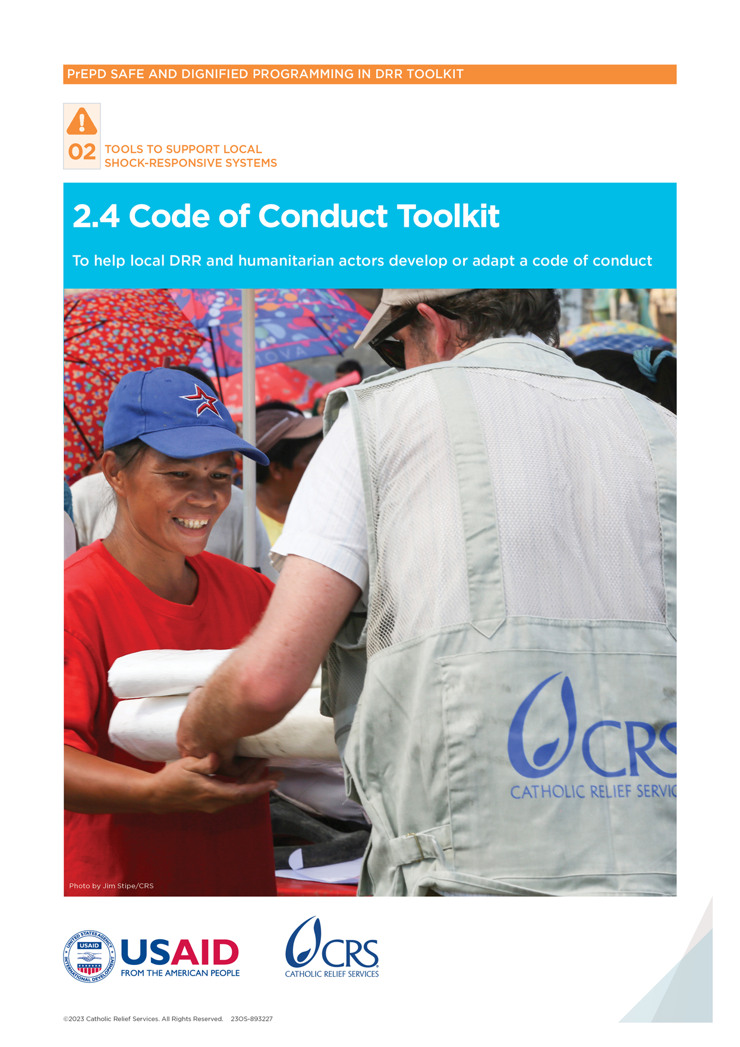

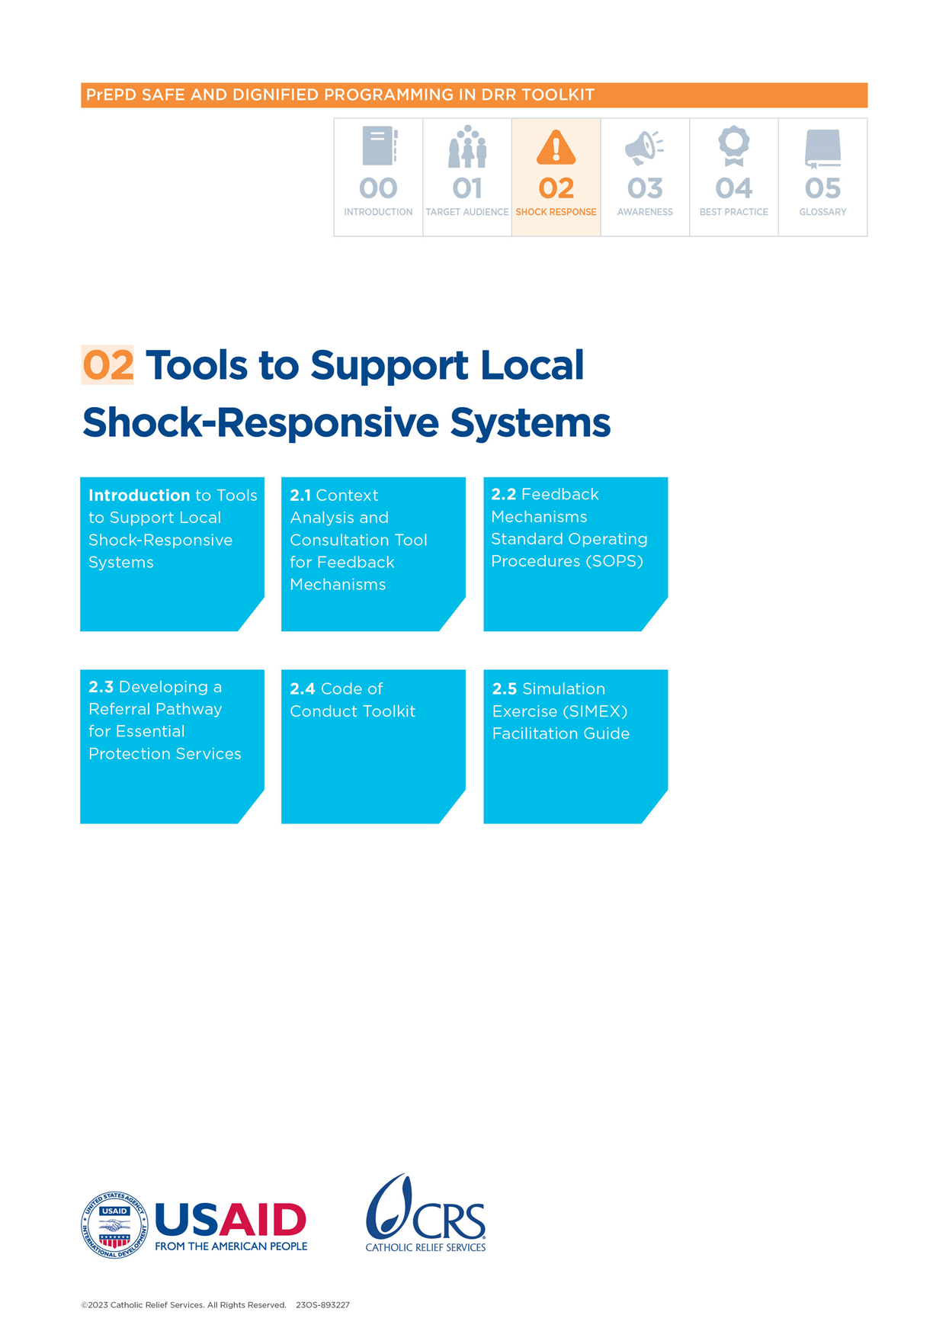

Code of Conduct Toolkit

# Introduction

Staff conduct is central to all that an organization does. This is especially true for local disaster risk reduction (DRR) and humanitarian actors who directly engage with communities during all phases of disaster planning and response. A Code of Conduct (CoC) serves two primary purposes: it protects the people that the organization serves as well as the reputation of the organization and its staff members. It is important that CoCs are locally owned, codified, adapted to the context, and that communities are aware of expected staff behavior.

In this document, “staff” refers to anyone with a contractual relationship with an organization that gives assistance and services to communities—including employees, volunteers, contractors, partners or any other affiliates.

## What is the purpose of this tool?

The following tools are designed to support local DRR and humanitarian actors to develop/adapt their CoC and to share the content of that code with local communities in an understandable and accessible way. This toolkit contains the following tools:

**Tool 1:**Minimum CoC content checklist

**Tool 2:** Example CoC template

**Tool 3:** Key messages for adults and children on safeguarding and Protection against Sexual Exploitation and Abuse (PSEA)

**Tool 4:** Information-sharing plan for communities on safeguarding and PSEA

## When to use this tool?

These tools can be used to develop or revise a CoC. DRR and humanitarian organizations should not work with communities until a CoC that meets these standards is in place and signed by all staff.

## How to use this tool?

Developing or revising a CoC is an intensive process. The following are recommendations for this process:

* **Consultative process:** Ensure that diverse staff and community members are involved in sharing ideas and input into developing a CoC.
* **Senior leadership:** Ensure senior leadership is involved and committed to continual support in the CoC development process.
* **All forms of conduct:** Identify other forms of conduct beyond forms of exploitation and abuse that are not allowed. For example, alcohol and substance abuse, use of organizational resources, safety of staff and information technology (IT) equipment use should be considered.
* **National labor laws and human resources standards:** Review human resources (HR) standards and national laws related to different disciplinary actions that apply if a CoC is breached. Make sure the CoC is in line with national labor laws.
* **Application of code for all affiliates:** Include the CoC in all contracts and relationships an organization enters into—including with vendors, contractors, volunteers and partners.
* **Strategy for dissemination and training staff:** Develop and implement a strategy for the dissemination/training on the CoC for all current and future staff at all levels.
* **Regular review:** Plan for periodic review of the CoC (e.g., every 2 years) to ensure it matches the work context. Any updates made to global standards can be incorporated. These include the Inter-Agency Standing Committee (IASC) Six Core Principles Relating to Sexual Exploitation and Abuse (i.e., “IASC Six Rules” toolkit).[1]

## Who to involve?

The process should involve all levels of an organization—including senior leadership, program teams, HR and operations staff.

## Key definitions

**Abuse:** When a person purposely hurts another person who they over-power. Abuse can be physical, emotional or sexual.

**Physical abuse:** When someone uses physical force that causes harm or suffering to another. Examples include hitting, shaking, kicking, pushing, grabbing and other physical acts.

**Emotional abuse:** When someone harms a person’s emotional state and negatively affects their behavior. Examples include degrading punishment, threats or bullying.

**Sexual abuse:** When someone forces or threatens someone with sexual contact because they are stronger or have more power. Examples include using inappropriate touching, sending unwanted sexual messages or rape.

**Discrimination:** When a person or group of people are unfairly treated differently from other people or groups based on characteristics—such as gender, race, age, religion, disability or other categories.

**Exploitation:** When someone trusted or with power over others takes advantage of their position to control others or achieve their consent. Examples include child labor, trafficking and sexual exploitation.

**Sexual exploitation:** Abusing a person’s vulnerability, unequal power or trust for sexual purposes. This can include profiting in any way from another person being sexually exploited. Examples include exchanging goods or services for sex.

**Harassment:** Harassment is behavior in the workplace that is unwanted/uninvited, threatening/offensive and creates a hostile environment. Examples include requests of a sexual nature, unwanted touching or sharing sexual or offensive images.

**Sexual Harassment:** Any unwelcome words, actions or any other behavior that is sexual between people in a workplace. This includes abusive or derogatory words, jokes or comments towards another staff member, or offensive messages or photos shared in the workplace.

**Zero tolerance:** No tolerance for inaction when allegations of sexual exploitation, abuse and harassment are received.

# Tool 1: Minimum Code of Conduct content checklist for DRR and humanitarian actors[2]

|  |  |
| --- | --- |
| Overview | |
| **Purpose** | This tool outlines the minimum content for a CoC. It covers various areas, including behaviors that are not allowed and reporting. DRR and local humanitarian actors can adapt this content based on the local context and existing ethical codes. All CoCs, at minimum, should contain the IASC Six Rules. |
| **When to use it?** | Before or during the development or revision of a CoC. Organizations should not work with communities until a CoC that meets these standards is in place and signed by all staff. |
| **How to use it?** | This checklist can be adapted based on the context and each actor’s existing ethical codes and guiding principles. The content can be used to develop or revise a CoC using the (CoC Template, Tool 2). |
| **Who to involve?** | Senior management, programs teams/field staff, HR and operations staff should be involved. |

## Content

**Is the purpose and scope of the CoC defined? Is it clearly stated that the code applies to all staff at all times?**

* The purpose of the CoC is to set clear expectations about the duty to treat all people with respect and prevent all forms of abuse and exploitation.
* This CoC applies to all staff. Anyone who works for the organization as an employee or on another basis (such as a volunteer or contractor) is considered a staff member and must adhere to this CoC.
* The Code is always applicable and mandatory. This includes when staff are at work, outside of work and while on leave.
* Zero tolerance: Breaches of the CoC are grounds for disciplinary action, up to and including dismissal.

**Are existing professional ethical codes and prohibited behaviors defined? This includes all forms of exploitation, abuse, harassment and discrimination against both community members and other staff members.**

* Our organization’s values and guiding principles: [insert values and principles key to the organization—such as integrity, respect or accountability].
* Prohibited staff behavior against other staff and against community members: *[insert prohibited staff behaviors].* This should cover all forms of:
* Exploitation
* Abuse
* Harassment
* Discrimination
* Staff must respect the dignity of all people, particularly community members in the organization’s work. All staff must conduct themselves with integrity and respect.
* Discrimination, harassment, exploitation and abuse of any form are NEVER acceptable under any circumstances and are grounds for disciplinary action—including dismissal.

**Are all IASC Six Rules included under prohibited behaviors?**

* Sexual exploitation and abuse by staff represent serious misconduct and are grounds for dismissal.
* Staff are not allowed to engage in any form of sexual misconduct, abuse or exploitation of community members, including:
* Touching anyone in a sexual or inappropriate manner
* Making inappropriate or sexualized comments
* Taking or sharing pornographic pictures
* Improperly using your position and power as a DRR or humanitarian organization or local government in a relationship with people who need assistance
* Staff are prohibited from exchanging money, employment, goods or services for sex—including sexual favors. This includes:
* Purchasing sex
* Exchange of assistance or services due to community members
* Having sexual relations with a child (anyone under 18 years of age) is prohibited regardless of the local age of consent. Mistaken belief regarding the age of a child is not an excuse.
* If a staff member has concerns or suspicions about sexual abuse or exploitation by a fellow staff member, whether in the same organization or not, he/she must report these concerns.
* Organizations must create an environment that prevents sexual exploitation and abuse and promotes adherence to the CoC.

**Is information about reporting complaints outlined—including the duty of staff to report concerns as well as how to report them?**

* Staff must immediately report any concerns or suspicions they witness, are made aware of, or are subject to which appear to breach the CoC. Any concern, however minor, must be reported**.**
* Staff receiving reports or concerns must act or refer the concern immediately as per the organization’s policies and procedures:
* Complaints reporting information: *[insert a summary of how complaints are reported]*
* Complaints reporting email: *[insert the reporting email* [*sample@xxxx.org*](mailto:sample@xxxx.org)*]*
* Complaints reporting hotline: *[insert the hotline number]*
* Staff can also make a complaint in person, by letter or by phone to one of the people listed: direct manager, administration manager, HR manager, director [delete/insert as necessary]
* All complaints will be received, processed/stored safely and kept confidential.

**Is there a statement to show the staff member has read and understood the CoC, including an understanding of disciplinary action up to dismissal for any breaches of the Code?**

* I acknowledge that I have read and understood the CoC and commit to upholding the behavioral conduct.
* I understand that failure to comply with the CoC or to report concerns of abuse and exploitation will result in disciplinary action and may result in termination of my contract.
* I understand I have a duty to report immediately if I see or suspect misconduct, if an allegation of misconduct is made against me or if another staff or program participant discloses misconduct to me.
* Signature line with date and location.

Other comments:

# Tool 2: Example Code of Conduct Template

|  |  |
| --- | --- |
| Overview | |
| Purpose | This tool gives an example template with various sections that a simple CoC could cover. |
| When to use? | It should be used during the development of a CoC in a consultative process. |
| How to use? | The Checklist (Tool 1) can be used to help actors develop and adapt the content in each section of the CoC (Tool 2), which should be based on each actor’s existing code of ethics and guiding principles. The process for developing the Code should be consultative and involve diverse organization members. |
| Who to involve? | Senior management, programs teams or field staff, HR and operations staff should be involved. |

## Example Code of Conduct

### Introduction: purpose and scope of the CoC

In line with its values, [insert organization] is committed to ethical conduct among all its staff and to provide a safe environment for all staff and community members free from discrimination, abuse and harassment.

The purpose of the CoC is to set clear expectations about the duty to treat all people with respect and prevent all forms of abuse and exploitation.

These policies apply to all staff, including: [insert staff, volunteers, contractors, partners, other affiliates].

The Code is always applicable and mandatory. This includes when staff are at work, outside of work and while on leave. Breaches of the CoC are grounds for appropriate disciplinary action, up to and including dismissal.

### Organization’s values and guiding principles

Our organization is committed to upholding the following **values and guiding principles:**

|  |
| --- |
| [Insert values and principles key to the organization—such as treating all people with dignity and respect.] |

#### Example:

* I will treat all staff and community members with dignity and care
* Prohibited behaviors

The following behaviors are prohibited by all staff towards program participants, community members and other staff members:

|  |
| --- |
| *[Insert the prohibited behaviors towards program participants, community members benefitting from assistance and services and staff members that cover discrimination, exploitation, abuse and harassment.]* |

#### Example:

* I will not harass other staff members, including sending inappropriate messages or photos.
* I will not emotionally abuse another child or adult.

### **Protection against sexual exploitation and abuse**

All staff must uphold the following rules:

|  |
| --- |
| *[Include the IASC six rules on sexual exploitation and abuse.]* |

#### Example:

* I will not exchange money, employment, goods or services for sex—including sexual favors. This includes:
* Purchasing sex
* Exchange of assistance or services due to program participants

### Other prohibited behaviors

|  |
| --- |
| *[Insert other areas that may not be included in the above, such as use of organizational resources; fraud, bribery, and corruption; confidentiality and data protection; political activity; safety and security.]* |

#### Example:

* I will not use any organizational funds for personal gain.

### Mandatory reporting

|  |
| --- |
| *[Include information on staff obligation to report and how to report any complaints.]* |

#### Example:

* Staff receiving reports or concerns are obliged to act or refer the concern immediately as per the following procedures:
* Complaints reporting information: *[insert a summary of how complaints are reported].*

### Declaration: receipt and acknowledgment

|  |
| --- |
| *[Include statements acknowledging that staff have read and understood the Code.]* |

#### Example:

* I acknowledge that I have read and understood the CoC and commit to upholding the behavioral conduct

Signature:

Date:

Location:

# Tool 3: Example of key messages for adults and children on safeguarding and PSEA

|  |  |
| --- | --- |
| Overview | |
| **Purpose** | Safeguarding and PSEA are complicated and sensitive topics. This tool summarizes key safeguarding and PSEA messages that DRR and local humanitarian actors can share with program participants and community members. It also aims to simplify key messages and make them more accessible. |
| **When to use?** | Use at the start of the program or service, to develop communication materials for communities and/or brief new staff members. |
| **How to use?** | The content can be adapted to the context. It should be translated into local languages/dialects. |
| **Who to involve?** | Program teams/field staff and HR staff should be involved. |

## Adults

### Your rights

Do you get assistance or other services from organizations and local governments? If so, you should know:

* Emergency assistance and services are always free.
* The types of assistance and services you get are based on your needs.
* No one should use their power to control you or your community.
* If any services are not free, the government or organization should clearly say the reason why and the amount of the fees.
* It is never okay if people working for organizations or local governments abuse their power, harm you or treat you inappropriately. For example, no one should ever ask you for favors in exchange for assistance or services.

### Your right to information

* You have the right to be told about the assistance and services available to you.
* You have the right to know how people are chosen to get assistance or services (this is called “selection criteria”).
* You have the right to ask questions and raise concerns about the assistance or services you get. Raising any concerns will not affect your right to assistance and services.

### You have the right to be safe and to be respected

The people giving assistance and services who work for organizations and local governments should:

* Always treat you with respect and dignity
* Always keep you safe from harm
* Never ask you for any kind of sexual favor in exchange for assistance or services
* Never harm, hurt or abuse you
* Never have any sexual contact or relationships with you, other people getting assistance or services or with anyone under 18 years of age

If any of these rules are broken, **please** report this to someone. This will help keep you and other people safe.

### Has a person who gave assistance harmed, hurt or abused you or someone else?

If anyone hurts or harms you, **it is never your fault**. It is the responsibility of organizations and local governments to keep you safe and treat you with respect and dignity.

* You have the right to make a complaint and report this person in a safe and private way. Your safety is the priority. All complaints are kept confidential and private.
* You have the right to get a response to your complaint or concern.
* Do you want to make a complaint about a person giving you assistance or services who works for an organization or local government? If so, report it to [insert reporting mechanisms].

It is important to make a complaint. You may be the only person to speak up. You may be the only person to help yourself or others.

### Do you need support after being harmed, hurt or abused?

* It is important to get support. You can contact *[insert name of organization or local government].* There you can get more information about people who can support you.
* Seek medical attention immediately if you experience sexual abuse. You deserve care and support.

## Children

* **Assistance is always free.** No one has the right to ask you for anything in exchange for the services that organizations and local governments are giving you. This includes food, water, schoolbooks, games—everything. Please tell your friends.
* Staff working for organizations and local government should make you **feel happy and safe**. They should always treat you with kindness and respect.
* Staff working for organizations and local governments should **never hurt you**, shout at you, touch you somewhere you do not like, make you feel sad or ask you to keep something a secret.
* **We will always listen.** Tell us if someone who works with us or any organization or local government hurts you, makes you feel sad or bad or touches you in a way that you do not like. Do not blame yourself. It is not your fault. Tell us and we will help you. Keeping you safe is what matters the most to us. Tell your friends.

# Tool 4: Information-sharing plan for communities on safeguarding and PSEA[3]

|  |  |
| --- | --- |
| Overview | |
| **Purpose** | Because safeguarding and PSEA are sensitive topics, Key Messages on Safeguarding and PSEA (Tool 3) must be shared in different formats so that they reach different groups. This tool enables DRR and local humanitarian actors to systematically plan what information should be shared, with who, and how, etc., so that appropriate mechanisms/formats are used. |
| **When to use?** | Use before or at the start of the program or service. |
| **How to use it?** | Go through each section, giving particular attention to more marginalized groups—including women, children, older people and people with disabilities. |
| **Who to involve** | Program teams or field staff should be involved. |

|  |  |  |  |  |
| --- | --- | --- | --- | --- |
| Activity/Program/Service | | | | |
| **WHAT information is to be shared?** | **WHO are you trying to reach with this information?** | **HOW will you reach different groups? What mechanism will be used?** | **WHERE will you be sharing the information?** | **WHEN will you share the information with different groups in each area?** |
| **Information about staff conduct and how to report** | Women and men | Community meeting | Community X and Y | Daily from Mon  1st–5th |
| Older men and women | Church announcements | Community X | Daily from Mon  1st–5th |
| Older men and women | Mosque Announcements | Community Y | Daily from Mon  1st–5th |
| Persons with disabilities and specific minority or ethnic groups | Door-to-door | Community X and Y | Daily from Mon  1st–5th |
| Children  (girls and boys) | Schools (posters;  information, education and communication [IEC] materials) | Schools A, B and C | Daily from Mon  1st–5th |
| **Targeting information** | Children (girls and boys) | School groups (posters, IEC materials) | Schools A, B and C | Weekly for 1 month |
| Boys and men | Sessions with men and boys | Market X and Y | Weekly for 1 month |
| Women | Face-to-face at water points | Water point X, Y, Z | Weekly for 1 month |
| Adult men and women | Radio messages | District X and Y | Weekly for 1 month |

1. [IASC Six Core Principles Relating to Sexual Exploitation and Abuse | IASC / PSEA (interagencystandingcommittee.org)](https://psea.interagencystandingcommittee.org/resources/iasc-six-core-principles-relating-sexual-exploitation-and-abuse).
2. Adapted from CRS, Partner Safeguarding Project Code of Conduct Template (2022); CRS Code of Conduct checklist in the CRS SPSEA Toolkit, (2021); International Committee of the Red Cross, Code of Conduct (2018).
3. Adapted from Information sharing template (Caritas Internationalis 2018).