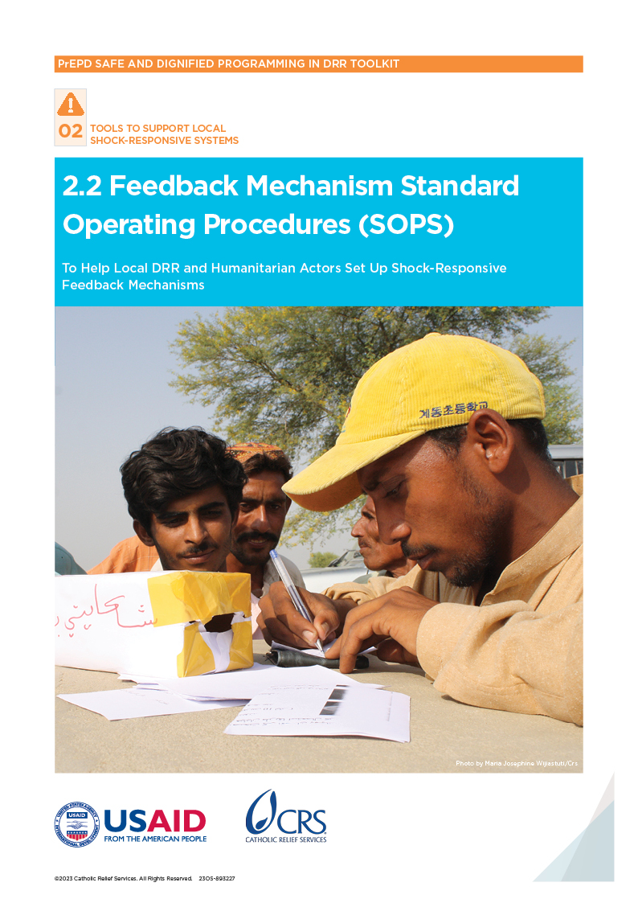

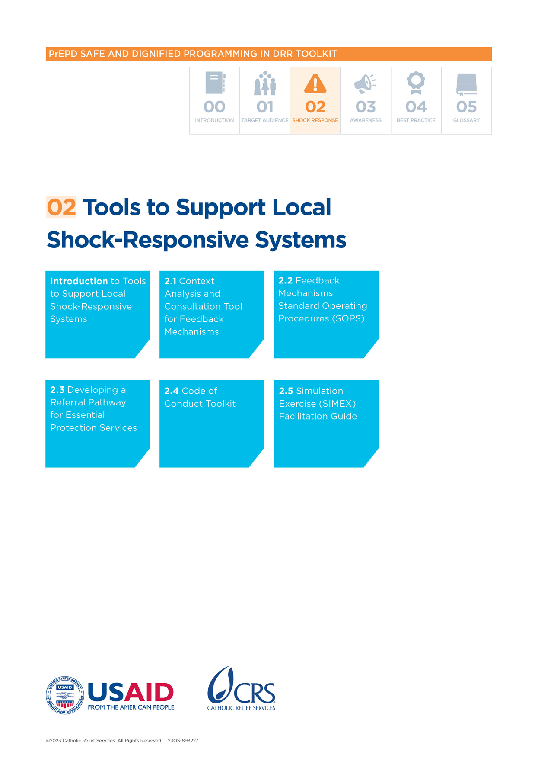

Feedback Mechanisms Standard Operating Procedures (SOPs)

## Introduction

Feedback mechanisms help make sure program decisions are informed by local perspectives and priorities. This contributes to safe and dignified programming. To work well, they need to be properly planned and supported with enough financial and human resources. Local disaster risk reduction (DRR) and humanitarian staff can use Standard Operating Procedures (SOPs) to set up and record the protocols and procedures that support them while they collect, acknowledge and respond to/refer feedback and complaints. This includes sensitive complaints about abuse and exploitation. The SOPs also outline different roles and responsibilities.

## What is the purpose of this tool?

SOPs are a useful way of recording protocols and processes related to feedback mechanisms.

## When to use this tool?

The tool is used when feedback mechanisms are set up.

## How to use this tool?

Adapt this example to the specific needs and context of the feedback mechanism and update it as the feedback mechanism evolves and improves.

## Who to involve?

The person responsible for managing the program should complete the SOPs with input from other program staff or community safeguarding agents.

## Key definitions

**Complaint:** A complaint is when a person expresses they are angry, dissatisfied or disappointed with an organization because of something it did/did not do.

**Confidentiality:** This is an obligation to make sure that information about a person is not shared without permission.

**Feedback:** This involves people’s opinions, complaints and suggestions about how organizations behave and what they should/should not do.

**Feedback mechanism:** This is a formal system that helps people who get assistance or are affected by a crisis to tell organizations if the assistance is helpful or if they have complaints.

# Section 1: Background

|  |
| --- |
| Content should include: An introduction, different feedback mechanism categories, staffing structure. |

## Introduction

*[Insert name of organization]* is committed to ensuring that all project stakeholders—especially members of the communities and affected populations—can talk directly with *[insert name of organization]* and that *[insert name of organization]* will listen to feedback and complaints and respond in a safe, timely and suitable way.

To do this, *[insert name of organization]* will set up a feedback mechanism.

All community members in *[insert the detailed targeted communities]* and program participants have the right to give feedback to *[insert name of organization]* and get a timely and fair response according to the following commitments. *[Insert name of organization]* will:

* Make sure its feedback mechanism matches the communication preferences and needs of individuals from the targeted communities—including vulnerable and marginalized groups
* Make sure to share information with communities and program participants about the feedback mechanism process, timeline and right to appeal
* Respect the confidentiality of feedback and complaints
* Protect the safety and security of the people who use the feedback mechanism
* Make sure community members who report a complaint do not experience negative consequences

## Feedback mechanism categories

|  |  |  |
| --- | --- | --- |
|  | **CATEGORY** | **DESCRIPTION** |
| **Programmatic feedback and complaints (information requests)** | **1. Request for information** | Questions about programs, services and who can access them, or about the organization.  For example: *When is the next distribution?* |
| **2. Request for individual program or service support** | A person asks for services they did not receive because of a possible targeting mistake or a bigger problem with access.  For example: *I can’t travel to the distribution site. How can I get assistance?* |
| **3. General suggestions to improve service and program** | Feedback on the relevancy of high-quality and appropriate services and programming; a request to change how *[insert name of organization]* offers support now or in future programs.  For example: *We need cash grants and training to make a real difference.* |
| **4. Appreciation of services or support** | Positive comments about activities or support.  For example: *Thank you for your help.* |
| **5. Complaints about services or support** | A complaint about how timely, appropriate or useful services/support are for the person.  For example: *Women don’t feel safe going to the latrines because they do not have lights.* |
| **Sensitive** | **6. Alleged violation of the organization’s Code of Conduct or Safeguarding Policy** | An allegation of misconduct by *[insert name of organization]* staff (including volunteers, partners, vendors/suppliers or other staff members).  For example: *One of your staff asked to marry my daughter.* |
| **7. Other protection issues** | An accusation of exploitation or abuse that does not involve *[insert name of organization]* staff or partners. An allegation of protection concerns that affect the communities we support. This includes any reference to exploitation or abuse from a government official, schoolteacher, community member or family member.  For example: *I heard a rumor that domestic violence increased in the community after you ran a distribution.* |
| **8. Safety and security concerns** | Information related to the safety or security of *[insert name of organization]* staff, offices or goods, of partners or any organization, or of the communities served.  For example: *There is flooding in the area and it damaged the road to the project site.* |
| **Other** | **9. Out-of-scope feedback** | A request for support that the project does not offer or programmatic feedback on support that another actor offers.  This category does not include safeguarding violations or issues of protection against abuse or fraud.  For example: *I have lost my goat. Can you help me find it?* |

## Key Roles and Responsibilities

Below is a breakdown of roles and responsibilities related to the feedback mechanism:

**Overall responsibility** *[insert staff title]*is responsible to ensure the feedback mechanism is in place/working. They:

* Make sure the feedback mechanism is in place
* Handle sensitive complaints
* Make sure there are enough resources and staff time to manage feedback mechanisms
* Make sure staff have the right training on the feedback mechanism (i.e., someone in a director/head of organization role)

**Feedback mechanism focal point or manager** [insert staff title] supports the feedback mechanisms. They:

* Coordinate feedback mechanisms
* Support teams to run the feedback mechanism
* Develop the SOP for the feedback mechanism
* Train staff on the feedback mechanism

**Field staff and outreach teams** are responsible for receiving, acknowledging, recording and responding to feedback and complaints from various channels. They:

* Talk to diverse groups in the community and make sure they can access the feedback mechanism
* Give communities information about how to give feedback
* Receive feedback through various channels

**Community safeguarding focal points** share information with communities about how to give feedback and complaints.

**Monitoring and evaluation staff** (if applicable)help analyze feedback and understand if any groups are excluded from the feedback mechanism.

# Section 2: Feedback and complaints channels

|  |
| --- |
| Content should include: Name and description of each feedback and complaints channel, access details for each channel, how to document feedback and complaints, how to acknowledge feedback and feedback/complaints on the channels themselves. |

Any individual, household, group of people, organization, partner, program staff, volunteer, contractor or other stakeholder can give feedback about [insert name of organization] projects, activities, staff, partners or suppliers. [Insert name of organization] currently receives feedback through the following channels [delete as needed]:

| Feedback AND complaint channel | | |
| --- | --- | --- |
| **Channel** | **Description** | **Details** (such as times/hours when it is possible to give feedback, contact details, languages used for feedback, translation services available) |
| **Suggestion box** | Community can submit written feedback and complaints using free text or forms that they put in a secure and accessible box. |  |
| **Hotline and SMS: Single prepaid account (managed in-house)** | Community members call and give feedback directly to a staff member using a dedicated phone/mobile number or hotline. |  |
| **Hotline: Call center (managed by external service provider)** | This is a dedicated number that individuals use to phone a call center company that represents *[insert name of organization].* |  |
| **Hotline: Interactive Voice Response (IVR)** | This is a dedicated number for community members to access information and record their feedback message. |  |
| **Face-to-face with *[insert name of organization]* staff** | These are staff members (such as community liaison officers with specific feedback mechanism tasks) who people in the field can approach and give feedback and complaints to directly. |  |
| **Help desk near project sites or designated drop-in at *[insert name of organization]*** | This is a desk or station set up at the office or in the field with set operating hours, with trained staff or community volunteers and interpreters who can answer questions and listen to concerns. |  |
| **Community focal point (sometimes called feedback and complaints committee)** | This is a locally managed focal point/committee, appointed by community members and trained to collect and record feedback and complaints and share them regularly with *[insert name of organization].* |  |
| **Open community meetings** | These are regular meetings in communities that bring together large groups of people to share information and collect feedback and complaints. There are also meetings for minority and excluded population groups. |  |
| **Regular consultations with key informants or community leaders** | Leaders collect feedback and complaints from their communities. |  |
| **Project site visits/observations** | These activities are done while monitoring a project or program where program participants or stakeholders can give or report feedback on what they have seen or experienced. |  |
| **Monitoring methods** | Questions can be added about how satisfied the community members/participants are with assistance and services. This way they are prepared in all relevant languages in the community. Examples include household or post-distribution surveys, focus group discussions, key informant interviews, etc. |  |
| **Social media and instant messaging platforms (for example, Twitter [X], WhatsApp)** | This is a dedicated number or account for people to share written or voice messages and pictures. |  |
| **Mail** | Individuals can mail letters to *[insert name of organization]*. |  |
| **Dedicated email address** | Individuals can send emails to an address set up for feedback. |  |

## Section 3: Response channels:

|  |
| --- |
| Content should include: Name and description of each response channel, commitment to replying within a set time to each feedback/complaint category and Annex 1, Annex 2, Annex 3 (response scripts, flow chart, referral pathways). |

|  |  |
| --- | --- |
| Response Channel: How [insert name of organization] will respond to feedback and complaints | Details: Process for responding to feedback and complaint *(for example, time commitment, staff responsible, language requirements)* |
| **Individual phone call or SMS** |  |
| **Hotline** |  |
| **Community noticeboard, banners, posters, leaflets, etc.** |  |
| **Household visits** |  |
| **Public community meetings** |  |
| **Radio show** |  |
| **Other** |  |

## Section 4: Managing sensitive complaints

|  |
| --- |
| **Content should include:** Procedures for escalating sensitive complaints, name and contact information of the focal point for sensitive complaints (organization/department leader or staff safeguarding focal point) and Annex 4 (setting up a feedback and complaints registry). |

Sometimes complaints will need to be passed on to someone higher up in the organization. Normally, these are sensitive complaints that relate to misconduct (Feedback Mechanism Category 6). Follow these steps:

* Ask the person who is complaining if is okay to be contacted. If they agree, ask for individual contact information. Let them know that someone will be in touch within 3 working days to follow up, depending on the seriousness of the situation.
* Share the complaint with the director/organization leader or person with overall responsibility for the feedback mechanism (as outlined above). Do this within 24 hours of receiving the complaint.
* The [director/organization leader or designate] will decide on the correct referral for follow-up and support. How long this process takes should reflect on the seriousness of the case.

## Section 5: Communication about the feedback mechanism

|  |
| --- |
| Content should include: Communication approaches for community awareness of feedback mechanisms and Annex 5 (Information, Education and Communication [IEC] materials). |

Program participants and key stakeholders will receive information about the feedback mechanism through the following:

* Different means *[insert whether this will be through posters, flyers, notice boards, social media, community meetings, etc.]*
* A wide range of materials and methods [insert whether this will be written, pictorial or verbal methods]
* Local languages and terms that people commonly use at home [insert which language the information will be presented]

Key messages to be shared with communities will include:

* Explanation of the feedback mechanism, including:
* How to give feedback and make complaints through the available channels
* How soon can they expect an acknowledgment of their feedback or complaint
* How soon can they expect a response to programmatic feedback and complaints, and sensitive feedback and complaints.
* The steps that [insert name of organization] will take to protect the safety, confidentiality and dignity of people who make a complaint, including how [insert name of organization] will handle complaints
* Rights and entitlements linked to the feedback mechanism, including:
* Their right to give feedback and complaints on [insert name of organization]’sprograms and operations
* That [insert name of organization] welcomes, encourages and takes complaints seriously
* The right to report any issues of misconduct that relate to expected and forbidden behavior for staff, volunteers and affiliates
* That sharing complaints will not negatively affect access to assistance or project participation

## Section 6: Effectiveness check

|  |
| --- |
| Content should include: Plans for checking how well the feedback mechanism is working during reflection events, annual effectiveness checks and during evaluation exercises. Use Annex 6. |

When planning the effectiveness check, the team will use the feedback mechanism effectiveness check tool and follow these key steps:

**Review the feedback and complaints received** to identify trends—including if and how different groups in the community used the channel. This could include:

* The number and types of feedback and complaints received (categories)
* Whether there have been changes in the number of types of feedback received
* How/if different groups in the community use the mechanism by gender, age, disability and other factors (such as religious or ethnic groups)
* Response rates to the feedback and complaints

**Interview staff** to see if they understand their roles and responsibilities related to the feedback mechanism. Ask about their experiences with it and ways to make the feedback mechanism more effective. This includes finding out the following:

* If staff understand their role in relation to the feedback mechanism
* What extra support or resources would be useful to them
* Their observations about how different groups in the community use the channels and whether these groups trust and value them
* If staff process feedback and complaints properly, and if they keep personal data confidential

Talk to **different groups in the community**, including men, women, children, people with disabilities, older persons and people from other marginalized groups. Use these conversations to understand how they access and use the feedback mechanism and if they trust it. If people are not comfortable using the channel, try to find out why and identify ways to address this. Topics could include:

* Whether different groups in the community are aware of the mechanism, and if not, why
* Their experiences (if any) of using the feedback mechanism
* Which channels they do/do not trust, and why
* Whether they understand what behavior is prohibited and what they would do if they saw or experienced that behavior

**Reflect on the information collected** with Monitoring and Evaluation (M&E), program and field staff to make key recommendations and an action plan. Questions could include:

* Which groups are most/least likely to use the feedback mechanism and why; what changes can be made so the community is more likely to use them?
* Are there are any other ways to collect feedback?
* Do all staff members understand the purpose of the feedback mechanism and how to improve it?

**Document and communicate changes** to the feedback mechanism with stakeholders—including donors and communities.

Annexes

# Annex 1: Sample script for acknowledgment by channel or category

This is an example of a script that could be adapted: “Thank you for sharing your feedback with us. We will record the information you are giving us to help [insert organization name] and its partners improve their activities and work. We will handle all information confidentially, and only authorized persons will access it. Do you agree to continue?”

# Annex 2: Flow chart

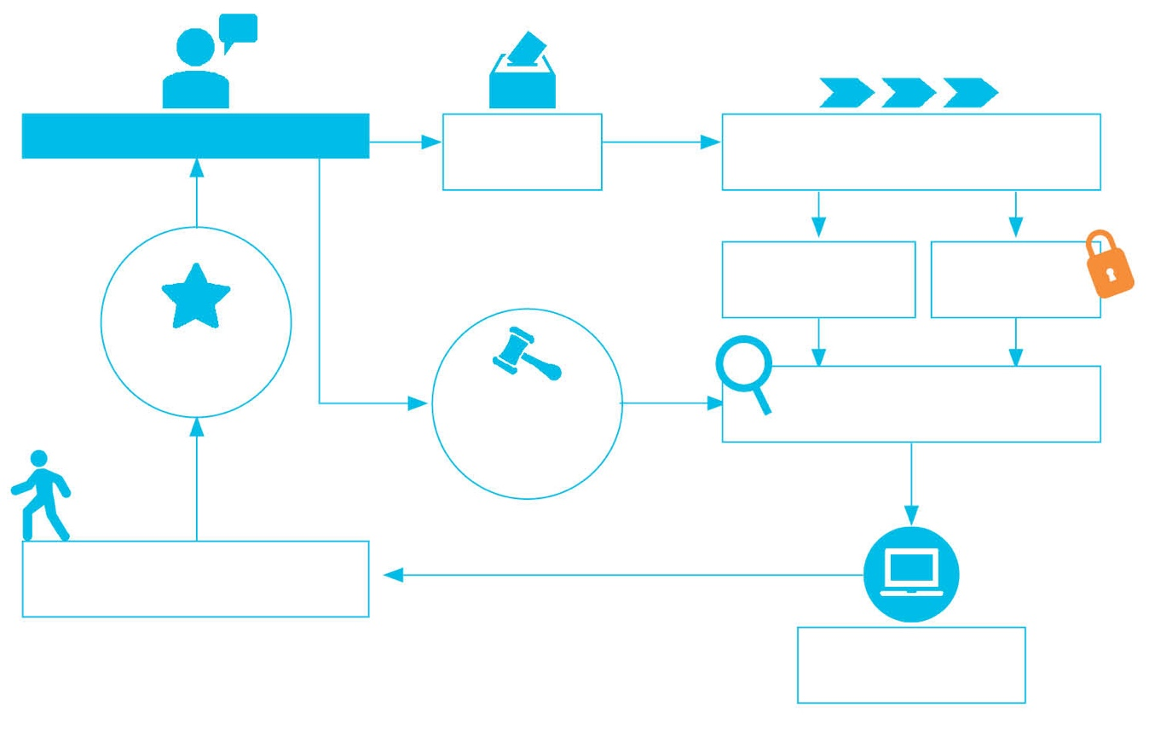

**Participant**

Receive complaint

Process complaint

Non-sensitive complaint

Sensitive complaint

Review and   
Investigate complaint

Track and Record complaint

Respond  
and act

Resolution

Appeals  
Process

# Annex 3: Referral pathways

Add in the mapping of services and referral pathway.

# Annex 4: Setting up the feedback and complaints registry

The registry is where information about the feedback and complaints received is logged. It can be as simple as an Excel table. Below are key categories that could be included in the registry.

### Consent to collect personally identifiable information

The person who is giving feedback gives [insert name of organization] full and clear permission to 1) record personally identifiable information (name and contact details) to contact them for follow‑up and 2) to share their contact information with another entity or organization to refer them.

### Reference number/unique identifier

This is a number that allows [insert name of organization] to easily track feedback and complaints from the system. Each feedback item should have a unique reference number.

### Administrative information

* **Name** of the person giving feedback [or note if the feedback was anonymous]
* **Sex/gender** and **age**/**age group**
* Other **vulnerability** status (if known and relevant)—including disability, unaccompanied minor, member of single‑headed households, internally displaced person, etc.
* **Location** or **project site** where the feedback originated

### Feedback information

* **Date received:** When someone gave feedback, or the date on which [insert name of organization] received the feedback through a channel—such as a suggestion box, WhatsApp, etc.
* **Channel used:** Hotline, suggestion box, community meeting, SMS, help desk, etc.; also include the name of the staff member who received the feedback
* **Feedback/complaint description:** Exactly as the individual(s) communicated the information—including timeframe and details
* **Feedback mechanism category:** Relevant category
* **Preferred means of follow‑up:** By phone or in-person to update the individual; make a note of contact information—such as phone number or address, depending on preferences
* **Acknowledgment:** Confirmation that the feedback/complaint was received □Yes □No

### Case management

* **Program/project/service** that the feedback relates to (if any)
* **Verification/investigation** required? □Yes □No
* **Lead point of contact:** A staff member who oversees the investigation
* **Response/decision:** Staff member responsible for deciding how to handle this feedback
* **Date when decision was requested:** When the decision-maker received feedback
* **Decision taken/status:** Details on decisions or actions; can use Open/Closed/Referred to track
* **Resolution date:** When the decision was made

### Response

* **Response date:** When [insert name of organization] responded to the individual
* **Response channel:** How [insert name of organization] shared decision
* **Duration of resolution:** Time from collection to resolution

# Annex 5: Information, Education, and Communication materials (IECs)

Add in any materials developed

# Annex 6: Feedback mechanism roles and responsibilities table

|  |  |  |  |  |  |
| --- | --- | --- | --- | --- | --- |
| Tasks | Primary responsible | Others involved | Timeline | Frequency | Support needed |
| **Receive feedback** |  |  |  |  |  |
| Receive by channel 1 |  |  |  |  |  |
| Receive by channel 2 |  |  |  |  |  |
| **Acknowledge feedback** |  |  |  |  |  |
| Acknowledge by channel 1 |  |  |  |  |  |
| Acknowledge by channel 2 |  |  |  |  |  |
| **Document feedback** |  |  |  |  |  |
| Document by channel 1 |  |  |  |  |  |
| Document by channel 2 |  |  |  |  |  |
| **Respond** |  |  |  |  |  |
| Respond by channel 1 |  |  |  |  |  |
| Respond by channel 2 |  |  |  |  |  |
| **Escalate sensitive complaints** |  |  |  |  |  |
| **Refer feedback** |  |  |  |  |  |
| **Support appeals process** |  |  |  |  |  |
| **Monitor feedback and resolution** |  |  |  |  |  |
| **Feedback mechanism effectiveness** |  |  |  |  |  |
| Check satisfaction with feedback mechanism |  |  |  |  |  |
| Conduct feedback mechanism effectiveness checks |  |  |  |  |  |
| **Other** |  |  |  |  |  |
|  |  |  |  |  |  |
|  |  |  |  |  |  |
|  |  |  |  |  |  |
|  |  |  |  |  |  |
|  |  |  |  |  |  |
|  |  |  |  |  |  |
|  |  |  |  |  |  |
|  |  |  |  |  |  |
|  |  |  |  |  |  |