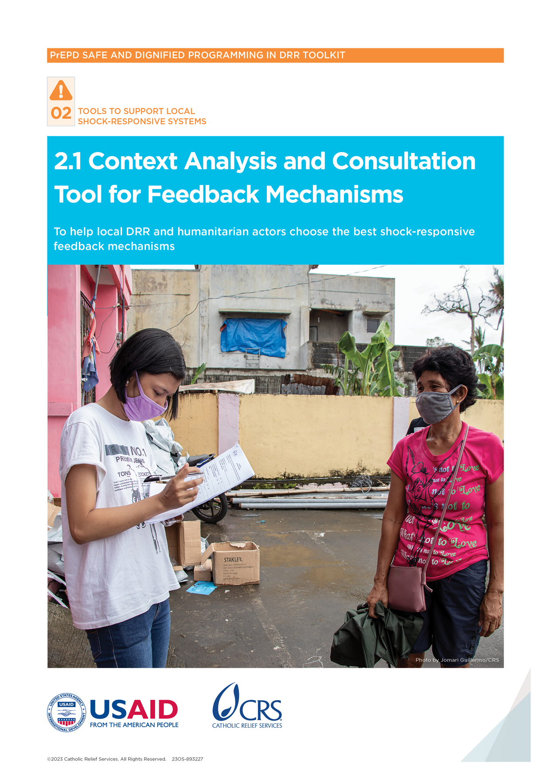

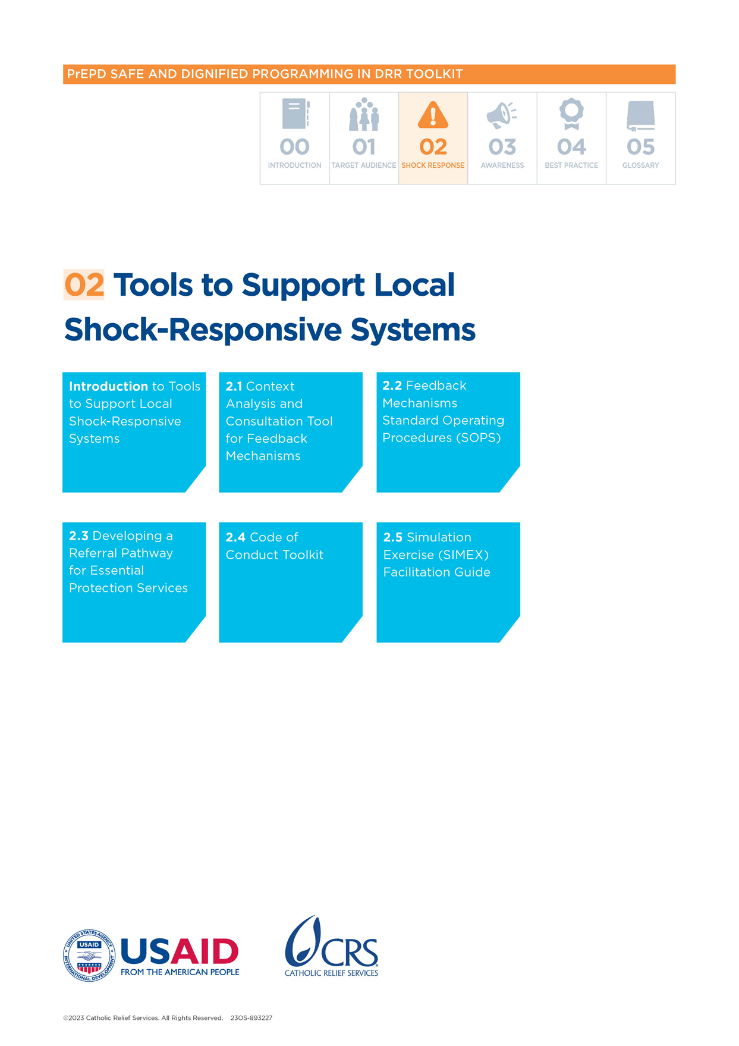

Context Analysis and Consultation Tool for Feedback Mechanisms

## Introduction

This tool is not just a checklist. It is a guide to help local disaster risk reduction (DRR) and humanitarian actors work with communities in disaster-prone areas when reviewing or setting up a shock-responsive feedback mechanism. This tool can help DRR actors analyze how communication works in the targeted community and whether feedback mechanisms exist in the community. It also helps clarify if they are reliable during a disaster and what changes can be made to make sure all members of the communities can use them.

## What is the purpose of this tool?

This tool is designed to help DRR and humanitarian actors:

* Understand whether existing feedback mechanisms already exist in the community;
* Analyze whether the feedback mechanisms are adaptable or reliable during crises; and
* If the feedback mechanisms are not adaptable, reliable or available, this tool will help with the design of an effective feedback mechanism that all members of the community can use.

## When to use this tool?

Ideally use this tool during emergency preparedness activities.

## How to use this tool?

It is recommended to organize focus group discussions (FGDs) with different members of the community to understand how widely available, effective and accessible are feedback mechanisms in different disaster-prone areas. To collect information effectively, consider doing a stakeholder mapping of the area first. This will help identify who should be invited to respond. The steps involved are:

After these steps, an assessment report can be developed with recommendations on the community’s preferred shock-responsive feedback, complaints and response mechanisms.

If using the Community-Led Disaster Risk Management (CLDRM)+, the tools in Session 2 (Mapping of Disaster Responders and Communication Preferences) ask similar questions. It is not recommended to use both if there is a risk of duplication.

## Who to involve?

Involve a range of stakeholders—including diverse members of the community.

## Key definitions

**Community:** This is a group of people who share or are thought to share cultural, religious or other social characteristics and have a collective identity and shared goals.

**Complaint:** A complaint is when a person expresses that they are angry, dissatisfied or disappointed with an organization because of something it did or something it failed to do.

**Feedback:** This involves people’s opinions, complaints and suggestions about how organizations behave and what they should/should not do.

**Feedback mechanism:** This is a formal system that helps people who get assistance or are affected by a crisis to tell organizations if the assistance is helpful or if they have complaints.

## Analyze the context

Focus on these elements during the context analysis:

**Disaster events that often happen in the community**

Here are two examples: are typhoons more frequent than earthquakes in some areas; are volcanic eruptions more likely than tsunami events? This type of information is useful to understand the fragility of certain feedback channels.

**Existing government frameworks for DRR and any requirements for communication and sharing information with communities**

In some places the government may require that all DRR actors have early warning systems to warn communities of dangerous situations. This information is helpful to understand how the feedback mechanism will fit into this system.

**Existing government approaches to feedback mechanisms for protection and shock-related information**

In some contexts, the government will already have set up helplines to report child protection or gender-based violence. It is important to understand if other government bodies use helplines or other feedback channels that already exist. This can help identify opportunities for expanding the channels for other protection and disaster-related issues.

**Community dynamics and information-sharing culture**

Existing secondary data[1] can be used to understand if the targeted community regularly shares information or complaints with external actors. Secondary sources can include reports from organizations that work in the area— including rapid needs assessments and local knowledge. Key questions to consider include:

* What is the communication landscape?
* How do different groups—including men and women, people with disabilities, older people, young men/women and children (boys and girls)—share information?
* What barriers can prevent different community members from getting information or using communication channels?
* Is face-to-face communication between the sexes culturally appropriate?
* Is technology—such as mobile phones and the internet—accessible regardless of gender, age, disability, literacy, ethnicity, language and socioeconomic status?
* Do community members receive information through traditional means? What are they?
* Which languages are most commonly used to communicate with men and women, people with disabilities, the elderly, young men/women and children (boys and girls)? How often is this in their primary language?
* What can affect people’s ability to give feedback or complain?
* Who are the most vulnerable and marginalized groups, based on gender, age, disability and other relevant factors (for example, minority ethnic, religious or political groups)? Does their status stop them giving feedback or making complaints?
* Does the preferred language of diverse groups in the community stop them from giving feedback and making complaints?
* What are the literacy rates across diverse groups according to gender, age and other relevant factors?
* What other barriers could community members face if they file a complaint? Common barriers include fear of losing access to services, fear of non-governmental organizations (NGOs) leaving the area, and fear of punishment if they complain about staff behavior.

**Government data protection and data sharing protocols**

Carefully read any written government policies or protocols on data management to make sure the planned feedback mechanism will be in line with them. For example, what information should be shared with which government or NGOs? Which personal details should be recorded when feedback is given by community members?

## Consult the community

To make sure the feedback mechanisms are inclusive and accessible to community members, consider doing targeted consultations to understand community preferences for feedback channels.

In these consultations, it is important to include a diverse cross-section of the target community to make sure that channels are appropriate, safe and accessible to all groups, regardless of gender, age or other diversity factors. At the very least, talk to men and women separately. It is best to also speak separately with groups that are considered vulnerable. Be sure to include older people, local or traditional authorities, speakers of marginalized languages, people with disabilities and representatives of youth groups and women’s associations.

Use these focus group discussions to understand their perspectives on existing communication channels, their communication preferences and any feedback/complaints channels they are using.

The following questions can guide discussions with representatives of diverse community members:

**Exploring existing feedback mechanisms**

* If you have concerns about DRR and other humanitarian actors working in the area, where can you report them? How do you report them?
* Are there channels that you use to share information about disaster interventions or other concerns with DRR committees, government bodies or other humanitarian actors?
* What are those channels? Who can use them? Who manages them? Who cannot or does not want to use them, and why?

**Feedback channel preferences**

* How would you prefer to give feedback or make a complaint to DRR and humanitarian actors about staff behavior?
* If a complaint was regarding a sensitive issue—such as sexual abuse—would you prefer a different reporting route? What would that be?
* How would you prefer to give feedback to DRR and humanitarian actors about how well and how much they support you?

**Literacy issues and other barriers**

* In which language do you prefer to communicate with DRR and humanitarian actors? What language do you prefer for written communication? What language do you prefer for spoken communication?
* Are there people in your community who cannot give written feedback and complaints to DRR actors? Who are they?
* How can DRR actors help women, men, older people, people with disabilities and people living in remote areas to share feedback and complaints in a safe and dignified way?
* Are DRR actors able to read and manage complaints and feedback in all the languages of the community?
* Are there other barriers that stop people from giving feedback and making complaints to DRR actors? How could DRR actors reduce or remove those barriers?
* Is your community covered by a mobile/phone network? Do women, men, older people, people with disabilities and young men/women have access to phones? Do phones have the correct scripts for local languages?

## Analyze the results and choose the appropriate channels

Data collected as part of this process should be disaggregated—at the very least, by age, sex and language. Ideally, it should be disaggregated by disability and any other diversity factors that are relevant in the context (social, economic or political factors). Table 1 can help with the choice of the most appropriate channels.

Table 1: Summary of community consultation

|  |  |  |  |  |  |  |
| --- | --- | --- | --- | --- | --- | --- |
| Target groups to consider  (please add relevant groups for the context) | Communication barriers | Previous channel most used overall | Previous channel most used for sensitive complaints | Safety concerns about giving feedback and complaints | Preferred channel for sensitive complaints | Preferred channel for programmatic feedback and complaints |
| **Women** |  |  |  |  |  |  |
| **Men** |  |  |  |  |  |  |
| **Girls** |  |  |  |  |  |  |
| **Boys** |  |  |  |  |  |  |
| **Adolescent girls** |  |  |  |  |  |  |
| **Adolescent boys** |  |  |  |  |  |  |
| **Older women** |  |  |  |  |  |  |
| **Older men** |  |  |  |  |  |  |
| **People with restricted mobility** |  |  |  |  |  |  |
| **People with other forms of disability** (please specify) |  |  |  |  |  |  |
| **Speakers of marginalized languages** (please specify) |  |  |  |  |  |  |
| **Minority groups** (please specify) |  |  |  |  |  |  |

Use the context analysis to decide which priority groups should be consulted so that all community members can safely access the feedback mechanisms (including people with disabilities, refugees and/or internally displaced people and minority groups).

Discuss the findings of each step with other DRR actors and government bodies to work out which channels members of the community prefer. Keep a record of community consultation results in a table like the one above. These results can be used with information from the feedback channels pros and cons list to choose one of the channel tools in Table 1.

Based on an analysis of the primary data, choose several channels that are safe and accessible for all community members. Consider diverse groups—including women, girls, people with disabilities or speakers of marginalized languages.

Also consider donor and government requirements and staffing/funding when making decisions. If possible, give feedback to community members on how the decision to set up the specific mechanism(s) was made so that community members see how their preferences and needs were considered.

# Feedback channels pros and cons[2]

The information below gives a summary of the pros and cons of different feedback channels. The choice of feedback mechanisms should be based on community members’ preferences, but there are other factors to consider. This information can help narrow down the options to suit the context.

## Suggestion box

Community members can leave written feedback and complaints in a secure box.

### Advantages

* Can have a wide reach if placed in high-traffic areas
* Easy to set up in small-scale projects
* Accessible to people who are not program participants
* Suitable for anonymous or confidential complaints (but the location of the box could limit privacy)
* Can be placed in the community for a long time, so members can access it at any time
* Can be mobile

### Disadvantages

* Not suitable for community members who cannot read and write
* Can exclude people with limited mobility—such as people who live in remote locations or older people
* Not ideal for communities spread out over large areas or for urban or large camp settings
* Going through and responding to written feedback can be slow
* It may be difficult to respond to individuals or communities if they do not give enough contact information
* Can be destroyed in a disaster—such as a typhon, flood or earthquake
* Responders may not be able to manage written communication in several local languages

## Hotline and short message service (SMS): Single prepaid account (managed in-house)

Community members can call a number and give feedback directly to a staff member.

### Advantages

* Very accessible if the location has good network coverage and if diverse program participants use mobile phones
* Suitable for remote areas and large-scale responses
* Suitable for anonymous or confidential complaints; however, if calls can be traced, this could be a barrier
* Easy to use for people with low digital literacy
* Accessible to people who are not program participants
* It is possible to quickly acknowledge, respond to and refer complaints
* Can be used to tell disaster actors about a disaster event and ask for prompt support
* Can be multilingual

### Disadvantages

* Requires set-up time, which may be too long for short projects
* Excludes community members who do not have access to a mobile phone, phone credit or electricity to charge a phone
* Can be expensive for callers if there is no toll-free number
* Personal data may not stay confidential
* There may be long delays in responding if the hotline has high traffic
* Some disaster events can interrupt phone coverage

## Hotline: Interactive Voice Response (IVR)

This is a dedicated number for community members to get information and record their feedback message.

### Advantages

* High accessibility (24/7) if there is good network coverage
* Program participants can call at any time
* Can help decrease the amount of feedback and complaints received because questions can be answered with key information
* Can be free for communities
* Suitable for anonymous or confidential complaints (the caller can decide if they want to leave contact information)
* Easy to use for people with low digital literacy
* Can be multilingual

### Disadvantages

* More effective for sharing information than managing feedback and complaints
* Excludes community members who do not have access to a mobile phone, phone credit or electricity to charge a phone
* Can be expensive for users if there is no toll-free number
* High staffing and resource costs: there must be an agreement with a service provider and staff time to listen to and log messages (alternatively, software can be purchased)
* Feedback may not include details needed for follow-up (e.g., name of agency the feedback is about, contact information), especially if feedback does not fit into set categories
* Audio must be transcribed and translated to manage multiple languages

## Face-to-face with staff

Individuals can approach staff (community liaison officers with specific responsibilities to work on feedback mechanisms) in the field; staff members receive and record feedback and complaints directly.

### Advantages

* Often one of the most popular channels
* Can reveal if programs are having unintended effects that are not being monitored
* Makes it possible to respond to urgent questions and refer people quickly; can resolve many issues immediately
* Can be multilingual

### Disadvantages

* Staff may find recording feedback time-consuming and tiring
* Staff may think complaints reflect poorly on them and be reluctant to process them
* If there is a disaster event, it can be difficult to reach people in remote areas because roads may be damaged
* During recruitment it is necessary to make sure staff have the appropriate language skills

## Community focal point (sometimes called feedback and complaints committee or community advisory group)

Locally managed focal point/committee appointed by community members are trained to collect and record feedback and complaints.

### Advantages

* Often a popular channel because community members may feel more comfortable talking to a community member than to a staff member
* Increased ownership by community
* Can build on existing social and cultural channels to resolve issues rather than imposing an unfamiliar approach
* Many issues and urgent questions can be resolved immediately; referrals can also be made immediately

### Disadvantages

* Requires training, time and effort from community members
* Complaints go through too many channels
* Usually not helpful for sensitive complaints as people may not feel comfortable reporting complaints to people they know
* Risk of high turnover or low effort if community members are not paid for this work
* Marginalized languages may be overlooked (depends on the focal points)

## Help desk near project sites or partner offices

Desk or hub is set up at the office or in the field, with set operating hours and trained staff or community volunteers to answer questions and listen to concerns.

### Advantages

* Easy to set up
* Highly accessible when set up with other program activities, like at a distribution site
* Good visibility if set up in high-traffic areas
* Useful in communities with low literacy
* Suitable for confidential feedback and complaints; however, complainants may not want to share information if the help desk is in a public place
* Offers face-to-face contact, which community members often prefer
* Fast and immediate response; possible to resolve many issues immediately
* Staff/volunteers can follow up or ask for more detailed information
* Can offer quick support and orientation if there is a disaster event
* Can be multilingual

### Disadvantages

* Low accessibility for those who are far from the project or office location
* Can be difficult to set up after a natural disaster event if infrastructure was damaged or destroyed
* Less accessible to people who are not program participants if it is set up as part of project activities
* It is not possible to stay anonymous
* Staff must be selected based on language skills

## Open community meetings

Meetings are organized periodically at project locations that bring together large groups of people to share information and collect feedback and complaints.

### Advantages

* Easy to set up
* Can ask for feedback and complaints from many people in a limited time
* Can involve people who are not program participants
* Can be adapted to the audience (for example, using child‑friendly approaches)
* Suitable for communities with low literacy
* Low staffing and resource costs
* Allows immediate response
* Can respond to common questions and concerns immediately and for many people simultaneously
* Can be multilingual

### Disadvantages

* Discussions may be limited if some people dominate the group
* May not be suitable in cultures where public criticism is not acceptable
* Can exclude most marginalized groups (such as women and children) who may not feel comfortable attending or sharing their concerns
* Not suitable for anonymous or confidential complaints
* May need interpreters for speakers of marginalized languages

## Social media and instant messaging platforms (e.g., Twitter [X], WhatsApp)

This involves a dedicated number or account where people can send written or voice messages and pictures.

### Advantages

* Can have a wide reach if the location has good network coverage
* Good way to quickly collect information about immediate needs in the first phase of an emergency response across a large area
* Can manage anonymous or confidential complaints if user accounts do not contain identifiable information
* Can be multilingual

### Disadvantages

* Requires good network coverage, access to a smartphone or computer and electricity
* Requires digital literacy to set up and use
* Can create a lot of feedback and questions, which can overwhelm staff
* Risk of online safeguarding issues
* In remote areas, it may be difficult to share the phone number or account with the community
* Requires staff to manage the platforms
* Some natural disasters can affect internet coverage
* Requires fast translation to send and receive messages in several languages

## Dedicated email address

Individuals can send emails to an address set up for feedback.

### Advantages

* Very accessible if the location has good network coverage and if communities have access to smartphones or computers and electricity
* Suitable for anonymous complaints if user email accounts do not contain identifiable information
* People may see emails as a formal and respectable way to give feedback
* Easy to set up

### Disadvantages

* Requires good network coverage, access to smartphone or computer and electricity
* Requires digital literacy
* Risk of online safeguarding issues
* There may be delays in response and flexibility
* Follow-up depends on the user supplying contact information
* Some natural disasters can affect internet coverage

1. Several sources can be used for secondary data. For example, Information and Communication Technologies (ICT) Working Group, Gender Analysis Report, The New Humanitarian website, Multisectoral Assessment Report, etc.
2. The content of this document is from the CRS MEAL in Emergencies e-learning course (2015). Click on the link to find a revised comprehensive version on the CRS EFOM site <https://efom.crs.org/wp-content/uploads/2021/11/Tool-3.docx>.