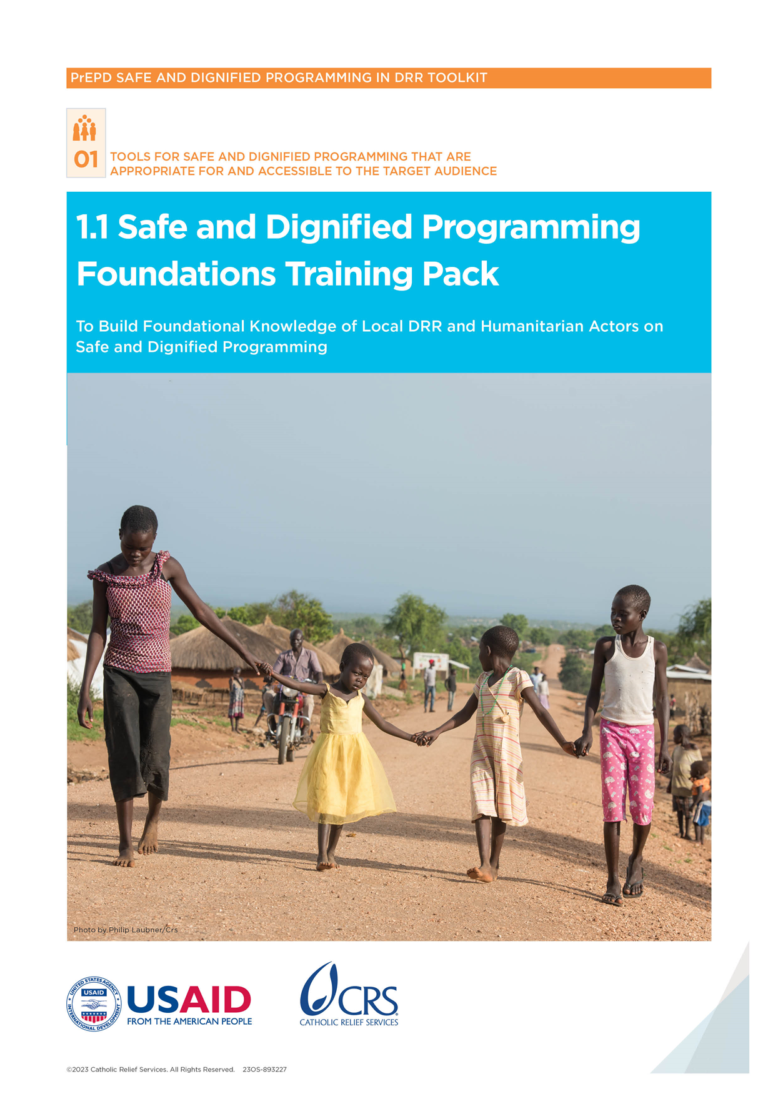

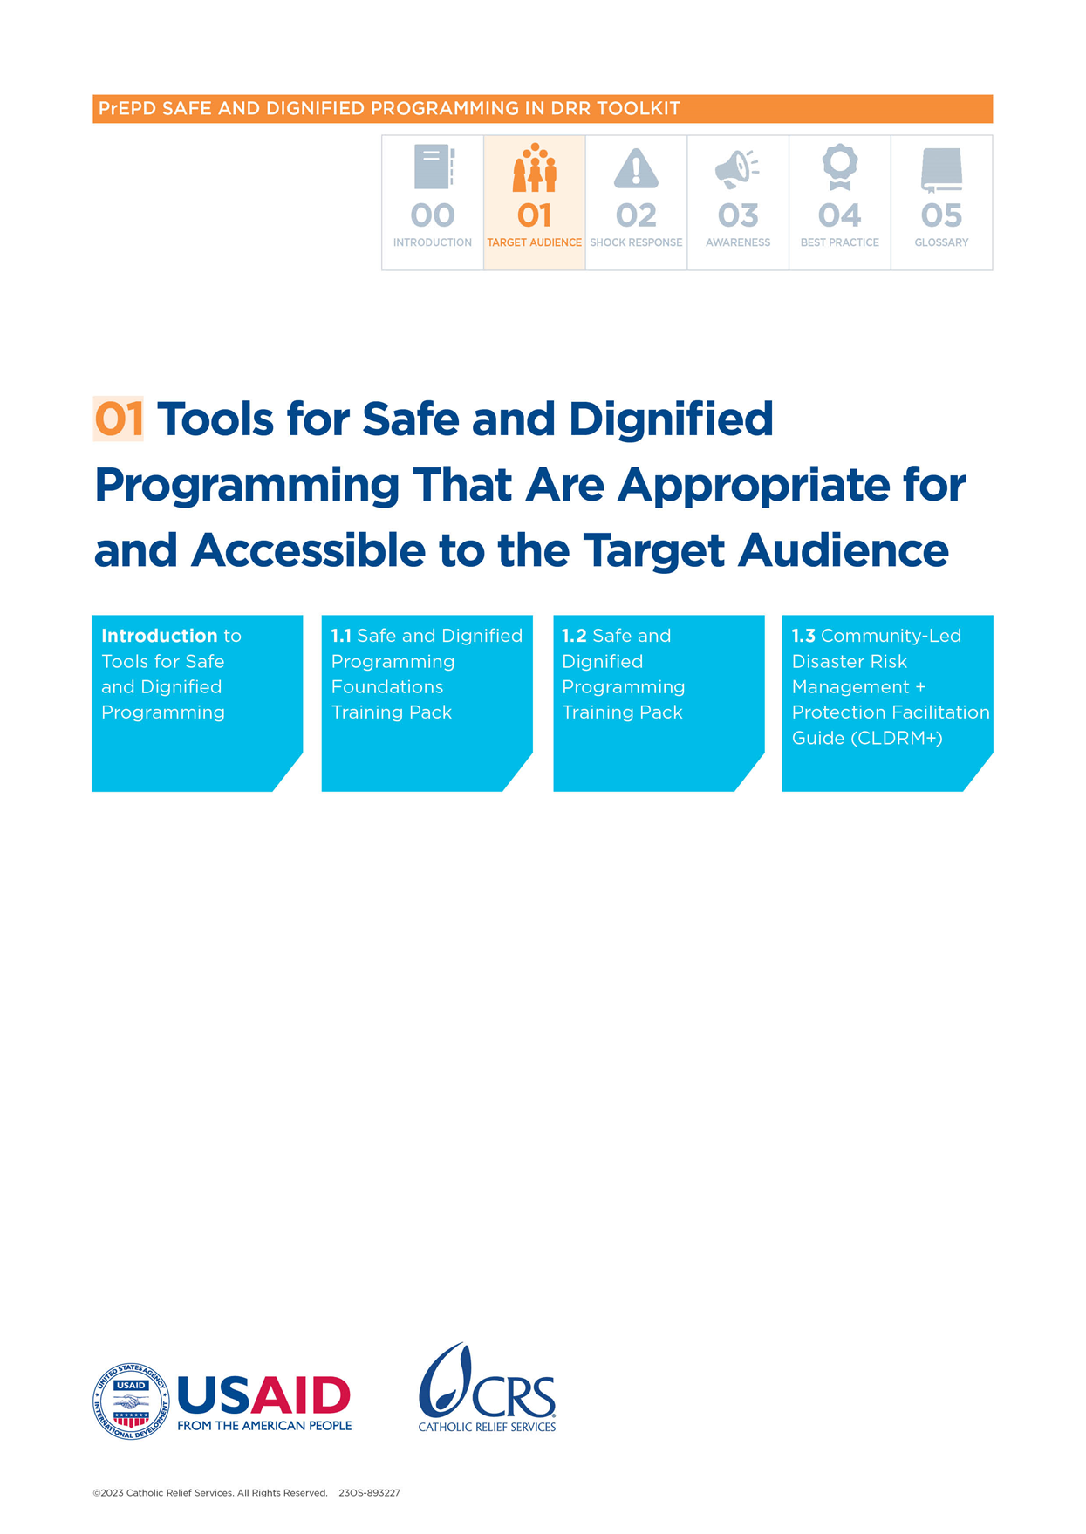

Safe and Dignified Program Foundations Training Pack

Purpose:

The aim of this training is to create an accessible, low-tech session to help disaster risk reduction (DRR) actors answer these questions:

* What are the basic elements of human rights?
* Who or what is responsible for threats?
* Who is vulnerable to them and why?
* What are the concepts and importance of safety and dignity?

Participants:

This training is for community disaster planners and officers—including village-level disaster risk reduction and management (DRRM) planners, coordinators, officers of home-owners associations, community emergency responders, civil society actors, protection actors, representatives of women’s groups, representatives of people with disabilities (PWD) associations and members of community-based organizations (CBOs) performing DRR needs assessments at the community level.

Time:

* 250 minutes

Handouts (HOs):

* HO 1: Universal Declaration of Human Rights
* HO 2: Definitions

Training tools (TTs):

* TT 1: Power Walk Characters
* TT 2: Protection Risks Role-Playing Scenarios
* TT 3: Vulnerabilities and Capacities Cards

Materials:

* Flip chart and markers
* Sticky notes
* Pens and paper

Session outline:

* Welcome and Introduction
* Section 1: Understanding Human Rights
* Section 2: Understanding Threats
* Section 3: Understanding Vulnerabilities and Capacities
* Session 4: Understanding Safety and Dignity
* Wrap-up

# Welcome and Introduction

Time:

* 30 minutes

Materials:

* Flip chart and markers

|  |  |
| --- | --- |
| **Introduction, 10 minutes** | |
| **Presentation** | WELCOME everyone to the workshop.  INTRODUCE an icebreaker to help the trainer and participants get to know each other. Use an activity that makes everyone in the room feel equal, regardless of role or status. This will encourage open discussion.  EXPLAIN the purpose and agenda for the day.  EXPLAIN that the aim of this training is to support community disaster planners and officers to better serve people affected by disasters. They will be the champions of this work. To be as prepared as possible, everyone must feel empowered to understand and explain the concepts.  EXPLAIN that this training is an introduction to Safe and Dignified Programming. The aim is to help participants understand the concepts and approaches. |

|  |  |
| --- | --- |
| **Introduction, 10 minutes** | |
| **Exercise** | Icebreakers are for trainer(s) and participants to get to know each other. Use an activity that makes everyone in the room feel equal, regardless of role or status. This can encourage open discussion. |

|  |  |
| --- | --- |
| **Creating a safe space, 10 minutes** | |
| **Exercise** | Purpose  Help participants understand and agree to ground rules to create a safe spaceand understand why this is important  Process  EXPLAIN that there is flip chart on the wall for comments or questions. It can include positive and negative comments. This is to encourage feedback and model why being open to feedback is important for learning and for accountability to the people with whom we work.  EXPLAIN that because this training is happening in a group setting and covers sensitive topics, it is important to set ground rules so everyone feels safe and respected.  ASK how we can make this space feel safe. WRITE the ideas on a flip chart and ensure everyone agrees on these ground rules. STICK the list in a place where everyone can easily see it. Be sure to include the following:  Treat others with dignity, even if we disagree. Respect the opinions of others.  Be open to new ideas.  Ask questions and be curious.  Listen to one another and speak one at a time. ***This will probably prompt lots of comments and conversation. The goal is for everyone to hear other people’s comments and learn from them.***  Respect confidentiality. Everything people say during these conversations should stay in the room unless there is a safety issue or someone feels uncomfortable.  Be open and honest.  No one should feel forced to join in. Participants can refuse or withdraw from activities without consequences. |

# Session 1: Understanding Human Rights

Time:

* 40 minutes

Objective:

* Participants understand the basic elements of human rights

Key Messages:

* The basic elements of human rights include life, justice, freedom and equality.
* Everyone has human rights, but not everyone is actually able to enjoy/access these rights depending on who is most vulnerable and who has more power.
* We must see for ourselves why rights are so important. This helps us develop a sense of responsibility.[1]

Materials:

* Flip chart and markers
* Sticky notes and pens

Handout:

* HO 1: Universal Declaration of Human Rights

Training Tool:

* TT 1: Power Walk Characters

Preparation:

* Adapt the Power Walk Characters to the context

|  |  |
| --- | --- |
| **Human rights – what are they? 15 minutes** | |
| **Exercise** | Purpose  To introduce the concept of human rights and what they mean.  Process  Part A  WRITE the words “HUMAN RIGHTS” at the top of the flip chart. Below the words, draw a large circle or the outline of a human being.  ASK participants to brainstorm what qualities define a human being, and write the words on sticky notes (they will be moved later). For example, “intelligence,” “kindness” or “sympathy.” STICK these inside the circle/outline.  ASK participants what they think is needed to protect and fully develop these qualities in a human being. For example, “education,” “friendship” or “loving family.” STICK their answers outside the circle/outline.  EXPLAIN that everything inside the circle/outline relates to human dignity, to the wholeness of being human. The things written outside the circle/outline are necessary to human dignity. Human rights are based on these necessities.  EXPLAIN that the Universal Declaration of Human Rights (UDHR) sets the standard for how human beings should behave toward one another so that everyone’s human dignity is respected. Read the following sentence:  “The recognition of the inherent dignity and of the equal and inalienable rights of all members of the human family is the foundation of the freedom, justice and peace in the world.”  **GIVE** each participant a copy of the **UDHR** (HO 1).  Part B  REVIEW the list of qualities that define a human as created by the group in Part A.  WRITE the words “SURVIVAL,” “HUMAN DIGNITY” and “LUXURY” on another flip chart page or blackboard. Discuss what these terms mean.  Place each item listed in Part A (things that are necessary to fully develop human qualities) under one of these headings. For example, is education necessary to survival? Is it necessary to human dignity? Or is education a luxury?  DISCUSS the answers with the group using the following questions:  Should human rights protect only what a human being needs to survive? Why or why not?  Should human rights also protect things you classified as “luxuries”? Why or why not?  What happens when a person or government tries to take away something that is necessary to human dignity?  Have participants ever been in a situation where they were not respected or treated ethically? How did that feel?  How would participants feel if they lost their homes or livelihoods in a flood? How would they want to be treated?  EXPLAIN that humans are more than our survival needs. Having more than just our survival needs met allows us to live full lives in dignity (the right of a person to be valued or respected and to be treated ethically).  Debrief  Rights belong to everyone and cannot be taken away. |

|  |  |
| --- | --- |
| **Who has power? Power Walk, 25 minutes** | |
| **Exercise** | Purpose  To show that not everyone has access to their human rights.[2]  Process  ASK participants to stand in a row across one side of the room, facing the facilitator.  Distribute the *Power Walk Character Preparation Cards* (TT 1) to the participants. Tell them not to share who their character is.  ASK them to pretend to be that character and to form a picture of who they are and what their life is like. They must then think about how their characters would reply to a list of questions that will be read aloud.  ASK them to listen to the questions and to take one step forward if their answer to a question is “yes,” and to stay where they are if their answer is “no.”  READ each of the following questions aloud and give participants enough time to decide whether to take a step:  Did you have enough to eat today?  Do you have cash in your pocket?  Do you have a valid, government-issued ID?  Do you have access to a telephone?  When you are sick, can you see a doctor and pay (if necessary) for their services?  Do you travel freely in your country of residence?  If you were robbed, would you go to the police to report the crime?  Did you finish primary school?  Does your family respect your opinions and ideas?  Can you read the newspaper?  Did you have access to clean water today?  Did you have access to a latrine or toilet today?  **ASK** the participants to reveal their identities and to explain why they stepped forward or not in response to particular questions. The following guiding questions may be helpful**:**  What did you assume about your character, regarding age, gender and ethnicity?  Who are the most vulnerable members in your community?  Who are the most powerful?  How can limited access to resources expose people to threats and insecurity?  If there is a natural disaster, who will it affect the most?  Imagine it is your job to help after a natural disaster. Which groups will need special attention?  Debrief  In plenary, HIGHLIGHT that:  Those with more power and better access to their rights were closer to the trainer, and those who were more vulnerable were further back in the room.  We are all born equal and with human rights. However, we do not all have access to those rights. This can be because of social, economic, political, ethnic or religious factors. These rights can be deliberately denied or abused, putting people’s safety and dignity at risk.  People in positions of power are more likely to have the resources and support they need to make sure their rights are respected. The most vulnerable may have fewer opportunities to claim their rights and may become invisible if humanitarian actors do not make a deliberate effort to find and listen to them. |

# People Need to Feel Valued: Understanding Threats

Time:

* 100 minutes

Objectives:

* Participants understand the concepts of violence, coercion, discrimination and deliberate deprivation
* Participants understand who has power in their community and how this influences how people are affected by a natural disaster

Key messages:

* Human rights underpin our work. However, in a natural disaster, human rights can be threatened by human-generated threats of violence, coercion, discrimination and deliberate deprivation.
* We need to consider what threats are present where we are working and how they affect individual and community safety, dignity and access to assistance.

Materials:

* Flip chart and markers
* Sticky notes and pens

Training tool:

* TT 2: Protection Risks Role-Playing Scenarios

Preparation:

* Create four flip charts, one for each human-made threat, and stick them on the wall.
* Print out the Protection Risk Role-Playing Scenarios.

|  |  |
| --- | --- |
| **What do we mean by threats? 30 minutes for part A; 45 minutes for Part B** | |
| **Exercise** | Purpose  Understand what the concepts of violence, coercion, deliberate deprivation and discrimination mean  Process  Part A  **EXPLAIN** that in natural disaster and conflict situations, we focus specifically on how four human-generated threats (violence, coercion, deliberate deprivation and discrimination) affect a person’s access to their rights.  STICK the words “VIOLENCE,” “COERCION,” “DELIBERATE DEPRIVATION” and “DISCRIMINATION” on a wall where they are clearly visible.  DIVIDE participants into four groups and give each group a card with one of the threats written on it. ASK them to write on a sheet of the flipchart:  A definition for each word  Examples from their own contexts or work  STICK the flipcharts on the wall and encourage groups to review with each other.  EXPLAIN the definitions of each of the four threats in plenary:  Violence is behavior that aims to harm someone. Violence can come in different forms—such as physical, sexual, psychological or even structural. Examples include deliberate killing, wounding, sexual violence, torture or creating fear of any of these.  Coercion and exploitation is making someone do something against their will by using force or threats. Examples include forced labor, forced displacement, sexual exploitation or forced recruitment.  Deliberate deprivation normally happens when a person with more power denies materials or other resources (such as information) to a more vulnerable person. Examples include blocking the delivery of humanitarian assistance, refusing to provide identification (ID) documents to individuals or groups, illegal taxes and preventing access to services—such as health, education, markets or the justice system.  Discrimination is treating different categories of people unfairly or with prejudice, especially due to race, age or sex. Examples include stopping certain groups from receiving assistance, limiting their access to jobs and services (such as education or healthcare) and not allowing them to occupy and work the land.  EXPLAIN that these four threats affect a person’s ability to access their most fundamental rights. In other words, if there is violence, coercion, discrimination or deprivation, a person’s rights are probably not being respected.  Part B  **ASK** two participants to act out a script from the *Protection Risk Role Playing Scenarios* (TT 2) before using the following questions to guide a discussion.  Ask the survivor:  How did you feel in the scenario?  Why did you feel that way?  Ask those watching:  What did you observe?  How did you feel while you were watching this scenario?  Is there anything wrong with this, in your opinion? If so, why?  Ask all participants:  What kind of protection threat do you think this is? (Relate back to the four human-made threats.)  What could have been done to prevent this? (Ask this question if there is time.) |

|  |  |
| --- | --- |
| *What do we mean by threats? 30 minutes for part A; 45 minutes for Part B* | |
| *…continued* | Debrief   * There are four main threats that affect a person’s rights. If there is violence, coercion, discrimination or deprivation, a person’s rights are not being respected, and a person can face serious harm. This can also affect their access to assistance. * We need to consider what threats are present where we are working and how these threats affect individual and community safety, dignity and access to assistance. |

|  |  |
| --- | --- |
| **Who or what is responsible for threats? (Persons and Things), 25 minutes** | |
| **Exercise** | Purpose  Reflect on how people use power in their relationships and how to promote fairer relationships and power-sharing in communities  Process  Part A  EXPLAINto the group that this activity focuses on the role of power in our relationships with others: how it influences the ways we treat others and how it affects individuals and relationships.  EXPLAINthat the group will do an exercise to understand what it means to have “power over” another person and to think about how they use their power over others in their daily lives.  ASK **the participants to divide into two equal groups:**  Participants in Group 1 will be “things.”  Participants in Group 2 will be “persons.”  READthe following directions to the group:  *Participants who are things:*You cannot think, feel or make decisions. You must do what the “persons” tell you. If you want to move or do something, you must ask the person for permission.  *Participants who are persons*: You can think, feel and make decisions. You can also tell the “things” what to do.  ASK each “person” to pair up with a “thing.” All participants should now be in pairs. If there is an unequal number of participants, one group can have three participants.  EXPLAIN that on the count of three, “persons” can tell the “things” what to do. For example: Jump up and down, spin around, sit on the ground, etc.  **Count down** “three, two, one, GO.”  After 2 minutes ASK the pairs to reverse roles: “persons” will become “things,” and “things” will become “persons.” The new “persons” now have 2 minutes to tell the “things” what to do.  **Count down** “three, two, one, GO.”  After 2 minutes,ASKthe participants to return to their tables and discuss the questions below:  What is this activity about?  When you were “things,” how did it feel to be treated like a thing?  When you were “persons,” how did it feel to treat someone like an object?  Why do people treat others like “things”?  Who has power in our culture?  In what ways do they use their power over others?  How can a natural disaster affect this power dynamic? Would those with power have more or less power than before? How about those without power? |

|  |  |
| --- | --- |
| *Who or what is responsible for threats? (Persons and Things), 25 minutes* | |
| *…continued* | Debrief   * There can be power imbalances in relationships that can lead one person to treat another like an object. They can also reduce a person’s ability to make decisions about their body and their life. * After a disaster, power imbalances can create situations of exploitation and abuse. Individuals who do not have power are vulnerable. They are dependent on others to meet their basic needs. Imagine what this feels like. Imagine the psychological impact and stress it can create. Making deliberate efforts to include vulnerable groups in making decisions helps reduce power imbalances in homes and communities. * As community leaders and individuals involved in disaster response, we have power. We control resources and access to services. It is important to recognize that power as we do this work so that we do not accidentally abuse it. |

# Session 3: Understanding Vulnerabilities

Time:

* 50 minutes

Objectives:

* Participants understand the concepts of sex, gender, age and diversity
* Participants understand who is vulnerable to threats in their local context and why

Key messages:

* Different factors can affect the risks a person faces as well as their vulnerabilities and capacities.
* It is important to understand how the overlapping vulnerabilities of a person’s sex/gender, age and other diversity factors can shape and affect the risks they face in a natural disaster.

Training Tools:

* TT3: Vulnerability and Capacity Cards

Preparation:

* Prepare the Vulnerability and Capacities Cards. Cut up a set of ten white Vulnerability Cards for each group. Do the same with the ten grey cards.

|  |  |
| --- | --- |
| Who is vulnerable to threats? (Sex/gender and age), **10 minutes** | |
| **Presentation** | Purpose  Understand who is vulnerable to threats in the local context, focusing on how sex/gender and age can affect this  Process  ASK participants to identify vulnerable people/groups in their community and to explain why they are vulnerable.  EXPLAIN that a person’s sex and the socially-prescribed differences between females and males (“gender”) are fundamentally important factors in emergencies because they shape people’s experiences of natural disasters and armed conflicts.  EMPHASIZE that women and men will:  Face different risks  Have different capacities and roles; women may be the primary caregivers, while men may be the primary breadwinners  Respond in different ways  ASK participants to think of examples of how women and men have different experiences during emergencies.  EXPLAIN that these factors often cause women and men to have significantly different experiences with getting life-saving help. Emergencies create, reinforce and worsen existing vulnerabilities,. Consequently, women are often affected more because of historic inequalities.  EMPHASIZE that understanding who has power, and therefore who controls access to resources, helps us understand the different needs that men and women have when they are affected by a disaster. For this reason, considering sex in analysis means disaggregating data by sex and also analyzing all other dynamics.  ASK participants to think of an example of how age might affect vulnerability.  EXPLAIN that if we look at the example of female community members, when we look at their potential life cycle, we can see clearly that their roles, needs and protection risks change with age and over time.  GIVEthe example of a young girl whose experiences will be very different than those of an older woman. Please note that it is also important to consider the protection risks that males experience throughout their life cycle.  EMPHASIZE that age is therefore also a fundamentally important factor we need to consider. This means collecting data disaggregated by sex *and* age, and then analyzing it so that we can understand the needs, vulnerabilities and capacities of men, women, boys and girls.  Debrief  The risks we face, but also the strengths and capacities we have, change throughout our lives. Programs need to consider these elements.  Age should be considered alongside sex (gender) and other diversity elements as people can experience different and overlapping factors of vulnerabilities that increase the risks they face. |

|  |  |
| --- | --- |
| Who is vulnerable to threats? (Diversity), **10 minutes** | |
| **Presentation** | Purpose  Understand who is vulnerable to threats in the local context, focusing on how other diversity factors can affect this  Process  EXPLAIN that so far we have looked at how sex and age are just two facets of a person. While age and gender are important factors for everyone, other characteristics vary from person to person. Humanitarian and DRR actors must recognize, understand and value differences in each emergency to protect the safety and dignity of all affected people. There are also other factors that determine vulnerability, needs and capacities.  ASK participants what they think of when they hear the term diversity and to give some examples of different factors of diversity—such as political beliefs or economic status.  EXPLAIN that diversity refers to different values, attitudes, cultural perspectives, beliefs, ethnic backgrounds, nationalities, sexual orientations, gender identities, abilities, health, social status, skills and other personal characteristics.  **Disability**: How a person’s physical abilities interact with attitudes and environmental factors to prevent equal participation in life roles and routines.  **Economic**: What skills and assets do people have? How do these skills and assets help them to cope in an emergency?  **Political**: People can be part of (or excluded from) formal political processes, but they can also have more (or no) informal influence and power.  **Social/cultural**: The set of factors that determine a person’s or a group’s standing—such as ethnicity, religion, being part of a minority group, class, etc.  **Context**: According to the context, there can be other elements of diversity.  EXPLAIN that as actors in an emergency, we need to recognize that the power dynamics in and between these groups will decide who controls resources and what limits they face. Who we talk to will affect which issues are raised because each group will have very different concerns and perspectives.  Debrief  “Diversity” vulnerability factors acknowledge that situations are very different from one context to another and that some differences (ethnic, religious, physical or mental capacities, social or cultural norms) can lead to complicated power dynamics and protection risks. |

|  |  |
| --- | --- |
| Vulnerability ranking, **30 minutes** | |
| **Exercise** | Purpose  Highlight that there can be many vulnerability factors (based on sex, age and other diversity factors) that overlap and can change after a disaster[3]  Process  DIVIDE participants into groups of three to five people. GIVE each group a set of the 10 white *Vulnerability Cards* (TT 3).  ASK the group to rank the individuals according to how vulnerable they think they are. They should consider sex, age and other diversity factors. Have participants rank them from 1 (most vulnerable) to 10 (least vulnerable).  In plenary, ASK:  What factors make people more vulnerable?  Why have you ranked the cards in that order?  REFER back to sex, age and other diversity factors; for example, “You chose the baby because of her age.”. This part of the exercise shows participants how we perceive an individual’s vulnerability, and how we base this on sex, age and other diversity factors. These perceptions affect who might be selected for humanitarian assistance.  Once that is complete, GIVE each group the corresponding gray set of cards, Vulnerability Cards (TT 3), which give them extra information for each character.  ASK the group to read the additional information, and discuss whether they now want to change their rankings. This part of the exercise shows how an individual’s capacities affect their vulnerability.  In plenary, ASK:  Why do we have to be careful about making assumptions about vulnerability?  How can you judge whether an individual or group is vulnerable in a context?  How does a natural disaster affect a person’s vulnerability? Can a natural disaster change who is vulnerable?  Debrief  Vulnerability is not a given. Staff should not make assumptions about who is vulnerable and in need.  Vulnerability is shaped by several factors that overlap—including sex, age and other diversity factors (such as ethnicity, nationality, political affiliation, etc.)  It is important to consider people’s capacities.  To identify and select those most in need, it is important to analyze who experiences a combination of overlapping vulnerabilities and who may not have the capacity to cope with risks. |

# Session 4: Understanding Safety, Access and Dignity

Time:

* 20 minutes

Objective:

* Participants understand the concepts of safety, dignity and access and how they relate to their context

Key Message:

* Emergency responses should focus on how programs can improve safety, dignity and meaningful access for all groups affected by crisis—especially the most vulnerable.

Materials:

* Flip chart and markers

|  |  |
| --- | --- |
| **Defining safety, access, and dignity, 20 minutes** | |
| **Exercise** | Purpose  Understand the three key concepts of Safe and Dignified Programming (protection mainstreaming): safety, dignity and meaningful access  Know how to use the concepts appropriately in context  Process  EXPLAIN that safety, dignity and meaningful access are the three key concepts that guide and support all Safe and Dignified Programming.  DIVIDE participants into three groups.  WRITE “SAFETY,” “DIGNITY” and “MEANINGFUL ACCESS” on separate sheets of flip chart paper, and give one to each of the groups.  ASK participants to write down other words or phrases that explain the word on their paper. Give each team 5 minutes and then ask them to rotate around the room to the next word. After another 5 minutes, ask them to rotate to the final word.  ASK them to return to the concept they started with and read the notes that other groups have added.  In plenary, DISCUSS the examples below:  Safety: Being free from danger or risk  Keeping program participants safe means understanding the types of violence, coercion, deliberate deprivation and discrimination they could face, and planning how to prevent or reduce these.  Note that safety here does not cover staff security.  Dignity: Feeling worthy of honor or respect  Being safe is not enough if people do not have their dignity. An individual’s inner experience is as important as their outward physical needs. People need to feel valued in order to have a sense of self-respect, personal identity and autonomy. Respect for these things can help carry people through extreme physical suffering.  Meaningful access: The right or opportunity to use and benefit from something  Access is defined as “the right or opportunity to make use of resources,” but people also need control and the power to decide how a resource is used. Although many people will access humanitarian support, this does not necessarily mean that the support is reaching those most in need. Equally, those who are most in need might not be able to control how resources are used. There are many barriers that can prevent people from using and controlling assistance.  GIVE each participant a copy of the definitions used through the training(HO 2)to read on their own time.  Debrief  “Safety,” “dignity” and “access” are key to understanding Safe and Dignified Programming approaches.  Practical implications can change depending on the context, so it is important to clarify what these words mean and how they are defined. |

|  |  |
| --- | --- |
| **Wrap-up, 20 minUTES** | |
|  | As a wrap-up, ASKparticipants to turn to their neighbor and tell each other:  One thing they have learned during this training  One thing they will do as a result of this training  In plenary, finish the session with any key messages from the training, including:  Everyone has human rights, but not everyone is actually able to enjoy/access these rights depending on who is most vulnerable and who has more power.  Different factors can affect the risks a person faces as well as their vulnerabilities and capacities.  Emergency responses should focus on how programs can improve safety, dignity and meaningful access for all groups affected by crisis—especially the most vulnerable.  **THANK** participants for their engagement and participation during the workshop, and make sure they are clear about any follow up and support available. |

# HO 1: Summary of the Universal Declaration of Human Rights

This is a simplified version of the full text of the Declaration from the International Rescue Committee.   
[*Protection Mainstreaming Training Facilitator’s Guide*](https://orange.ngo/wp-content/uploads/2017/07/Protection_Mainstreaming_Training-_Facilitators_Guide.pdf), 2013.

1. Everyone is born free and has dignity because they are human.
2. Everyone has equal rights regardless of the differences between them—such as gender, race, religion, language, wealth or political opinion.
3. Everyone has the right to life and the right to live in freedom and safety.
4. No one shall be held in slavery.
5. Everyone has the right not to be hurt, tortured or treated cruelly.
6. Everyone has the right to be treated as a person under the law everywhere.
7. The law is the same for everyone and should protect everyone equally.
8. Everyone has the right to ask for legal help when their basic rights are not respected.
9. No one should be arrested, imprisoned or expelled from their country without good reason.
10. Everyone has the right to a fair trial if accused of a crime.
11. Everyone has the right to be presumed innocent until proven guilty if accused of a crime.
12. Everyone has the right to privacy.
13. Everyone has the right to travel within and outside their own country.
14. Everyone has the right to seek asylum in another country if they are being persecuted in their own country.
15. Everyone has the right to a nationality.
16. Everyone has the right to marry and have a family.
17. Everyone has the right to own property on their own or with others. No one should have their property taken from them without good cause.
18. Everyone has the right to their own free thoughts, conscience and religion, including the right to practice their religion privately or in public.
19. Everyone has the right to say what they think and to share information with others.
20. Everyone has the right to meet with others publicly and privately, and to freely form and join peaceful associations.
21. Everyone has the right to vote in regular democratic elections and to take part in the government of their country.
22. Every country must do its best to ensure that everyone has enough to live a life of dignity.
23. Everyone has the right to work for a fair wage in a safe environment and has the right to join a trade union.
24. Everyone has the right to rest and leisure time.
25. Everyone has the right to a home, enough food and health care.
26. Everyone has the right to education and free primary education.
27. Everyone has the right to take part in the cultural life of their community and the right to benefit from scientific and artistic learning.
28. National and international laws and institutions must make possible the rights and freedoms set out in this declaration.
29. Everyone has the responsibility to respect and uphold the rights of others in their community and the wider world.
30. No one has the right to take away any of the rights in this declaration.

# HO 2: Definitions

**Capacities:** The ability (knowledge, expertise, resources) of organizations or communities to deliver aid, reduce disaster risks and strengthen resilience.

**Coercion and exploitation:** Making someone do something against their will by using force or threats.

**Deliberate deprivation:** When a person with more power denies materials or other resources (such as information) to a more vulnerable person.

**Dignity:** The importance and value of a person, which gives them self-respect and makes others respect them.

**Discrimination:** Treating different categories of people unfairly or with prejudice, especially because of race, age or sex.

**Meaningful access:** Giving people access to help and services based on their needs and without barriers (that is, without discrimination).

**Protection risks:** The possibility of someone experiencing danger or harm—including through violence, coercion, discrimination or deliberate deprivation.

**Safety:** Being protected from danger, risk or injury, including physical, environmental, social, spiritual, political, emotional or psychological harm.

**Safe and dignified programming:** Making sure programs respect the safety, meaningful access and dignity of people and communities.

**Violence**: Behavior that aims to harm someone. It can be physical, sexual, psychological or structural.

**Vulnerability:** A characteristic or circumstance that puts a person at higher risk of being harmed or hurt. Vulnerability is different for each person and situation.

# TT 1: Power Walk Characters

Adapted from Church World Service, Putting Dignity First: A guide to protective action in programming, 2009.

Adapt to the audience.

|  |  |  |  |
| --- | --- | --- | --- |
| **Member of a Religious Minority** | **65-Year-Old Male Farmer with a Wife and Six Children Living in a Region that Often has Extreme Flooding** | **Religious Leader Working in a Peaceful Community** | **15-Year-Old Female Head of Household in a Rural Village with Two Younger Sisters** |
| **14-Year-Old Second Wife of a Polygamous Husband** | **Refugee from a Neighboring Country** | **22-Year-Old Male Former Child Soldier** | **Male Police Officer** |
| **Permanently Disabled Survivor of an Earthquake** | **Member of Parliament** | **45-Year-Old Widow with Six Children** | **NGO Employee (Expatriate Staff)** |
| **Person Displaced by a Hurricane** | **Child Separated from Their Parents in Floods** | **NGO Employee (Local Staff)** | **Successful Male Business Owner** |
| **17-Year-Old HIV-Positive Boy Living on the Streets of a Large City** | **16-Year-Old Single Mother and Sex Worker** | **10-Year-Old Deaf Girl in an Orphanage** | **Humanitarian Worker with the United Nations** |

# TT 2: Protection Risks Role-Playing Scenarios

## Scene One: At the house of the Local Committee Chairperson (LCC)

*LCC and young single mother*

**WOMAN:** Approaches LCC at his home. “My family lost our home in the flood. We really need support.”

**LCC:** Walks up to the woman. “That’s terrible. I can help. That international agency is asking for lists of people who need help. I can put your name down.”

**WOMAN:** “Thank you! My husband is gone and I have no one else to help me. I have three young children and they are hungry and cold at night.”

**LCC:** “I can put you on the list, but you need to do something for me. Come inside my home and we can talk about it in private.”

## Scene Two: After a food distribution

*A teenage boy, a young man and a motorcycle taxi driver*

The **teenage boy** has just received a bag of maize and is walking up the mountain back to his village to finally help his mother prepare some food for him and his siblings. It is 5 km away.

**YOUNG MAN:** “Hey! Where did you get that maize?”

**TEENAGE BOY:** “The district committee gave it to me.”

**YOUNG MAN:** Pushes the boy down. “Why wasn’t I given some? Give me yours.”

**TEENAGE BOY:** “I need this for my family. Someone help!”

**DRIVER:** A motorcycle taxi driver stops. “Hey! Leave that boy alone. (Speaking to the teenage boy) “Here, I’ll give you a ride, but only if you give me half of your bag of maize.”

**TEENAGE BOY:** Sighs and gets into the taxi, relieved to be away from the young man who pushed him.

## Scene Three: Post-distribution monitoring

A second wife in a polygamous marriage, a Community District Officer (CDO) and a community member.

**WIFE:** Approaches CDO at sub-county office. “Please help me. I know you are giving out food and my children and I have not eaten in 3 days.”

**CDO:** “okay, what is your name?”

**WIFE:** “Rose Okello.”

**CDO:** Looking down at the list. “Last name Okello. Hmm. Your family is already on this list. Are you trying to cheat us? You can’t come twice to the distribution!”

**WIFE:** “I’m not trying to cheat! That is my husband. Please, I need help.”

**CDO:** (Turns the woman away and continues to the next person in line.)

*…ONE WEEK LATER*

**COMMUNITY MEMBER:** Approaches CDO at the sub-county office. “I think my neighbor was missed during the distribution. Her kids look very hungry, and I think it’s been many days since they’ve eaten.”

**CDO:** “What is your neighbor’s name?”

**COMMUNITY MEMBER:** “Rose Okello.”

**CDO:** “Her husband was given food!”

**COMMUNITY MEMBER:** “Her husband has two wives. I don’t think Rose was given any food.”

## Scene Four: District disaster meeting

Chief Accounting Officer (CAO) and sub-county (SC) Chief

**CAO:** “There is money from this NGO to do cash-for-work activities. They said we can have people help replant the trees or dig trenches to earn money and recover their livelihood losses. Who do you want to offer this opportunity to?”

**SC CHIEF:** “I have some men that could do the work. They’ve been helping me recently and deserve it.”

**CAO:** “What about the larger community? They said we should include women.”

**SC CHIEF:** “Women cannot do this work. They need to watch their children.”

# TT 3: Vulnerabilities and Capacities Cards

From Oxfam, [*Improving the Safety of Civilians: A Protection Training Pack*](https://policy-practice.oxfam.org/resources/improving-the-safety-of-civilians-a-protection-training-pack-115396/)*,* (2009).

|  |  |
| --- | --- |
| **Profile 1**  A 10-year-old girl | **Additional information for Profile 1:**  This 10-year-old girl has a mother and father and is currently able to go to school regularly. |
| **Profile 2**  A local committee member | **Additional information for Profile 2:**  This committee member is a woman who is trying to create gender balance in local committees, but she is from an ethnic minority group that is discriminated against. She is being verbally abused and targeted by men in the community while she tries to do her job. |
| **Profile 3**  A farmer | **Additional information for Profile 3:**  This farmer had to leave his land to find a safer location for his family. All of his crops were destroyed and his farming equipment was stolen. He currently has no access to land. |
| **Profile 4**  A disabled man | **Additional information for Profile 4:**  This disabled man has a job working with the local Red Crescent Society. |
| **Profile 5**  A cleaner at a UN peacekeeping base | **Additional information for Profile 5:**  This cleaner is being forced to provide sexual favors to one of the UN workers. She is afraid she might lose her job if she refuses or complains. |
| **Profile 6**  A worker for a national NGO | **Additional information for Profile 6:**  This man works for a local human rights NGO that is being targeted by the government. A couple of his colleagues were arrested last month. |
| **Profile 7**  A grandmother | **Additional information for Profile 7:**  This grandmother is living with her daughter and her family. They have enough food and support. |
| **Profile 8**  A mother with five children | **Additional information for Profile 8:**  This mother’s husband died and two of her children are missing after recent floods. She has no stable income to support her remaining three children and is very distressed. |
| **Profile 9**  An internally displaced person returning to his place of origin | **Additional information for Profile 9:**  This internally displaced person has received a support package to return to his place of origin. It will allow him to rebuild his home and buy some livestock. |
| **Profile 10**  A new-born baby | **Additional information for Profile 10:**  This new-born baby is the daughter of a family that has just been recognized as refugees by the UNHCR and will be moving to Norway soon. |

1. [Teaching Human Rights- Practical Activities for Primary and Secondary Schools](https://www.google.com/url?sa=t&rct=j&q=&esrc=s&source=web&cd=&ved=2ahUKEwii3KLT4oH2AhURJBoKHfJ_BRwQFnoECAgQAQ&url=https%3A%2F%2Fwww.ohchr.org%2FDocuments%2FPublications%2FABCChapter1en.pdf&usg=AOvVaw2zL_MIyVLIsQQWcVOm9bK2), Office of the United Nations High Commissioner for Human Rights (UN OHCHR).
2. This exercise was adapted from Church World Service (CWS), (2009). *Putting Safety and Dignity First.*
3. From Oxfam. (2009). [*Improving the Safety of Civilians: A Protection Training Pack.*](http://www.globalprotectioncluster.org/_assets/files/aors/protection_mainstreaming/Oxfam_Improving_Safety_Civilians_Training_PAck_2008_EN.pdf)